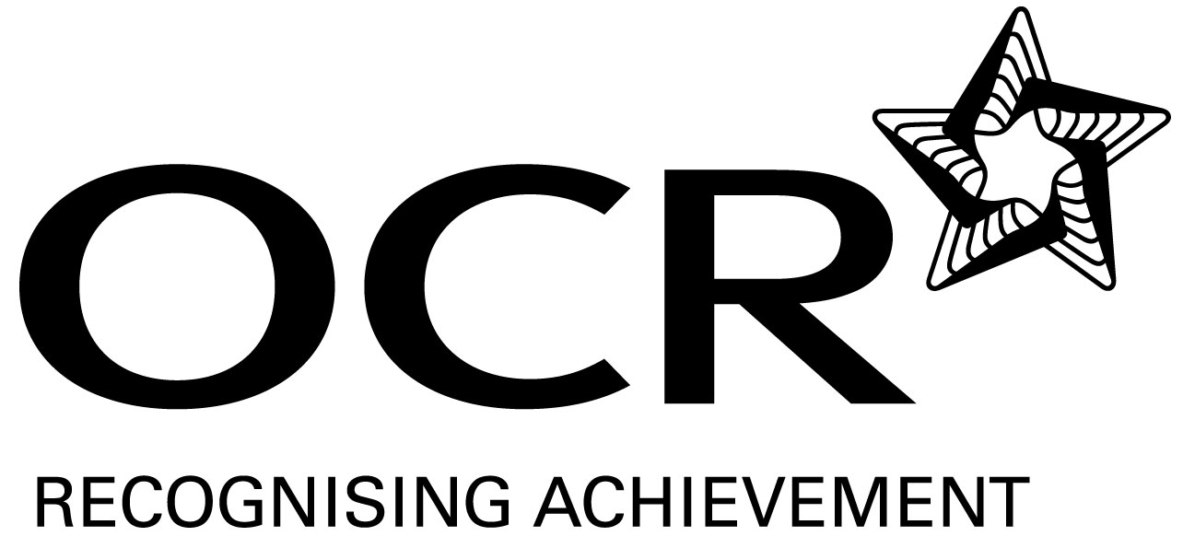
Sample Schemes of Work and Lesson Plans
GCSE History A (Schools History Project)
OCR GCSE History A: J415
Unit A952/22: Developments in Crime and Punishment in Britain, 1200–1945

This Support Material booklet is designed to accompany the OCR GCSE History A specification for teaching from September 2009.

Contents
Contents 2
Introduction 3
Sample Scheme of Work: Unit A952/22: Developments in Crime and Punishment in Britain, 1200–1945 5
Sample Lesson Plan: Unit A952/22: Developments in Crime and Punishment in Britain, 1200–1945 8

Introduction

Background
Following a review of 14–19 education and the Secondary Curriculum Review, the Qualifications and Curriculum Authority (QCA) has revised the subject criteria for GCSEs for first teaching in September 2009. This applies to all awarding bodies.
The new GCSEs have more up-to-date content and encourage the development of personal learning and thinking skills in your students.
We have taken this opportunity to redevelop all our GCSEs to ensure they meet your requirements. These changes will give you greater control of assessment activities and make the assessment process more manageable for you and your students. Controlled assessment will be introduced for most subjects.
OCR has produced a summary brochure, which summarises the changes to History A. This can be found at www.ocr.org.uk along with the new specification.
In order to help you plan effectively for the implementation of the new specification, we have produced these Schemes of Work and sample Lesson Plans for History A. These Support Materials are designed for guidance only and play a secondary role to the Specification.

Our Ethos
OCR involves teachers in the development of new support materials to capture current teaching practices tailored to our new specifications. These support materials are designed to inspire teachers and facilitate different ideas and teaching practices.
Each Scheme of Work and set of sample Lesson Plans is provided in Word format – so that you can use it as a foundation to build upon and amend the content to suit your teaching style and students’ needs.
The Scheme of Work and sample Lesson Plans provide examples of how to teach this unit and the teaching hours are suggestions only. Some or all of them may be applicable to your teaching.
The specification is the document on which assessment is based and specifies what content and skills need to be covered in delivering the course. At all times, therefore, this Support Material booklet should be read in conjunction with the specification. If clarification on a particular point is sought, then that clarification should be found in the specification itself.

A Guided Tour through the Scheme of Work

= Innovative Teaching Idea
This icon is used to highlight exceptionally innovative ideas.


= ICT Opportunity
This icon is used to illustrate when an activity could be taught using ICT facilities.

Unit A952/22: Developments in Crime and Punishment in Britain, 1200–1945
Suggested teaching time | << hours>> | Topic | Suffragettes
Topic outline |  | Suggested teaching and homework activities |  | Suggested resources | Points to note
Who were the suffragettes? |  | - Brainstorm any prior knowledge of suffragettes – what rights do women have today? Class activity  - ICT OPPORTUNITY - Using BBC website, give pupils 20 minutes to research the suffragettes. What have they learned? Feedback to the class  - Transition: Brief teacher exposition of who the suffragettes were and what they were trying to achieve  - Refer to initial starter activity, which of these do you think were not available to women at the time of the suffragettes? (input from teacher) |  | - http://news.bbc.co.uk/1/hi/uk/3153388.stm (can be downloaded for whiteboard or printed for individuals)  - http://www.historylearningsite.co.uk/suffragettes.htm  - Crime and Punishment Through Time, Ian Dawson, John Murray. The page references under activities refer to this book
Why were the suffragettes seen as criminals? |  | - Use p160-161 to read through the suffragettes’ methods of protest. Make a list of all those mentioned  - Using 2 colours and a key, sort these into violent and non-violent methods  - What does this information tell you about the actions and methods used by the suffragettes?  - Look at the following website for primary source information about the suffragettes’ methods (option to answer source based questions)  - http://www.learningcurve.gov.uk/Politics/g9/source/g9s4.htm  - How would you deal with these acts if you were the government? Write a speech to the leaders of parliament outlining your ideas – stay within the limits of the punishments available to you at the time (p160 if guidance needed) |  | - DARTS activity supports literacy
Why did the government need to change their tactics and the law? |  | - Next, read the government’s responses on p160. suggest reasons why the government chose these punishments rather than others available to them  - Why do you think the punishment was more severe than other strikers had received earlier? Did the punishment seem to work? Use: http://www.learningcurve.gov.uk/Politics/g9/source/g9s1a.htm to help  - Look at the sources on this page and answer the questions on the treatment of the suffragettes  - Study the document again. How reliable do you think this source is when trying to find out about the way suffragettes were dealt with?  - EXT: Read source 4 p161 . Does this source show a similar or contrasting view? Explain  - Why did the government introduce the Cat and Mouse act?

Unit A952/22: Developments in Crime and Punishment in Britain, 1200–1945
Suggested teaching time | << hours>> | Topic | Suffragettes
Topic outline |  | Suggested teaching and homework activities |  | Suggested resources | Points to note
What did most of the public think about the suffragettes at the time? |  | - Using worksheet 29 write a newspaper account of the methods and treatment of the suffragettes  - Include the following - How do you think the following members of the public would contribute to your story?  - male voters  - the police force  - young women  - Use shrieking sister cartoon – what does this source tell you about the opinion of some women towards the suffragettes? Teacher introduces suffragists who had obviously different tactics  - http://www.cartoons.ac.uk/record/WH0520 ( will they get it cartoon) What does this source tell you about the opinion of the government?  - Try to reach a balanced conclusion that shows different opinions about the suffragettes |  | - ICT opportunity – all resources can be printed to use in the classroom  - Supports literacy  - Extension – more able could interview classmates in order to gain quotes about the public’s opinion – AFL checks understanding
(Optional)  Did the suffragettes achieve their goals? |  | - Focus on the extent to which the suffragettes alone were responsible for gaining women the vote  - To what extent did the women’s war effort contribute to gaining suffrage?

Unit A952/22: Developments in Crime and Punishment in Britain, 1200–1945

Suffragettes – what did most of the public think about the suffragettes?
OCR recognises that the teaching of this qualification will vary greatly from school to school and from teacher to teacher. With that in mind, this lesson plan is offered as a possible approach but will be subject to modification by the individual teacher.
Lesson length is assumed to be one hour.

Learning Objectives for the Lesson
Objective 1 | To be able to identify different opinions held about the suffragettes
Objective 2 | To understand that different members of society held different opinions
Objective 3 | To be able to explain some of the reasons for these differences in opinion
Objective 4 | To use primary evidence to show understanding of some opinions regarding suffragettes

Recap of Previous Experience and Prior Knowledge
- Why were the suffragettes considered to be criminals?
- What methods did they use to achieve their goals?

Content
Time | Content
5 minutes | Recap previous knowledge. 5 minutes hot seat activity where one student is asked questions by the others to recall knowledge/ understanding (several students can take part).
10 minutes | Teacher introduces task (provide writing frame if necessary) and briefly discusses initial ideas of how each group might perceive the suffragettes.
5-10 minutes | Shrieking sister cartoon – in pairs, what do you think the message of the cartoon is? Explain. Share with another pair to explore different ideas. Can be repeated with ‘Will they get it’ cartoon
15 minutes | Draft outline of newspaper articles – make sure students are clear that they must provide an unbiased account of the actions so far of the suffragettes and include a balanced range of opinions about them
10 minutes | Read to class one or two articles – students to question the views presented and writer offered constructive feedback.

Consolidation
Time | Content
5 minutes | Opportunity for others to alter their work based on previous activity
10 minutes | What issues were raised by this lesson? How difficult was it to find a balanced argument? Was it easy not to project your own opinions in your writing?  Why do you think there were various thoughts about what the suffragettes did?

