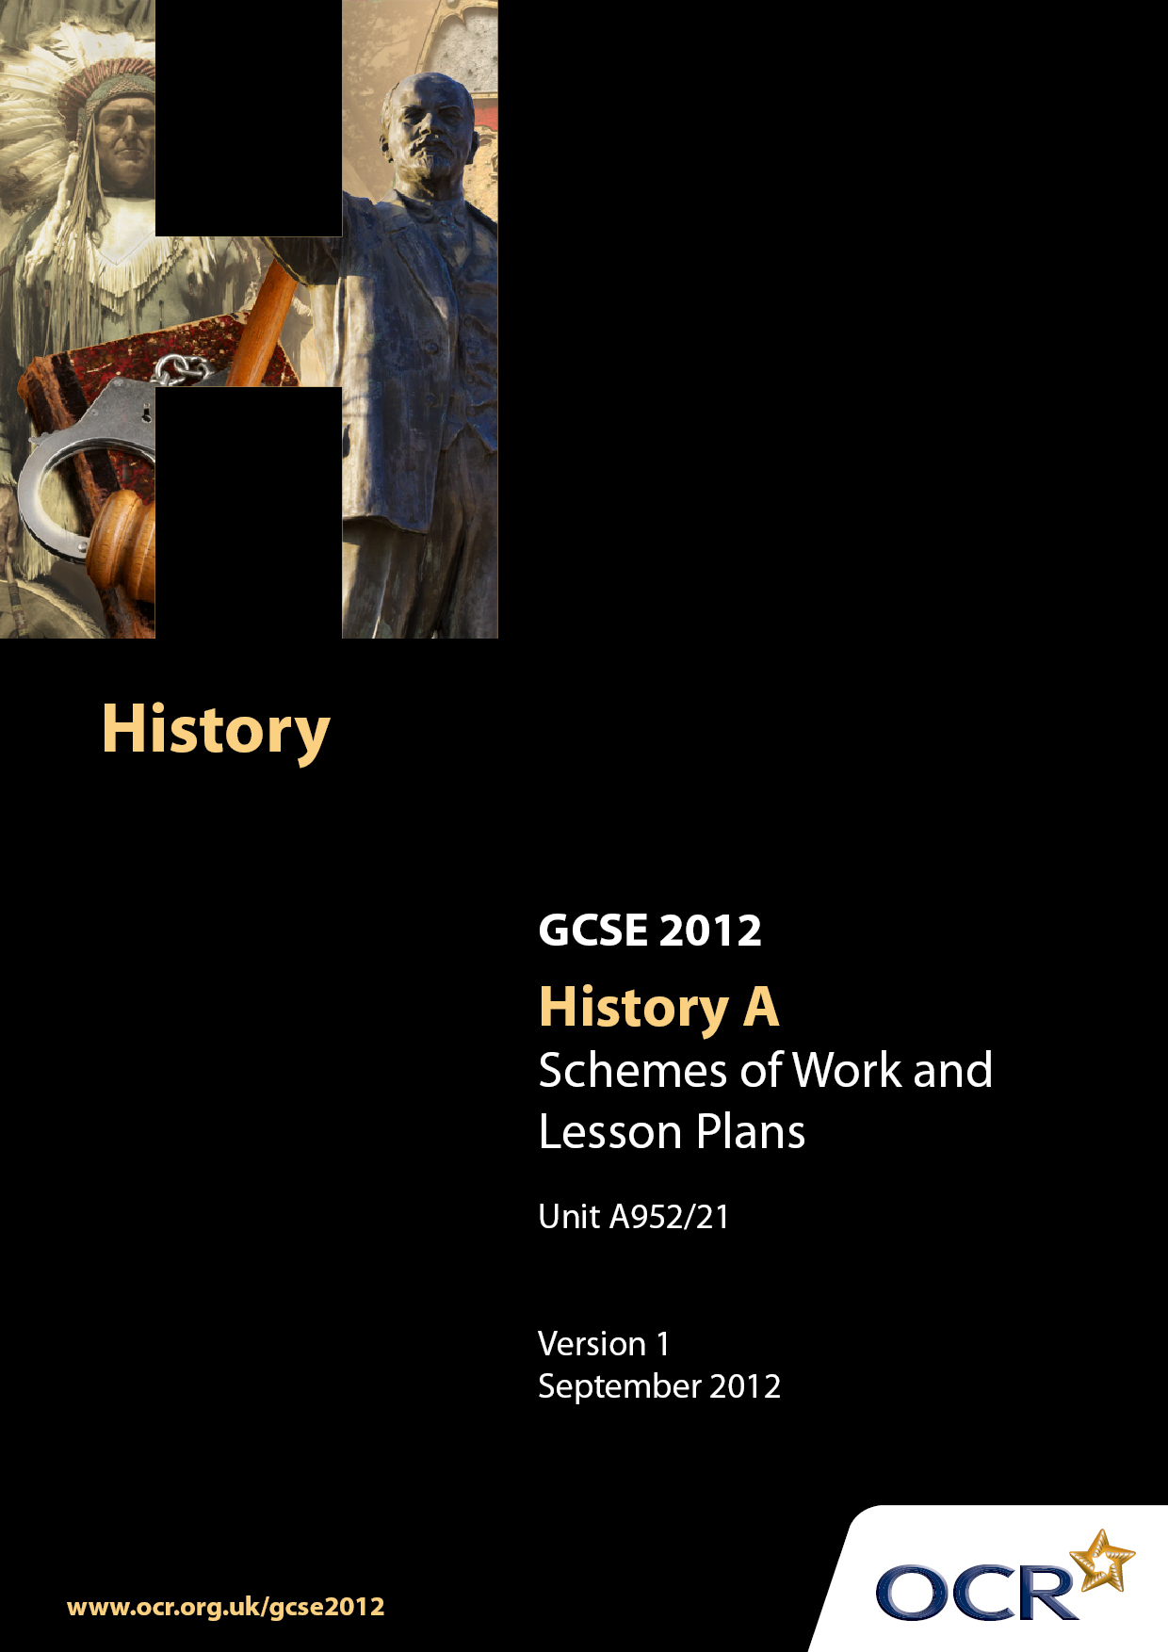

Contents
Contents 2
Introduction 3
Sample Scheme of Work: Unit A952/21: Developments in British Medicine, 1200–1945 6
Sample Lesson Plan: Unit A952/21: Developments in British Medicine,1200–1945 12

Introduction

Background
Following a review of 14–19 education and the Secondary Curriculum Review, the Qualifications and Curriculum Authority (QCA) has revised the subject criteria for GCSEs for first teaching in September 2009. This applies to all awarding bodies.
The new GCSEs have more up-to-date content and encourage the development of personal learning and thinking skills in your students.
We have taken this opportunity to redevelop all our GCSEs to ensure they meet your requirements. These changes will give you greater control of assessment activities and make the assessment process more manageable for you and your students. Controlled assessment will be introduced for most subjects.
From September 2012, assessment tasks may be undertaken at any point between release of the task and the examination series for which the task must be submitted. Centres must ensure that candidates undertake a task that is valid for submission in the year in which the candidate intends to submit it.
OCR has produced a summary brochure, which summarises the changes to History. This can be found at www.ocr.org.uk along with the new specification.
In order to help you plan effectively for the implementation of the new specification, we have produced these Schemes of Work and sample Lesson Plans for History. These Support Materials are designed for guidance only and play a secondary role to the Specification.

Our Ethos
OCR involves teachers in the development of new support materials to capture current teaching practices tailored to our new specifications. These support materials are designed to inspire teachers and facilitate different ideas and teaching practices.
Each Scheme of Work and set of sample Lesson Plans is provided in Word format – so that you can use it as a foundation to build upon and amend the content to suit your teaching style and students’ needs.
The Scheme of Work and sample Lesson Plans provide examples of how to teach this unit and the teaching hours are suggestions only. Some or all of them may be applicable to your teaching.
The specification is the document on which assessment is based and specifies what content and skills need to be covered in delivering the course. At all times, therefore, this Support Material booklet should be read in conjunction with the specification. If clarification on a particular point is sought, then that clarification should be found in the specification itself.

A Guided Tour through the Scheme of Work

= Innovative Teaching Idea
This icon is used to highlight exceptionally innovative ideas.


= ICT Opportunity
This icon is used to illustrate when an activity could be taught using ICT facilities.

Unit A952/21: Developments in British Medicine, 1200–1945
Suggested teaching time | 5 hours | Topic | Historical Sources Investigation
Topic outline |  | Suggested teaching and homework activities |  | Suggested resources | Points to note
Interpreting sources  Key question:  What is the message of this source? Use the source to explain your answer. |  | - Teacher to provide students with a worksheet containing an historical source, student friendly copy of mark scheme for an interpretation question and a mock answer to Level 1 standard  - Students to mark answer then suggest how the answer could be improved, with reference to the pupil friendly mark scheme  - Students feedback to class at which point teacher can model construction of interpretation answers  - Teacher introduces a second source on a similar subject with students creating their own answer  - Students swap answers then peer assess each other’s work, adding targets for improvement from pupil friendly mark scheme |  | - Two historical sources (subject to be determined by classroom teacher, but cartoons will work well with this exercise)  - OCR paper 2 mark scheme  - sources of conditions in Victorian London: http://www.victorianlondon.org/houses/slums.htm  - Also useful will be Medicine Investigations, C Shephard and R Rees, John Murray. There is guidance at the beginning on answering Paper 2 questions and source exercises (some on nineteenth- century public health). | - Paper 2 mark scheme can be found by following link or alternatively going to OCR home page
Interpretation in context  How does Source A (A Court for King Cholera) help you understand the importance of the work of John Snow? Use the source and your own knowledge. |  | - Students will be shown how to use an historical source and their own knowledge together to construct question answers  - Pupils to arrange a list of statements into order regarding threats to public health in the nineteenth century. e.g. Lack of proper sewers allowed filth to get into drinking water  - Give pupils Source A (A Court for King Cholera) for them to highlight all threats to public health  - Pupils to annotate source with detailed inferences of each threat to public health  Teacher to lead pupils through question highlighting what is the important part (importance of the work of John Snow)  - Group work to mind map work of John Snow (recall task) and examine how his work in 1832 links to the source in question  - Class discussion on how the source is related to the work of John Snow  - Pupils to attempt key question |  | - OCR paper 2 mark scheme  - Work of John Snow- John Snow society  - Work of John Snow- BBC  Source A (A Court for King Cholera) The Development of Medicine for OCR GCSE, C Shephard, Hodder, page 125. The threats to public health are detailed here but need to be deleted when the cartoon is first given to students. | - Students will need a basic knowledge of John Snow and his work in Broad Street  - Teachers should familiarise themselves with mark scheme for this type of question found at OCR website
Usefulness of sources  Key question:  How useful is this source as evidence about the work of Edwin Chadwick in the 19th century? Use the source and your knowledge to explain your answer. |  | - Students will develop their ability to evaluate the usefulness of historical sources  - Teacher to lead introduction to issue of usefulness of sources by explaining it is not the same as reliability and that the usefulness of sources depends on what you want to find out  - Pupils to conduct usefulness investigation into a range of sources - what would they be useful as evidence of, what they would not be useful as evidence of?  - Pupils must state what is useful/ not useful for each source to foster idea every source has something positive to offer and should not be discarded  - Pupils complete a table with useful/ not useful columns to asses the usefulness of the source  - Pupils to attempt key question |  | - OCR Paper 2 mark scheme  Source C. A Cholera Warning poster. Warrington Board of Health. www.1museumstreet.co.uk/wdia/house_health/02a.htm&h=247&w=350&sz=43&hl=en&start=1&usg=__DveuMqRqcSdg4NDNMHxdtmnNu8g=&tbnid=4UVvmU62vU58JM:&tbnh=85&tbnw=120&prev=/images%3Fq%3D1832%2Bcholera%2Bwarrington%26gbv%3D2%26hl%3Den | - Pupils will need a knowledge of Edwin Chadwick and the social reform process of the 19th century  - Teachers should familiarise themselves with mark scheme for this type of question found at OCR website
Source Comparison  Key question:  Do you think source C is more useful than Source D in enquiring into Public Health in early 19th century Britain? |  | - Pupils will practise all techniques developed so far, interpretation, inference and source usefulness and further develop the ability to compare sources as pieces of historical evidence  - Groups to complete individual useful/ not useful tables examining content of Source C then feed back to class  - Individual pupils complete above task for Source D individually  - Teacher- led modelling of how to show/ highlight the similarities and differences between historical sources by drawing a simple table to record the similarities and differences between the two sources. This process must be done simultaneously  - Pupils to complete above process  - Pupils to attempt key questions |  | - OCR Paper 2 mark scheme  Source D. Painting of 19th Century Westminster. Westminster Slum. G.B Roy www.medphoto.wellcome.ac.uk | - Pupils will need a basic understanding of the lack of public health measures in Britain in the early part of the 19th century (before any reforms)  - Teachers should familiarise themselves with mark scheme for this type of question found at OCR website
Interpretation  Key question:  Edwin Chadwick was of huge importance in changing Public Health in Britain.  How far do the sources on this paper support this view? Explain your answer.  Remember to identify the sources you use |  | - Students will reach a conclusion about an historical interpretation using a collection of sources and their own knowledge  - Groups read collection of sources and record which sources agree with and disagree with the interpretation.  Groups to be reminded to select quotes to justify their assertions  - Teacher to model a Level 3 response, reminding pupils of the need to use their own knowledge to support what the source is saying. “Source B shows Chadwick highlighting the awful condition people lived in the towns with evidence. This shows what a big problem there was and spurred others to solve the problems”  - Teacher to inform class that to gain a Level 4 they must use the sources and their own knowledge and the sources to both agree and disagree with the interpretation  - Pupils to attempt similar task but disagreeing with the interpretation using a different source  - Pupils to conclude answer giving their own opinion on the interpretation using the sources and their knowledge |  | - OCR Paper 2 mark scheme  Source B. The sanitary conditions of the labouring population Sparticus Schoolnet www.sparticus.schoolnet.co.uk/PHchadwick.htm | - Pupils will need an overview of public health problems and solutions of the 19th century.  - Teachers should familiarise themselves with mark scheme for this type of question found at OCR website

Unit A952/21: Developments in British Medicine,1200–1945

Comprehension and inference
OCR recognises that the teaching of this qualification will vary greatly from school to school and from teacher to teacher. With that in mind, this lesson plan is offered as a possible approach but will be subject to modification by the individual teacher.
Lesson length is assumed to be one hour.

Learning Objectives for the Lesson
Objective 1 | To select evidence to use in an interpretation question
Objective 2 | To make simple inferences based on source material
Objective 3 | To make complex inferences about medicine from an historical source

Recap of Previous Experience and Prior Knowledge
- First Key Stage Four lesson on using historical sources. A basic knowledge of medicine through time will be needed. As this is a generic source skills lesson, the lesson plan can be adapted to any topic

Content
Time | Content
10 minutes | Hand out cards to selected pupils with emotions on them happy sad etc. Pupils to act out these emotions whilst rest of class tries to guess the emotion. Teacher to explain how they have just worked with a source and determined its meaning.
15 minutes | Teacher to give students:  An historical source (subject to be determined by teacher and can be either picture/ text etc  Student- friendly copy of mark scheme for interpretation questions  Mock answer to Level 1 standard.  Pupils attempt to mark answer  Reflect how it could be improved
10 minutes | Class as a group mark answer underlining where answer hits Level 1  Class discuss how the answer could be improved (with reference to mark scheme) AFL

15 minutes | Teacher introduces second source with interpretation question.  Pupils to place source subject in historical context and refresh their knowledge on the subject  Pupils to attempt question

Consolidation
Time | Content
10 minutes | Pupils to explain in their own words what an inference is.  For more able explain how an inference becomes a complex inference

