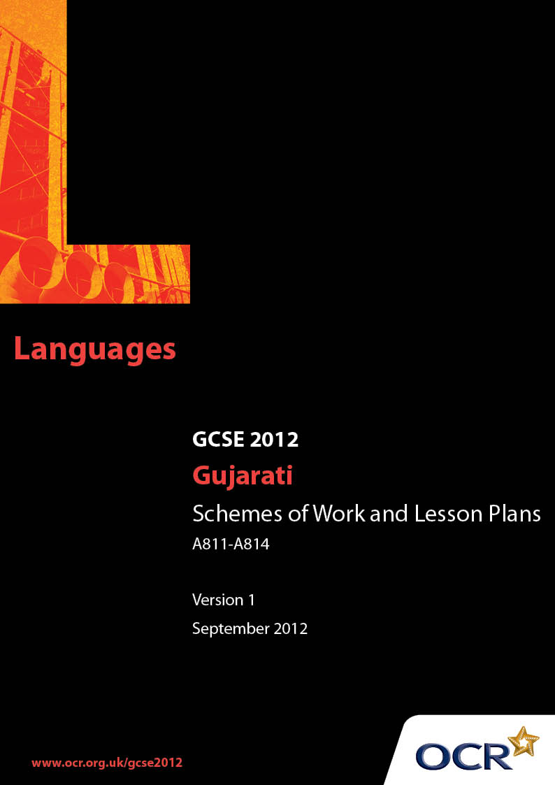

Contents
Contents 2
Introduction 3
Sample Scheme of Work: OCR GCSE Gujarati: J734 Unit A811-A814:
Local area, facilities and getting around 5
Sample Lesson Plan: OCR GCSE Gujarati: J734 Unit A811- A814:
Local area 13

Introduction

Background
OCR has produced a summary brochure, which summarises the changes to Gujarati. This can be found at www.ocr.org.uk, along with the new specification.
In addition and in response to reforms announced by the Government and in response to Ofqual mandated changes to GCSEs, unitised assessment of this qualification is being replaced by linear assessment from September 2012. This means that candidates commencing a two year course from September 2012 will take all of their GCSE units at the end of the course in June 2014.
In order to help you plan effectively for the implementation of the new specification we have produced this Scheme of Work and Sample Lesson Plan for Gujarati. These Support Materials are designed for guidance only and play a secondary role to the Specification.

Our Ethos
OCR involves teachers in the development of new support materials to capture current teaching practices tailored to our new specifications. These support materials are designed to inspire teachers and facilitate different ideas and teaching practices.
Each Scheme of Work and set of sample Lesson Plans is provided in Word format so that you can use it as a foundation to build upon and amend the content to suit your teaching style and students’ needs.
The Scheme of Work and sample Lesson plans provide examples of how to teach this unit and the teaching hours are suggestions only. Some or all of it may be applicable to your teaching.
The Specification is the document on which assessment is based and specifies what content and skills need to be covered in delivering the course. At all times, therefore, this Support Material booklet should be read in conjunction with the Specification. If clarification on a particular point is sought then that clarification should be found in the Specification itself.

A Guided Tour through the Scheme of Work

= Innovative Teaching Idea
This icon is used to highlight exceptionally innovative ideas.


= ICT Opportunity
This icon is used to illustrate when an activity could be taught using ICT facilities.

OCR GCSE Gujarati: J734 Unit A811-A814: Home and Local Area
Suggested teaching time | 11 hours | Topic | Local area, facilities and getting around
Topic outline |  | Suggested teaching and homework activities |  | Suggested resources | Points to note
Information and opinions about your local town |  | - Brainstorm of vocabulary about your home town and region e.g. size of town, facilities, shopping, tourist attractions etc. |  | - PPT’s, interactive white board vocabulary - (can be a dictation) or write on white board or flashcards. | - Internet facilities should be available either at home or in school/or use some printed extract with background history and current facilities about town in English.
 |  | - Spoken presentation for name of town/region, where it is, what kind of town, description, number of inhabitants, list of available facilities and opinions - done in groups or pairs.  (Listening and Speaking skills) |  |  | - Encourage students to give opinions and justifications at each stage and using each skill.
 |  | - Written worksheets – matching exercise for vocabulary.  (Reading skills) |  | - Written worksheets prepared by teacher – matching exercise.
 |  | - Write a simple description and opinions about your home town in short sentences/paragraphs.  (Writing skills) |  | - Internet – information on local area in English – research done by students. Can be done as homework or class work to know and understand their town better. | - Students acquire enhanced knowledge and understanding about their own town  from internet/research.
Give an account of the area you live in |  | - Discussion on how long you have lived in the area around your home and what there is to do/see. Can be done in groups or pairs.  (Speaking and Listening skills) |  | - flash cards/written on whiteboard or ppt with vocabulary. | - Cue cards can be used by less able students to help them remember vocabulary.
 |  | - Written exercise to match words to consolidate vocabulary.  (Writing skills) |  | - Do as a matching exercise prepared by teacher (vocabulary should be different from above).
Give an account of the area you live in (cont.) |  | - Read a short passage and answer in Gujarati.  (Reading skills) |  | - Comprehension – prepared by teacher.
 |  | - Written information about the area around your home – can do short letter/e-mail.  (Writing skills) |  | - Students can use spider diagram or cue cards to help them to organise speaking or writing exercises. | - More able students can do a letter with good quality of language.  - Written exercise can be done as H/W.  - Opinions and justifications plus different tenses to be included.
Area/town that you have visited or plan to visit |  | - Oral discussion – consolidate vocabulary and tenses on a place/area you have visited or – plan to visit – highlight the similarities/differences (giving opinions and justifications) within the towns in the UK.  (Listening and Speaking skills) |  | - Tense revision and vocabulary revision orally – teacher leads the discussion.  - Draw from students’ experiences. | - This can also be a reading or listening exercise.  - Teacher should encourage students to use opposites and opinions and justifications.
 |  | - Written exercise – fill in the blanks in Gujarati (with a bank of words given in brackets).  (Reading and Writing skills) |  | - Worksheets with fill in the blanks exercise in past and future tense – prepared by teacher.
 |  | - Pair work/presentation by students with prior experiences of areas visited in the UK – larger town/tourist attraction.  (Listening and Speaking skills) |  | - Students could design cue cards with attractions in their town and another area in the UK. | - This can also be done on computer by students – they could work in pairs to prepare ppt presentation and more  able can give 1 min presentation.
 |  | - Write a post card/letter about your town to a relative who lives in a smaller town/village.  (Writing skills) |  |  | - Include opinions and different tenses.
Changes to your local area/town |  | - A newspaper article about likely changes to your local area and their effects – teacher led discussion.  (Listening and Speaking skills) |  | - English newspaper/magazine or an internet article as stimulus for discussion. | - Refer to environment/safely issues.  - Include opinions and justifications.
 |  | - Worksheet with answers in Gujarati.  (Reading and Writing skills) |  | - Worksheet and questions in Gujarati – prepared by teacher.
 |  | - Write a post card/letter inviting your friend who lives in a smaller town to see changes to your town.  (Writing skills) |  |  | - Less able students could design a poster with speech bubbles: more dustbins required – to keep my town clean; traffic lights required near my school/my younger brother’s school – for children to cross safely etc.
Compare your town/ area with a town/area in UK including Gujarat |  | - Discuss orally differences in facilities between the UK towns and a town in Gujarat.  (Speaking and Listening skills) |  | - Teacher prepares a list of words for facilities mainly referring to a town in Gujarat. | - This should be mainly with regards to facilities rather than attractions in the towns.  - Use experiences of students who have visited Gujarat.
 |  | - Listening exercise – answer in English.  (Listening skills) |  | - Listening practice from past papers.
 |  | - Reading exercise on a town in Gujarat – answer questions in Gujarati – H/W activity. (Reading and Writing skills) |  | - Internet article/tourist information can be used for a written worksheet with information in English/Gujarati – prepared by teacher. | - Opinions and justifications.
Compare your town/ area with a town/area in UK including Gujarat (cont.) |  | - Speaking practice – plan a tour for a visitor from Gujarat around your town. Divide class into 2 teams – one from the UK and one from Gujarat, and practise as a role play/presentation to the class of 1-2 minutes in length.  (Speaking and Listening skills) |  | - pair work – areas visited – students could use cue cards with attractions in your town and create new ones for a town in Gujarat. | - Can be done as peer assessment  if students are capable of doing  so. Low ability students can learn  from this and gain confidence.  - More able students can include  where they would like to live if  they won the lottery and why.
Different modes of transport |  | - Different types of transport – private and public. Brainstorm advantages and disadvantages of different types.  (Listening and Speaking skills) |  | - Could use a ppt/interactive whiteboard. | - Teachers create resources according to the ability of students.
 |  | - Pictures and words – matching exercise.  (Reading and Writing skills) |  | - Picture exercise could use ppt, OHP, whiteboard or worksheet.
 |  | - Pair work/groups – common forms of transport in town e.g. car, cycle, walking, bus, train etc. Divide into groups or pairs and give details of a trip in a short speech or Q&A session – where, when, how, what did you do etc.  (Speaking and Listening skills) |  | - Teacher directed activity – students can make cue cards to help them with vocabulary. | - Teacher can give reward points to those who can make it more interesting, good length and good quality of language or peer review (other students can vote on this by giving their comments on their  performances as well as giving  ideas for improvement).
Different modes of transport (cont.) |  | - Write a short account of your journey to meet a friend(s) to go to your local library (can be shopping, going to school, going to cinema, park etc) use of transport (car, bus, cycle) length of time and meeting times include opinions and justifications.  (Writing skills) |  |  | - Teacher directed activity to revise past tense well.
 |  | - Listening activity – journey to town centre and shopping – answer in Gujarati.  (Listening skills) |  | - Listening tape/CD –prepared by teacher. | - Can use past papers.
Use Directions to get to places |  | - Oral exercise to turn on the spot – left, right etc. |  | - Could use a ppt/interactive white board. | - Can use world map/globe to enhance directions.
 |  | - A demonstration with an able pair  of students to go from A to B  within the class using vocabulary  and different turns. Students can write vocabulary in their work books.  (Listening and Speaking skills) |  | - Exercise/work sheet/dictation.
 |  | - Simple compass directions – worksheet to fill in the blanks.  (Writing skills) |  | - Work sheet on compass directions.
 |  | - Pair work – to revise directions and journey to school.  (Listening and Speaking skills) |  | - Cue cards or a simplified map of the area.
Use of public transport – Train/bus/coach/car/  bicycle/plane/boat or walking and facilities in your town & in Gujarat town |  | - Brainstorm how to get to facilities around your area and how long you take to get there – bank/post offices/shops/town centre.  (Speaking and Listening skills) |  | - Could use ppt/interactive white board exercise/flash cards produced for facilities as prompts for discussion of transport.  - Simple map of the local area. | - More able students can have an extension with different tenses and opinions.
 |  | - Pair work conversation to get information about times and timetables for buses and railway destination and to buy or reserve tickets.  (Speaking and Listening skills) |  | - Teacher led activity – can have a copy of coach/train timetable for a day and give copies to students to help with pair work. | - Revise 24 hour clock.  - Dialogue – at railway station/bus  station – can have a classroom as  a platform and students can giving information about destinations check times on timetable, issue tickets, reserve it etc. – depends on students abilities.
 |  | - “A school organises a day trip to see a play” – using time reference write in a paragraph from jumbled up text.  (Reading and Writing skills) |  | - Work sheet with mixed up sentences on trip – prepared by teacher.  Or  - Can have sentences that are cut in  strips and put in an envelope, students then re-organise by time reference and write in work books (this can be done in pairs with mixed ability). | - Match pictures with sentences using time reference.  - Can be done as a speaking presentation by students prepared as homework.
Use of public transport – Train/bus/coach/car/  bicycle/plane/boat or walking and facilities in your town & in Gujarat town (cont.) |  | - A reading exercise covering different types of transport in the UK and in India and places of interests and facilities to consolidate vocabulary – answer in English – as homework.  (Reading skills) |  | - Reading passage worksheet – prepared by teacher. | - Can be done as a listening activity as well.
- Write an e-mail inviting your friend to your birthday party in a restaurant next weekend – giving details how to reach there.
- (Writing skills)
 |  | - A listening exercise on types of transport in India compared with the UK and answer in English.  (Listening skills) |  | - Listening activity prepared by teacher. | - Use prior knowledge of students who have been to India and differences between the UK and India. Include opinions and justifications.
 |  | - A comprehension passage that gives an account of a planned shopping trip to another town or in Gujarat – answer in English – as Homework.  (Reading skills) |  | - Comprehension text prepared by teacher. | - Include time reference in the passage.
Give an account of an accident |  | - DVD/video or recorded news article on accidents that happened on roads in UK/Gujarat. Students listen to the text and can explain in their own words – what happened, how, discuss causes, blame and consequences.  (Listening and Speaking skills) |  | - DVD/Video/recorded news article. | - Draw on students’ experiences where they themselves or their families may be involved.  - Can include informing police and talking as a witness, calling an ambulance and taking to doctor etc.
 |  | - Discuss what you would do under the circumstances.  (Listening skills) |  | - Teacher led exercise where questions can be asked to encourage and motivate students to answer.  - Consolidate with explanation from teacher. | - Opinions and justifications.
 |  | - A reading passage from past papers with answers in English (can discuss and make a list of difficult words and use a dictionary to find meanings).  (Reading skills) |  | - Past exam paper exercises. | - Can be done as a listening exercise.
Consolidation |  | - Students to make their own cue cards and notes.  (Writing skills) |  | - Related book/ magazine articles. | - More able students can read around this topic.
 |  | - Explore previous exam question papers on this topic. |  | - Past exam question papers.
 |  | - Extra reading exercises.

OCR GCSE Gujarati: J734 Unit A811- A814: Local area, facilities and getting around

Local area
OCR recognises that the teaching of this qualification above will vary greatly from school to school and from teacher to teacher. With that in mind this lesson plan is offered as a possible approach but will be subject to modifications by the individual teacher.
Lesson length is assumed to be one hour.

Learning Objectives for the Lesson
Objective 1 | To be able to identify vocabulary about facilities in the home town done previously
Objective 2 | Students to demonstrate the ability to ask questions and give answers in Gujarati using different tenses.
Objective 3 | To be able to do class reading and to understand the passage on local area – (prepared by the teacher).
Objective 4 | To be able to answer questions in Gujarati.
Objective 5 | To be able to use simple tenses correctly.

Recap of Previous Experience and Prior Knowledge
- Recap vocabulary for facilities and simple tenses learnt previously about your area.

Content
Time | Content
5 minutes | Power Point slide, OHP or black board with a string of the vocabulary words – teachers could use interactive whiteboard or Smartboard. Each student comes to the board, identifies a word, cross it off the list and gives the meaning in English.
5 -10 minutes | Divide the class in 2 teams: a student from Group 1 asks a question to one in Group 2, it is then his turn to ask a different question to a student in Group 1. To make this game competitive points can be given per team and can be done against the clock (Teachers should ensure that there is no repetition of questions or answers and different tenses are used) – prompt students to use different tenses if necessary.  This exercise should cover - how long students have lived in the area and standard facilities – e.g. schools, banks, various shops, supermarket, hospital, museum, library, police station, post office etc in Gujarati – including facilities used in the past and in the future.
5 minutes | Comprehension passage prepared by teacher. Quiet reading by students.
15 minutes | A passage to be read aloud by students – each student reads a sentence out loud and explains in English. The class can discuss difficult words as a group. The passage can be read from Power Point slides (teacher directed reading) or handouts.
10 minutes | Answer Questions in Gujarati (less able students can answer in English).

Consolidation
Time | Content
5 -10 minutes | Recap of vocabulary from the session and verb endings and structures for different tenses used within the written text.  Write an e-mail to your friend on the facilities in your area including which ones you like most and why (this activity can be done in pairs – for less able).
5 minutes | Recap objectives and outcome of the lesson. Draw from students what they have learnt.  More able students (or all students if applicable) to say a sentence using only past/future tense – this can be done as they leave the classroom.

Home work
Write a short paragraph on –

“Going to your local park or a leisure centre next weekend”.
(This should cover – with whom, when and how long for, how you will reach there, what you will do etc – encourage students to use more complex sentence structures in future tense
(e.g. જ્યારથી/ત્યારથી....જ્યારથી આ શહેરમાં/વિસ્તારમાં રહેવા આવી/આવ્યો ત્યારથી......).

