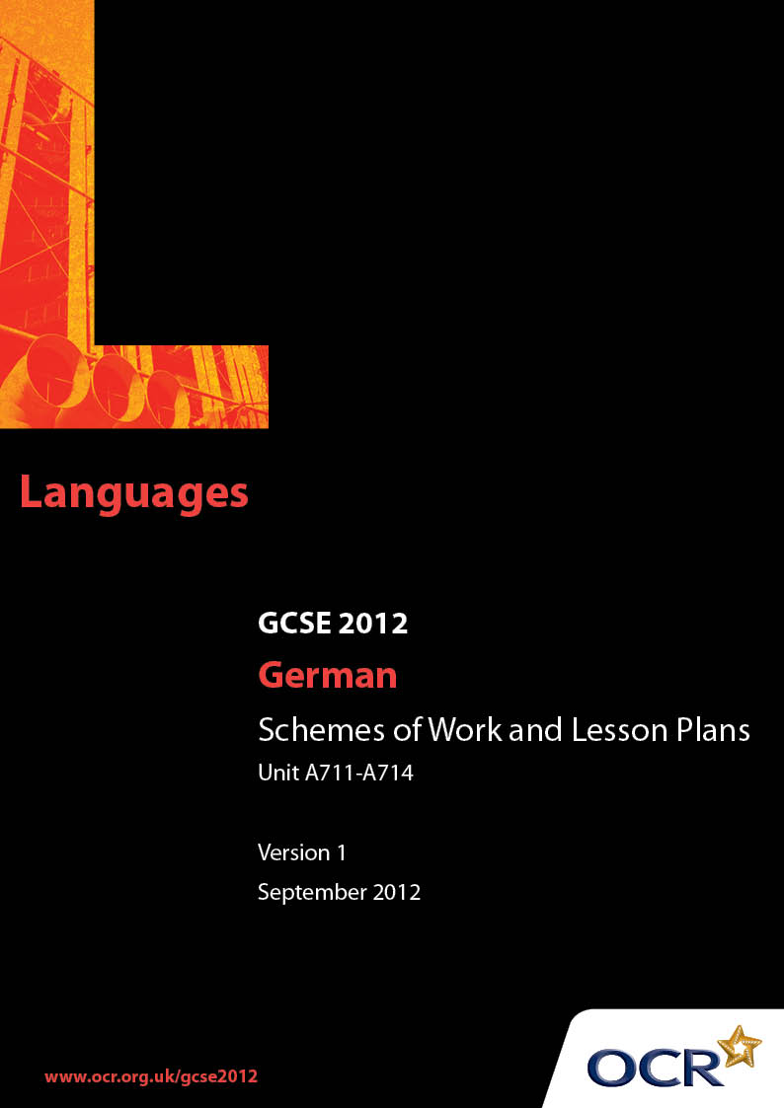

Contents
Introduction 3
Sample Scheme of Work:
OCR GCSE German J731: Topic Area 5 – Education and work 5
Sample Lesson Plan:
OCR GCSE German J731 Units A711-A714: Work experience 13

Introduction

Background
OCR has produced a brochure, which summarises the changes to German. This can be found at www.ocr.org.uk along with the new 2012 specification.
In addition and in response to reforms announced by the Government and in response to Ofqual mandated changes to GCSEs, unitised assessment of this qualification is being replaced by linear assessment from September 2012. This means that candidates commencing a two year course from September 2012 will take all of their GCSE units at the end of the course in June 2014.
In order to help you plan effectively for the implementation of the specification we have produced these Schemes of Work and Sample Lesson Plans for German. These Support Materials are designed for guidance only and play a secondary role to the Specification.

Our Ethos
OCR involves teachers in the development of new support materials to capture current teaching practices tailored to our new specifications. These support materials are designed to inspire teachers and facilitate different ideas and teaching practices.
Each Scheme of Work and set of sample Lesson Plans is provided in Word format – so that you can use it as a foundation to build upon and amend the content to suit your teaching style and students’ needs.
The Scheme of Work and sample Lesson plans provide examples of how to teach this unit and the teaching hours are suggestions only. Some or all of it may be applicable to your teaching.
The Specification is the document on which assessment is based and specifies what content and skills need to be covered in delivering the course. At all times, therefore, this Support Material booklet should be read in conjunction with the Specification. If clarification on a particular point is sought then that clarification should be found in the Specification itself.

A Guided Tour through the Scheme of Work

= Innovative Teaching Idea
This icon is used to highlight exceptionally innovative ideas.


= ICT Opportunity
This icon is used to illustrate when an activity could be taught using ICT facilities.

OCR GCSE German J731: Topic Area 5 – Education and work
Suggested teaching time | 12 hours | Topic | Work experience, future study and jobs, working abroad
Topic outline |  | Suggested teaching and homework activities |  | Suggested resources | Points to note
Review past tenses |  | - common perfect tense usage  - common imperfect tense usage  Possible suggestions:  - use simple table for students to complete  - students write down as many as they can in a set time  - students re-write jumbled sentences with words in correct order  - students sort cards with subject, complement, auxiliary, past participle  - students guess which verb teacher/other students has/have written on a piece of paper/in ex. books  - Students could be tested after learning homework, including some verbs they have chosen themselves to use in their own context(s). |  | - Use verb tables from commercially produced materials  - e.g. GCSE German for OCR: OUP Students Book, pages 211– 212”  - or OCR edition of Oxford Learner’s German Dictionary  - Use explanations of how to form and use past tenses in German and activities to practise this  - e.g. GCSE German for OCR: OUP Students Book”, pages 45, 55, 83, 86 and 208  - or GCSE German for OCR: OUP Grammar Workbook, pages 48–54  - or GCSE German for OCR: OUP Exam Skills Workbook (Foundation and Higher), pages 34 and 42 | - Imperfect tenses beyond “war” and modals are suitable for more able students.
Review expressions of opinions |  | - Students produce lists of positive and negative opinions  - Play the boaster game (a variation of I went to the shop and I bought) Each student has to repeat previous opinion(s) and add another. |  | - If German Assistant is available, enlist his/her help with this, perhaps in small groups  - Dictionaries could also be consulted, perhaps with groups finding the most positive/negative/oddest/longest/shortest opinion words against a time limit. GCSE German for OCR: OUP Students’ Book, pages 47, 49, 112 and 113 | - Students could use www.warmduscher-abc.ch/ to check synonyms for Warmduscher.
Review justification of opinions |  | - Reinforce subordinate clauses with weil, obwohl, sodass, da, aus dem Grund dass, and adverbs such as folglich, demzufolge, letzlich, zunächst  - Possible justifications: who can be the first to find 5, 10, 20?  - Encourage students to develop and justify individual ideas and points of view. |  | - Many textbooks contain justification and practice of subordinate clauses with weil  - e.g GCSE German for OCR: OUP Students Book, pages 93, 112, 140, 141 and 210  - or GCSE German for OCR: OUP Grammar Workbook, pages 63 and 64  - or GCSE German for OCR: OUP Exam Skills Workbook (Foundation and Higher), page 38  - Students can consult dictionaries or German Assistant/each other. | - Students need to be able to justify their opinions in a varied manner in order to access high marks in Controlled Assessment final tasks – See Appendix C and D  - Online dictionaries could be consulted; alternatively the published vocabulary for grades C-G is available in pdf format on www.ocr.org.uk and is searchable  - Many of the strategies for expression of opinion can be adapted to justifications.
Questionnaire about work experience |  | - Students listen to interview(s) with questions about work experience  - (They could respond by verbal or non-verbal responses.)  - Students answer (similar or identical) questionnaire about their work experience – where, when, times, job title location, travel to work, clothing, tasks undertaken, Feierabend, colleagues, lunch time activities, opinions and justifications, whether they have changed their view of the job  - Students move on to writing about their own experience, perhaps using a writing frame as a guide. |  | - Texts pertinent to this topic can be found in most textbooks  - e.g GCSE German for OCR: OUP Students’ Book, pages 156 and 157  - or GCSE German for OCR: OUP Exam Skills Workbook (Foundation and Higher), pages 60 and 61  - SAM Reading A713F / A713 H has a text on this topic. It is targeted at Grade C. | - This is a useful opportunity to prepare a Writing or Speaking Controlled Assessment final task. (See sample tasks)  - Ensure the Controlled Assessment final task is not a direct repetition of work done in class  - Consult the Specification Section 4 and the Guides to Controlled Assessment in Speaking and Writing for detailed guidance  - This could be improved by reference to opinions and justifications learnt/reviewed. Students should be encouraged to develop and flesh out their answers.
Jobs |  | - Use the relative clause to move on from ein Busfahrer ist ein Mann, der einen Bus fährt, eine Busfahrerin ist eine Frau, die einen Bus fährt, etc.  - (Differentiate task according to ability of group / individuals)  - “Guessing the job” whole-class or group activity, using a limited list of jobs at first. |  | - Most textbooks have lists of jobs  - GCSE German for OCR: OUP Students’ Book, unit 5B  - Use textbooks to reinforce use of relative clauses  - e.g GCSE German for OCR: OUP Students’ Book pages 102, 206 and 207  - or GCSE German for OCR: OUP Grammar Workbook, page 35  - or GCSE German for OCR: OUP Exam Skills Workbook (Foundation and Higher), page 46  - However, if students are to talk about their own or their parents’ jobs, some assistance may be needed, perhaps using a combination of dictionaries and a German Assistant  - There is a good list of jobs and professions in Your GCSE German Vocabulary Guide. | - Online dictionaries may be useful  - www.arbeitsagentur.de is the German Arbeitsamt site.
What do we know about different jobs? |  | - Use a standard questionnaire to help students evaluate different jobs: (What you have to do, hours, location, clothing, rough pay level, indoors/outdoors, active/sedentary, people contact or focus, etc.) |  | - Many textbooks include job adverts as a starting point  - GCSE German for OCR: OUP Students’ Book, unit 5B  - Newspaper job small ads can be helpful – local newspapers most helpful. | - Use www.de.wikepedia.org  to check information  - Typical local paper is www.ksta.de
Advantages and disadvantages of different jobs |  | - Students draw up list of advantages and disadvantages, perhaps in a group on a large piece of paper  - Ask for opinions and appropriate justifications  - Follow up for homework. |  | - GCSE German for OCR: OUP Students’ Book, unit 5B | - The group could build a database  of advantages/disadvantages of  different jobs on school intranet  - See Controlled Assessment final Task Assessment Criteria for Speaking and Writing in Specification Appendix C / D for the importance of opinions and justifications.
Future study and jobs |  | - Teach/review future tense with werden and simple conditionals ( e.g.Ich möchte / ich würde gern.)  - Ask about study next year/after the exams, after A Levels or apprenticeship/ employment and at age 18, 21, 25, 30  - Seek reasons for choices. |  | - Course books such as those in the resources list provide much useful material and teach/review the future tense with werden and the simple conditional GCSE German for OCR: OUP Students’ Book, pages 144 and 145, unit 5B and pages 81, 87, 118 and 209  - GCSE German for OCR: OUP Grammar Workbook, pages 56 and 57  - GCSE German for OCR: OUP Exam Skills Workbook (Foundation and Higher), pages 50 and 54 | - The composition of the group will determine the emphasis on post 16 full-time study and apprenticeship/vocational training.
Working abroad |  | - Give questionnaire about working abroad: country, location, duration, reasons, advantages, disadvantages  - Students could draw countries out of a hat and prepare this in writing for discussion in class, making use of the conditional tense. |  | - The Economist publishes a handy Facts and Figures book annually which enables quick international comparisons | - Use www.de.wikepedia.org to check information
Ambitions |  | - Animate discussion of ambitions at different ages: 16, 18, 21, 25, 30, 40, 65  - Extend the discussion to work, life partner, children, location, housing, money, travel, sport and hobbies  - (Seek reasons where possible, extending beyond the simple). |  | GCSE German for OCR: OUP Students’ Book, pages 164 and 165 | - Links to Citizenship. This really  extends the structures learnt and  reviews other specification topics  already covered
End of topic |  | - Students show a group or the whole class what they can do on this topic  - Controlled Assessment final task Writing and Speaking opportunity |  | - The Guides to Controlled Assessment for Speaking and Writing give full details of procedures to be followed.  - Teachers should choose final task, which may be differentiated, with suggestions for students written on the Information Form (Teachers)  - Each student will need a Speaking Notes Form or Writing Notes Form on which to write their 40 words of notes. | - There is a considerable advantage in familiarising students with the Controlled Assessment final task procedure, and perhaps recording on audio or video  - For the Controlled Assessment procedures follow the instructions in Section 4 of the Specification  - Remember to store the Speaking Information Form (Teachers) or the Writing Information Form (Teachers) as directed.

OCR GCSE German J731 Units A711-A714: Work experience

Mein Berufspraktikum
OCR recognises that the teaching of this qualification above will vary greatly from school to school and from teacher to teacher. With that in mind this lesson plan is offered as a possible approach but will be subject to modifications by the individual teacher.
Lesson length is assumed to be one hour.

Learning Objectives for the Lesson
AO1 Understand Spoken Language
AO3 Understand Written Language
AO4 Communicate in Writing
AO2 Communicate in Speech
Objective 1 | Students will know how to discuss work experience in German
Objective 2 | Students will be able to identify key ideas from a listening comprehension about work experience
Objective 3 | Students will be able to pick out key ideas about work experience from a reading comprehension
Objective 4 | Students will be able to write about their work experience, including opinions and justifications
Objective 5 | Students will be able to discuss work experience including opinions and justifications and will have the knowledge required to complete a Speaking Controlled Assessment task.

Recap of Previous Experience and Prior Knowledge
- As a starter activity, read a brief passage containing the key vocabulary for work experience (or German assistant reads it out loud). It will contain 1. routines, 2. clothing, 3. travel, 4. eating and 5. times of day as well as Berufspraktikum, Firma, etc

Content
Time | Content
5 minutes | Starter: Check previous knowledge with starter passage – e.g. pick out key words for ‘clothing’ (each group picks out key words from a different category)
10 minutes | Play an audio recording of one or more people discussing work experience - Discuss outcomes, giving key vocabulary and improving confidence. (Each group listens out for something different as in previous activity and notes key vocabulary to share with class)
10 minutes | Students read similar passage about work experience, which has answers provided. This is in interview format in pairs. They can underline parts they might change for themselves
10 minutes | Students then have a version, which only has the interview questions, and there is the chance for them to ask about things they need to say. Written response required.
10 minutes | Some students read what they have written, as others note what they say

Consolidation
Time | Content
5 minutes | Students are given a homework assignment to prepare a presentation of 4 minutes on their work experience using the interview constructed during class.
 | Plenary: What have we learnt today? How can we get the marks we deserve for the presentation?
Extension | Students can write an article for a magazine about their work experience and future plans

Published Resources
OCR offers centres a wealth of quality published support for new specifications with a fantastic choice of ‘Official Publisher Partner’ and ‘Approved Publication’ resources, all endorsed by OCR.

Publisher partners
We work in close collaboration with out three publisher partners; Hodder Education, Heinemann and Oxford University Press to ensure you have access to quality materials, written by experts, when you need it. The publisher partnerships are not exclusive (see Approved Publications below). All OCR endorsed resources undergo our thorough quality assurance process to ensure match to the specification.
Oxford University Press is the publisher partner for OCR GCSE German.
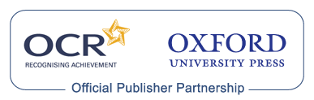

Oxford University Press has produces the following resources for OCR GCSE German for first teaching in September 2009.
Morag McCrorie et al, GCSE German for OCR Students' Book, ISBN: 9780199154944 (Publication 25 June 2009)

Adams, GCSE German for OCR Teacher's Resources Book (including e-Copymasters), ISBN: 9780199154968 (Publication 09 July 2009)

McCrorie et al, GCSE German for OCR Exam Skills Workbook Higher, ISBN: 9780199154951 (Publication 16 July 2009)

Morag McCrorie et al, GCSE German for OCR Exam Skills Workbook Foundation, ISBN: 9780199135394 (Publication 16 July 2009)

Maria Hunt, GCSE German for OCR Grammar Workbook, ISBN: 9780199154920 (Publication 28 May 2009)

McCrorie et al, GCSE German for OCR Audio CDs, ISBN: 9780199154975 (Publication 02 July 2009)

GCSE German for OCR Resources and Planning OxBox, ISBN: 9780199154937 (Publication August 2009 (estimated))

GCSE German for OCR Assessment OxBox CD-ROM, ISBN: 9780199139583 (Publication January 2010 (estimated))

Approved publications
OCR still endorses other publisher materials, which undergo a thorough quality assurance process to achieve endorsement. By offering a choice of endorsed materials, centres can be assured of quality support for all OCR qualifications.

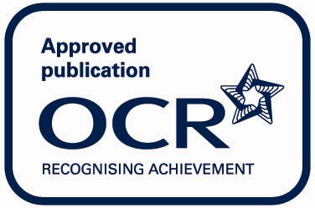

There are currently no OCR Approved publications for GCSE German.

