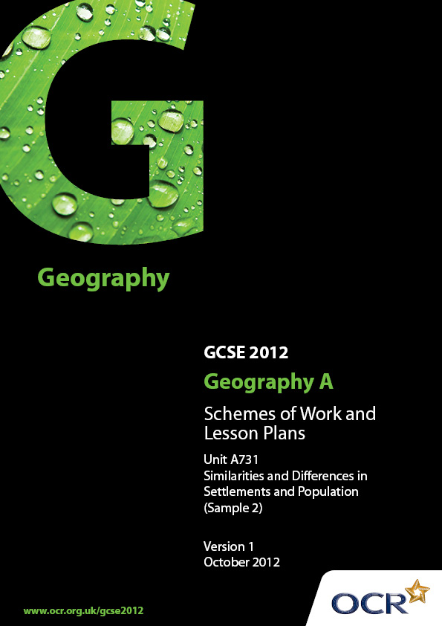
Contents

Contents 2
Introduction 3
Sample Scheme of Work: OCR GCSE Geography A - Similarities and Differences in Settlements and Population 4
Sample Lesson Plan: OCR GCSE Geography A - Similarities and Differences in Settlements and Population 15

Introduction

OCR involves teachers in the development of new support materials to capture current teaching practices tailored to our new specifications. These support materials are designed to inspire teachers and facilitate different ideas and teaching practices.
Each Scheme of Work and set of Sample Lesson Plans is provided in Word format – so that you can use it as a foundation to build upon and amend the content to suit your teaching style and students’ needs.
The Scheme of Work and sample Lesson plans provide examples of how to teach this unit and the teaching hours are suggestions only. Some or all of it may be applicable to your teaching.
The Specification is the document on which assessment is based and specifies what content and skills need to be covered in delivering the course. At all times, therefore, this Support Material booklet should be read in conjunction with the Specification. If clarification on a particular point is sought then that clarification should be found in the Specification itself.

Topic: Similarities and Differences in Settlements and Population
Suggested teaching time: 20 hours

Topic outline | Suggested teaching and homework activities | Suggested resources | Points to note
1) What are the types of settlement and how can they be categorised? | - Introduce the concept of settlement hierarchy to students. This could be done by looking at a school hierarchy with there being 1 Headteacher, 2 deputy heads etc.  - Look at the different types of settlements, this could be done with pictures of different types, students can name each type and then put them into order in terms of population size, services etc.  - Most likely to…. Which picture is most likely to have a secondary school (even though there will be more than one answer students need to explain why).  - Which of these places is most likely to be in a rural/urban location? |  | - Remember to categorise your UK and non-UK place. Even though the place might be a region e.g. Gulu in Uganda the main settlement is a city with many rural villages surrounding it. Likewise Exeter is a city with many villages and hamlets surrounding it.
2) What are the functions of different types of settlement and what is the land use like? | - Explain to students what a function of a place is and how larger towns/cities might have more than one function. |  | - It is important here to ensure that the UK and non-UK place functions are given. The place might be regional however it is still possible to look at a settlement within this place.
3) What are the physical and human characteristics of our UK and non-UK places? | - Fieldwork in your UK place to look at and investigate the physical and human geography and how this has helped to characterise the place e.g. how rivers have influenced the location of the settlement, how flat land has influenced the location of industry and housing (especially if on floodplains).  - Use pictures, videos etc. of non-UK place that the school has access to. This should enable students to investiagte what the place is like using a virtual fieldwork approach. Google earth could be used to view aerial imagery of the place and in some cases street view. Students could then use pins to locate specific physical and human characteristics of the place (ICT opportunity). | - Google earth | - Ensure that landscape and climate are discussed.
4) How does population density vary across the world? | - Using a world map showing global population variations, get students into groups to explain why they think these variations occur.  - They should consider Human and Physical factors.  - Students should then present back to the class and record their reasons in a table.  - Students investigate the population growth and distribution of their UK and non-UK place and compare the similarities and differences.  - Students consider the physical and human characteristics for these patterns. | - World map of global population distribution.  - Work sheet - Table outlining human and physical factors that influence population distribution.  - Up to date atlas for global population distribution.  - Some useful websites for population -  www.peopleandplanet.net  www.prb.org  www.unfpa.org | - Ensure that key terms from the specification are covered.
5) Where in the world is population growing fastest and where in the world is it growing slowest? | - Using global population distribution map locate countries where population is growing fastest (e.g. Gambia) and slowest (e.g. Poland). Compare Demographic components, birth rate and death rate.  - Students consider the extent to which their UK and non-UK place fits into this pattern. | - Case study material on Gambia - DVD youthful population. Pumpkin http://www.pumpkin-interactive.co.uk/collections/geography/products/managing-youthful-populations  - Case study material for Poland. DVD the poles are coming. (BBC 2 Documentary)  - http://www.unfpa.org/worldwide/ - on this web site you can compare demographic components for different countries.  - www.peopleandplanet.net - population pressures. | - Centres should be careful to manage the issues around migration carefully. Ensure a balanced argument is given.
6) Is the population the same or different in my UK and non-UK place? | - Introduce the concept of population pyramids what they show and how they can be used to show different levels of development.  - Produce population pyramids for the UK and non-UK place. | - Data from 2011 cenus on population including data to produce population pyramid  - http://www.ons.gov.uk/ons/publications/re-reference-tables.html?edition=tcm%3A77-257414  - Download Table P04 2011 Census: Usual resident population by five-year age group, local authorities in England and Wales.  - Tables below can be used to produce population pyramids for the UK place.  - Table P05 2011 Census: Male usual resident population by five-year age group, local authorities in England and Wales.  - Table P06 2011 Census: Female usual resident population by five-year age group, local authorities in England and Wales.
7) What is migration? | - Define migration and look at global migratory routes. Define forced and voluntary migration.  - For forced migration Democratic republic of Congo and voluntary migration Brits to Spain.  - Students could investigate their UK and non-UK place and what migration patterns are found in each place. This would help develop their conceptual knowledge of their ‘places’. | - Blank world map to mark on main migratory routes - voluntary and forced.  - Poles in Peterborough DVD. (BBC)  - UK census data from ONS provides information on current regional and national migration patterns. | - DVD - The poles are coming - BBC 2. You can combine the case study for Poland for declining population and migration.  - Specification states that migration needs to be looked at within and between countries, not necessarily their UK or non-UK place.
8) What positive and negative impacts does it have on the host and source countries? | - List impacts that migration has on the source and host countries using the examples from above.  - This could be investigated for their UK and non-UK place to help give conceptual knowledge. For their UK place local news articles about migration in their place might be a useful source of information. | - Case study voluntary migration British to Spain, or poles to Peterborough.  - Forced migration Democratic republic of Congo, Africa Oct/Nov 2008 or Darfur 2006.  - http://www.internal-displacement.org/countries/drcongo  - http://news.bbc.co.uk/1/hi/world/africa/3496731.stm  - http://www.bbc.co.uk/news/world-asia-18244025
9) Why is there global variation in development?  10) What is the development Gap? | - Look at global levels of development using a suitable atlas choropleth map. Students identify those countries that are developed and those that are not. Students think of reasons for the variations. Human, Physical, Environmental and Political. What trends can they identify?  - Students locate their UK and non-UK place onto these maps.  - Students consider how we measure development using GDP, GNP, HDI, Energy consumption. Students consider which is the most accurate and why.  - Blank world map mark on the Brandt line and explain what the development gap is using atlas, students mark on their UK and non-UK place.  - Explanation of the demographic transition model required to show why the variations might exist.  - Investigate both UK and non-UK place to suggest the level of development and how this affects the people that live in those places e.g. quality of life.  - Students consider how their place is similar/different in terms of development than other places in the region. This could be a contrast between the main settlements. | - Atlas  - Blank Map of the world with Brandt line on it, mark the Northern and Southern hemisphere.  - http://www.bbc.co.uk/news/world-asia-india-19044076 (India)  - http://www.bbc.co.uk/news/world-asia-18903059 (China)  - Contrasts shown by the BBC Programme ‘China on Four Wheels’ http://www.bbc.co.uk/programmes/p00wrgyp  - UK Census could be used to find out latest data by using the search facility. | Refer to specification to ensure that all theories and measures are covered and that students know what each means. This could be achieved through a key term list with regular tests of understanding.
11) What are the similarities, differences and links between your UK and non-UK place? | - Students need to know and understand the difference between similarities, differences and links.  - Students compile a table for quick reference for similarities, differences and links between the two chosen places. Many of those referred to in the specification could have already been taught in the settlement, population and development lessons.  - Students should research links and consider the strength of the links e.g. a school link between the UK and non-UK place might be considered strong. A link through air travel might be considered a weaker link. | - Resources will be dependent upon the places selected to study.  - http://schoolsonline.britishcouncil.org/projects-and-resources/projects/schools-world-service/resources | Similarities could be that both places have an airport. Unless aircraft fly from one airport to the other it is not a link.
12) What might the future of the UK and non-UK place be? | - Students put together a questionnaire to ask local residents of their place and how they think it should change in the future - this could relate to new facilities, transport etc.  - Students investigate one change and consider which groups might be in favour or against the proposal; this could lead to a local planning debate.  - Students investigate future change in their non-UK place by e-mailing or using video conferencing/Skype to links within the non-UK place e.g. school link. | - Visiting speakers from the local council could provide useful insight into future plans for the UK place.  - Local news articles relating to potential future change in the area.  - Search online newspapers at www.thebigproject.co.uk/news
13) What is global climate change and what are the main causes? | - What is the green house effect and what is Global warming. Labelled diagrams of both.  - Look at the different causes of global warming. | - Diagrams of Global warming, blanks for students to label.  - www.peopleplanet.net - Climate change.
14) How might climate change influence the future of your UK and non-UK place? | - Overview of the impacts of global warming on the world. Students locate their UK and non-UK place. How could these impacts affect people? (sea level, tropical storms, crop yield, pest, disease).  - Students consider what their UK and non-UK place could do to reduce the impact of climate change. This could relate to an increase in flood defences due to changing climate patterns.  - Students consider which groups will benefit or be adversely affected by the impact of the changes. | - Atlas.  - Pupils create their own Carbon footprint. Ask various questions. How do they get to school? Do they recycle? How many food miles does their lunch contain? Class survey.  - Blank outline of a carbon foot print. | - Both positive and negative impacts should be considered.  - Groups must be named groups e.g. residents of the local housing estate, local farmers, business owners of factories on the floodplain.
15) Why is planning for our future so important?  16) What will be the impacts of change?  17) What is sustainable development and why is it so important? | - Group discussion on reasons why planning is so important for our future.  - Use categories of Urban, Transport, Food and Water to form the basis of the discussion.  - Link the importance of planning to Sustainable Development.  - Use the example of the Bed Zed Eco village development in Wallington south London. Conservation and re-use of water, grow your own vegetables, have an allotment or buy locally produced goods. | - Provide blank table with headings of URBAN, TRANSPORT, FOOD and WATER.  - Example of a sustainable village Bed ZED:  http://www.bioregional.com/our-services/our-services/visitor-centre/ | - Many of these points can be incorporated into the other questions e.g. UK ageing population and planning for leisure facilities for the ageing population of the UK.  - Farm Africa covers the need to plan for the future or the provision of food for future generations.
Topic: Issues in our Fast Changing World – Population Change
Suggested teaching time: 5 hours

Topic outline | Suggested teaching and homework activities | Suggested resources | Points to note
1) What is the issue?  How is Uganda’s population changing? | - Use world mapper (Website 1) to show a map of population growth. Ask students what patterns they notice, especially where population growth is most/least.  - Look at graphs on website 2 – ask students which continents population is predicted to continue to grow by 2050? (Africa).  - Read through the article in website 3. Ask students to scan the article and pick out the issues that Uganda faces. | - http://www.worldmapper.org/display_extra.php?selected=369 or Gapminder could be used.  - http://www.prb.org/Educators/TeachersGuides/HumanPopulation/PopulationGrowth.aspx (Scroll down to comparison graphs)  - http://www.newvision.co.ug/news/18769-Uganda-s-population-now-at-34-5-million.html  - http://www.worldwatch.org/node/4525
2) What are the causes of the issue? | - Starter – use the data on website 1 to draw a line graph to show the growth of population in Uganda and analyse.  - Use the map on website 2 to highlight how high Ugandas Total Fertility rate (TFR) is compared to the rest of Africa.  - Students should look at reasons for this population growth and how this leads to an increase in population growth by looking at the Demographic Transition Model. | - http://sitemaker.umich.edu/section7group4/population_growth  - http://www.indexmundi.com/map/?v=31&r=af&l=en  - There are numerous textbooks that cover the Demographic Transition Model.
3) What are the short- and long- term effects of the issue both positive and negative? | - Create a Starter card sort – Positives and negatives of population growth. e.g. +ve children to work the land in rural areas and provide incomes –ve not enough services like healthcare.  - Read the article and highlight the social, economic and environmental problems relating to population growth in Uganda.  - In small groups students should decide if population growth is a positive or negative for Uganda. This could be achieved through independent research, then produce a speech to be read to another group. | - http://www.independent.co.ug/News/news-analysis/4841-population-growth-in-uganda
4) How can the issue be managed?  5) How might it develop in the future? | - Ask students ‘How can the population growth of Uganda be reduced?’  - Introduce the idea of how to reduce population growth rates. (Website 1)  - Read the Guardian Article – Do Ugandans want to reduce their population growth rate? (Website 2)  - Students could watch the TED talk (Website 3).  - They should then produce an advertising campaign that either encourages Ugandan’s to use contraception to reduce fertility rates or produce a presentation to the UN explaining why Ugandan’s should not reduce their fertility rates. | - http://www.globaleye.org.uk/secondary_summer2002/focuson/case1.html (This could be used as an example of how another place has reduced its fertility and population rates)  - http://www.guardian.co.uk/society/katineblog/2008/jul/11/isbirthcontroloneofuganda  - Useful TED talk that explores the issue of contraception in more detail – watch first before showing class.  http://www.ted.com/talks/lang/en/melinda_gates_let_s_put_birth_control_back_on_the_agenda.html

OCR Geography GCSE A

Lesson title: How is my UK place linked to my non-UK place
OCR recognises that the teaching of this qualification above will vary greatly from school to school and from teacher to teacher. With that in mind this lesson plan is offered as a possible approach but will be subject to modifications by the individual teacher.
Lesson length is assumed to be one hour.

Learning Objectives for the Lesson
Objective 1 | To know what a link is
Objective 2 | To understand how my UK and non-UK places are linked
Objective 3 | To be able to show how strong the links are

Recap of Previous Experience and Prior Knowledge

Content
Time | Content
5 minutes | Show pictures of links between UK and non-UK place. This could be pictures of two schools that are linked or links between hospitals. Ask students how places could be linked e.g. the schools are linked as the UK place has sent money to the non-UK place. The UK hospital has trained staff that work in the non-UK hospital.
10 minutes | Students should draw a table to show these links.  UK place Link Non-UK place  RD and E hospital Trained nurses St Mary’s hospital  Our school Raised money to build a classroom Keyo Secondary  School
20 minutes | Students research the links between the two places using the internet. They use local news sites and search for links or the place name. Students then add these links to their table.
15 minutes | Give out pictures of the links with some blank pieces of paper. Students write down any other links on the blank paper. In groups of 3, students rank these in terms of the strength of the link. This could be the link that has had the biggest impact in the non-UK place.

Consolidation
Time | Content
5 minutes | Groups join together (to make a group of six) one group of three explain to the other group which links they think are the strongest and why. The other group then explain the weakest link and why.
5 minutes | Students identify strongest and weakest link on their table and explain why.

