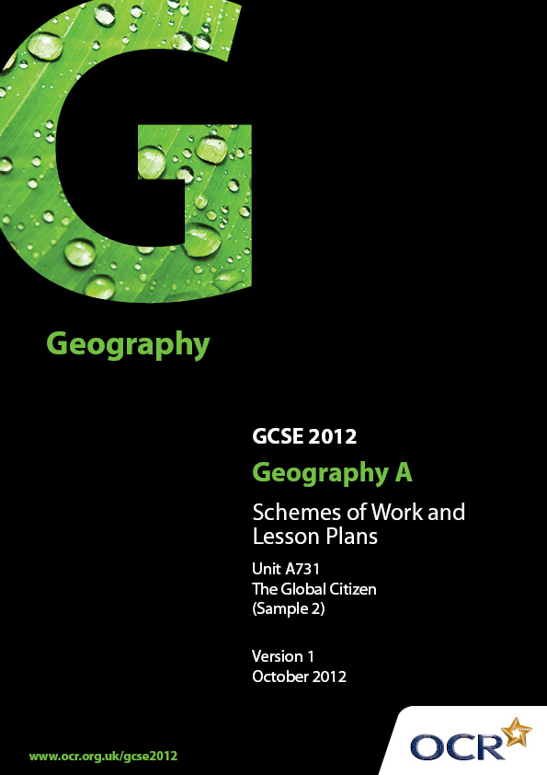
Contents

Contents 2
Introduction 3
Sample Scheme of Work: OCR GCSE Geography A - The Global Citizen 4
Sample Lesson Plan: OCR GCSE Geography A - The Global Citizen 9

Introduction

OCR involves teachers in the development of new support materials to capture current teaching practices tailored to our new specifications. These support materials are designed to inspire teachers and facilitate different ideas and teaching practices.
Each Scheme of Work and set of Sample Lesson Plans is provided in Word format – so that you can use it as a foundation to build upon and amend the content to suit your teaching style and students’ needs.
The Scheme of Work and sample Lesson plans provide examples of how to teach this unit and the teaching hours are suggestions only. Some or all of it may be applicable to your teaching.
The Specification is the document on which assessment is based and specifies what content and skills need to be covered in delivering the course. At all times, therefore, this Support Material booklet should be read in conjunction with the Specification. If clarification on a particular point is sought then that clarification should be found in the Specification itself.

Topic: The Global Citizen
Suggested teaching time: 25 hours

Topic outline | Suggested teaching and homework activities | Suggested resources | Points to note
1) What are producers and consumers? | - Introduce the types of economic activities of primary, secondary and tertiary to draw out idea that these are all producers of goods and services.  - Look at a range of products in class/home and find out where they were made. Produce a world map to show this pattern and if goods were primary, secondary or tertiary.  - Compile a list of all the things that you have consumed today in a table as shown below:  Primary Secondary Tertiary  Eggs Clothes Electricity  Milk Pen Teacher  - Use data from global issues website to draw out where and who the major consumers are - there are many graphs that can be analysed. | - Useful website for statistics about consumption and locational differences: http://www.globalissues.org/issue/235/consumption-and-consumerism | - Refer to specification to ensure that the full range of products and services have been explored.
2) Where does my mobile really come from? | - Introduce the idea of globalisation; this could be done by using the BBC box website.  - Look at where your mobile comes from - this could look at where all of the different components come from. | - http://news.bbc.co.uk/1/hi/in_depth/business/2008/the_box/default.stm  - http://www.rgs.org/OurWork/Schools/Teaching+resources/Key+Stage+3+resources/The+geography+of+my+stuff/Where+does+my+stuff+come+from.htm  - http://sourcemap.com/view/3968 useful map to show where mobiles come from.  - BBC Classclip to show issues around mobile phone production: http://www.bbc.co.uk/learningzone/clips/recycling-my-mobile/12003.html | - Students also need to study one service. This could be linked to call centres.
3) How do we measure and classify economic activity? | - Introduce measures of economic activity such as GNP and GDP. Use CIA world factbook to find the 5 countries with the highest.  - Introduce the idea of trade balance and employment structures highlighting the difference between sectors and formal/informal employment. This can be done by looking at employment within the mobile phone industry. | - https://www.cia.gov/library/publications/the-world-factbook/
4) How do employment structures vary? | - Using the mobile phone industry students could investigate the working conditions in factories that make mobile phones.  - Students produce a leaflet to explain to consumers the conditions their chosen product is produced in. | - BBC documentaries like ‘Blood, Sweat and T-shirts’ can be used to exemplify the issue and conditions. Short clip available at http://www.bbc.co.uk/programmes/p00vd46h
5) How do my products reach me? | - How do products get to my house? Students brainstorm all of the different transport methods that might get a mobile phone into the UK.  - Look at BBC news clip to show how containers have shaped world trade.  - Introduce the idea of trade blocs, tariffs etc. This could be done through the use of numerous textbooks and DVD’s that are available. | - http://news.bbc.co.uk/1/hi/business_world/7604207.stm  - Useful website to show the problems around free trade: http://www.oxfam.org.uk/education/resources/milking_it/milkingit/information/the_issues/free_trade.htm | - Ensure that all key ideas in the specification are covered.
6) What can consumers do to influence socio-economic consequences of their decisions? | - Students should investigate fair-trade - looking at where the products come from and what benefits it has on producers.  - Students then debate how as consumers we can improve the conditions our mobile phones are produced in. | - http://www.fairtrade.org.uk/
7) Where might my products come from in the future? | - This could be an opportunity for students to visit a local supermarket to look at which products are locally produced to help reduce their carbon footprint.  - Could mobile phones ever be locally produced? | - Useful news article to look at low carbon products http://www.guardian.co.uk/environment/2011/jul/01/carbon-trust-research-footprint-consumer-demand

Topic: Issues in our Fast Changing World - Energy
Suggested teaching time: 5 hours

Topic outline | Suggested teaching and homework activities | Suggested resources | Points to note
1) What are the different sources of energy production? | - Compare a picture of a petrol car and an electric car with a pie chart that shows the sources of electricity generation in the UK. Pose the question which has the lowest carbon footprint.  - Challenge students to think of where the electricity comes from to power the car. | - http://www.ecofriendlykids.co.uk/RenewableNonRenewableSources.html
2) What is the issue? | - Use news articles about the potential of energy blackouts in the UK.  - Use graphs/data tables to investigate how and why the demand for energy in the UK has increased. | - Useful article: http://news.bbc.co.uk/1/hi/8249540.stm  - http://www.decc.gov.uk/en/content/cms/statistics/publications/ecuk/ecuk.aspx - numerous data tables that can be used to investigate the changing energy use in the UK.
3) What are the impacts of this issue and how can they be managed? | - Show pictures of wind farms and ask students for the positive and negative impacts. Students could draw a table to help them compare.  Social Economic Environmental  - Students debate if a wind farm should be built in the local area. They should develop ideas based around different groups of people e.g. local business owners, residents etc.  - Use the UN Rio summit website to investigate what other countries are doing surrounding energy use. | - PowerPoint can be used to show a variety of pictures and views of wind farms from the UK and other countries around the world.  - There are numerous news articles available on the internet to support this debate and issue.  - http://www.un.org/en/sustainablefuture/energy.shtml  - The Humber estuary is set to become a hub for the wind turbine manufacturing industry.  - http://www.eon-uk.com/generation/humbergateway.aspx  - http://www.bbc.co.uk/news/10550298  - http://www.bbc.co.uk/news/uk-england-humber-14866088
4) What might the future be like for energy? | - The Sahara is a big potential source of solar energy in the future. Mountains might provide HEP power. Which of these is most likely to develop in the future? Which of these might be affected by climate change?

OCR Geography GCSE A

Lesson title: Where does my mobile really come from?
OCR recognises that the teaching of this qualification above will vary greatly from school to school and from teacher to teacher. With that in mind this lesson plan is offered as a possible approach but will be subject to modifications by the individual teacher.
Lesson length is assumed to be one hour.

Learning Objectives for the Lesson
Objective 1 | To know which countries are involved in the production of my mobile
Objective 2 | To understand the positive and negative impacts on people
Objective 3 | To be able to accurately locate countries

Recap of Previous Experience and Prior Knowledge

Content
Time | Content
10 minutes | Introduce students to where different parts of their mobile phones come from. This could be done using a ‘most likely to’ card sort, with a list of components and countries – students need to match these up. Go through and discuss correct answers.
10 minutes | Locate all of these countries on a world map. Write on name of country and component that it produces.
20 minutes | Use the CIA world factbook to find the GDP for each country and decide the countries level of development. Colour countries at contrasting levels of development. Students should analyse to see if there is any pattern.
15 minutes | Watch BBC Class clip 12003 (just section on the Democratic Republic of the Congo)  Students should begin to produce a mind map to show the positive and negative impacts on people in the DRC.

Consolidation
Time | Content
5 minutes | Students should move around room and share their positive and negative ideas with each other. Their aim is to find 3 more ideas to add to their mind map.

