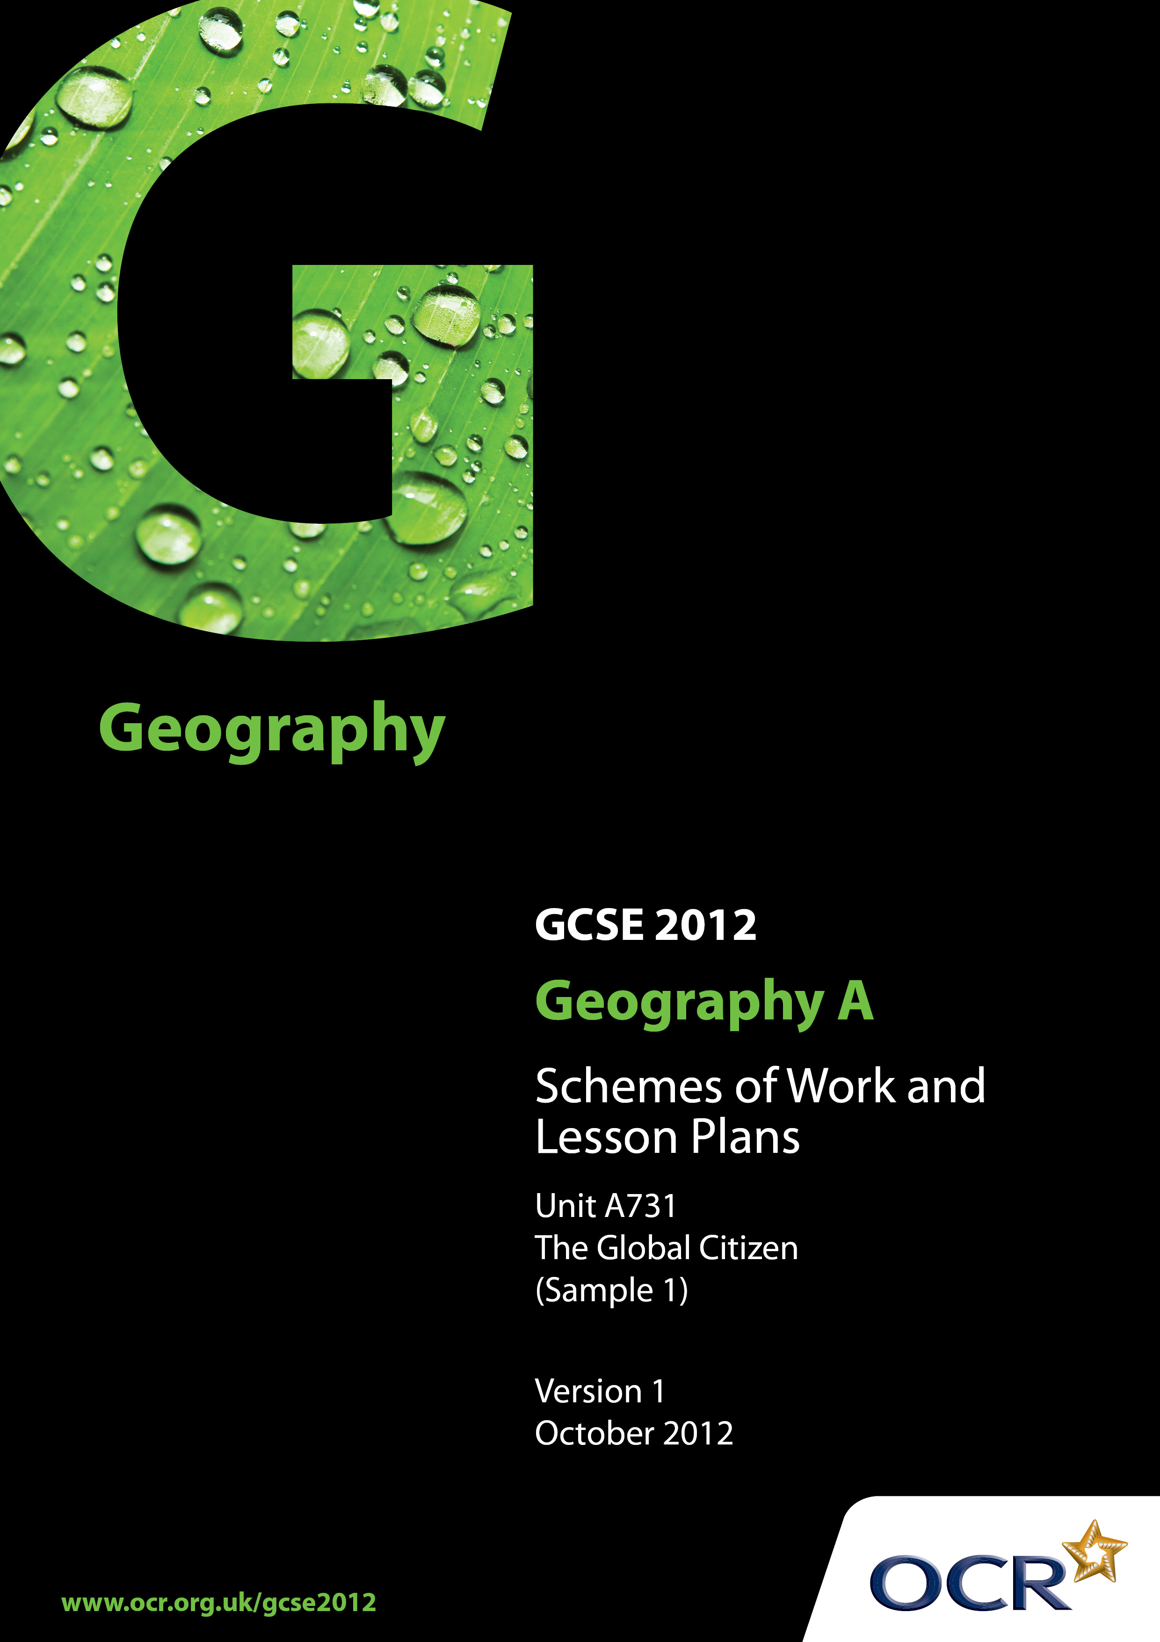
Contents

Contents 2
Introduction 3
Sample Scheme of Work: OCR GCSE Geography A - The Global Citizen 4
Sample Lesson Plan: OCR GCSE Geography A - The Global Citizen 10

Introduction

OCR involves teachers in the development of new support materials to capture current teaching practices tailored to our new specifications. These support materials are designed to inspire teachers and facilitate different ideas and teaching practices.
Each Scheme of Work and set of Sample Lesson Plans is provided in Word format – so that you can use it as a foundation to build upon and amend the content to suit your teaching style and students’ needs.
The Scheme of Work and sample Lesson plans provide examples of how to teach this unit and the teaching hours are suggestions only. Some or all of it may be applicable to your teaching.
The Specification is the document on which assessment is based and specifies what content and skills need to be covered in delivering the course. At all times, therefore, this Support Material booklet should be read in conjunction with the Specification. If clarification on a particular point is sought then that clarification should be found in the Specification itself.

Topic: The Global Citizen
Suggested teaching time: 25 hours

Topic outline | Suggested teaching and homework activities | Suggested resources | Points to note
1) Who are producers and consumers? | - Define what is meant by economic producers and economic consumers.  - Consider examples at different scales - individual, small company, national company, multinational company.  - Ask students to research a local, national and MNC for homework – what do they produce and consume?  - The global pattern of production and consumption. Look at patterns of production and consumption of one good – discuss how level of development might affect this. | - http://www.princeton.edu/~ina/images/infographics/starbucks.jpg Excellent graphic for discussion relating to TNCs - McDonalds and Starbucks  - Case study of global fashion http://www.globaleye.org.uk/secondary_summer/focuson/case-fash.html | - There might be an opportunity to link some of the content from Theme 2 to the study of a local area in Theme 3 by investigating local firms.
2) What types of products and services are there, how and where are they produced? | - Classification of the following types of products and services: food, clothing, electronic products, transport, healthcare, tourism and utilities supplies.  - Research the global production of chosen product and consumption of chosen service. Students to identify patterns in global distribution.  - Discussion of how globalisation affected the chosen product and service. | - http://www.worldmapper.org/ has some excellent posters comparing coffee production and consumption.  - Useful resource about teaching globalisation from the RGS http://www.rgs.org/NR/rdonlyres/FB25E128-B08F-43D6-BEAD-9AD5510AADA9/0/Feb052.pdf  - Tourism is a potential service industry that could be investigated. Some graphs alongside other resources about its global growth can be found here http://coolgeography.co.uk/GCSE/AQA/Tourism/Tourism.htm
3) How do we measure and classify economic activity? | - Use atlas to find development indicators which show ways to measure economic activity: Gross Domestic Product (GDP), Gross National Product (GNP), trade balance and employment structure.  - Compare these measures for a variety of countries at different levels of development.  - Evaluate effectiveness of these measures.  - Define the differences that exist between the sectors: primary, secondary, tertiary.  - Look at case studies of formal and informal employment linked to chosen product and service. Consider the difficulties the informal sector can provide in measuring economic activity.  - Investigate a range of employment associated with chosen product and service and consider how it fits into the different economic sectors. Look at Working conditions, pay and hours. | - Most modern school atlases now contain this kind of data. Alternatively the CIA world factbook is a good source of statistics  https://www.cia.gov/library/publications/the-world-factbook/  - Informal sector case studies http://wiego.org/resources  - Coffee workers in Ethiopia http://www.oxfam.org/en/development/ethiopia-starbucks-campaign-anatomy-win  - http://www.juicygeography.co.uk/diamonds.htm identifies a range of interesting resources relating to the diamond trade including the issue of conflict diamonds.  - http://freemarketmojo.wordpress.com/category/poverty/page/3/ great graphic here about working hours needed to buy a big mac. | - Students should be aware of the difference between GNP and GDP as a way of measuring economic activity.
4) Who are the different consumer groups for products and services and who can access them? | - Students might consider their family’s own shopping habits or conduct a class survey. What kind of consumer are they?  - Consider consumers of named product and service, at a variety of scales.  - Produce a choropleth map of the top international consumers of their chosen product and service.  - Students to consider factors that can affect accessibility of chosen product and service (time, cost, available technology and distance). Use a range of people in different contexts as examples and students should consider how each factor would affect their consumption patterns. |  | - Good opportunity to look at a range of different mapping techniques when considering international/national scale consumption patterns.
5) How are goods transported? | - Students could map the journey of their chosen product to its consumption and consider the forms of transport used at each stage.  - At each stage of the process the environmental impact might be scored.  - Define the terms trade agreements, trade barriers, tariff, quotas, and subsidy.  - For homework students might be asked to investigate how trade barriers and incentives may affect their chosen product and service. | - http://www.guardian.co.uk/starbucks-fairtrade/journey-of-the-coffee-bean  - http://bsalinas.com/wp-content/uploads/2009/10/coffeeposter.jpg  - Some useful resources from BBC Bitesize on world trade, focusing on banana production http://www.bbc.co.uk/schools/gcsebitesize/geography/development/trade_rev2.shtml  - Oxfam has a range of resources on the unfairness of the world trade system http://www.oxfam.org/en/campaigns/trade | - Students should always be aware of bias in the resources they use. The first suggested resource here, for example, is an advertisment for the named company.
6) To what extent can consumers influence sustainability? | - Students put together a presentation on ethical consumerism and how consumer decisions made can have an impact upon people and the environment. This might be presented in an assembly, or put together as a movie maker file. | - A good beginners guide can be found here, which might be used as the basis for a presentation http://www.ethicalconsumer.org/linkclick.aspx?fileticket=20E2V6AnK5k%3D&tabid=1510  - Another very good resource on sustainable consumption http://www.c2p2online.com/documents/C2P2_web_reader.pdf
7) What are the alternative futures for products and services? | - Consider alternative futures for chosen product and service through the use of ‘what if’ scenarios.  - Use the scenarios to produce consequence diagrams for the chosen product and service.

Topic: Issues in our Fast Changing World - Energy
Suggested teaching time: 10 hours

Topic outline | Suggested teaching and homework activities | Suggested resources | Points to note
1) What is the issue?  Is nuclear the answer to the UK’s energy problems? | - Produce a table such as the one on the Bitesize website of different energy reosurces evaluating pros and cons of each.  - Use BBC news article as an introduction to chosen issue. Conduct 5W’s activity to identify questions to investigate.  - Conduct a webquest on nuclear power as a source of energy. | - http://www.bbc.co.uk/schools/gcsebitesize/geography/energy_resources/energy_rev1.shtml  - http://www.bbc.co.uk/news/science-environment-18540178 for a report on a recent energy issue.  - BBC guide to nuclear power (on bbc news website) | - Chosen issue is provided to illustrate how centres might approach this unit. There are a wide range of energy issues which might be considered e.g windfarms, the energy gap, development of renewables etc.  - A ‘recent’ energy supply issue in the context of this specification is considered to be one occurring within the last five years of the students starting their course.
2) What are the causes of this issue? | - Compare UK Energy use and mix to countries at contrasting stages of development.  - Consider where demand is likely to rise and fall in the future. | - EDF energy have this resource on the energy gap in the UK http://www.edfenergy.com/energyfuture/key-info/the-energy-gap
3) What are the short- and long- term impacts of this issue, both positive and negative? | - Set up a debate into the further development of nuclear energy in the UK.  - For homework students could write up a follow up report that demonstrates their understanding of both sides of the argument. | - For alternative viewpoints these websites may be useful  www.world-nuclear.org  www.greenpeace.org.uk
4) How is this issue managed? | - Identify key stakeholders in the development of nuclear power.  - Set up a roleplay where students have to stay in role to explain how they have a say in the management of this issue and what their opinion would be.  - Homework – research how international agreements might affect how the UK’s energy mix is balanced. | - Nice animation where students can try to find the right energy mix for the UK http://www.jointhepod.org/activities/11-14/energy/energy-mix/interactive/  - Roles might be taken from bbc webpage on development of dungeness http://news.bbc.co.uk/1/hi/magazine/4633024.stm
5) How may this issue  develop in the future? | - Conduct a decision making exercise using OS maps/satellite images on the potential sites for a new nuclear power plant in the UK.  - Students should be asked to explain why it is such a challenging isssue to solve. |  | - Good opportunity to develop some of the key elements for the skills paper.

OCR Geography GCSE A

Lesson title - Where does my iPhone come from?
OCR recognises that the teaching of this qualification above will vary greatly from school to school and from teacher to teacher. With that in mind this lesson plan is offered as a possible approach but will be subject to modifications by the individual teacher.
Lesson length is assumed to be one hour.

Learning Objectives for the Lesson
Objective 1 | To be able to describe the growth of the smartphone industry
Objective 2 | To investigate the working conditions of iPhone manufacturers
Objective 3 | To evaluate the effect of consumer purchases on other people

Recap of Previous Experience and Prior Knowledge

Content
Time | Content
5 minutes | Display image of an iPhone. Ask students to write down as much as they can about it. You might provide a few hints e.g. cost, where designed, manufactured etc.
10 minutes | Use 5W’s technique to get students to come up with appropriate questions to investigate about iPhone manufacture.
10 minutes | Provide a range of graphical data about the growth of the smartphone industry. Students should describe the patterns that emerge and suggest reasons for them.
25 minutes | Card sort activity looking at the working conditions of workers in a factory in Shenzhen. Working in pairs students must work out how to classify the information, before feeding back to the rest of the class.

Consolidation
Time | Content
10 minutes | Students write an answer to the question ‘Has the iPhone brought benefits to the workers who make it?’ - with peer assessment of answers.

