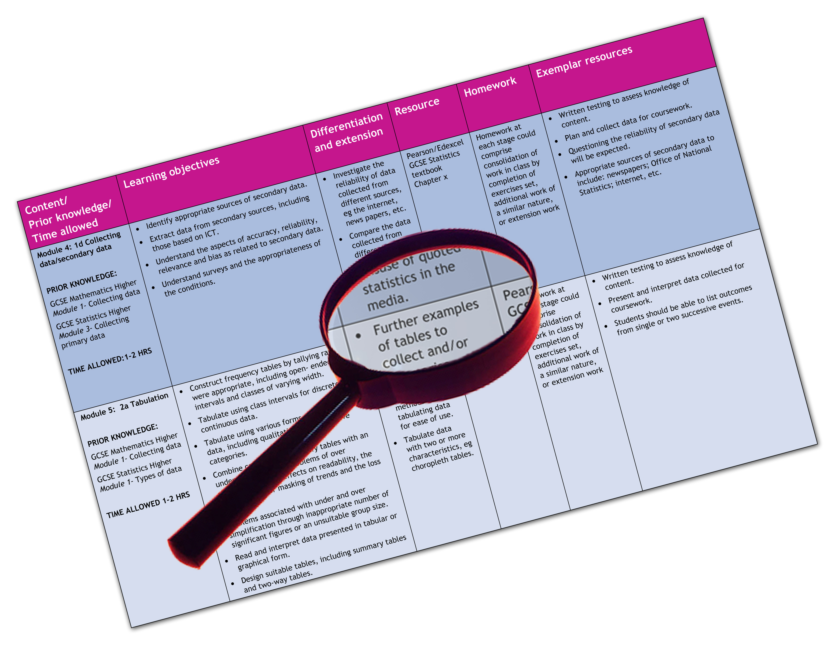


Edexcel GCSE 2009 Geography B (Year 11)
Extra options (Topic 6: Changing Countryside, Topic 8: World of Work)
We are happy to provide this scheme of work for you to amend and adapt to suit your teaching purposes.

We hope you find this useful.
Editable scheme of work

Detailed help on resources

Week by week content coverage

Exemplar activities

Learning outcome

Practical support to help you deliver this Edexcel specification
Scheme of work
This scheme of work has been produced to help you implement this Edexcel specification. It is offered as an example of one possible model that you should feel free to adapt to meet your needs and is not intended to be in any way prescriptive. It is in editable word format to make adaptation as easy as possible.
Other course planning support
You will find other support for planning the course in the Teacher’s Guide. This is a free downloadable resource that you can access at www.edexcel.com/gcse2009
Teaching resource exemplars
The scheme of work contains suggestions for resources that you can use to support your teaching. These are suggestions only of material you may find useful and you are encouraged to use a wide range of resources that suit the needs of your students.
Other Edexcel teaching resources
Pearson Education produce a wide range their own teaching resources including:
- Student books — full colour textbooks matched to the specification
- ActiveTeach — digital teaching resources on one easy to use CD ROM
- Exam Wizard — instant access to banks of GCSE and GCE questions from past papers.
You’ll find details of all of these at www.edexcel.com/gcse2009
We are also working with a range of publishers to support you, textbooks have been produced to support this subject by Oxford University Press (OUP).
Edexcel Subject Advisors
Edexcel has a team of specialist subject advisors available to help you with implementation of this specification. You can contact them by email or phone.
Email: GeographySubjectAdvisor@edexcelexperts.co.uk
Edexcel additional support
- Ask the Expert — puts you in direct email contact with over 200 of our senior subject experts
- Edexcel’s community — these message boards are designed to enable you to access peer-to-peer support from fellow Edexcel teaching and delivery staff in schools and colleges.

Edexcel GCSE Geography B (Year 11) Extra options
Edexcel scheme of work
Topic 6: Changing Countryside
Topic 8: World of Work

Y11 Week | Content coverage/  key questions | Learning outcomes | Exemplar activities | Exemplar resources
1 | 6.1 What are the issues facing rural areas in the developed world?  a Some rural areas in developing countries face a number of challenges such as isolation, depopulation and economic decline, while others in the developed world face pressures to expand. | - To know the changes taking place in rural areas.  - To recognise that the rural changes in developing countries are very different from those in developed countries. | - Students produce a table to compare MEDC and LEDC (more and less economically developed countries) with rural changes divided up into population, distance from urban areas, employment, services, environment, global changes and subdivided by process and impacts. Students make brief notes into table using textbook as stimulus. | - Chapter 14 of the Edexcel GCSE Geography B Student Book is a good source of information on more and less economically developed countries.
 | b These challenges often reflect change away from the rural area, e.g. in the global economy or in urban areas. | - To understand that the reasons for the changes often lie outside rural areas. | - Students copy Figure 9 in Chapter 14 of the Edexcel GCSE Geography B Student Book and write in examples of outside causes of rural change.  - Students create an annotated diagram of the spiral of rural decline in LEDCs and MEDCs to identify similarities and differences. | - Figure 4 in Chapter 14 of the Edexcel GCSE Geography B Student Book is a good diagram for the activity. Figures 2 and 9 show diagrams on the spiral of rural decline.

Y11 Week | Content coverage/  key questions | Learning outcomes | Exemplar activities | Exemplar resources
2 | 6.2 How might these issues be resolved sustainably?  a Planners and local initiatives can bring about change, which can boost the economy in declining rural areas. | - To know why rural areas in have been declining.  - To recognise the different ways of protecting and conserving rural areas. | - Students produce posters of different conservation practices complete with mini case study.  - Students produce a mind map of ‘Crops and Shops’ in Ethiopia | - Chapter 14 of the Edexcel GCSE Geography B Student Book has a table of designated protected areas in England as inspiration but this can be widened with more international examples, e.g. CITES  - Ethiopia on the FarmAfrica website has good additional material, such as interviews, videos etc, to supplement the material in Chapter 14 of the Edexcel GCSE Geography B Student Book: http://www.farmafrica.org.uk/
3 | b The future of rural areas needs to be managed more sustainably. | - To understand that rural areas need to be managed in a more sustainable way. | - Students focus on MEDC agriculture with less environmental impact through organic farming practices and consumer power against factory farming. Students list the sustainable practices and how they work.  - Students practice DME (decision-making exercise) through management of Stonehenge as an example of rural tourism management. | - Figure 20 in Chapter 14 of the Edexcel GCSE Geography B Student Book gives an overview of the environmental impacts of agriculture.  - Soil Association website for Organic Farming: http://www.soilassociation.org/web/SA/saweb.nsf/5f473da5a76ca15b80256b4400428a12/c092399648d837d080256adf004760db!OpenDocument  - ‘The Meatrix Trilogy’ are a series of cartoons on anti-factory farming: http://www.themeatrix.com/  - Chapter 14 of the Edexcel GCSE Geography B Student Book has an introduction to decision-making in sustainable management.  - Use the Stonehenge Management activity from Google Earth DME: http://www.juicygeography.co.uk/googleearth.htm
4 | 8.1 How does the ‘new economy’ function in different places? Who wins and who loses?  a The global economy is changing, with new employment sectors replacing traditional work. | - To know what the global economy is.  - To recognise that countries vary in terms of what they contribute to the global economy. | - Students look back over their work on economic sectors, triangular graphs and the Clark Fisher model to identify how the economy changes with development.  - Students annotate their previous notes (in a different colour) to show how countries at different levels of development contribute to different parts of the global economy. | - Chapter 16 of the Edexcel GCSE Geography B Student Book has good material to support ‘new economy’ work including some good figures, maps, graphs and activities.  - Also link to Chapter 12 and the Clark Fisher model.

Y11 Week | Content coverage/  key questions | Learning outcomes | Exemplar activities | Exemplar resources
 | b Transnational companies (TNC) control a substantial part of the global economy, and have created a global shift. | - To understand why the benefits of the new economy are not shared equally. | - Students analyse the Doonesbury Cartoon (by Garry Trudeau) on Nike: How does the American’s impression change during the cartoon?; What is the attitude of the factory towards the Americans and workers?; Why should we be careful about this resource?  - Students put together a case for and case against Nike, to debate and draw conclusions. | - Doonesbury Cartoon on Nike: http://www.geocities.com/athens/acropolis/5232/comicmay97.htm  - Against Nike links: http://www.geocities.com/athens/acropolis/5232/comicmay97.htm  - Nike’s own statements: http://www.nikebiz.com/responsibility  - Chapter 16 of the Edexcel GCSE Geography B Student Book has a good overview of the major TNCs and their operations.
5 | 8.2 How sustainable might the future world of work be?  a Changes in employment location and technology are creating different forms of work. | - To know some of the changes that are taking place in the world of work. | - Students skim-read Chapter 16 of the Edexcel GCSE Geography B Student Book and note down all the changes taking place and look for similarities and differences between them. | - Chapter 16 of the Edexcel GCSE Geography B Student Book has good material on the world of work to support this.
6 | b Workplaces are likely to change in response to company relocation, new technology and outsourcing. | - To explain why those changes are taking place.  - To understand why many of the changes are not sustainable. | - Students can research a Scottish island each. Plot the population change and follow the web links to explain the positive and negative changes.  - Teacher draws similarities from different islands and looks for general trend, which can be discussed with respect to sustainability. | - Chapter 16 of the Edexcel GCSE Geography B Student Book has material and activities to support changes in the workplace.  - Scottish Island Federation: http://www.scottish-islands-federation.co.uk/index.htm  - Scottish Island Populations: http://www.scottish-islands-federation.co.uk/population.htm  - This can be contrasted with Science Parks in Southampton and LEDCs, such as Kenya and China, from information in Chapter 16 of the Edexcel GCSE Geography B Student Book.
2715ma100609\LT\PD\Scheme of work (Phase 2)\Geography B YR 11 SOW Extra options.doc.1-11/1

This grid is for you to create your own scheme of work if needed.

Y11 Week | Content coverage/  key questions | Learning outcomes | Exemplar activities | Exemplar resources

