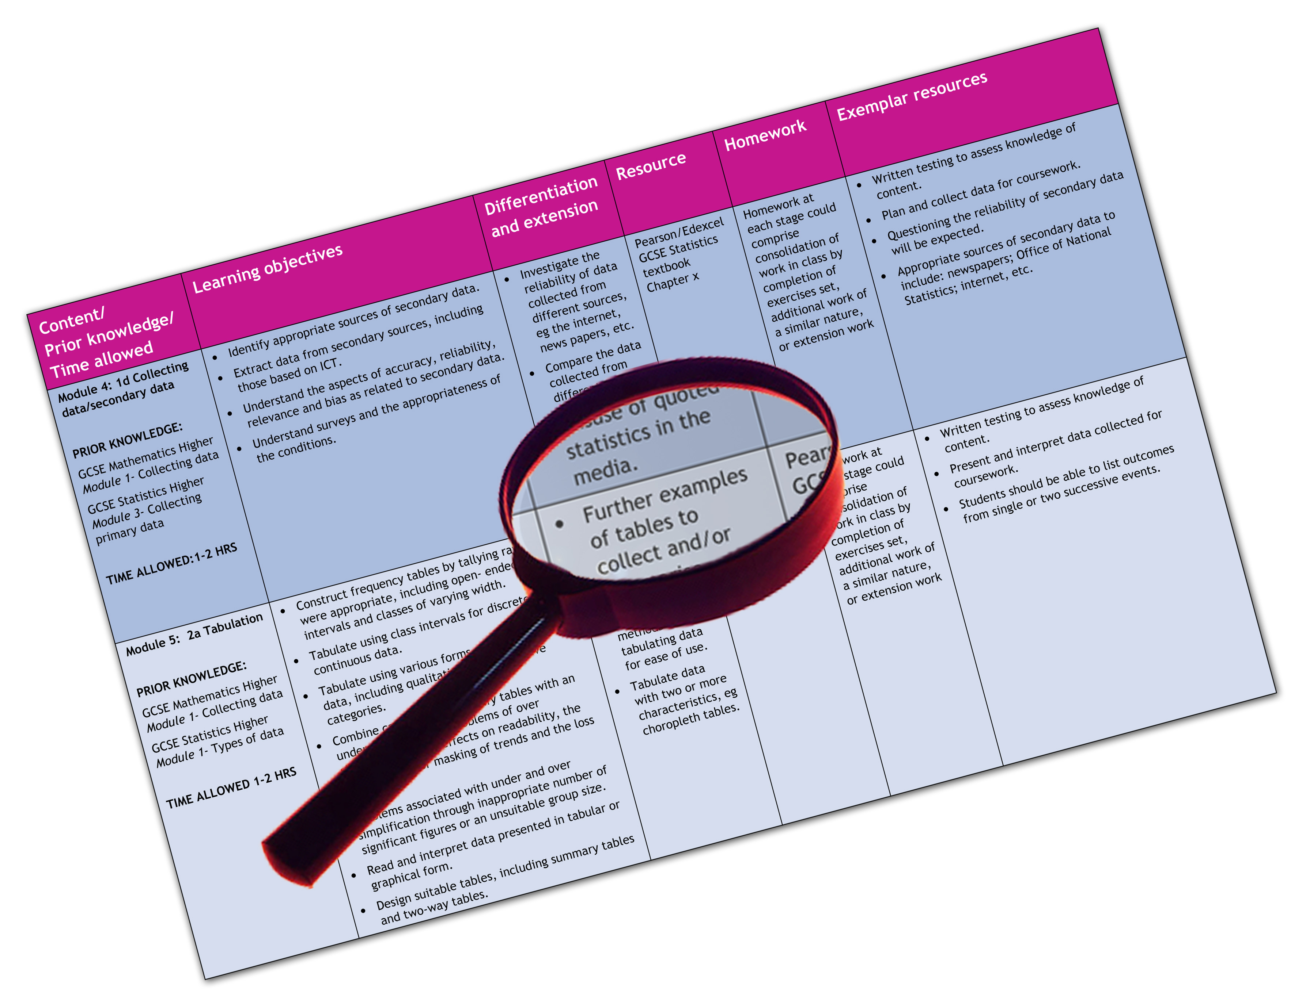


Edexcel GCSE 2009 Geography B (Year 10)
Extra options (Topic 5: Coastal Change and Conflict,
Topic 8: Extreme Climates)
We are happy to provide this scheme of work for you to amend and adapt to suit your teaching purposes.

We hope you find this useful.
Editable scheme of work

Detailed help on resources

Week by week content coverage

Exemplar activities

Learning outcome

Practical support to help you deliver this Edexcel specification
Scheme of work
This scheme of work has been produced to help you implement this Edexcel specification. It is offered as an example of one possible model that you should feel free to adapt to meet your needs and is not intended to be in any way prescriptive. It is in editable word format to make adaptation as easy as possible.
Other course planning support
You will find other support for planning the course in the Teacher’s Guide. This is a free downloadable resource that you can access at www.edexcel.com/gcse2009
Teaching resource exemplars
The scheme of work contains suggestions for resources that you can use to support your teaching. These are suggestions only of material you may find useful and you are encouraged to use a wide range of resources that suit the needs of your students.
Other Edexcel teaching resources
Pearson Education produce a wide range their own teaching resources including:
- Student books — full colour textbooks matched to the specification
- ActiveTeach — digital teaching resources on one easy to use CD ROM
- Exam Wizard — instant access to banks of GCSE and GCE questions from past papers
You’ll find details of all of these at www.edexcel.com/gcse2009
We are also working with a range of Publishers to support you, textbooks have been produced to support this subject by Oxford University Press (OUP).
Edexcel Subject Advisors
Edexcel has a team of specialist subject advisors available to help you with implementation of this specification. You can contact them by email or phone.
Email: GeographySubjectAdvisor@edexcelexperts.co.uk
Edexcel Additional Support
- Ask the Expert — puts you in direct email contact with over 200 of our senior subject experts
- Edexcel's community — these message boards are designed to enable you to access peer-to-peer support from fellow Edexcel teaching and delivery staff in schools and colleges.
Edexcel GCSE Geography B (Year 10) Extra options
Edexcel scheme of work
Topic 5: Coastal Change and Conflict
Topic 8: Extreme Climates

Y10  Week | Content coverage/  key questions | Learning outcomes | Exemplar activities | Exemplar resources
1 | 5.1 How are different coastlines produced by physical processes?  a Geological structure and rock type have a major influence on coastal development and landforms. | - To know how different rock types affect the coastline.  - To describe some of the landforms on coastlines with hard and soft rock. | - Students use an atlas geology map to find named stretches of coastline that are made of a particular rocks. Students then locate pictures of these coastlines using FLICKR and annotate to name and describe the features before deciding if they are hard or soft rock types. For extension they could be added to Google earth or Google map.  - Students work in groups to research concordant and discordant coastline to produce a better entry into Wikipedia by locating good graphics, animations and references. Students could write a page in a html editor or in a word processor. | - Chapter 5 in the Edexcel GCSE Geography B Student Book contains a table contrasting hard and soft rock landforms: http://www.flickr.com/ http://maps.google.co.uk/  - Chapter 5 in the Edexcel GCSE Geography B Student Book also has a good description of the difference between concordant and discordant coastlines: http://en.wikipedia.org/wiki/Discordant_  coastline http://en.wikipedia.org/wiki/Concordant_  coastline  - Google sites are good for web writing and displaying: http://sites.google.com/site/sites/

Y10  Week | Content coverage/  key questions | Learning outcomes | Exemplar activities | Exemplar resources
2 | b Marine processes, sub-aerial processes, mass movement and climate change are also important. | To understand the physical processes which act on coastal geology to create distinctive landforms. | - Students could use fieldwork to study erosion, transport, deposition and weathering associated with a coast or through virtual fieldwork.  - Students create a flickbook of a changing coastal landform using one of the BBC Education Class Clips as inspiration. On the back of the flickbook they write the explanation of the processes at work. Peer assessment increases the range of processes students cover. | - GeoActive (Nelson Thornes) 356 Coastal Fieldwork is good and has data that can be used in the classroom.  - Virtual fieldwork (of Reculver) at: http://www.georesources.co.uk/recintro.htm  - Chapter 5 in the Edexcel GCSE Geography B Student Book has good supportive material.  - BBC Education Class Clip archive has good clips on coastal regions: http://www.bbc.co.uk/  apps/ifl/learningzone/clips/queryengine?ContentType=text/html%3b%20charset=utf-8;SuppressCaching=1;attrib_1=SCHOOL_LEVEL_NAME;attrib_2=SUBJECT_NAME;attrib_3=TOPIC;attrib_4=SearchText;bool_1=AND;bool_2=AND;bool_3=AND;config=results_within;format=;oper_1=eq;oper_2=eq;oper_3=eq;oper_4=eq;val_1_1=Secondary;val_2_1=Geography;val_3_1=Coastal%20Regions;val_4_1=;page=1;pagesize=12 and Coastal Processes: http://www.bbc.co.uk/schools/gcsebitesize/  geography/coastal/coastalprocessesrev1.shtml

Y10  Week | Content coverage/  key questions | Learning outcomes | Exemplar activities | Exemplar resources
3 | 5.2 Why does conflict occur on the coast, and how can this be managed?  a Physical processes lead to coastal change and retreat, which threatens people and property and generates conflicting views. | - To know the factors affecting cliff retreat.  - To explain the effects of coastal retreat on people and the environment. | - Students produce an annotated diagram to show the stages of cliff retreat with its causes.  - Student groups do an Internet search for the impact of retreat on people and the environment set up by topic (agriculture, tourism, transport, housing etc) and then feedback to the class.  - Class take notes from feedback in a structured table. | - Chapter 5 of the Edexcel GCSE Geography B Student Book has good material and activities to support the factors affecting cliff retreat.  - Wave power activity: http://www.pbs.org/wnet/savageseas/multimedia/wavemachine.html  - BBC GCSE Bitesize Geography has video material on coastal retreat: http://www.bbc.co.uk/schools/gcsebitesize/geography/  - Holderness as an example of coastline retreat at: http://www.hull.ac.uk/coastalobs/general/erosionandflooding/erosion.html  - BBC News offers a good site to search for coastline stories.
 | b There is a range of coastal management options from traditional hard engineering to more modern holistic approaches. | - To understand the advantages and disadvantages of the different coastal management techniques. | - Students use a case study to understand the unique situation for the location and its problems before evaluating and scoring the range of techniques on their advantages and disadvantages and making a decision specific to a coastline. | - Chapter 5 of the Edexcel GCSE Geography B Student Book has tables of advantages and disadvantages for hard and soft engineering methods, which students can discuss, score and use to write their response. The Student Book also contains an activity similar to this.  - Actual or virtual fieldwork should be used to support this, such as the virtual fieldwork example of Reculver at: http://www.georesources.co.uk/recintro.htm  - There is a great deal of material on the Holderness coastline available online (GIS, video material, photographs, interviews etc) Also, found on Google Earth, BBC GCSE Bitesize Geography website, a multitude of textbooks including Chapter 5 of the Edexcel GCSE Geography B Student Book and recently updated Geoactive (Nelson Thornes) 407: http://www.hull.ac.uk/coastalobs/general/erosionandflooding/erosion.html

Y10  Week | Content coverage/  key questions | Learning outcomes | Exemplar activities | Exemplar resources
4 | 8.1 What are the challenges of extreme climates?  a Extreme climates are located in polar regions and hot arid areas; each has key physical characteristics. | - To describe the characteristics of a named extreme climatic environment.  - To explain how ecosystems have adapted to the environment. | - Students work in groups on different climatic locations to produce a presentation or poster on the characteristics and ecosystem adaptations. | - Chapter 8 of the Edexcel GCSE Geography B Student Book covers a range of extreme climates with facts figures and images.
 | b People adapt to the challenges of extreme climates in a variety of ways. | - To explain how people have adapted to life in that environment.  - To understand that people living in these environments make a unique and valuable contribution to world culture. | - After the presentations groups are then reassigned to investigate the impact on and culture of people in others’ presentations. This could be in the form of an oral report, podcast, travel journal etc. | - Chapter 8 of the Edexcel GCSE Geography B Student Book can provide a good starting point and template for the research.  - YouTube clips, Michael Palin (also http://www.palinstravels.co.uk/), Billy Connelly and other travel DVDs can be a good source of material. As can travel writing from Bill Bryson et al.
5 | 8.2 How can extreme environments be managed and protected from the threats they face?  a Extreme climates are under threat from a range of processes, which include climate change. | - To describe the physical and human threats faced by one extreme environment.  - To explain how climate change could further threaten this environment and its people. | - Students use the online comic creation program Pixton to produce a comic strip on life in a threatened extreme environment to cover the physical and human threats including climate change.  - Students then remix by online sharing and improving the cartoons. | - Chapter 8 of the Edexcel GCSE Geography B Student Book has material on both the Sahel and Alaska for both parts of this section.  - Online comic creation on Pixton website: http://pixton.com/  - Juicy Geography discussion of Pixton use, including remixing at: http://www.juicygeography.co.uk/  pixton.html
6 | b Sustainable management is needed locally and globally, if extreme environments are to survive. | - To understand that a range of local and global management strategies can help protect this environment. | - Students take their studied environment and produce a leaflet on strategies to make a more sustainable life, subdivided into a local and global scale. | - Chapter 8 of the Edexcel GCSE Geography B Student Book has some ideas but they will need tweaking to specific environments and may need some individual student research.

2625ma100609\LT\PD\Scheme of work (Phase 2)\Geography B YR 10 SOW Extra options.doc.1-11/1

This grid is for you to create your own scheme of work if needed.

Y10 Week | Content coverage/  key questions | Learning outcomes | Exemplar activities | Exemplar resources

