Edexcel GCSE 2009 Geography B


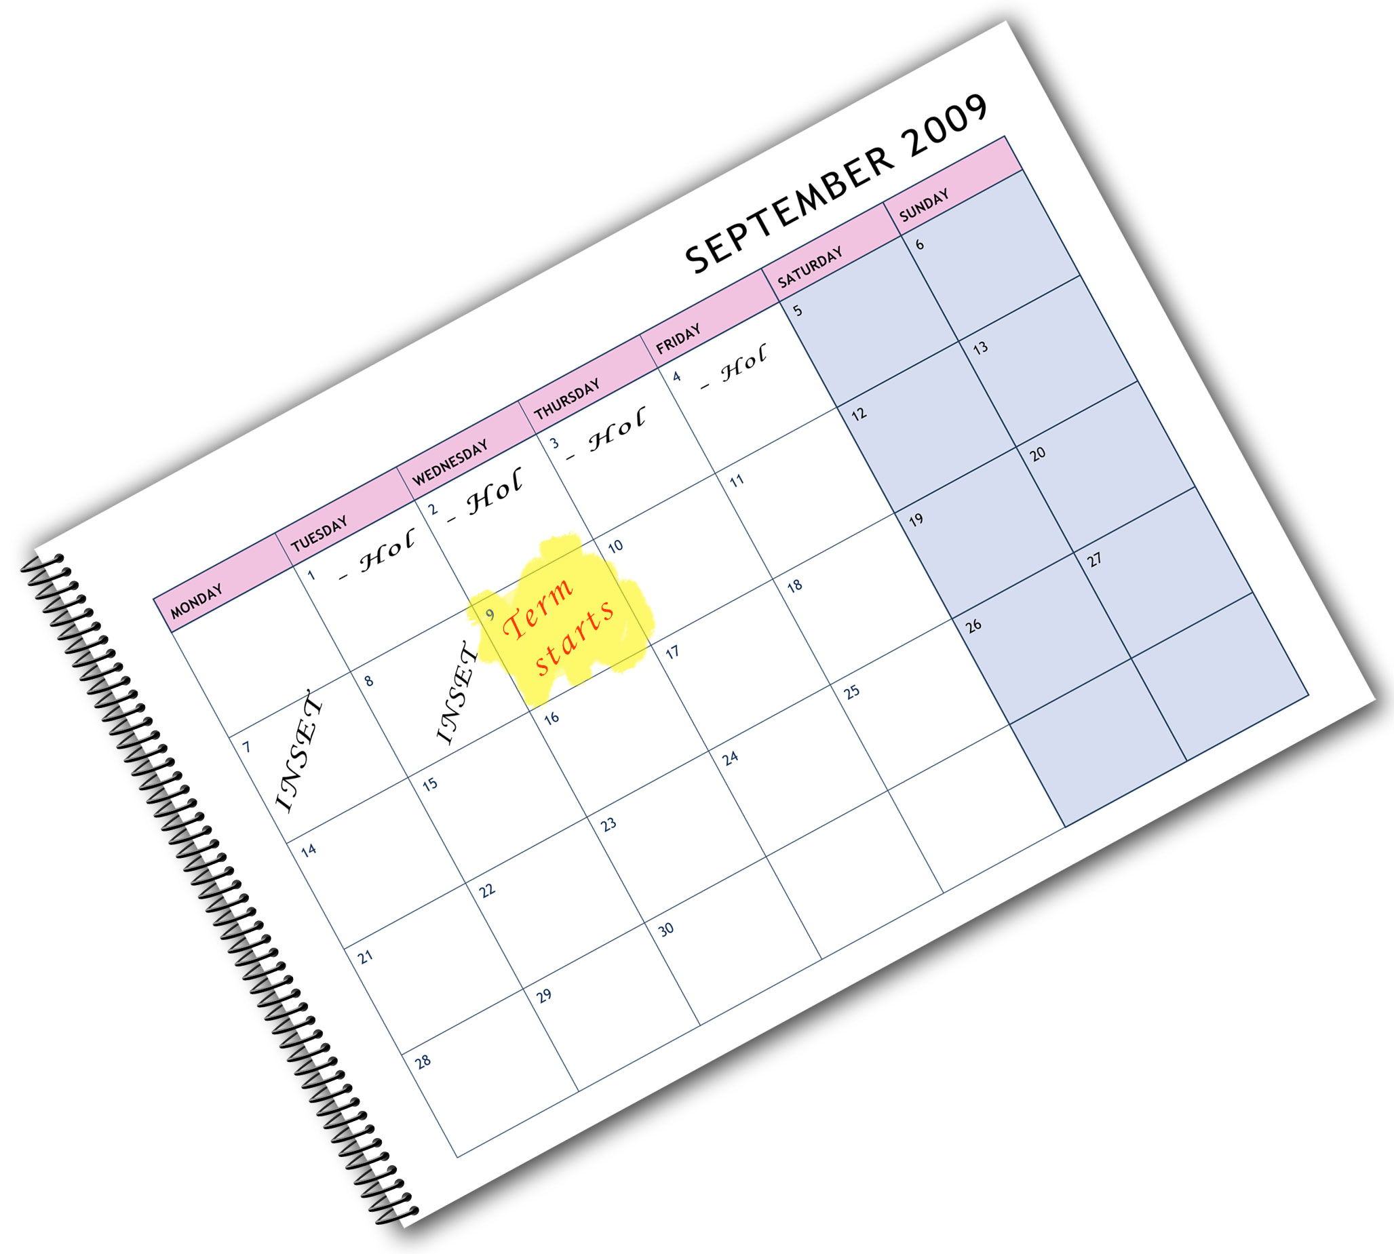
We are happy to provide this course planner for you to
amend and adapt to suit
your teaching purposes.
We hope you find
this useful.
Editable course planner

Practical support to help you deliver this Edexcel specification
Course planner
This course planner has been produced to help you implement this Edexcel specification. It is offered as an example of one possible model that you should feel free to adapt to meet your needs and is not intended to be in any way prescriptive. It is in editable word format to make adaptation as easy as possible.
Other course planning support
You will find other support for planning the course in the Teacher’s Guide and editable Scheme of Work. This is a free downloadable resource that you can access at www.edexcel.com/gcse2009
Teaching resource exemplars
The course planner contains suggestions for resources that you can use to support your teaching. These are suggestions only of material you may find useful and you are encouraged to use a wide range of resources that suit the needs of your students.
Other Edexcel teaching resources
Pearson Education produce a wide range their own teaching resources including:
- Student books — full colour textbooks matched to the specification
- ActiveTeach — digital teaching resources on one easy to use CD ROM
- Exam Wizard — instant access to banks of GCSE and GCE questions from past papers.
You’ll find details of all of these at www.edexcel.com/gcse2009
We are also working with a range of Publishers to support you, textbooks have been produced to support this subject by Oxford University Press (OUP).
Edexcel Subject Advisors
Edexcel has a team of specialist subject advisors available to help you with implementation of this specification. You can contact them by email or phone.
Email: GeographySubjectAdvisor@edexcelexperts.co.uk
Edexcel Additional Support
- Ask the Expert — puts you in direct email contact with over 200 of our senior subject experts
- Edexcel's community — these message boards are designed to enable you to access peer-to-peer support from fellow Edexcel teaching and delivery staff in schools and colleges.

Editable course planner — GCSE 2009 Geography B
This course planner shows how the specification content can be mapped against the two years (five and a half terms) of the GCSE.

Term/week | Content | Notes
Autumn term, Year 10
Week 1 | Introduction to Geography GCSE; exploring prior learning and content links. | Introductory activities and the big picture.
Weeks 2-4 | Unit 1: Dynamic Planet  Topic 1: Restless Earth | Geology fieldwork opportunities.
Weeks 5-6 | Unit 1: Dynamic Planet  Topic 2: Climate and Change
Half-term
Week 7 | Unit 1: Dynamic Planet  Topic 2: Climate and Change
Weeks 8-10 | Unit 1: Dynamic Planet  Topic 3: Battle for the Biosphere | Ecosystem fieldwork opportunities.
Weeks 11-13 | Unit 1: Dynamic Planet  Topic 4: Water World | Water cycle fieldwork opportunities.
Week 14 | Unit 1 Core consolidation week | Reviewing Unit 1 and drawing out links.
Spring term
Weeks 1-4 | Unit 1 Option  Topic 5: Coastal Change and Conflict or Topic 6: River Processes and Pressures | Opportunities to practise fieldwork for Unit 4.
Weeks 5-6 | Unit 1 Option  Topic 7: Oceans on the Edge or Topic 8: Extreme Climates
Half-term
Weeks 7-8 | Unit 1 Option  Topic 7: Oceans on the Edge or Topic 8: Extreme Climates
Weeks 9-12 | Unit 3 Introduction to the principles of making geographical decisions | Decision-making activities based on physical topics covered.

Term/week | Content | Notes
Summer term
Weeks 1-4 | Revision time for Unit 1 | This model assumes Unit 1 (or Unit 2) will be taken in June of Year 10.
Week 5 | Study leave to prepare for modular exams | (Or revision in class.)
Half-term followed by examinations
Week 6-7 | Examination Unit 1
Weeks 8-9 | Introduction to Unit 4: Researching Geography. Depending on the nature of the controlled assessment to be completed, centres could use this time to prepare for fieldwork, conduct fieldwork, or begin Unit 2. | Note that the controlled assessment can be carried out at any time. Planning fieldwork and formulating aims.  However, if students are going to take a particular task it can be started in June only and submitted the following May.

Term/week | Content | Notes
Autumn term, Year 11
Weeks 1-3 | Unit 2: People and the Planet  Topic 1: Population Dynamics
Week 4 | Unit 4 Fieldwork | Day trip(s) or residential.
Weeks 5-6 | Unit 4 Research and initial drafting of report | Working in the classroom — possible research out of class.
Half-term
Weeks 7-8 | Unit 4 Analysis, conclusions and evaluation write up | Working in the classroom.
Weeks 9-11 | Unit 2: People and the Planet  Topic 2: Consuming Resources | Use of decision-making activities.
Weeks 12-14 | Unit 2: People and the Planet  Topic 3: Living Spaces | Use of decision-making activities.
Spring term
Weeks 1-3 | Preparation for Unit 3 examination | Decision-making skills and  pre-release work for Unit 3 exam.
Weeks 4-6 | Unit 2: People and the Planet  Topic 4: Making a Living
Half-term
Weeks 7-9 | Unit 2 Option  Topic 5: Changing Cities or Topic 6: Changing Countryside
Weeks 10-12 | Unit 2 Option  Topic 7: Development Dilemmas or Topic 8: World of Work
Summer term
Weeks 1-4 | Revision for Unit 2 exam | Submission of controlled assessment.
Week 5 | Study leave to prepare for modular exams | (Or revision in class.)
Half-term followed by examinations
The scheme shown here assumes a modular approach to the exams.
- Unit 1 is taken at the end of Year 10.
- Unit 3 is taken in June of Year 10. (Unit 3 exam offered in June only.)
- Unit 4 is submitted for June of Year 11.
- Unit 2 is taken in June of Year 11.
The specification could be taught in a more traditional linear fashion leaving most, or all, of the exams until the summer of Year 11.
You may choose to start with Unit 1 or 2, as the teaching order is flexible. The decision may depend on whether the controlled assessment fieldwork focuses on physical or human geography. If two teachers are teaching the course — Unit 1 and Unit 2 could be taught in tandem giving greater flexibility. The controlled assessment can be carried out at any time. You could wait until the spring of Year 11, when the majority of the core units would have been taught. Alternatively, the options from Unit 1 and Unit 2 could be taught earlier, with the benefit of more choice in the controlled assessment tasks.

2077rl060309/tmp/in/input.doc.1–8/0
This grid is for you to create your own course planner if needed.

Term/week | Content | Notes
Autumn term, Year 10
Half-term
Spring term
Half-term

