|  |
| --- |
| Edexcel GCSE 2012 Geography B  (first teaching September 2012 for a 2 year course) |

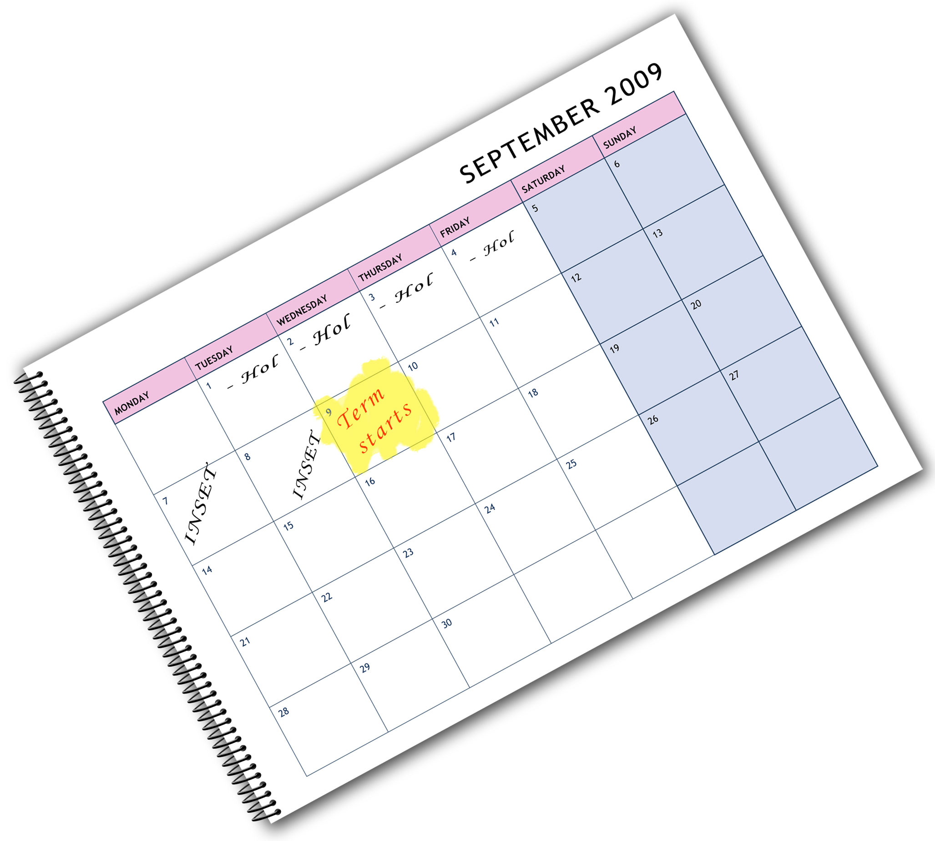

We are happy to provide this course planner for you to   
amend and adapt to suit   
your teaching purposes.

We hope you find   
this useful.



Editable course planner

Practical support to help you deliver this Edexcel specification

Course planner

This course planner has been produced to help you implement this Edexcel specification. It is offered as an example of one possible model that you should feel free to adapt to meet your needs and is not intended to be in any way prescriptive. It is in editable word format to make adaptation as easy as possible.

Other course planning support

You will find other support for planning the course and editable Schemes of Work on our web site along with other useful resources [www.edexcel.com/GCSE2012GeographyB](http://www.edexcel.com/GCSE2012GeographyB)

Teaching resource exemplars

The course planner may contain suggestions for resources that you can use to support your teaching. These are suggestions only of material you may find useful and you are encouraged to use a wide range of resources that suit the needs of your students.

Other Edexcel teaching resources

* **Revision guides** – help students prepare for their exams.

Further details can be found at [www.pearsonschoolsandfecolleges.co.uk](http://www.pearsonschoolsandfecolleges.co.uk).

Edexcel Subject Advisors

Edexcel has a team of specialist subject advisors available to help you with implementation of this specification. You can contact them by email or phone.

Email: [TeachingGeography@pearson.com](mailto:TeachingGeography@pearson.com)   
Telephone: 0844 372 2185

Edexcel additional support

Ask the Expert – puts you in direct email contact with over 200 of our senior subject experts.

Edexcel’s community forum – these message boards are designed to enable you to access peer-to-peer support from fellow Edexcel teaching and delivery staff in schools and colleges.

Editable course planner — GCSE 2012 Geography B (First teaching September 2012 for a 2 year course)

* The following course planner covers the content of the whole specification and is based on two hours a week.
* Your choice of Unit 4 controlled assessment task might determine whether Unit 1 (Physical) or Unit 2 (Human) is taught first. This planner assumes controlled assessment is completed in the Summer term of Yr 10, but it can be completed at any time.

**Please note that from September 2012:**

* All examinations are taken at the end of the course. This is a linear Specification.
* Unit 4 controlled assessment is submitted at the end of Year 11 but schools may continue to schedule controlled assessments at their discretion.
* The Core topics in Section A of Unit 2 have changed from the 2009 specification, as have the options in Sections B and C
* Unit 3 is remains a decision-making exercise but with cross-cutting themes to teach synoptic understanding. An unseen examination with no pre-released booklet (students will receive a Resource Booklet in the examination). 6 Key Ideas which form the taught content of Unit 3.

|  |  |  |  |
| --- | --- | --- | --- |
| Date (w/b)  2012 | Term/week | Content | Notes |
| Autumn term, Year 10 | | |
| Sept 3rd | Week 1 | **Unit 1 Dynamic Planet:**  **Topic 1 Restless Earth**  1.1 How and why do Earth’s tectonic plates move? | Section A of Unit 1 contains 4 compulsory topics. |
| Sept 10th | Week 2 | 1.1 How and why do Earth’s tectonic plates move? |  |
| Sept 17th | Week 3 | 1.2 What are the effects and management issues resulting from tectonic hazards? |  |
| Sept 24th | Week 4 | 1.2 What are the effects and management issues resulting from tectonic hazards? |  |
| Oct 1st | Week 5 | **Topic 2 Changing Climate**  2.1 How and why has climate changed in the past? |  |
| Oct 8th | Week 6 | 2.1 How and why has climate changed in the past? |  |
| Oct 15th | Week 7 | 2.2 What challenges might our future climate present us with? |  |
| Oct 22nd | Week 8 | 2.2 What challenges might our future climate present us with? |  |
|  | Half-term | | |
| Nov 5th | Week 9 | **Consolidation and assessment week** | Review topics 1 and 2 |
| Nov 12th | Week 10 | **Topic 3 Battle for the Biosphere**  3.1 What is the value of the biosphere? |  |
| Nov 19th | Week 11 | 3.1 What is the value of the biosphere? |  |
| Nov 26th | Week 12 | 3.2 How have humans affected the biosphere and how might it be conserved? |  |
| Dec 3rd | Week 13 | 3.2 How have humans affected the biosphere and how might it be conserved? |  |
| Dec 10th | Week 14 | **Topic 4 Water World**  4.1 Why is water important to the health of the planet? |  |
| Dec 17th | Week 15 | 4.1 Why is water important to the health of the planet? |  |
| 2013 | Christmas break followed by: Spring term | | |
| Jan 7th | Week 1 | 4.2 How can water resources be managed sustainably? |  |
| Jan 14th | Week 2 | 4.2 How can water resources be managed sustainably? |  |
| Jan 21st | Week 3 | **Consolidation and assessment week** | Review topics 3 and 4 |
| Jan 28th | Week 4 | **Topic 5 Coastal Change and Conflict** *or* **Topic 6****River Processes and Pressures**  5.1 How are different coastlines produced by physical processes?  6.1 How do river systems develop**?** | Section B of Unit 1 contains 2 option topics, choose 1 (*delete as appropriate*). |
| Feb 4th | Week 5 | 5.1 How are different coastlines produced by physical processes?  6.1 How do river systems develop? |  |
| Feb 11th | Week 6 | 5.2 Why does conflict occur on the coast and how can this be managed?  6.2 Why do rivers flood and how can flooding be managed? |  |
|  | Half-term | | |
| Feb 25th | Week 7 | 5.2 Why does conflict occur on the coast and how can this be managed?  6.2 Why do rivers flood and how can flooding be managed? |  |
| Mar 4th | Week 8 | **Topic 7 Oceans on the Edge** *or* **Topic 8****Extreme Environments**  7.1 How and why are some ecosystems threatened with destruction?  8.1 What are the challenges of extreme climates? | Section C of Unit 1 contains 2 option topics, choose 1 (*delete as appropriate*). |
| Mar 11th | Week 9 | 7.1 How and why are some ecosystems threatened with destruction?  8.1 What are the challenges of extreme climates? |  |
| Mar 18th | Week 10 | 7.2 How should ecosystems be managed sustainably?  8.2 How can extreme environments be managed and protected from the threats they face? |  |
| Mar 25th | Week 11 | 7.2 How should ecosystems be managed sustainably?  8.2 How can extreme environments be managed and protected from the threats they face? |  |
|  | Easter break followed by: Summer term | | |
| Apr 15th | Week 1 | **Consolidation and assessment week** | Review Unit 1 Section B and C options |
| Apr 22nd | Week 2 | **Unit 2 People and the Planet:**  **Topic 1 Population Dynamics**  1.1 How and why is population changing in different parts of the world? | Section A of Unit 2 contains 4 compulsory topics. |
| Apr 29th | Week 3 | 1.1 How and why is population changing in different parts of the world? |  |
| May 6th | Week 4 | 1.2 How far can population change and migration be managed sustainably? |  |
| May 13th | Week 5 | 1.2 How far can population change and migration be managed sustainably? |  |
| May 20th | Week 6 | **Unit 4 Controlled Assessment**  Introduction to Task and Planning | Classroom Low-Cont |
|  | Half-term | | |
| June 3rd | Week 7 | Data collection | Fieldwork |
| June 10th | Week 8 | Planning & Methodology section write up | Classroom Low-Cont |
| June 17th | Week 9 | Presentation | Classroom Low-Cont |
| June 24th | Week 10 | Analysis and conclusions | Classroom High-Cont |
| July 1st | Week 11 | Analysis and conclusions | Classroom High-Cont |
| July 8th | Week 12 | Evaluation | Classroom High-Cont |
| July 15th | Week 13 | (review week / extension to Unit 4 time) |  |
|  | **Start of summer break, end of Year 10** | | |
| **2013** | **Autumn term, Year 11** | | |
| Sept 2nd | Week 1 | **Topic 2 Consuming Resources**  2.1 How and why does resource consumption vary in different parts of the world? |  |
| Sept 9th | Week 2 | 2.1 How and why does resource consumption vary in different parts of the world? |  |
| Sept 16th | Week 3 | 2.2 How sustainable is the current pattern of resource supply and consumption? |  |
| Sept 23rd | Week 4 | 2.2 How sustainable is the current pattern of resource supply and consumption? |  |
| Sept 30th | Week 5 | **Consolidation and assessment week** | Review topics 1 and 2 |
| Oct 7th | Week 6 | **Topic 3 Globalisation**  3.1 How does the economy of the globalised world function in different places? |  |
| Oct 14th | Week 7 | 3.1 How does the economy of the globalised world function in different places? |  |
| Oct 21st | Week 8 | 3.2 What changes have taken place in the flow of goods and capital? |  |
|  | **Half term** | | |
| Nov 4th | Week 9 | 3.2 What changes have taken place in the flow of goods and capital? |  |
| Nov 11th | Week 10 | **Topic 4 Development Dilemmas**  4.1 How and why do countries develop in different ways? |  |
| Nov 18th | Week 11 | 4.1 How and why do countries develop in different ways? |  |
| Nov 25th | Week 12 | 4.2 How might the development gap be closed? |  |
| Dec 2nd | Week 13 | 4.2 How might the development gap be closed? |  |
| Dec 9th | Week 14 | **Consolidation and assessment week** | Review topics 3 and 4 |
| Dec 16th | Week 15 | **Topic 5 The Changing Economy of the UK** *or* **Topic 6 Changing Settlement in the UK**  5.1 How and why is the economy changing?  6.1 How and why are settlements changing? | Section B of Unit 2 contains 2 option topics, choose 1 (*delete as appropriate*). |
| 2014 | Christmas break followed by: Spring term | | |
| Jan 6th | Week 1 | 5.1 How and why is the economy changing?  6.1 How and why are settlements changing? |  |
| Jan 13th | Week 2 | 5.2 What is the impact of changing work on people and places?  6.2 How easy is it to manage the demand for high quality places to live? |  |
| Jan 20th | Week 3 | 5.2 What is the impact of changing work on people and places?  6.2 How easy is it to manage the demand for high quality places to live? |  |
| Jan 27th | Week 4 | **Topic 7 The Challenges of an Urban World** *or* **Topic 8 The Challenges of a Rural World.**  7.1 How have cities grown and what challenges do they face?  8.1 What are the issues facing rural areas? | Section C of Unit 2 contains 2 option topics, choose 1 (*delete as appropriate*). |
| Feb 3rd | Week 5 | 7.1 How have cities grown and what challenges do they face?  8.1 What are the issues facing rural areas? |  |
| Feb 10th | Week 6 | 7.2 How far can these challenges be managed?  8.2 How might these issues be resolved? |  |
|  | Half-term | | |
| Feb 24th | Week 7 | 7.2 How far can these challenges be managed?  8.2 How might these issues be resolved? |  |
| Mar 3rd | Week 8 | **Consolidation and assessment week** | Review Section B and C option topics. |
| Mar 10th | Week 9 | **Unit 3 Making Geographical Decisions**  1. Sustainable development is an important concept | This new Specification has 6 key ideas to be taught in preparation for the Unit 3 exam |
| Mar 17th | Week 10 | 2. Since the 1990s ‘environmental sustainability’ has become increasingly important |  |
| Mar 24th | Week 11 | 3. Demand for resources is rising globally but resource supply is often finite which may lead to conflict |  |
| Mar 30th | Week 12 | 4. Balancing the needs of economic development and conservation is a difficult challenge. |  |
|  | Easter break followed by: Summer term | | |
| Apr 21st | Week 1 | 5. Achieving sustainable development requires funding, management and leadership. |  |
| Apr 28th | Week 2 | 6. Physical processes and environmental changes increasingly put people at risk. |  |
| May 5th | Week 3 | Revision |  |
| May 12th | Week 4 | Revision |  |
| May 19th | Week 5 | Revision |  |
|  | Half-term followed by examinations | | |

This grid is for you to create your own course planner if needed.

|  |  |  |
| --- | --- | --- |
| Term/week | Content | Notes |
| Autumn term, Year 10 | | |
|  |  |  |
|  |  |  |
|  |  |  |
| Half-term | | |
|  |  |  |
|  |  |  |
|  |  |  |
|  |  |  |
| Spring term | | |
|  |  |  |
|  |  |  |
| Half-term | | |
|  |  |  |
|  |  |  |