Next steps!
If you are interested, start to find out more. Here are some ideas:
• talk to your geography teacher or anyone in the geography department to find out what they are planning for you
• ask students in Years 10 and 11 about how they enjoyed geography
• look on the Edexcel website (www.edexcel.com/gcse2009). There is a lot of useful information there about what you will be studying and how you will be assessed
• look at GCSE revision websites such as BBC Bitesize (www.bbc.co.uk/schools/gcsebitesize).

Geography Question:
The Mariana Trench is the lowest point on the Earth’s crust. How deep do you think the Trench is?
Geography Answer:
(d) It is deeper than the highest mountain is tall

Edexcel
190 High Holborn, London WC1V 7BH
Online enquiries: www.edexcel.com/gcse2009-ask
Tel: 0844 576 0027
Fax: 020 7190 5700
www.edexcel.com

Edexcel Limited. Registered in England and Wales No. 4496750
Registered Office: 190 High Holborn, London, WC1V 7BH
VAT Reg No 780 0898 07.

About Edexcel
Edexcel is a Pearson company and the UK's largest awarding body. We offer academic and vocational qualifications and testing to schools, colleges, employers and other places of learning here and in over 85 countries worldwide.

Edexcel GCSE
Geography A

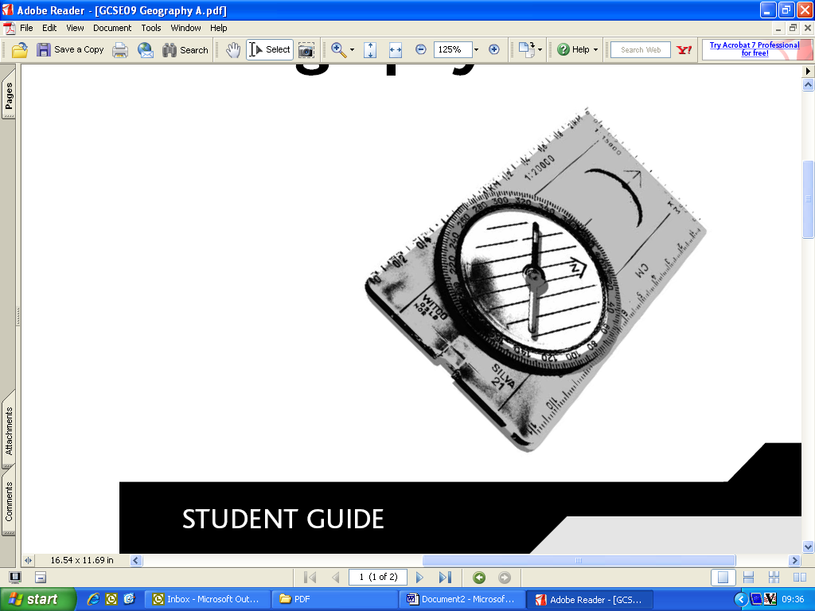

STUDENT GUIDE
Is this the right subject for me?
If you enjoy:

• learning more about the world we live in
• developing skills that will help you in other areas, such as IT and research
• completing some of your own practical work away from the classroom
• working in a team with other students
• learning through investigating and doing, as well as listening and reading

then this GCSE Geography A course is the ideal subject for you.

What do I need to know, or be able to do, before taking this course?
You will have learned a number of geographical skills and gained a body of geographical knowledge in Years 7, 8 and 9. This will be developed further during the GCSE course to give you a deeper understanding of the world. Much will be new but your previous study of geography will have prepared you and helped you to think like a geographer.
What will I learn?
The world is always changing. Geography gives you the chance to learn about these changes. There are four units in the Edexcel Geography A qualification.
How will I be assessed?
Unit 1: Geographical Skills  and Challenges  This unit will build on the skills you learned in Years 7, 8 and 9 and give you new challenges and the opportunity to develop more advanced skills appropriate for a GCSE geographer. You will learn about two of the major issues facing the world today – climate change and sustainable development. | Unit 3: The Human Environment  This unit is based on human geography and you will study one of the following topics:  • Economic Change  • Farming and the Countryside  • Settlement Change  • Population Change  Plus one of these topics  • A Moving World  • A Tourist’s World.  Your teacher may decide to cover more than one topic for Units 2 and 3, so that you have more choice of which question to answer in the exam.
Unit 2: The Natural Environment
This unit is based on physical geography and you will need to study one of the following topics:
• Coastal Landscapes
• River Landscapes
• Glaciated Landscapes
• Tectonic Landscapes.
Plus one of these topics:
• A Wasteful World
• A Watery World.
Unit 4: Investigating Geography
This unit will involve going out of the school to carry out fieldwork and then writing it up. The final writing up will be carried out in class time.
Modules
The course is modular. This means you will not be expected to learn information for the whole of Years 10 and 11 and then be examined at the end of Year 11.
You will take exams throughout the two years and the marks will be added together to make your final grade.
Each of Units 1-3 has an exam which lasts for 1 hour and is worth 25% of your total marks.
The exam has two tiers:
1. Higher – allowing you to achieve grades D-A*
2. Foundation – allowing you to achieve grades G-C.
This means that you can work at the level that suits you.
What can I do after I’ve completed the course?
Geography is well known as a subject that links to all other subjects in the curriculum, so a GCSE in Geography is a stepping stone to a whole range of opportunities. A good grade will help to move you on to any AS, Applied A Level or BTEC course. You may want to continue your study of geography or take a course such as a BTEC National in Travel and Tourism which has a more work related approach.
The skills you develop can lead you to employment opportunities in journalism, media, engineering, IT, travel and tourism, environmental management, marketing, business management and teaching. Geographers are everywhere!
Geography Question:
The Mariana Trench is the lowest point on the Earth’s
crust. How deep do you think the Trench is?
(a) As deep as Ben Nevis is tall
(b) As deep as Mont Blanc is tall
(c) As deep as Mount Everest is tall
(d) It is deeper than the highest mountain is tall

