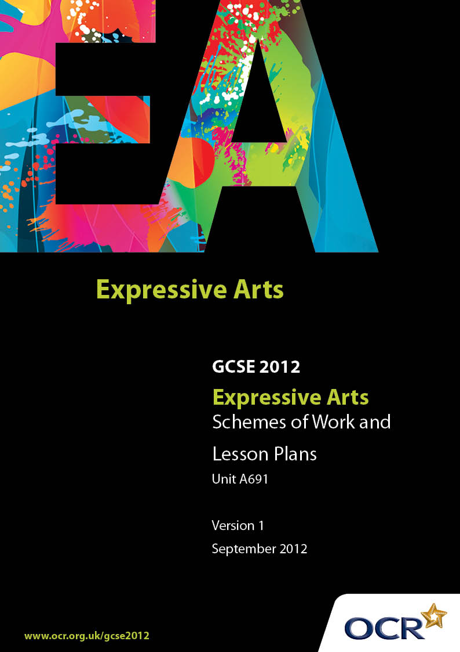

Contents
Introduction 3
Sample Scheme of Work: OCR GCSE Expressive Arts J367 Unit A691: Expressive Arts: Working in Response to the study of Artworks by Practitioners 5
Sample Lesson Plan: OCR GCSE Expressive Arts J367 Unit A691: Expressive
Arts: Working in Response to the study of Artworks by Practitioners 13

Introduction

Background
Following a review of 14 – 19 education and the Secondary Curriculum Review, the Qualifications and Curriculum Authority (QCA) has revised the subject criteria for GCSEs, for first teaching in September 2009. This applies to all awarding bodies.
The new GCSEs have more up-to-date content and encourage the development of personal, learning and thinking skills in your students.
We’ve taken this opportunity to redevelop all our GCSEs, to ensure they meet your requirements. These changes will give you greater control of assessment activities and make the assessment process more manageable for you and your students. Controlled assessment will be introduced for most subjects.
From September 2012 assessment tasks may be undertaken and internally assessed at any point between release of the task and the examination series for which the task must be submitted.
OCR has produced a summary brochure, which summarises the changes to Expressive Arts. This can be found at www.ocr.org.uk, along with the new specification.
In order to help you plan effectively for the implementation of the new specification we have produced these Schemes of Work and Sample Lesson Plans for Expressive Arts. These Support Materials are designed for guidance only and play a secondary role to the Specification.

Our Ethos
OCR involves teachers in the development of new support materials to capture current teaching practices tailored to our new specifications. These support materials are designed to inspire teachers and facilitate different ideas and teaching practices.
Each Scheme of Work and set of sample Lesson Plans is provided in Word format – so that you can use it as a foundation to build upon and amend the content to suit your teaching style and students’ needs.
The Scheme of Work and sample Lesson plans provide examples of how to teach this unit and the teaching hours are suggestions only. Some or all of it may be applicable to your teaching.
The Specification is the document on which assessment is based and specifies what content and skills need to be covered in delivering the course. At all times, therefore, this Support Material booklet should be read in conjunction with the Specification. If clarification on a particular point is sought then that clarification should be found in the Specification itself.

Unit A691:
At the beginning of the unit, the teacher should consider all aspects of the practitioners chosen and the works studied. Remember, the focus is on the practitioner and not on a whole art work, and so a single extract or a range of extracts from the work of a practitioner can be selected to demonstrate the areas of study in action.
The teacher should then select a stimulus that stems directly from the study of the works of art by at least three different practitioners. These practitioners cannot be used again in Unit A692.
In the example below, the practitioners chosen are
- Charles Dickens (Creative writing)
- Rick Wakeman (Music)
- Salvador Dali (Art).
You will notice that the examples given for study mix extracts with full works, and each work of art will provide clear examples of one or more of the areas of study.

A Guided Tour through the Scheme of Work

= Innovative Teaching Idea
This icon is used to highlight exceptionally innovative ideas.


= ICT Opportunity
This icon is used to illustrate when an activity could be taught using ICT facilities.

OCR GCSE Expressive Arts J367 Unit A691: Expressive Arts working in response to the study of artworks by practitioners
Suggested teaching time | 7 hours | Topic | Introducing Areas of Study and the Works of Art
Topic outline |  | Suggested teaching and homework activities |  | Suggested resources | Points to note
The teacher should lead candidates to explore each work of art using the Areas of Study. Candidates should be encouraged to understand that skills in one artform can be transferred to another.  1 hour |  | - Introduction to the Areas of Study  - Class discussion as to what they think each might mean  - Introduce the three practitioners and the work of art chosen. For example: Charles Dickens and Great Expectations; Rick Wakeman and Journey to the Centre of the Earth; Salvador Dali and Persistence of Memory |  | - The specification and the definitions of each Area of Study contained within it.  - Learners should be encouraged to come up with their own examples from their own experiences once each of the practitioners and works of art have been presented to them. This will allow the teacher to begin to assess where the learners are in terms of their understanding of the underlying features of the works of art. | - This topic might start off this Unit and is one way of introducing to the Learners the Areas of Study and the Works of Art and Practitioners in an integrated way that will help them to see Areas of Study as tools in their work, not as isolated chunks of knowledge.  - All of the Areas of Study do not have to be applied to all of the works of art.  - Additional works of art can be used, and candidates may suggest works themselves as they recognise what they are being taught and understand the concepts.
Charles Dickens and Great Expectations  2 hours |  | Take the opening on the moor in the mist with Magwitch and Pip.  Areas of Study to be explored:  - Atmosphere  - Audience  - Narrative  - Social, Political, Historical and Cultural Contexts  For an activity learners could create their own atmospheric moment using light and sound and the minimum of dialogue.  Homework could consist of:  1 finding a passage, either in Great Expectations, or in another Dickens’ novel, where an atmosphere is created  2 suggesting how the scene might be created on a stage to retain the essence of the novel’s description. |  | Text extracts from the book.  - Film clip of the opening when Magwitch is hiding on the moors, preferably the black and white version. | - The whole work is not being considered, although an outline of the story should be given to learners.  - Sharing the Social and Historical contexts might help learners understand why the structure used by Dickens was chosen
Music album by Rick Wakeman:  ‘Journey to the Centre of the Earth’  2 hours |  | Take one section of the work, although it is probably short enough to play the entire piece.  Areas of Study to be explored:  - Atmosphere  - Audience  - Structure and Shape  - Narrative  - Motif  - Genre  - It would be useful to compare and contrast with the Dickens’ work in terms of Audience – both were intended for popular audiences, but history has caused the Dickens’ piece to be less accessible, and what effect might time have on Rick Wakeman’s piece? This could also link into Social, Political, Historical and Cultural Contexts.  - For structure it might be useful to compare the episodic nature of Great Expectations with the single concert version of the music.  - The rock genre could lead to candidates sharing their own experiences and knowledge of rock music, and possibly pieces that use keyboard and drums extensively, as this piece does.  - Musical Theatre might also be a line of exploration – telling a story through music and words.  - The telling of a story and the way atmosphere helps in this is relevant to both Great Expectations and Journey to the Centre of the Earth.  - Learners could explore the way drumming is used in music and could build a story using just drumming as a soundtrack or background. |  | - The novel by Jules Verne that forms the basis of the music piece could be referred to, and there is a recent film.  - Other rock artists such as Queen may be useful as comparators. | - Learners may have examples of other songs that take a narrative approach.  - It might be appropriate to introduce the idea of Musical Theatre and to explore how this piece is different from a modern musical.
Salvador Dali and Persistence of Memory  2 hours |  | Take the painting as a single work and look at how the following Areas of Study are represented:  - Atmosphere  - Audience  - Motif  - Genre  - Symbol  - Atmosphere and Audience lend themselves to comparison with the other two works, but probably this work would be most useful for looking at Motif, Genre and Symbol. It may be that looking at other Dali works might support individual Areas of Study.  - The Surrealism movement might be something learners could explore for homework. |  | - There are many websites that explore the works of Dali and the Surrealism his work represented.  It may be useful to use television and film examples to help recognise genre:  - Horror  - Fantasy  - Musical (High School Musical!)  - Soaps on TV such as Eastenders and Coronation Street | - Remember this is not an Art course. The interest should be focused on the Areas of Study chosen, and it is the concepts that need to be understood.  - There is no need to do a detailed study of Dali and his life, apart from anything it is felt necessary to provide understanding of aspects of the painting, and perhaps some insight into surrealism.

This stimulus might be a genre, a social context, an era or a political comment. It might be an aspect of style or technique. The three practitioners and the chosen works might have features in common or show a contrast in providing the stimulus. The link must be clear and not a general theme which has no direct connection with the works of art and the practitioners explored.
For example, the stimulus The Storyteller would reflect all three of the practitioners and the works of art given in this example, but allow the learner to approach their outcome in a variety of ways. The following example works through a possible response.
Outcome Example
Aspect | Content | Comment
Stimulus | The Storyteller
Intention | Entertain | Learners need to have a very clear focus
Audience | Primary school children in year 6 at the end of a term | Be specific about the audience and avoid generalisations like ‘schoolchildren’ or ‘young people’
Nature of Realisation | Play with music | Remember that the main purpose of this is the examination, so do not be tempted into allowing learners to attempt outcomes of epic proportions. If performance is involved the guidance is that about two minutes per person is sufficient to demonstrate skills in an outcome
Art forms that could be used | Creative writing (writing the piece)  Drama (performing the piece)  Music (simple background music composed by the learners) | Try not to make any art form ‘bolt-on’ and ensure each contributes properly. The balance in this example is likely to be more on creative writing and drama, so it would be important not to make the music too demanding. A simple melody or background sounds to improve atmosphere would be sufficient, depending on the contribution of different learners. It may be that in a group one learner may have a different balance in working in an art form than others
Practitioner influence | The way each of the works studied tells a story, each in a different way | In creating the drama it should be easy for the learner to reference the nature of the story in Great Expectations, especially the episodic nature and the way tension is built at the end of each episode that would appear in the magazine version that was published originally. Characterisation could also be referred to. Wakeman’s music has a similar approach and is dramatic in its concept, with a linear storyline. The Dali work is more surreal, and the learner could question whether a naturalistic approach is wanted, or whether there might be more suggestive and symbolic references.
Genre and Style | Play with music. | The learner may decide to use musical theatre as the genre, or consider melodrama depending upon the content.
Areas of Study | Atmosphere – all three pieces have very distinct atmosphere connections  Audience – Learners could compare the intended audience for their practitioners works with their own audience, and how the creation of work relates to its audience  Structure and Shape – The Dickens and Wakeman pieces both have very clearly defined structures. Will the learner choose the same?  Narrative – telling a story is implicit in this example  Motif – Dali provides the best example here, although there will be motifs in the music too  Genre – Each of the three practitioners work in different ways and the examples of their work take different approaches, partly through their purpose  Symbol – Both Dali and Dickens’s works will provide examples of symbols  Social, Political, Historical, and Cultural Contexts – the social context for Dickens’s work reflects the society of the day; Wakeman’s work is very much part of the rock culture of its day; and Dali’s work resulted from a mixture of sources, some personal, some political, some cultural. | Learners do not have to take their influences from their practitioners always in a positive way. It is entirely acceptable to consider the way their practitioner operated in one aspect, and to reject that for their own work, explaining why an alternative has been chosen
Alternative Outcomes
The example above uses a Play with Music as the outcome. The comments could still apply if a different outcome was chosen. Examples could include:
- A comic book taking an exciting story from history – perhaps one with historical importance. This would involve Creative Writing and Art and Design. The link with practitioners would be the way they deal with story.
- A surreal film using cartoon characters and using the latest technology in animation. The film could have a voice over or a musical soundtrack. The art forms here would be Creative Writing, Art and Design, and either Music or Drama. Its link with the practitioners could be taking the area of study of ‘atmosphere’.
- A dance with a backdrop created by a slide or projection. The dance could tell a story either realistically or in an abstract way sharing feelings and emotions. The projection could be abstract designs and use colours or textures, or photographs to develop the atmosphere of the piece. Dance, Art and Design, possibly Creative Writing might be used.
- Explore how movement can be stimulated by literature, paintings, sculpture and music. As the work develops learners could explore combinations between original stimulus and movement. For example, skills in collage and composition, the relationship between sounds and action, and the structuring of narrative. This could lead into an abstract piece where the outcome is tightly influenced by two of the practitioners’ works acting together.
- Develop a kinetic sculpture that exploits light and sound as well as space, into which the human form is introduced. Practitioners could be linked, for example, ‘How might Dali view Dickens’ London?’

OCR GCSE Expressive Arts J367 Unit A691: Expressive Arts: Working in Response to the study of Artworks by Practitioners

Introducing a stimulus for an Outcome for this Unit
OCR recognises that the teaching of this qualification above will vary greatly from school to school and from teacher to teacher. With that in mind this lesson plan is offered as a possible approach but will be subject to modifications by the individual teacher.
Lesson length is assumed to be one hour.

Learning Objectives for the Lesson
Objective 1 | Introduce the stimulus
Objective 2 | Understand how Areas of Study must be used
Objective 3 | Develop creativity by exploring possible responses
Objective 4 | Begin a simple plan

Recap of Previous Experience and Prior Knowledge
- Learners will have been introduced to three practitioners and a piece of artwork or an extract or section of an artwork in previous lessons.

Content
Time | Content
5 minutes | Listen to an extract from the soundtrack from Hitchcock’s... and with a partner develop a short 15 second mime that could be what an audience might see whilst listening to the music.
10 minutes | In groups of three discussions over examples of atmosphere represented in the three artworks studied their purpose, and how they worked.
5-10 minutes | Class discussion over the results of their group discussions. Ideas written on board or displayed on data projector for all to see. No quality assurance initially just record ideas. This to be followed by discussion as to what represented the best example of ‘atmosphere’ and why. Ask learners if any other Area of Study might have an impact upon the development of their examples.
15 minutes | Teacher decides on groupings for their work. This can be as an individual, a pair or in a small group of up to five. The teacher will need to decide if there is any element of choice, whether s/he will decide, or whether there may be negotiation. Once in their working groups, pairs or as individuals, thought shower examples of atmosphere that could be a stimulus for an outcome.  This is to help with their imagination and creativity and at this stage learners should understand that ideas they have will not necessarily be the one they follow.  Discuss the outcome of their thought shower with individual groups if possible, to the whole group if not; and question how their idea might be achieved, in general terms. Then ask what artforms might be used for their ideas.
10 minutes | Class discussion on some of the ideas, especially how they link with the artworks studied. Pick examples of things that have no links or are not practical, and suggest they be eliminated from the learners’ considerations.

Consolidation
Time | Content
5 minutes | Into original groups for narrowing down choices or even making selection of topic to follow through to an outcome for this unit.
10 minutes | Focus on the next steps and how they will lead on from the work in the lesson. Early stages of planning, check lists of what to include:  - intended audience  - purpose of the outcome  - how to use areas of study  - selection of art forms  - links with works studied, using work on atmosphere in this lesson as an example  - how they will record their planning, exploration and development, in what form will they gather evidence.

