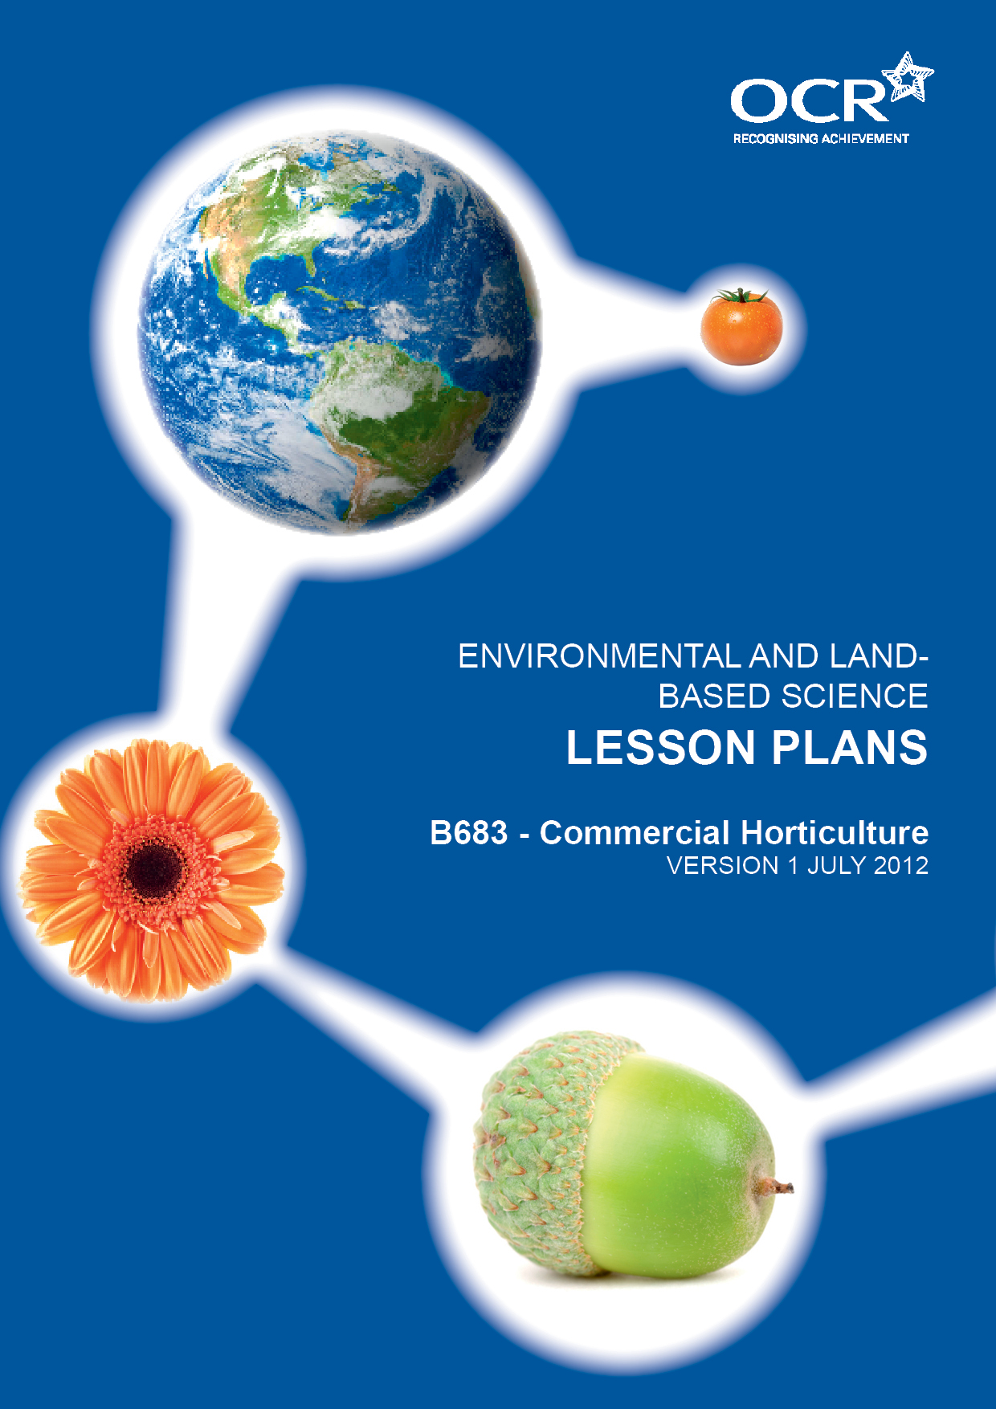
Introduction
OCR involves teachers in the development of new support materials to capture current teaching practices tailored to our new specifications. These support materials are designed to inspire teachers and facilitate different ideas and teaching practices. Each Lesson Plan is provided in Word format – so that you can use it as a foundation to build upon and amend the content to suit your teaching style and students’ needs.
The Lesson Plans provide examples of how to teach this unit and the teaching hours are suggestions only. Some or all of it may be applicable to your teaching.
The Specification is the document on which assessment is based and specifies what content and skills need to be covered in delivering the course. At all times, therefore, this Support Material booklet should be read in conjunction with the Specification. If clarification on a particular point is sought then that clarification should be found in the Specification itself. References to the content statements for each lesson are given in the ‘Points to note’ column.
PowerPoints, Worksheets and other resources can be found on the following website: www.elbs.info.

lesson | Learning objectives | Lesson outline | Resources
1  LO1 LD | Candidates should understand  - the role of growing media and nutrients in optimising plant growth  - the ideal conditions for different crops | Reminder of factors identified in last session.  Discussion into why potting compost is more suited to indoor pot production than soil – relating to concepts of nutrient availability, structure, weeds etc.  Intro to nutrient use. (link to B491)  Identification of specific growing needs | Examples of compost and soil.  NPK flower diagram.  Worksheet for different plant needs
2  LO1 SD/HD | Candidates should know  - the conditions needed for photosynthesis.  - how these growing conditions are controlled | Re-cap on the photosynthesis reaction.  Discussion on which of these factors of light, temperature, water and CO₂ may be controlled and how.  High demand – Rate limiting factors | Relate factors to the greenhouse available on-site (if available)
3  LO2 | Candidates should know:  - how to raise plants from seed.  - high demand- the uses, advantages and disadvantages of heated propagators, mist propagators and capillary matting when raising plants from seed | Review progress of seeds sown last time.  Recap: students to produce a ‘storyboard’ on hand-outs of the process of sowing seeds carried out last time.  Demonstration: sowing of larger seeds into individual pots and use of cell trays  Sowing of very small seed using sand  Alternative techniques- pelleted seed or seed tapes | Storyboard hand-out  Cell trays  Pelleted seed  Seed tapes  Fine seed eg lobelia or begonia  Silver sand.  Propagator/ mist propagator capillary matting
4  LO2 | Candidates should know:  - how to prick out and thin out seedlings | IF SEEDLINGS ARE AT SUITABLE STAGE  - otherwise defer to a later week  Discussion on the aftercare of seedlings  Definition and demonstration of techniques:  Pricking out, Thinning.  Students to practice ( to be continued) | Seedlings from previous sessions  Pots  Trays  Compost  Labels
5  LO3 | Candidates should know  - the differences between annual, biennial and perennial life cycles.  - the differences between deciduous and evergreen | Discussion of life cycles: use concept of the ‘timeline’ to explain  produce pressings of annual and perennial weeds with notes on how/why the control of each is different | Examples of plants or annual biennial and perennial weeds  hand-out  Books/ internet
6  LO3 | Candidates should know  - the advantages and disadvantages of propagating plants asexually and sexually.  - named examples of bulbs, corms, rhizomes, tubers and runners | Produce a list of advantages and disadvantages of growing plants from seed.  Explain the genetic differences from seed propagation compared to vegetative production.  With named examples of bulbs, corms, runners, tubers and rhizomes  Role of tissue culture in banana propagation | Live examples if available, otherwise pictures.
7  LO3 | - practical activity  Marketing of tete a tete bulbs | NOTE: date of this activity will depend on plant development stage so may be earlier or later.  Bulbs planted in week 4 should be ready for sale in bud. This date may also coincide with Mother’s day. (Adapt programme accordingly).  Students to devise point of sale materials, set the price, and build a display. Activity may also include creating gift-wrap or pot covers to help market the product and/ or care cards. | Planted bulbs  Materials for posters etc
8  LO4 | - to understand why and how selective breeding is used in producing new plant varieties  - understand the concept of hybrid vigour  - high demand- how genetic engineering might be used in plant breeding and the ethical environmental concerns | Comparison of a traditional tomato variety such as money-maker with an F1 hybrid such as Shirley. (numbers of seed in packet and cost per packet) Reasons for the differences.  Possible practical skills comparing yield of each  Class discussion following internet research (homework) on the advantages and disadvantages of genetically engineering new  plant varieties. | Packets of tomato seeds traditional /F1.  Pots and compost if a practical is to be carried out  Access to computers

lesson | Learning objectives | Lesson outline | Resources
9  LO5 | Candidates should know  - named examples of plants used in bedding schemes tubs and baskets to include Fuchsia, Pelargonium, Begonia, marigold, Lobelia  - Features of plants used in bedding schemes, tubs and baskets and how these are maintained  - high demand - factors used in the choice of bedding plants to include aspect, shade drainage | Students to use internet for find examples of bedding schemes and planting in tubs and baskets.  Discussion as to the qualities of a good bedding plant or one suitable for a container.  Students to use knowledge to produce a design for their own container, basket or bedding scheme.  Produce and maintain their own container basket or bedding scheme. Practical skills could include the numbers of flowers produced with and without dead-heading | Internet or reference books such as “The bedding plant expert” by D G Hessayan.
10  LO6 | Candidates should understand:  - named examples of trees and shrubs used in parks gardens and street plantings to include cherry, Acer, beech, birch and Hydrangea, Buddleia, Forsythia, Viburnum  - how to choose suitable plants for a specific situation. | Introduce the concepts of tree and shrub and how they differ  Design practical: a shrub bed to be situated within the school grounds.  Plants to be selected with reference to factors such as:  Shade  Aspect  Drainage  pH (carry out a pH test if time)  Size  Season of colour | pH test equipment  books  internet  Scale plan of bed involved.
11  LO7 | Candidates should know:  - the need to maintain permanent planting by watering, feeding using organic or inorganic fertilisers, weeding and pruning  - How to maintain permanent planting by weed control: mechanical, chemical and cultural, and by pruning: reasons for pruning and basic techniques used  - high demand - the hormonal effects of pruning on plants, to include  - bud and flower development and fruiting | Pupils could produce a maintenance plan for beds within the school  Carry out routine maintenance on these plots.  Possible practical skills investigate the effect of pruning / not pruning the same shrub species. | Plan of school site

lesson | Learning objectives | Lesson outline | Resources
12  LO9 | Candidates should understand:  - how to grow a lawn from seed  - the different uses of lawns  - high demand – know the different grass mixtures used to include amenity and sport | Tour of site to look at the use of grass in different situations  Comment upon: quality, height, amount of weeds, amount of wear.  Produce a table of the advantages/disadvantages of producing a lawn from seed or turf  Produce a storyboard hand-out for the process of producing a lawn from seed. | Storyboard hand-out  “The Lawn Expert”  Dr D.G.Hessayon
13  LO9 | Candidates should be able to:  - describe how a lawn is made from turf  - identify the advantages and disadvantages of using turf compared to growing from seed | Produce a storyboard hand-out for production of a lawn from turf.  Use the internet or books as source material.  General discussion of pros and cons of this method over seed raised lawns | Storyboard hand-out  Internet  books
14  LO8 | Candidates should know:  - the different types of lawn mower available to the gardener.  - the advantages and disadvantages of each type. | Look at the different cutting actions of different mower types (either on actual machines or via pictures)  Activity: simulation of cutting actions  (use scissors to cut long grass – simulates cylinder action)  (use a bamboo cane to cut long grass – simulates rotary and hover actions)  - Which is: quicker?  - Which gives the better quality cut?  Discuss most suitable cut for different situations. | Mowers or pictures  Scissors, bamboo canes, area of long grass
15  LO8 | Candidates should know:  - how to set the height of cut for different seasons and growing conditions | Demonstrate on a machine how to change the cutting height.  HD- Discuss the needs for different cutting heights and regimes | Examples of different types of mowers
16  LO10 | Candidates should know:  - the uses of glasshouses, polytunnels, cloches, and fleece  - advantages and disadvantages of each  - high demand- the functions of cold frames , their functions to include hardening off | Use the images to produce a guide to each type of protective cultivation  Measure temperatures inside and outside structures  Statement that large structures are strictly ‘greenhouses’ as other materials may be used, not just glass. | Pictures of the different types of protective cultivation.

lesson | Learning objectives | Lesson outline | Resources
17  LO11 | Candidates should understand:  - the factors affecting the siting of a glasshouse.  - the advantages and disadvantages of different  materials used in glasshouse construction, to include plastic and glass and their different properties  - the economic factors involved when using a  glasshouse: usage all year round to grow crops out  of season, temperature control and automation to  reduce labour costs. | Discuss the position in relation to the sun, overhanging trees/shade, access , availability of services, safety  Activity: work out the cost of covering 10m² with each of the alternatives. Use the internet for research and prices  Production of a table to give different materials as ‘star’ rating. – include polythene, glass, twin-walled polycarbonate  Impact of fuel prices on the heating of glasshouse all year round. Mind map options for the grower. | Access to internet.
18  LO12 | - the differences between biological and non-biological methods of pest control  - the advantages and disadvantages of biological pest control  - the pest control implications of the use of biological control agents in protective culture. | Comparison of the different methods of controlling whitefly in the greenhouse  to include the use of Encarsia formosa, systemic insecticides, contact insecticide  Produce a table of the advantages and disadvantages of each system  Discussion of why glasshouse growers are frequently turning to biological methods of pest control
19  LO13 | - the differences between the types of compost available: soil based, peat based, soil-less and  peat-free  - high demand - the advantages and disadvantages of using different growing media in the glasshouse, including environmental and ethical considerations in the use of peat. | List other types of compost available  Research “peat is a good compost base- but what are the alternatives?”  Discussion: environmental impact of peat and its alternatives
20  LO13 | Candidates should know:  - the differences between the different types of compost available | Practical investigation: Students to evaluate the properties of different potting composts  With respect to: pH , mass, density, water holding capacity, ‘feel’  Discuss how these issues may affect the use of the compost eg use in hanging baskets or large pots | A range of composts to include  Soil based (John Innes)  Peat based  Peat free and or Coir/reduced peat

lesson | Learning objectives | Lesson outline | Resources
21  LO13 | Candidates should know:  - the dangers associated with growing plants year after year in glasshouse soil | Discussion : “Chrysanthemums grown in same greenhouse soil are not performing well, why might this be?” | Internet
22 | - how hydroponics can be used as an alternative to compost  - the commercial and environmental advantages of using hydroponics  - HD- the use of ICT to maintain hydroponic systems. | Set up a demonstration hydroponics system in the greenhouse or classroom,  Discuss the advantages of hydroponics over compost or soil culture.  Identify how ICT could be used | Demo hydroponics unit  http://www.greenhousesensation.co.uk/hydroponics/hydrogrow-nft.html
23 | Visit: to a commercial glasshouse grower | Students to visit a grower and interview them as to the types of control systems used and the advantages and disadvantages of their current systems?  What trends are there going forward?  Summative session to consolidate previous sessions.
24 | Mock Exam | On-line specimen paper

