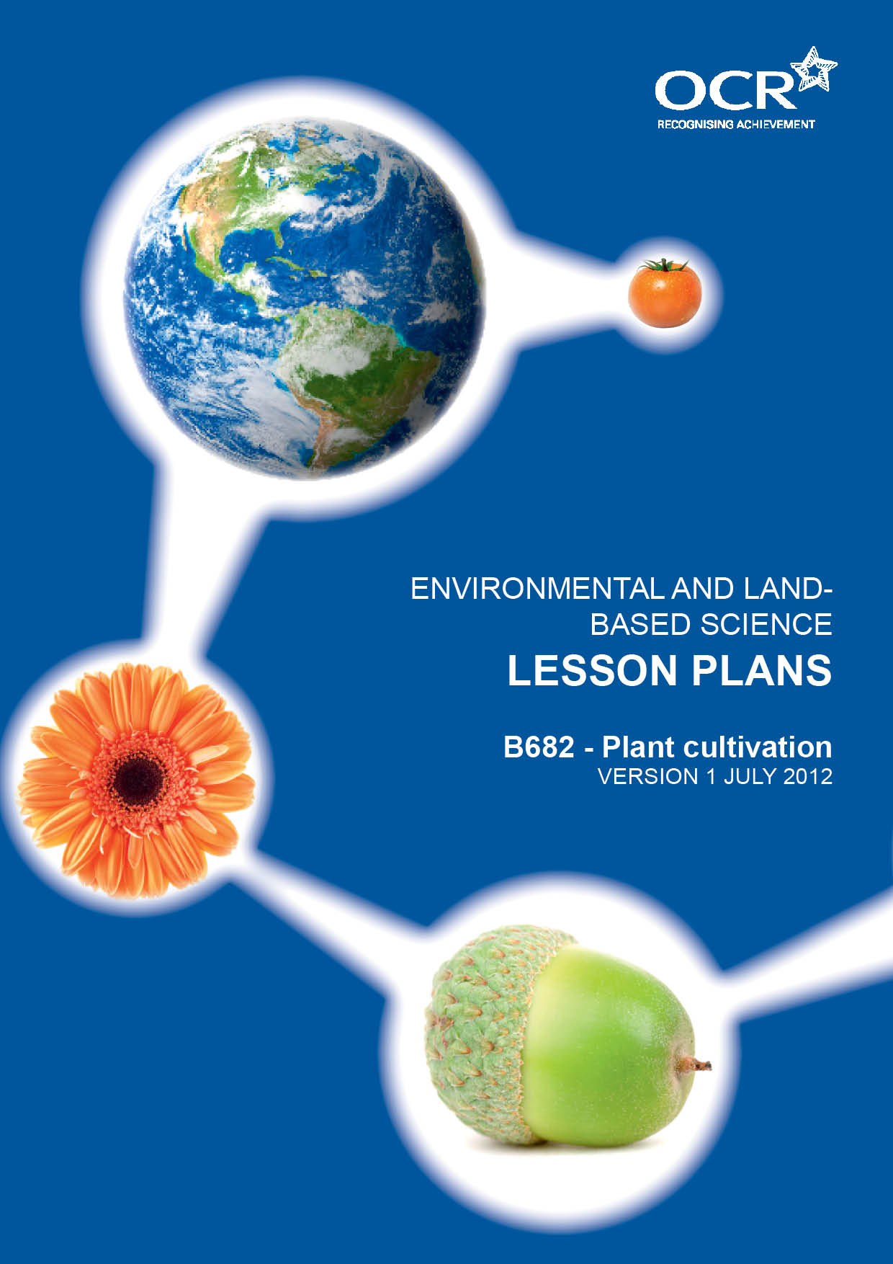
TWENTY FIRST CENTURY SCIENCE SUITE
SCHEMES OF WORK AND LESSON PLANS
C3: Chemicals in our lives
VERSION 1 JULY 2011
Introduction
OCR involves teachers in the development of new support materials to capture current teaching practices tailored to our new specifications. These support materials are designed to inspire teachers and facilitate different ideas and teaching practices. Each Lesson Plan is provided in Word format – so that you can use it as a foundation to build upon and amend the content to suit your teaching style and students’ needs.
The Lesson Plans provide examples of how to teach this unit and the teaching hours are suggestions only. Some or all of it may be applicable to your teaching.
The Specification is the document on which assessment is based and specifies what content and skills need to be covered in delivering the course. At all times, therefore, this Support Material booklet should be read in conjunction with the Specification. If clarification on a particular point is sought then that clarification should be found in the Specification itself. References to the content statements for each lesson are given in the ‘Points to note’ column.
PowerPoints, Worksheets and other resources can be found on the following website: www.elbs.info.

Lesson 1 – Plant growing environment
Learning outcomes: by the end of the lesson Candidates should know:- | - how growing medium, water, humidity, nutrients, temperature and light can be controlled in crop production and the effects of these factors on plant growth.  - the balanced symbol equation for photosynthesis.  - how CO₂, temperature and light affect photosynthesis, including consideration of limiting factors.
Suggested lesson details and activities: | Starter: Students sketch a plant and annotate it with everything it needs to stay alive. Teacher led discussion of students’ diagrams.  Main Activity: Work in groups to design a greenhouse with optimum growing conditions.  Plenary: Each group to present its ideas to the class.  Homework: Learn the word and balanced symbol equation for photosynthesis.
Suggested resources: | Plant growing environment Powerpoint

Lesson 2 – Healthy and unhealthy plans
Learning outcomes: by the end of the lesson Candidates should know:- | - the signs of a healthy and an unhealthy plant.  - the causes of plant ill health: pests, including aphids and slugs, fungal disease including damping off and potato blight, over and under watering; the effect of these factors on yield.  - how pests, viruses and fungi are controlled in plant cultivation.
Suggested lesson details and activities: | Starter: Brainstorm the signs of a healthy plant to include leaf colour, turgidity, leaf and root growth, flowers, fruits etc.  Main Activity: Practical on signs of unhealthy plants.  Tour of school greenhouse to identify what methods are used to keep the plants healthy and what could be improved.  Plenary: Post it Head – Students are paired up and one of the students has a post it on their forehead describing an unhealthy plant. They have to guess what it is using only YES or NO answers.  Homework: Collect examples of leaves from different plants to demonstrate different problems.  Research information on the potato famine in Ireland.
Suggested practicals: | Students identify examples of unhealthy plants eg. wilting, slug damage, aphids, chlorosis, etiolation.
Suggested resources: | Healthy and unhealthy plants Powerpoint

Lesson 3 – Pest control
Learning outcomes: by the end of the lesson Candidates should know:- | - the differences between biological and non-biological methods of pest control.  - the advantages and disadvantages of biological pest control.  - how biological control agents are used in glasshouses, using a named example.
Suggested lesson details and activities: | Starter: Students write down on a piece of paper one method of controlling pests. The papers are then passed around 4 or 5 times with students adding different answers to the paper. At the end the students discuss what is on their piece of paper.  Main Activity: Students design an investigation to compare different methods of pest control. Teacher led discussion of ideas and students work in groups to set up glasshouses with different conditions.  Presentation of results by each group.  Discussion and evaluation of results.  Plenary: Each student states either an advantage or disadvantage biological pest control.  Homework: Research a further example of biological control.
Suggested practicals: | Set up an investigation to compare whitefly numbers in glasshouses with different pest control methods. For example use of Encarsia Formosa, marigolds and sticky traps.
Suggested resources: | Biological and Non-biological methods of pest control Powerpoint

Lesson 4 – Plant nutrients
Learning outcomes: by the end of the lesson Candidates should know:- | - the effects of excess N deficiencies of N, P, K and Mg on plant growth and development.  - how nutrients NPK are taken in by plants.  - the uses plants make of NPK to produce growth, including N for proteins, P for DNA and cell membranes, K for enzymes used in photosynthesis and respiration.
Suggested lesson details and activities: | Starter: Introduction on what nutrients are and where they come from. Brainstorm students on which nutrients are important to plants.  Discussion of the major nutrients.
Suggested practicals: | Use of commercial kits to test different soils for N, P, K.  Set up seed trays of grass and treat with different concentrations of nitrate fertiliser.
Suggested resources: | Plant Nutrients Powerpoint  Card sort  Soil testing kits  B491 6a – A Lawn Problem

Lesson 5 – Fertilisers
Learning outcomes: by the end of the lesson Candidates should know:- | - the differences between organic and inorganic fertilisers.  - the advantages and disadvantages of using organic and inorganic fertilisers.  - how plant nutrient ratios in common fertilisers; general purpose (1:1;1), high N (2:1:1), high P (1:2:1) and high K(1:1:2), relate to their use for brassicas, legumes, root crops and tomatoes.
Suggested lesson details and activities: | Starter: Students shown examples of different types of fertiliser and asked to group them into different categories. Teacher led discussion of different categories leading to identification of organic and inorganic fertilisers.  Main Activity: Students are encouraged to brainstorm the advantages and disadvantages of organic and inorganic fertilisers.  Students work in groups to design a fertiliser packet for a given crop with specific criteria.  Students match the different crop to the appropriate fertiliser.  Students identify root nodules and discuss the implications of these for fertiliser use.  Plenary: Each group reviews the fertiliser packets against the criteria given and give them a score. The group with the highest score wins.  Homework: Plant Health and Fertiliser Sheet.
Suggested practicals: | Students to prepare vegetable plots for sowing seeds, adding organic fertiliser to one plot and inorganic fertiliser to another. Comparison and evaluation of crops grown.  Students are shown examples of different crops eg. cabbage, wheat, carrots and tomatoes and asked to match them up to the appropriate fertiliser label giving reasons for their choice.  Students dig up clover, peas or beans and wash the roots to see nodules.
Suggested resources: | Organic and Inorganic fertilisers Powerpoint  Examples of different organic and inorganic fertiliser  Examples of crops and fertiliser bags

Lesson 6 – Pollination
Learning outcomes: by the end of the lesson Candidates should know:- | - the adaptations of flower structure for wind and insect pollination.  - the adaptations in plants to prevent self pollination and encourage cross-pollination, to include dioecious plants.  - the management of pollination in crop production and breeding.
Suggested lesson details and activities: | Starter: Students given flower structure sheet and label one organ then pass it on. Teacher discusses answers to determine prior knowledge.  Main Activity: Flower dissection.  Produce a poster to compare wind and insect pollinated flowers  Plenary: Students are split into two groups. They act as the expert to answer a letter in a magazine from a gardener who wants to know how he can improve the yield of fruits. One group explains how this could be done in his glasshouse and the other group on his allotment.  Homework: Sexual Reproduction in plants sheet.
Suggested practicals: | Students to dissect a large flower and make a poster by sticking all the relevant parts on and annotating them.  Students collect different examples of wind and pollinated flowers and produce a poster that describes the similarities and differences.
Suggested resources: | Pollination Powerpoint

Lesson 7 – Seeds
Learning outcomes: by the end of the lesson Candidates should know:- | - the structure of a pea or bean seed to include the testa, cotyledon, embryo, plumule and radicle.  - the functions of testa, cotelydon, plumule and radicle and their roles in germination; the role of oxygen, water and temperature in germination to include mobilisation of enzymes.  - techniques used to encourage different seeds to break dormancy, to include light and vernalisation.
Suggested lesson details and activities: | Starter: http://www.youtube.com/watch?v=fPTJ3qD1ikk&feature=related  Main Activity: Students collect seeds from different plants such as sunflowers, peas and relate the work on flowers and pollination to seed development. Teacher led discussion of the conditions needed to store the seeds ready for sowing in the future.  Seed dissection.  Set up experiment to show the stages of germination.  Students plan an investigation to demonstrate conditions necessary for germination.  Plenary: Students write down the new terms, together with the conditions needed for germination, using whichever hand they do not normally write with.  Homework: Students produce a word search of all the terms relating to seeds.
Suggested practicals: | Students cut a runner bean seed in half lengthways to show the internal structures.  Students set up a runner bean and a pea seed in a beaker containing tissue paper to show the stages of germination.  Students set up a variety of investigations to show the effect of planting depth, temperature, water or light on germination.
Suggested resources: | Seeds Powerpoint

Lesson 8 – Sowing seeds
Learning outcomes: by the end of the lesson Candidates should know:- | - how a named plant is grown from seed to include the process of sowing, thinning, pricking out and potting on.  - the reasons for thinning, pricking out and potting on.  - the advantages and disadvantages of heated propagators, mist propagators and capillary matting, cloches and cold frames when raising plants from seed.
Suggested lesson details and activities: | Starter: Students shown examples of compost and soil and asked to brainstorm the differences.  Discussion of why compost is used rather than soil.  Main Activity: Practical to make compost and sow seeds under cover. Comparison of germination success when germinating seeds in a glasshouse compared to a heated propagator. Ongoing care of seedlings and plants to include hardening off in a cold frame. Recap conditions needed for germination.  Use of mist sprays and capillary matting to water seedlings and comparison of the advantages and disadvantages of each.  Students grow seeds outside in vegetable plots. Comparison of growth of plants with and without cloches.  Plenary: Question and answer session to confirm understanding of the topics covered.  Homework: Students produce a plan of a vegetable plot showing what they will grow where. This is kept up to date by adding dates and methods for sowing each seed variety.
Suggested practicals: | Students to make compost using peat/old grow bags, sand and inorganic fertiliser.  Students to sow seeds in compost in a seed tray and prick out seedlings.  Potting on, supporting, feeding and side-shooting a tomato plant.  Students to sow seeds in vegetable plots using seed drills, thin them out and harvest them.
Suggested resources: | Sowing seeds Powerpoint

Lesson 9 – Taking softwood cuttings
Learning outcomes: by the end of the lesson Candidates should know:- | - how plants can be propagated using softwood leaf and root cuttings, using named examples.  - how the procedures used, including the control of the environment, ensure successful propagation.
Suggested lesson details and activities: | Starter: Using plants inside or outside the classroom students identify what is meant by a softwood plant.  Main Activity: Students take softwood leaf and root cuttings.  Plenary: Produce a comic strip style illustration of how to take either root or leaf cuttings.  Homework: Taking softwood cuttings question sheets.
Suggested practicals: | Take stem cuttings on a non flowering shoot below the node using a sharp knife.  Comparison between cuttings using hormone rooting powder and those without.  Comparison between cuttings placed in plastic bags and those without.  Take root cuttings and leaf cutting using suitable plants.
Suggested resources: | Taking softwood cuttings Powerpoint

Lesson 9H
Learning outcomes: by the end of the lesson Candidates should know:- | - the techniques used in tissue culture (cloning) for plant propagation and the advantages of these methods, using named examples.
Suggested lesson details and activities: | Starter: Discussion of the disadvantages of taking cuttings to produce clones, leading on to the advantages of tissue culture.  Main Activity: Tissue culture using cauliflower.  http://www.saps.org.uk/secondary/teaching-resources/720  Plenary: Students take it in turns to describe and explain the steps taken to clone the cauliflower.  Homework: Produce a practical report on how to clone cauliflowers, including the reasons for the techniques used.
Suggested practicals: | Cauliflower cloning
Suggested resources:

Lesson 10
Learning outcomes: by the end of the lesson Candidates should know:- | - that plants are selectively bred to improve yield, disease resistance, hardiness and appearance.  - how selective breeding is used to produce new varieties of plants such as tomato; the meaning and importance of hybrid vigour.
Suggested lesson details and activities: | Starter: Show students a range of different types of tomatoes and brainstorm them as to how they could have been produced.  Main Activity: Students produce an illustrated flow diagram to explain how one such variety was developed.  Plenary: Using the principles of selective breeding students improve a current fruit or vegetable. Students present these ideas to the class and the most popular one wins a prize.  Homework: Students to research what is meant by hybrid vigour and present their findings to the class the following lesson.
Suggested practicals:
Suggested resources:

Lesson 10H
Learning outcomes: by the end of the lesson Candidates should know:- | - the uses and advantages of genetic engineering in the production of new varieties of plants, and the possible environmental and ethical issues arising.
Suggested lesson details and activities: | Starter: Students write down their ideas on genetic engineering. They share these with the other students to see if they agree or disagree.  Main activity: Make a genetically modified plasmid using the DNA templates.  Discussion of students ideas on GMO’s.  Plenary: Students write down their own ideas on the environmental and ethical issues arising from genetic engineering.  Homework: Write a newspaper article about a new genetically modified crop explaining both sides of the argument.
Suggested practicals: | The gene is cut out of the DNA of the host at the base sequence AAATTT and then stuck into the circular plasmid DNA that has also been cut at the same base sequence.
Suggested resources: | Genetic Engineering Powerpoint

Lesson 11 – Sexual reproduction
Learning outcomes: by the end of the lesson Candidates should know:- | - the differences between a bulb, a runner, a tuber, a corm and a rhizome used in plant cultivation and a named example of each.  - how plants are propagated asexually including runners, rhizomes, tubers, corms and bulbs.  - the advantages and disadvantages of sexual and asexual reproduction in plant breeding.
Suggested lesson details and activities: | Starter: Use of a variety of plants to show examples of vegetative propagation and explain its importance in producing offspring that are genetically identical to the parent.  Main Activity: Dissect a bulb and draw and label the structures seen. Show that bulbs store starch. Complete sheet on reproduction in bulbs.  Propagate a variety of plants asexually.  Plenary: Asexual reproduction worksheet.  Homework: Plant Cultivation questions.
Suggested practicals: | Propagation of strawberry plants or spider plants.  Dig up some couch grass.  Dissection of an onion or daffodil bulb to show the swollen leaf bases.  Testing the onion for starch.  Growing potatoes from seed potatoes on a vegetable plot.
Suggested resources: | Sexual reproduction Powerpoint

Lesson 12 – Plant breeding
Learning outcomes: by the end of the lesson Candidates should know:- | - the terms: chromosomes, genes, mutation, dominant, recessive, genotype, phenotype and F1 and their meanings in relation to plant breeding.  - how to apply the mechanism of simple monohybrid inheritance, where there have been dominant and recessive alleles, to plant breeding.
Suggested lesson details and activities: | Starter: Match up pictures of celebrities with their babies/children leading onto a discussion of dominant and recessive genes.  Main Activity: Designing plants activity.  Worksheet ‘Genetics’.  Plenary: Plant Reproduction loop.  Homework: Students produce a crossword including all the key genetics words.
Suggested practicals:
Suggested resources: | Plant Breeding Powerpoint  Monohybrid inheritance

Lesson 13 – Soil cultivation
Learning outcomes: by the end of the lesson Candidates should know:- | - the principles and purpose of soil cultivation by hand.  - the importance of (soil) crumb structure; the use of humus, garden compost and manure in maintaining soil fertility.  - methods of improving soil fertility and crumb structure using lime, coarse sand and well rotted manure.
Suggested lesson details and activities: | Starter: Give each student or group a common garden tool. They have to explain each use to the rest of the class.  Main Activity: Brainstorm student’s ideas about soil components and structure.  Carry out soil cultivation by hand and reinforce the reasons for carrying out each of the different practises. Label diagram of a soil crumb.  Complete worksheet on Bastard Trenching.  Use a table to show the effect of pH on nutrient availability.  Plenary: Cultivating the soil worksheet.  Homework: Worksheets ‘Soil cultivation’.
Suggested practicals: | Pupils to prepare a vegetable plot by single digging to produce a good tilth. Pupils understand the reasons for carrying out the different practices.  Addition of lime to soil in a beaker of water to show flocculation and increase in pH.  Test the pH of well rotted FYM.
Suggested resources: | Powerpoint  Soil CultivationB491/8 – Soil Crumbs OHT and diagrams  Soil pH table  Worksheet  B491/9 – Drainage information and questions  Worksheet ‘Bastard Trenching  Selection of garden tools  B491/10 – Garden Tools

Lesson 14 – Crop storage
Learning outcomes: by the end of the lesson Candidates should know:- | - the problems associated with storing crops: relative perishability of crops and pests and diseases.  - that systems for crop storage can extend storage life by controlling pests and diseases, using a named example.  - how a controlled atmosphere, humidity and temperature can be used to manage storage life, to include the role of ethylene gas.
Suggested lesson details and activities: | Starter: Present the students with some crops that have perished during storage and get them to brainstorm possible causes.  Main Activity: Design and set up an investigation to determine the best conditions for storing crops.  Complete worksheet ‘Storing Grain’.  Plenary: Predict, with reasons, what will happen to the crops in the different environments.  Homework: Students to produce a cartoon strip to describe the transportation of a banana to the UK.
Suggested practicals: | Set up soft fruit in a variety of different environments to determine which are best for storage eg. bruised vs non bruised fruit, humid vs dry, warm vs cold, closed vs open containers.
Suggested resources:

