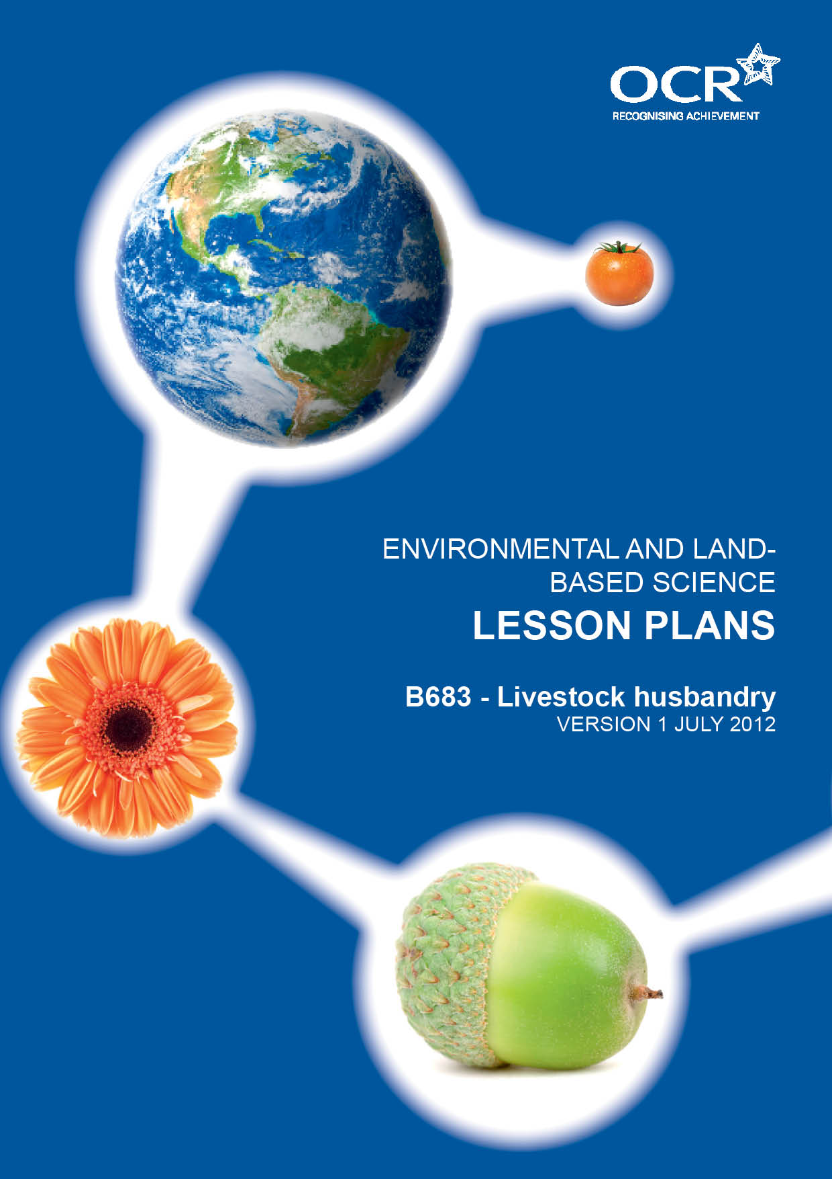
TWENTY FIRST CENTURY SCIENCE SUITE
SCHEMES OF WORK AND LESSON PLANS
C3: Chemicals in our lives
VERSION 1 JULY 2011
Introduction
OCR involves teachers in the development of new support materials to capture current teaching practices tailored to our new specifications. These support materials are designed to inspire teachers and facilitate different ideas and teaching practices. Each Lesson Plan is provided in Word format – so that you can use it as a foundation to build upon and amend the content to suit your teaching style and students’ needs.
The Lesson Plans provide examples of how to teach this unit and the teaching hours are suggestions only. Some or all of it may be applicable to your teaching.
The Specification is the document on which assessment is based and specifies what content and skills need to be covered in delivering the course. At all times, therefore, this Support Material booklet should be read in conjunction with the Specification. If clarification on a particular point is sought then that clarification should be found in the Specification itself. References to the content statements for each lesson are given in the ‘Points to note’ column.
PowerPoints, Worksheets and other resources can be found at the following website: www.elbs.info.
Lesson | Learning objectives | Lesson outline | Resources
1  LO1 | Candidates should understand:  - the purpose of husbandry is to keep animals healthy  - that animals need food, water and a suitable environment for good health. | Tour of the farm with an introduction to each animal. Students to make notes on the general husbandry requirements of pigs, sheep and cattle to include feed, water and housing.  Homework: Write up husbandry requirements for each animal.
2  LO2 | Candidates should know:  - how to recognise a healthy and unhealthy animal  - the health care strategies used in livestock husbandry aimed at preventing potential health problems  - the effects and risks of routine use of antibiotics to prevent disease and enhance growth. | Use line diagrams to label signs of a healthy and unhealthy animal.  Using the sheep as an example go through the annual routine health care to include dagging, foot trimming, spraying to prevent fly strike and worming.  Analysis of feed labels for poultry to show it contains antibiotics. Discussion of the need for antibiotics. | Line diagrams healthy and unhealthy animal.  Question sheets.  Feed labels containing antibiotics.
3  LO2 | Candidates should be able to describe:  - the care needed for pregnant animals and for new born animals including housing, diet and health care. | Case study of the pigs. Students should take every opportunity to study the pigs at each stage of the reproductive cycle from pregnancy to birth and care of the piglets.
4  LO3 | Candidates should know:  - how diseases caused by bacteria, viruses, fungi and parasites can be recognised. | Practical: Using model cow and fake udder students have a go at milking a cow to understand how bacteria can enter teats.  - Bacterial diseases affecting animals – mastitis  - External parasites affecting animals – louse  - Fungi - ringworm  Internal parasites affecting animals – intestinal roundworm  Discussion of animal diseases and how to recognise them.
5  LO5 | Candidates should know:  - the different forms of housing used for farm animals  - that animal housing should be dry, have adequate ventilation and be draught free  - the risks involved with inadequate housing and poor management of farm livestock. | Produce a plan of an animal house including all the features that make it suitable for keeping livestock in. | PowerPoint presentation of different animal housing.
6  LO5 | Candidates should know:  - the range of different types of food used with farm livestock. | Question and answer session to recap the constituents of a balanced diet.  Students to be shown examples of animal feedbags and labels of what they contain.  Use of printed animal feed label – students to stick them in their books and annotate them to explain the need for the different proportions of nutrients depending on the species of animal and the stage in their lifecycle. | AN 1a – Feed labels.  AN 1b – Food questions (Homework).  AN 1c – Healthy Eating questions.

Lesson | Learning objectives | Lesson outline | Resources
7  LO5 | Candidates should know:  - the difference between bulk and concentrate foods and an example of each  - the difference between the role of maintenance and production rations and an example of how each is used with farm livestock. | Students shown examples of different types of food stuffs and encouraged to brainstorm the uses of each to distinguish bulk and concentrate foods and maintenance and production rations.  Candidates will gain additional knowledge during stock duties. | Identify examples of foods used on the farm and classify them.
8  LO5 HD | Candidates should know:  - what is meant by a food conversion ratio and how it is calculated. | Use historical data from the turkeys calculate their F/C ratio.
9  LO6 | Candidates should know:  - the constituents of an animal’s diet: carbohydrates, proteins, fats, fibre and water; the importance of a balanced diet  - the importance of carbohydrates, proteins, fats, fibre and water in an animal’s diet; the role of vitamins (A, C and D) and minerals (Ca and Fe);  - the effects of a poor diet, to include deficiencies in fibre, vitamins (A, C and D) and minerals (Ca and Fe) and excesses of fats and carbohydrates  - high demand - how different livestock animals meet their dietary requirements, to include omnivores and ruminants. | Students to use feed labels to show what foods contain.  Produce a table to show the components of a balanced diet.  Use the internet, and their own knowledge, to identify on the table the role of each of the components.  Discussion about what happens if you eat too much carbohydrate or fat.  Compare what the pigs and poultry eat to what the cattle and sheep eat. Ask what happens if your dog eats grass – Why? | Feed labels.  Access to the internet.
10  LO7 | Candidates should know:  - the role of digestion in breaking down the food an animal eats into simpler molecules that it can use  - the functions of the main parts of the digestive system in a pig and a ruminant  - high demand - the differences between digestion in pigs and ruminants. | Revise what they know from core science that digestion is the breaking down of large insoluble molecules into smaller soluble ones.  How and why this happens.  Label a diagram of the pig and cows digestive system; identify the main functions of each part.  Compare the roles of ruminant in cattle and the stomach in pigs. How the organs and the microorganisms they contain enable the cow to digest grass.

Lesson | Learning objectives | Lesson outline | Resources
11  LO8 | Candidates should be able to:  - recognise and know the function of the main features of the male and female reproductive systems of a mammal: ovary, oviduct, testis, sperm ducts, uterus, vagina and penis  - know the signs that signify an animals on heat, ready to mate  - outline the process of gamete formation and fertilisation  - demonstrate knowledge of development and birth. | Use of the model cow with the stick on reproductive organs to show the position and explain the function of each organ. Explain the process of fertilisation and where this takes place.  Students to label diagram of the reproductive organs and mark where fertilisation occurs and where the embryo develops.  Practical: Students to produce a report detailing the breeding cycle of one of the farm pigs from putting the female to the boar through to weaning the piglets. | Model of a cows reproductive system with stick on organs.
12  LO8 HD | Candidates should know how:  - hormones control the timing of reproduction in animals  - the factors that influence hormone production. | Look at a diagram which shows how the major hormones change their proportions in the body during the reproductive cycle.  Compare animal with seasonal reproductive cycle such as the sheep discuss what might bring a sheep into season in the autumn, with a pig which breeds all year round. | Diagram showing the changing levels of hormones during the reproductive cycle in mammals.
13  LO9 | Candidates should know how:  the signs that signify that an animal is on heat, ready to mate; why it is important to recognise these signs. | Discuss the signs of heat in cattle and pigs.  The techniques used by famers to identify when an animal is on heat.  Why the farmer needs to know this both for AI and introducing the male.
14  LO9  14  LO9 HD | Candidates should know:  - the techniques used in artificial insemination and embryo transfer  high demand - how artificial insemination (AI) and embryo transfer are used in animal breeding, their advantages and the ethical and animal welfare issues involved. | Demonstration of AI straws for insemination of cattle and pigs. Use of catalogues to explain how farmers choose sperm.  Discuss the advantages and disadvantages of these techniques in the context of both intensive farming and maintaining rare breeds. | Powerpoint – AI and Embryo transfer.  AI straws and pig inseminator.
15  LO11 | Candidates should:  - know the meaning of the following genetic terms: gene, chromosome, phenotype, genotype, dominant, recessive, mutation and F1 in relation to breeding livestock. | Use the example of white face or being polled in Hereford cattle to demonstrate dominant characteristics, explaining in each case what would happen if the Hereford were crossed with another breed such as a Friesian which has black on its face and horns.  Use this example to draw out diagrams showing genotype and phenotype in each case. | Worksheet – Genetic terms mix and match.  Powerpoint – Genetics and breeding.  Powerpoint – Livestock breeding.

Lesson | Learning objectives | Lesson outline | Resources
15  LO11 HD | Candidates should be able to:  - apply the mechanism of simple monohybrid inheritance, where there are dominant and recessive alleles, to animal breeding. | Work through examples using the Punnet square method to determine genotype and phenotype.
16  LO12 | Candidates should know:  - cloning is an example of asexual reproduction  - use of cloning to produce many animals with the same desirable characteristics; the ethical issues concerning cloning  - high demand- the techniques of cloning to include nuclear transfer and implantation of the embryo; the risks and benefits of using cloning technology  - describe the uses and advantages of genetic engineering in breeding farm livestock. | Use the BBC bite size to look at cloning issues  http://www.bbc.co.uk/schools/gcsebitesize/science/21c/genes/cloning_stem_cellsrev3.shtml  Make note on the two methods of cloning.  Discuss the implications for agriculture to include rare breeds  Watch the CWF video on genetic engineering. Discuss the pros and cons of genetic engineering – point out that the video is produced by an organisation opposed to genetic engineering. | Internet access.  CWF video – genetic engineering.
17  LO13 | Candidates should know:  - animals are bred to improve yield, disease resistance, hardiness and conformation; the role of selective breeding to produce the characteristics of a named commercial breed of cattle, pig or sheep; how desirable characteristics have changed over time  - the meaning and importance of hybrid vigour; selective breeding can lead to inbreeding, which can cause health problems to animals  - high demand - how selective breeding can reduce genetic variation, and the role of rare breeds in maintaining a wide genetic base (gene pool); why certain breeds have fallen in popularity over time and why it is considered important to preserve these rare breeds. | Judge the sheep.  Compare modern chickens both meat and egg producing hybrids with the characteristics of jungle fowl.  Discuss how these changes have been achieved.  Discuss why many commercial breeds of poultry and pigs are hybrids rather than pure breeds. Relate to the differences between mongrel dogs and many highly bred pedigrees. | Worksheet - Selective  breeding in livestock animals.

Lesson | Learning objectives | Lesson outline | Resources
18  LO13 | Candidates should know:  - the role of rare breeds in maintaining a wide genetic base  - why certain breeds have fallen in popularity over time  - why it is considered important to preserve these rare breeds. | Comparison of our Tamworth pigs with modern hybrids and the advantages and disadvantages of each breed.  Discuss the role of rare breed s as genetic reservoirs.  How / why rare breeds are gaining in popularity.  Role of RBST Use ARK magazine _ Rare breeds survival trust to show how they are being preserved. | Candidates should know:  - The role of rare breeds in maintaining a wide genetic base  - why certain breeds have fallen in popularity over time  - why it is considered important to preserve these rare breeds.
18  LO4 | Candidates should know:  - the advantages and disadvantages of intensive and extensive systems of livestock management  - the ethical and animal welfare issues related to the intensive and extensive management of livestock.  - high demand- how analysis of economic and environmental factors has been used in discussions about intensive and extensive systems of livestock management. | Students brainstorm ways in which animals are kept for food.  Students to work in small groups using the laminated cards and sort them into acceptability.  Students to watch introductory video Farm Animals and Us (20 mins) and answer questions.  Students briefly consider whether they wish to change any of their cards and then the class discuss issues raised on the video.  Students to read pages 2, 3, 14, 15 of the booklet. On the sheet provided they should make a general comparison between extensive and intensive farming to include the advantages and disadvantages of each.  Students to watch video Farm Animals and Us – 2 either in sections or as a whole and answer questions as appropriate. Use of booklet pages 6-11 to read and discuss issues as appropriate. | Card-sort activity  Video (compassion in world farming)  Video questions  Intensive Farming and Welfare of Farm Animals booklets  Video questions  Laminated sheets on Jail Birds  Past exam question  Pig Farming question (homework)  Poultry Farming question (homework).
19  LO10 | Candidates should know:  - the structures of milk producing organs in mammals  - the factors that influence milk production  - the main features of the lactation curve and how the principal components of milk differ during lactation. | Label a diagram of a cow’s milk producing organs.  Use diagrams of changes in quantity and quality of milk throughout the lactation.  Relate this to the needs of the growing calf. | Diagram to label.

Lesson | Learning objectives | Lesson outline | Resources
20  LO14 | Candidates should know:  - how to approach a farm animal safely  - how to move a large animal around the farm safely  - the importance of handling livestock animals in the correct manner and the hazards of poor handling, including disease (tetanus, salmonella), parasites, being hurt; the ways these hazards may be reduced. | Using the boar or large sow as an example demonstrate how to approach the animal, how to get them to follow you using a bucket and the use of a pig board. If possible this should be combined with moving the pigs using the trailer.  .
21  LO14 HD | Candidates should know:  - the basic requirements for moving livestock beyond the farm, including legal requirements. | Use DEFRA advise documentation to identify the key points.  Candidates to fill in for imaginary journey. | Movement documentation for cattle sheep or pigs.
22  LO14 | Candidates should know:  - how to weigh large animals safely  - why weighing is an important management tool. | Use the weigh crate to weigh weener pigs. Compare this with using a weigh band to weigh larger pigs or cattle. | Video on how to weigh a pig.
23 | End of unit test.

