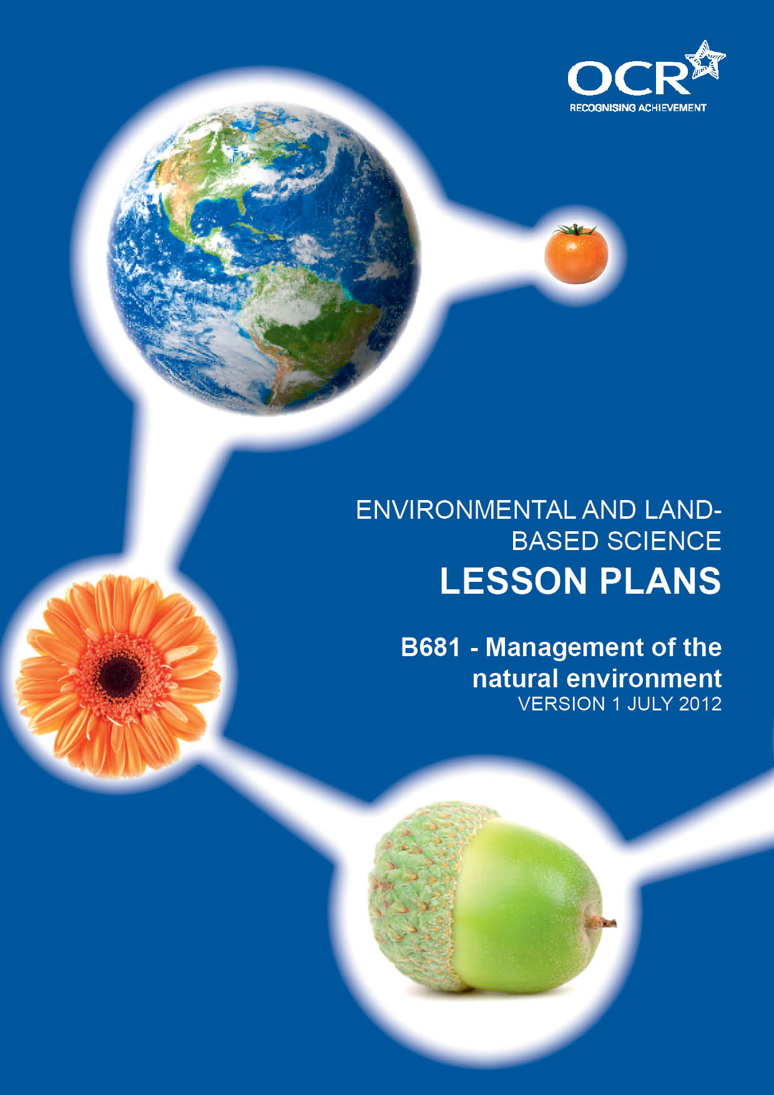
TWENTY FIRST CENTURY SCIENCE SUITE
SCHEMES OF WORK AND LESSON PLANS
C3: Chemicals in our lives
VERSION 1 JULY 2011
Introduction
OCR involves teachers in the development of new support materials to capture current teaching practices tailored to our new specifications. These support materials are designed to inspire teachers and facilitate different ideas and teaching practices. Each Lesson Plan is provided in Word format – so that you can use it as a foundation to build upon and amend the content to suit your teaching style and students’ needs.
The Lesson Plans provide examples of how to teach this unit and the teaching hours are suggestions only. Some or all of it may be applicable to your teaching.
The Specification is the document on which assessment is based and specifies what content and skills need to be covered in delivering the course. At all times, therefore, this Support Material booklet should be read in conjunction with the Specification. If clarification on a particular point is sought then that clarification should be found in the Specification itself. References to the content statements for each lesson are given in the ‘Points to note’ column.
PowerPoints, Worksheets and other resources can be found on the following website: www.elbs.info.

Lesson 1 and 2 – Understanding Ecosystems
Lesson aims | Understand what makes an ecosystem and the factors that may affect ecological relationships.
Learning outcomes: by the end of the lesson Candidates should:- | LOW DEMAND G - D  State what makes an Ecosystem  Describe factors that affect:-  - habitat  - climate  - soil  - organisms.
STANDARD DEMAND C - B
Describe the characteristics of the major types of ecosystem in the UK to include:-
- deciduous and coniferous woodland
- meadows, ley grassland, wetland and moorland.
Explain (using examples) of how animals and plants are supported in these ecosystems.
HIGH DEMAND A – A*
Explain using two of the major UK ecosystems in terms of the ecological relationships between plants and animals and their non-living surroundings.
Illustrate in detail a study of a food web.
Suggested lesson details and activities: | Starter: Show pictures of meadows ancient and new, woodland, wetland etc. Ask candidates to look at pictures what are the main characteristics of each? Why does each ecosystem have these particular characteristics? Candidates can write their answers on show me boards.  Main: Split class up into groups, give each group an ecosystem. Candidates produce a poster outlining the main characteristics of their given ecosystem. Poster should include characteristics, animals contained within that ecosystem and a detailed food web to include energy flow, abiotic factors and biotic factors that affect the ecosystem ask pupils what does it mean? Give candidates various pictures of ecosystems mentioned above. In groups candidates discuss the different characteristics within each ecosystem. What factors are involved eg, soil type, climate, (abiotic/biotic)? How do these factors affect the ecosystem? The difference between Natural and artificial ecosystems; fish farms and greenhouses, intensive/organic farming.  Plenary: Groups move around class looking at posters and peer assessing poster presentation.  Homework: Compare farming methods in other countries for example, where there is intense heat/cold, lack of water.
Suggested resources: | Understanding Ecosystems Powerpoint  Ecosystems Pictures  Peer assessment worksheet

Lesson 3 – Distribution of organisms
Lesson aims | Understand how abiotic factors affect the distribution of organisms within ecosystems.
Learning outcomes: by the end of the lesson Candidates should:- | LOW DEMAND G - D  Describe how climate can influence the distribution throughout the UK of Organisms. For example the growing seasons in the North of the UK are shorter than those in the South.
STANDARD DEMAND C - B
Link how abiotic factors and human activity can affect micro-climates, including planting hedgerows and trees
HIGH DEMAND A – A*
Discuss the ways that human activity can impact on organisms, so changing the balance of plant and animal populations in an ecosystem.
Suggested lesson details and activities: | Starter: Brainstorm pupils as to what ABIOTIC/BIOTIC FACTORS are? E.g. Temperature, Weather, etc. discuss how temperature within the UK can affect growing seasons – North: shorter growing season and South; longer warmer growing season. This is linked to tomato growth lesson.  Main: Possible use of ICT. Split into groups, each group having a specific type of growing system they need to research. Pupils to come up with how that growing system is affected by the abiotic factors mentioned. Link abiotic factors and human activity such as farming, forestry into growth in organisms. The growth of monocultures, fish farms could be examples used. Mention that field margins strips at the edge of fields are used to encourage rare species when planting crops. Beetle banks to encourage detritivores, and saprophytes also to encourage wild birds that feed on insects. Discuss bottom feeder detritivores, used in fish farms, planting hedgerows; this could be as a buffer for railway track and field boundaries.  Plenary: Pupils present their findings to rest of class as a powerpoint presentation and discuss with each group how each system differs.
Suggested resources: | Distribution of organisms Powerpoint

Lesson 4 – Food webs and energy transfer
Lesson aims | Understand the trophic levels of food chains, food webs and how energy is transferred at each level.
Learning outcomes: by the end of the lesson Candidates should:- | LOW DEMAND G - D  Illustrate the inter-relationships between plants and animals in the food web.
STANDARD DEMAND C - B
Describe how energy is lost between trophic levels; the concept of energy transfer in a food chain; pyramids of biomass and energy in animal and plant production systems.
HIGH DEMAND A – A*
Explain the management of food chains and food webs to increase the output of agricultural and horticultural systems; how intensive production improves the efficiency of energy transfer.
Suggested lesson details and activities: | Starter: Brainstorm Energy where does energy come from; get pupils to give an example of a food chain.  Main: Investigate energy in a food chain, give pupils equipment and get them to design an investigation into desiccant energy within an animal or plant. How does this relate to the weight/energy of the live plant/animal. Pupils are to include prediction, plan of investigation, results, evaluation and conclusion.  Plenary: Whole class discussion of results. Are there any trends to be identified?
Suggested practicals: | Pupils investigate the dry mass of an animal or plant compared to the wet mass  Worksheet  Live plants/animals  Dry plants/animals  Balance  Graph paper.
Suggested resources: | Food webs and energy transfer Powerpoint  Food web mobile Worksheet

Lesson 5 – Monitoring environments using ICT
Lesson aims | Understand how Environments are monitored using ICT
Learning outcomes: by the end of the lesson Candidates should:- | LOW DEMAND G - D  State why it is important to monitor and keep records of environmental conditions (level D).
STANDARD DEMAND C - B
Investigate how ICT and technology can be used to monitor and record environmental conditions.
HIGH DEMAND A – A*
Explain the advantages of the use of ICT and technology in monitoring and recording environmental conditions.
Suggested lesson details and activities: | Starter:  Brainstorm the question ‘Why should we monitor the environment?’ get pupils thinking about pollution, give examples of oil spills, DDT in food chains, soil pollutions, rainfall amounts related to floods, species diversity and losses connected with these factors.  Main:  Split class up into groups and give each group an investigation to carry out.  Investigation 1, dust on walls  Cut off a short length of sellotape about 8 cm long.  Place the sticky side of the sellotape against a wall outdoors and press it gently  Hold the selloptape against a sheet of white paper and note down how much dust it has picked up.  Use a hand lens or microscope to examine in more detail.  Repeat the experiment on other walls in different places.  Create a table and graph of your results using ICT.  Suggest reasons why some of the walls may be dirtier than others.  Investigation 2, Dust in the environment.  Using the plates containing agar jelly place them in different places out of doors. (make sure they are in a safe place that won’t be disturbed)  Leave the plates in position for a couple of days but monitor them carefully.  After a couple of days look at the effects, use a hand lens or microscope to see how dense any particles of dust are.  Create a table and graph of your results using ICT.  Suggest reasons why some of the plates may be dirtier than others.  How would you carry out a larger scale survey?  Investigation 3, Pollution in rainwater  Set up a jar with a funnel and filter paper.  When it is raining place the jar outside for a day.  Examine the filter paper for particles of dust that have been brought down with the rain.  Using universal indicator measure the pH of the rainwater in the jar.  Create a table and graph of your results using ICT.  Suggest reasons why some of the water may have a different pH than others.  If the air was very polluted the water may be acidic, suggest reasons for this.  Research the rest of the country for water pH.  Make a list of as many harmful effects of acid rain as you can think of.  Investigation 4, Measuring noise levels in different areas  Using a sound meter measure and record the minimum and maximum noise levels in different places.  Note down the times of day or night that you take the readings.  Create a table and graph to compare your results.  Look at the table to compare your results.  How could you find the average noise level in a particular place?  Plenary: Present class results from the different investigations carried out.  Suggest other ways that ICT could be used apart from generating tables and graphs to monitor environmental conditions.
Suggested practicals and equipment: | Investigations 1,2,3,4, Computers  Hand lens, Microscope, filter paper, jars, funnels, sellotape, sound meters, agar plates, universal indicator. Use of computers.
Suggested resources: | Monitoring environments using ICT Powerpoint

Lesson 6 – The formation of soil and landscapes
Lesson aims | Understand the levels of the formation of soil and how this affects the landscape.
Learning outcomes: by the end of the lesson Candidates should:- | LOW DEMAND G - D  State how weathering, erosion and deposition are involved in the formation of soil and landscapes.
STANDARD DEMAND C - B
Describe how plants, animals and rock type may affect the formation of soil and landscapes.
HIGH DEMAND A – A*
Explain ways in which the impact of human activity can affect the landscape to include ways of managing soil erosion.
Suggested lesson details and activities: | Starter: Brainstorm what pupils think of when they hear the word LANDSCAPE. How does the landscape form?  Main: Use power point to explain some of the key terms of how soil is formed. Pupils can then use pictures to form their own flow diagram explaining how soil is formed from pioneer species through to woodland climax community.  Plenary: Answer exam style questions on last slide of power point.  Homework: Pupils to choose and area and investigate how that area got to the stage that it is now. They must include any Human intervention such as farming, woodland management, erosion.
Suggested resources: | The formation of soil and landscapes Powerpoint  The formation of soil and landscapes Worksheet

Lesson 7 – Biodiversity within habitats
Lesson aims | Understand the Biodiversity within habitats both natural and artificial
Learning outcomes: by the end of the lesson Candidates should:- | LOW DEMAND G - D  State how biodiversity is the variety of different species living in a habitat.
STANDARD DEMAND C - B
Describe the differences in biodiversity in natural and artificial ecosystems.
HIGH DEMAND A – A*
Explain the reasons for the differences in biodiversity in different ecosystems.
Suggested lesson details and activities: | Starter:  Explain that  - Biodiversity is the degree of variation of life forms within a given ecosystem.  - Biodiversity is a measure of the health of ecosystems.  - Biodiversity is in part a function of climate.  - In terrestrial habitats, tropical regions are typically rich whereas polar regions support fewer species. Show pictures of different habitats for example ocean, farming and arctic. Pupils to give five examples of diversity within each ecosystem. Linked to ecosystem and the number of species that ecosystem can support naturally.  Main:  Give examples to pupils of natural and artificial ecosystems and what can affect the particular ecosystem. ie salmon farms vs natural salmon rivers. Get pupils to spot the diversity of plants/animals. In agriculture growing monocultures vs diversity of producing a variety of crops that encourages natural pollination from bees. Pupils then produce a poster outlining the biodiversity within their chosen habitat. They must include factors that support the biodiversity and also factors that can affect the biodiversity of that ecosystem.  Plenary:  Pupils present their posters to rest of group, these can be judged by others in class.
Suggested resources: | Biodiversity within habitats Powerpoint  Peer assessment sheet

Lesson 8 – Sampling techniques
Lesson aims | To understand that different sampling techniques are required when investigation the distribution of species.
Learning outcomes: by the end of the lesson Candidates should:- | LOW DEMAND G - D  Describe how measures of species’ distributions and population size, and the diversity of communities, are estimates based on samples.
STANDARD DEMAND C - B
Explain the use of sampling techniques, including quadrats, to establish species’ distributions and population size, and the diversity of communities.
HIGH DEMAND A – A*
Make connections between how estimates of species’ distributions and population size, and the diversity of communities, depend upon the way in which samples are taken.
Suggested lesson details and activities: | Starter: Ask pupils what organisms live where? How do we know?  Main: Show pupils the different pictures of the different sampling tools used. Ask them to name the type of organism it each catches. Confirm with pupils and explain how each one is used.  Pupils then plan a detailed investigation to sample an area available to them. Explain that the investigation must have a:  - prediction  - list of apparatus  - method  - results table and graph  - conclusion  - evaluation  - Risk assessment  Ask pupils to come up with any factors that could influence the investigation such as weather conditions, temperature on the day. Would they obtain different results if these factors were different on different days?  Pupils to then present their investigation in poster form to rest of class.  Plenary: Class could discuss with other groups their finding if different.  If no areas are available for sampling pupils use worksheet for lesson 8 looking at organisms in leaf litter.
Suggested practicals: | Organisms in leaflitter Worksheet
Suggested resources: | Pitfall traps  Sweep nets  Pooters  Longworth traps  Beating trays  Tullgren funnel  Poster and Graph paper  Possible IT links to carry out data presentation.  Sampling techniques Powerpoint

Lesson 9 – Investigating soils
Lesson aims | Soil testing. Pupils investigate the different components of different soils. Understand the need to know the pH of soils, how well soils drain, the water content of soils and the lime content within soils. Pupils can also investigate the organic content within soils.
Learning outcomes: by the end of the lesson Candidates should:- | LOW DEMAND G - D  State reasons why Soil is tested.
STANDARD DEMAND C - B
Describe the types of soil used in planting crops.
HIGH DEMAND A – A*
Explain why it is important to carry out investigations into soil to determine its type.
Suggested lesson details and activities:
Suggested practicals: | Starter: Recap on how soil is formed. Ask pupils how many layers of soil do they think there are? Go through the different layers of soil i.e topsoil, formed by surface weathering and organism activities also decaying remains of dead organisms also may be covered in leaf litter. Subsoil formed beneath the topsoil, lighter in colour made up of gravel, stones clay, contains deeper roots of large plants and trees nothing more lives there. Further down is rock non porous and won’t left water through so tends to gather above it this surface water is referred to as the water table. These layers can vary greatly depending on where the place is.  Main: Explain that soil has six main components - Rock, soil water, humus, mineral salts, lime and air. Pupils design a series of investigations to look at components of the soil, drainage, water content, humus, pH, lime and air.  Investigation 1 separating components worksheet  Investigation 2 how well do types of drain?  Investigation 3 water content in soil.  Investigation 4 humus in soil.  Investigation 5 pH levels in soil.  Investigation 6 lime content in soil.  Pupils must include:-  - planning within their investigation  - apparatus and method  - results table and graph  - evaluation and conclusion  - risk assessment.  Plenary: Discuss results of investigations with rest of class.
Suggested resources: | Various soil samples, Measuring cylinders, funnel, filter paper, test tubes, barium sulphate, hydrochloric acid, pH scale, universal indicator, spatulas, test tube rack, Bunsen burners, crucibles, stop clocks, balances.  Investigating Soils Powerpoint  Investigating Soils Worksheets 1-6

Lesson 10 – The role of earthworms in soil
Lesson aims | Understand how the earthworm improves the soil and plan and carry out and investigation to the different types of earthworms in the UK.
Learning outcomes: by the end of the lesson Candidates should:- | LOW DEMAND G - D  State the role of earthworms in improving soil structure and fertility.
STANDARD DEMAND C - B
Describe how living organisms in the soil require supplies of air and water.
HIGH DEMAND A – A*
Explain how human activity (to include cultivation, use of organic matter and drainage) can affect the structure of the soil and its fertility.
Suggested lesson details and activities: | Starter: Pupils come up with at least 5 facts about earthworms  Main: Explain to pupils the role that earthworms have in the fertility of soil.  Pupils to carry out an investigation into the types of earthworms found in soils. Pupils need to plan their investigation including an hypothesis, prediction, apparatus, method, results table and graph, evaluation and conclusion. Identify each earthworm found using the OPAL identification key.  Plenary: Ask pupils if their results relate to their prediction did they find other organisms. From their knowledge of earthworms how does earthworm activity help with human activity in growing crops and to improve soil structure.
Suggested practicals: | Earthworm investigation, Tray, water, spade, detergent such as fairy liquid.
Suggested resources: | The role of earthworms in soil Powerpoint  OPAL identification key

Lesson 11 – pH in soils
Lesson aims | Understand that the pH content in soil is an important factor when growing plants. It can determine the yield of a crop and the cation exchange within the soil.
Learning outcomes: by the end of the lesson Candidates should:- | LOW DEMAND G - D  carry out pH tests on soil and why these are important
STANDARD DEMAND C - B
Describe the importance of pH in determining the plants which can be grown and the yields obtained; the effects of lime on cropping, including provision of calcium.
HIGH DEMAND A – A*
Explain the effects of lime and pH on mineral availability and flocculation in the soil.
Suggested lesson details and activities: | Starter: Ask pupils what they know about soil pH. What is extreme acid, alkali and neutral? What are the colours of the scale?  Main: Explain to pupils that the acidity or alkalinity of a soil is important in order for plants to grow. Some plants grow better in acid soils eg heathers and some grow better in alkali soils eg carnations. Explain to pupils about cation exchange and the differences in pH of soils.  Investigation worksheet 5 pH in soil could be used (linked with lesson 9) this looks at the pH of 3 or more different soil types and the pH levels contained in them.  Pupils must Include:  - planning within their investigation  - apparatus and method  - results table and graph  - evaluation and conclusion  - risk assessment.  Plenary: Discus with class their results, how could these be improved?  Homework: There is a competition at the local allotment society and Mr Parsnip always wins with his enormous carrots and broccoli, he claims it is to do with the pH in his soil. You have been asked by the soil association to investigate which soil pH is best suited when growing these particular crops.  Your article should include:-  ₋ pH ranges in the different soil types.  - Which crops grow best in certain pH soils.  - How to improve pH ranges in some soils to obtain optimum growth of crops.
Suggested practicals: | pH in soils Investigation  Test tubes, test tube racks, distilled water, barium sulphate, universal indicator, pH scale.
Suggested resources: | pH in soils Powerpoint  pH in soils Worksheet

