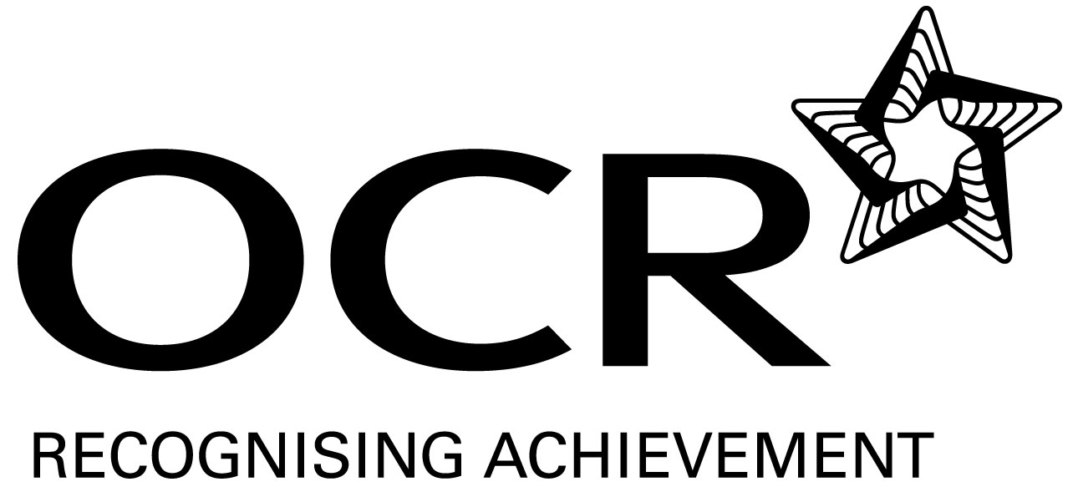
Sample Schemes of Work and Lesson Plans
GCSE English Language
OCR GCSE in English Language: J355
Unit A652: Section B – Spoken language

This Support Material booklet is designed to accompany the OCR GCSE English Language specification for teaching from September 2010.

Contents
Contents 2
Introduction 3
Sample Schemes of Work: OCR GCSE in English Language Unit A652: Section B – Spoken language 5
Sample Lesson Plan: OCR GCSE in English Language Unit A652: Section B – Spoken language 11

Introduction

Background
Following a review of 14 – 19 education and the Secondary Curriculum Review, the Qualifications Development Agency (QCDA) has revised the subject criteria for GCSEs, for first teaching in September 2009. This applies to all awarding bodies.
The new GCSEs have more up-to-date content and encourage the development of personal, learning and thinking skills in your students.
We’ve taken this opportunity to redevelop all our GCSEs, to ensure they meet your requirements. These changes will give you greater control of assessment activities and make the assessment process more manageable for you and your students. Controlled assessment will be introduced for most subjects.
OCR has produced a summary document, which summarises the changes to English Language. This can be found at www.ocr.org.uk, along with the new specification.
In order to help you plan effectively for the implementation of the new specification we have produced these Schemes of Work and Sample Lesson Plans for English Language. These Support Materials are designed for guidance only and play a secondary role to the Specification.

Our Ethos
OCR involves teachers in the development of new support materials to capture current teaching practices tailored to our new specifications. These support materials are designed to inspire teachers and facilitate different ideas and teaching practices.
Each scheme of work and set of sample lesson plans are provided in:
- PDF format – for immediate use
- Word format – so that you can use it as a foundation to build upon and amend the content to suit your teaching style and students’ needs.
The Scheme of Work and sample Lesson plans provide examples of how to teach this unit and the teaching hours are suggestions only. Some or all of it may be applicable to your teaching.
The specification is the document on which assessment is based and specifies what content and skills need to be covered in delivering the course. At all times, therefore, this support material booklet should be read in conjunction with the specification. If clarification on a particular point is sought then that clarification should be found in the specification itself.

A Guided Tour through the Scheme of Work

= Innovative Teaching Idea
This icon is used to highlight exceptionally innovative ideas.


= ICT Opportunity
This icon is used to illustrate when an activity could be taught using ICT facilities.

OCR GCSE in English Language Unit A652: Section B – Spoken language
Suggested teaching time | 15 hours plus 1 | Topic | A2: The study of the spoken language of a particular interviewer
Topic outline |  | Suggested teaching and homework activities |  | Suggested resources | Points to note
Identifying the features of interviews |  | - Use the selected clips to explore all the various features of interviews and how the way they are used impacts on the audience  - Consider how the interview is structured; the use of pre-planned and follow-up questions to direct the interview; the use and impact of open and closed questions; how the interviewer supports and challenges the interviewee and the impact that has on the interviewee and the listener; the use and impact of pace and pause and body language if the text is visual  - Eg Newsnight – Dizzee Rascal interview (on Youtube) could focus on:  - exploring independently different aspects, possibly through guided group work  - how the interview is structured & the use of pre-planned and follow-up questions, as well as the impact of technology to facilitate an interview between people in three different locations |  | - Martin Bashir’s Interview of Diana Princess of Wales: http://www.youtube.com/watch?v=wT6sov__8wY  - John Humpries from the Today Programme Archive: http://news.bbc.co.uk/today/hi/today/newsid_7392000/7392367.stm  - Kirsty Young, Desert Island Discs: http://www.youtube.com/watch?v=ONhK9IgWCoI&feature=related  http://breeze.bucksgfl.org.uk/p41793598/  - Transcripts of interviews | - There is a vast array of possible resources for this unit available on the internet; the choice of interviewer and subject should be made by the teacher using his/her professional judgement with regard to suitability and interest for the particular teaching group. The key issue is to explore contrasting interview styles  - NB: some websites eg You Tube may be blocked by school networks  - Comparing and contrasting the different interview styles can help students help students identify impacts
 |  | - key features of interview technique, eg establishing rapport, use/impact of open & closed questions, how interviewer supports/challenges interviewee
Talking about spoken language |  | - Model to the students how to talk about their analysis of the interviewer's styles  - In pairs students put together a presentation based on one of the interviewers they have studied as a class |  | - Students may need a worksheet to help them organise their thoughts
Research and preparation |  | - In pairs or groups students study and analyse an interview or interviews by one of the named interviewers  - Pupils prepare notes or equivalent for the controlled assessment task |  | - Video/audio clips of interviews by the named interviewers  - Transcripts of interviews  - Students may benefit from a worksheet grid in which they can record the different features, examples of those features and the impact on the audience | - How students have access to the clips will depend on the resources available in the centre. Ideally individuals or groups would have access to a laptop in order to play and replay the relevant clips

OCR GCSE in English Language Unit A652: Section B – Spoken language
Suggested teaching time | 15 hours plus 1 | Topic | A2: The study of the spoken language of a particular interviewer
Topic outline |  | Suggested teaching and homework activities |  | Suggested resources | Points to note
Controlled assessment task |  | - Pupils complete the controlled assessment task – written task – up to 1000 words |  | - Access to ICT facilities for visual/audio and/or written transcript(s) | - The Centre might prefer to refine the task into a question form

OCR GCSE in English Language Unit A652: Section B – Spoken language
Suggested teaching time | 15 hours plus 4 | Topic | B3 Language and society (with group activity)
Topic outline |  | Suggested teaching and homework activities |  | Suggested resources | Points to note
Introduction to “Restricted Code” and “Elaborated Code” |  | - Ask students what groups they consider themselves to be members of (social, school, family, sports etc)  - Identify words/phrases/references that they use when with members of that group which would not be understood by people outside the group  - Classify the different types of language eg technical terminology; specialist language; abbreviated references to shared events or ideas  - Identify the reasons for the different types of language: to be precise; to convey complex ideas; as ‘shorthand’  - Discuss the ideas of inclusion and exclusion: how do they feel when they are in a group using language/references that others don’t understand? Can they think of times when they have deliberately used language to exclude other people? (eg slang, ‘code’ words)  - Introduce the term ‘restricted code’ (NB the word ‘restricted‘ does not suggest deficiency) |  | - Teacher resource:  - http://www.doceo.co.uk/background/language_codes.htm  provides more detail on restricted and elaborated codes  - Google e-books allow free access to various relevant texts on spoken language | - Bernstein’s theory associated the different codes with classes. We are using the terminology only to describe the language styles  - Key Words:  - emotive language  - lexis  - register  - rapport  - non-verbal signs  - ‘filler’ words/phrases  - intonation
- When might it be appropriate to use a restricted code?
- Introduce and explain the term ‘elaborated code’ When might it be appropriate to use elaborated code?
Shared analysis of spoken text |  | - As a class, identify and analyse the features of the group talk. How does it fit with the ideas of restricted and elaborated codes? What are the features? What is their purpose? How have they evolved? |  | - Video/audio clips/transcripts of one occupational or social group | - If access is available, students could work in small groups with their own copies of the clips on laptops
Writing about spoken language |  | - Model and practise writing about the analysis of group talk |  | - Transcripts of spoken texts for reference | - Students will probably need to be shown the conventions of quoting from transcripts
Individual/pair investigation |  | - Pairs/small groups independently analyse the talk of a group of their own choice. This could be from a selection provided by the Centre or from students’ research |  | - Clips and transcripts of spoken language from a range of occupations

OCR GCSE in English Language Unit A652: Section B – Spoken language
Suggested teaching time | 15 hours plus 4 | Topic | B3 Language and society (with group activity)
Topic outline |  | Suggested teaching and homework activities |  | Suggested resources | Points to note
Reflection on own speech |  | - Discuss the features of group speech evident in their discussions. Are they appropriate to the context? How does the fact of having an audience (the assessor) affect what is appropriate? |  | - Video/audio recording of students in discussion – from the group activity for Speaking and Listening controlled assessment | - This activity could take place before this unit and students could reflect on how they might change/develop their speech or could be a part of the unit, with students focussing on working in either restricted or elaborated code as appropriate
Controlled assessment task |  | - Students complete the controlled assessment – written task – up to 1000 words |  | - Access to ICT facilities for visual/audio and/or written transcript(s) | - The Centre might prefer to refine the task into a question form, eg How do particular occupational groups speak? Why is this? How is this reflected in your own group speaking?

OCR GCSE in English Language Unit A652: Section B – Spoken language

Introduction to Group Language
OCR recognises that the teaching of this qualification above will vary greatly from school to school and from teacher to teacher. With that in mind this lesson plan is offered, as a possible approach but will be subject to modifications by the individual teacher.
Lesson length is assumed to be one hour.

Learning Objectives for the Lesson
Objective 1 | To understand that different groups of people use language to include/exclude others
Objective 2 | To understand the concept of ‘restricted code’

Recap of Previous Experience and Prior Knowledge
- This is an introductory lesson for the unit.

Content
Time | Content
5 minutes | Watch the QI video on Cockney Rhyming slang (available on You Tube: http://www.youtube.com/watch?v=9ak5vYS0tvg 2 mins 32 secs)  Identify the structures ie that the slang must have two parts (eg plates of meat), the first is spoken, the second is the rhyme that gives the clue to the item being referred to
10 minutes | Group activity: in pairs, students design some rhymes relevant to school (eg Bill and Ben – pen) and practice a dialogue.  Pairs join in groups of 4 and try out their new slang on each other.
5-10 minutes | Feedback session: what did students learn about this kind of slang? (easiest if word being referred to is 1 syllable; only works if the person you’re speaking to already knows what you’re referring to)
10 minutes | Introduce the term ‘restricted code’ (see http://www.doceo.co.uk/background/language_codes.htm) and explain its meaning.  Watch the MSU film on Cockney rhyming slang (available on You Tube: http://www.youtube.com/watch?v=DHclbalPoi8 1 min 20)  Key message: CRS was used to stop other people (the police) understanding what was being said.
10 minutes | Pair activity: identify examples of restricted code that they use/ know of, eg ‘shortcuts’ that are used within their family/ friendship groups.  Feedback to class

Consolidation
Time | Content
5 minutes | Identify examples of groups (social or occupational) who are known for using restricted codes eg lawyers, doctors, surfers, groups associated with types of music etc
10 minutes | Discuss the reasons for using restricted code – draw out  For accuracy (technical language)  As ‘shorthand’  To create a sense of identity/ include  To exclude others

OCR GCSE in Spoken Language: the Language of an interviewer

Lead and follow up questions
OCR recognises that the teaching of this qualification above will vary greatly from school to school and from teacher to teacher. With that in mind this lesson plan is offered, as a possible approach but will be subject to modifications by the individual teacher.
Lesson length is assumed to be one hour,

Learning Objectives for the lesson

Objective 1 | To understand how questions are used to structure and shape an interview

Recap of previous experience and prior knowledge
This is an introductory lesson

Content
Time | Content
5 minutes | Ideally, show a montage of short clips from different types of interviews to remind learners of the range of styles of interview. As a class, create a list of the different purposes of interviews eg for entertainment – a comedian on a chat show is likely to launch into a ‘routine’ whereas a politician on the radio is likely to be cross questioned about policies etc.
10 minutes | Group activity: provide groups of 3 learners with a list of 5 ‘interview’ questions; these questions should be about themselves and ones which they can readily answer. Each member takes a role – interviewer, interviewee and observer. Interviewer reads the questions and interviewee answers.
10 minutes | Take feedback from the observers about the interview – did it seem comfortable? Fluent? Why? Why not? [depending on the class, one pair could present the role play to the rest of the group and the class as a whole could discuss it]
15 minutes | Look at an entertainment interview (Michael Parkinson is good for this) along with a transcript. Which questions were planned in advance? Which are spontaneous follow up questions? How can you tell (what is the difference) between them? What is the function of each type of question?
10 minutes | Go back to the role play activity. This time the interviewer must add in spontaneous follow-up questions. If time, swap roles.
10 minutes | Plenary: take feedback from the observers – how were the interviews different this time? Take feedback from the interviewees – did this interview feel different? How? Why? Take feedback from the interviewers – was this easier or more challenging than the first interview? Why? What did you have to do differently?

