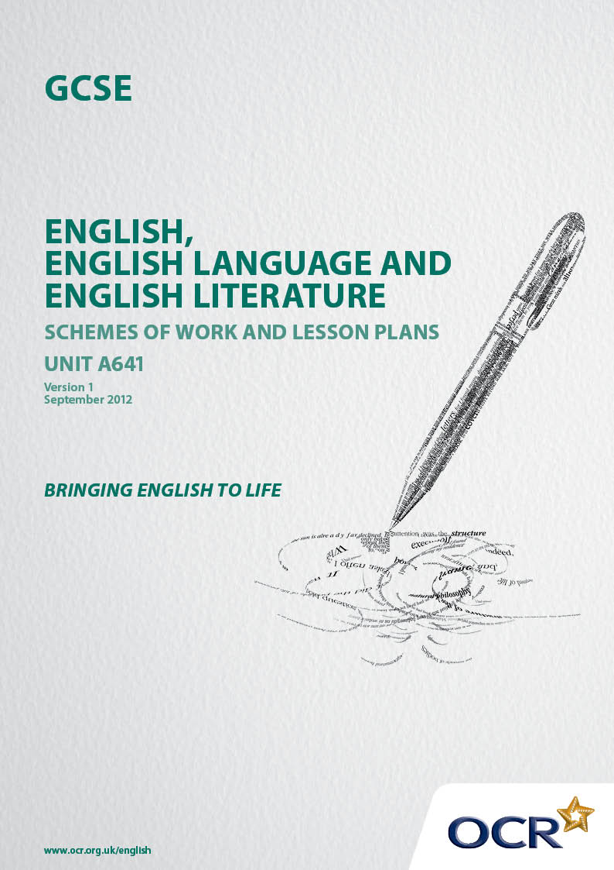
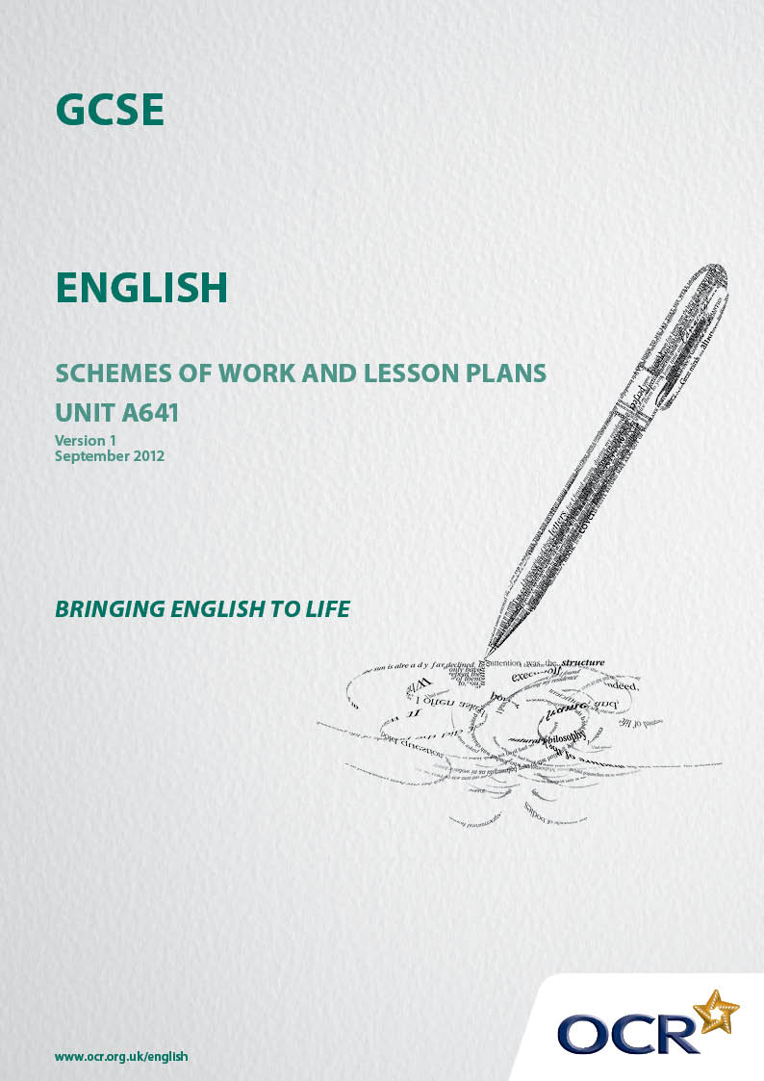

Contents
Contents 2
Introduction 3
Sample Scheme of Work: GCSE English J350 Unit A641 Reading Literary Texts 5
Sample Lesson Plan: GCSE English J350 Unit A641 Reading Literary Texts 8

Introduction

Background
Following a review of 14 – 19 education and the Secondary Curriculum Review, the Qualifications and Curriculum Development Authority (QCDA) has revised the subject criteria for GCSEs, for first teaching in September 2010. This applies to all awarding bodies.
The new GCSEs have more up-to-date content and encourage the development of personal, learning and thinking skills in your students.
We’ve taken this opportunity to redevelop all our GCSEs, to ensure they meet your requirements. These changes will give you greater control of assessment activities and make the assessment process more manageable for you and your students. Controlled assessment will be introduced for most subjects.
From September 2012, assessment tasks may be undertaken at any point between release of the task and the examination series for which the task must be submitted. Centres must ensure that candidates undertake a task that is valid for submission in the year in which the candidate intends to submit it.
OCR has produced a summary document, which summarises the changes to English. This can be found at www.ocr.org.uk, along with the new specification.
In order to help you plan effectively for the implementation of the new specification we have produced these Schemes of Work and Sample Lesson Plans for English. These Support Materials are designed for guidance only and play a secondary role to the Specification.

Our Ethos
OCR involves teachers in the development of new support materials to capture current teaching practices tailored to our new specifications. These support materials are designed to inspire teachers and facilitate different ideas and teaching practices.
Each Scheme of Work and set of sample Lesson Plans is provided in Word format so that you can use it as a foundation to build upon and amend the content to suit your teaching style and students’ needs.
The Scheme of Work and sample Lesson plans provide examples of how to teach this unit and the teaching hours are suggestions only. Some or all of it may be applicable to your teaching.
The Specification is the document on which assessment is based and specifies what content and skills need to be covered in delivering the course. At all times, therefore, this Support Material booklet should be read in conjunction with the Specification. If clarification on a particular point is sought then that clarification should be found in the Specification itself.

A Guided Tour through the Scheme of Work

= Innovative Teaching Idea
This icon is used to highlight exceptionally innovative ideas.


= ICT Opportunity
This icon is used to illustrate when an activity could be taught using ICT facilities.

GCSE English J350 Unit A641 Reading Literary Texts
Suggested teaching time | 15 hours | Topic | Kate Adie – The Kindness of Strangers
Topic outline |  | Suggested teaching and homework activities |  | Suggested resources | Points to note
Introduction |  | - The length of the autobiography prevents it being read wholly in class. Consequently, it would be wise to focus on key chapters in class and encourage students to read other chapters for homework or during a holiday period.  - Introduce Kate Adie through an ICT lesson. What can they discover about her life and exploits on the internet? |  | - BBC archive sites have a wealth of information and film footage of Kate on location.  - The autobiography has encouraged a range of her fans/supporters to write about Kate’s strengths as a reporter and can be found on newspaper and magazine sites across the internet.
 |  | - Key chapters include:  - 1-How does Kate capture the joys and pitfalls of a BBC news reporter? (Pages 1+2) How does Kate portray the changing nature of television journalism? (Pages 6-9)  - 2-How does Kate present her own childhood and teenage years? How is her inquisitive nature revealed? (Pages 31+32) The treatment of vulnerable people by authority figures. (Pages 33-35)  - 4-The danger of taking things at face value. (Pages 71-73)  - 5-How does Kate reveal her inexperience? (Pages 83+84) What problems does Kate encounter in the reporting of people and places? (Pages 95-97)  - 6-How does Kate capture the unglamorous ‘behind the scenes’ of news reporting and the excitement of filming on location. (Pages 100+101 and 112-117)  - 7-How does Kate portray the Department of Correction? (Pages 144-147)  - 9-How is Sunderland of the 1950’s revealed by Kate? (Pages 185-187) How does Kate capture a visit to Buckingham Palace and the funny side of Royal Tours? (Pages 192-225)  - 11-How does Kate capture audience expectations and the reality of war? (Pages 262+263) How does Kate reveal the increasing hardship and danger of reporting on location? (Pages 264-265)  - 16-How does Kate explain the changing face of news reporting in the 20th century? (Pages 400-425)  - Do you believe it is true when Kate Adie states, ‘I just stick to the facts.’?  - Timed homeworks should be based on the questions, proving that students can use their notes and ideas productively. |  |  | - The chapters themselves are quite long. To ensure that work is tightly focused, a particular passage of two or three pages which focus on an aspect of Kate’s life or reporting may be the most productive for study in the classroom.  - As these individual studies progress it is obvious themes in the writing recur. These are identified in bold under suggested activities.

GCSE English J350 Unit A641 Reading Literary Texts

The Kindness of Strangers-Chapter 4-How does Kate present the dangers of taking things at face value?
OCR recognises that the teaching of this qualification above will vary greatly from school to school and from teacher to teacher. With that in mind this lesson plan is offered, as a possible approach but will be subject to modifications by the individual teacher.
Lesson length is assumed to be one hour.

Learning Objectives for the Lesson
Objective 1 | Students understand how the perspective of the audience can be manipulated by news media.
Objective 2 | Students understand how experiences shape our view of the world.
Objective 3 | Students see the importance of non fiction prose in capturing real events and real people.
Objective 4 | SEAL- Students will understand not to take everything at face value.
Objective 5 | A4L – Students will be able to identify and explain at least six examples that Kate presents of things that should not be taken at face value and explain why Kate thinks them so important to news reporting.

Recap of Previous Experience and Prior Knowledge
This short chapter should have been read for homework following the previous lesson.
Ask the question-How honest has Kate tried to be in her reporting of events so far in the autobiography? Explain that good notes taken in the lesson will be essential in completing a successful homework

Content
Time | Content
10 minutes | Starter- Open the lesson with a short anecdote about how you took things at face value and were proved to be mistaken. Ask a few students to contribute their own experiences.
5 minutes | Ask for a volunteer to read page 71 and the first paragraph of page 72.
15 minutes | Pose the question-What examples of mistaken reality does Kate present? (It may be necessary to simplify or expound further) In pairs they should discuss the examples and decide why Kate has chosen them. Report back until we have a useful selection together with some thought as to why they were important to Kate. This should be recorded as they will need evidence gathered for homework.
5 minutes | Ask a volunteer to read the remainder of page 72 to the top of page 73.
15 minutes | Pose the question-How has this insight impacted on Kate and how does she get across her passion for the truth? Paired work leading to feedback which should be recorded in note form. There is plenty of scope for language study in the second half of the question.

Consolidation
Time | Content
5 minutes | Review the learning objectives. Get the class to quickly identify the six examples of things that should not have been taken at face value.
5 minutes | Set homework. How does Kate make clear to her reader that most important feature of reporting is representing the truth? Students will use all notes taken in lesson.

