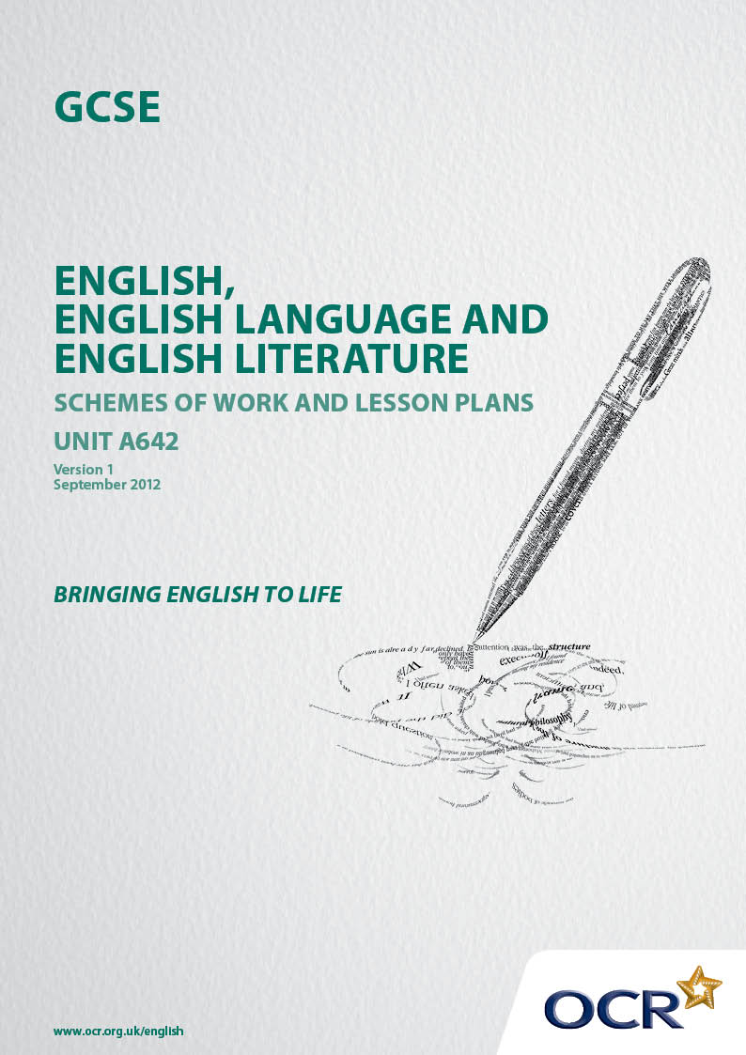
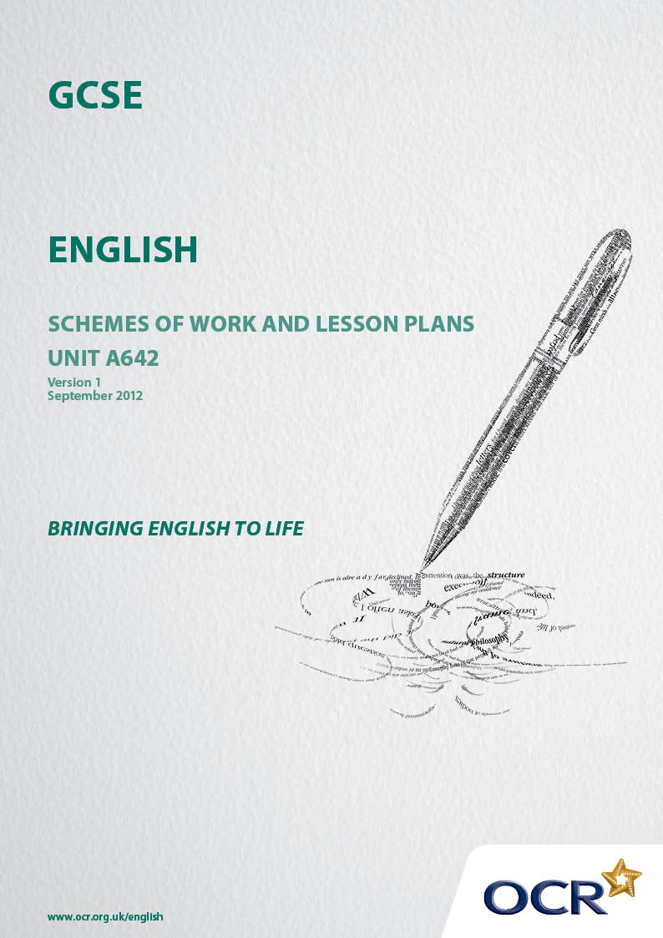

Contents
Contents 2
Introduction 3
Sample Schemes of Work OCR GCSE English Unit A642: Imaginative writing 5
Sample Lesson Plans OCR GCSE English Unit A642: Imaginative Writing 22

Introduction

Background
Following a review of 14 – 19 education and the Secondary Curriculum Review, the Qualifications and Curriculum Development Agency (QCDA) has revised the subject criteria for GCSEs, for first teaching in September 2010. This applies to all awarding bodies.
The new GCSEs have more up-to-date content and encourage the development of personal, learning and thinking skills in your students.
We’ve taken this opportunity to redevelop all our GCSEs, to ensure they meet your requirements. These changes will give you greater control of assessment activities and make the assessment process more manageable for you and your students. Controlled assessment will be introduced for most subjects.
From September 2012, assessment tasks may be undertaken at any point between release of the task and the examination series for which the task must be submitted. Centres must ensure that candidates undertake a task that is valid for submission in the year in which the candidate intends to submit it.
OCR has produced a summary document, which summarises the changes to English. This can be found at www.ocr.org.uk, along with the new specification.
In order to help you plan effectively for the implementation of the new specification we have produced these Schemes of Work and Sample Lesson Plans for English. These Support materials are designed for guidance only and play a secondary role to the Specification.

Our Ethos
OCR involves teachers in the development of new Support materials to capture current teaching practices tailored to our new specifications. These Support materials are designed to inspire teachers and facilitate different ideas and teaching practices.
Each Scheme of Work and set of sample Lesson Plans is provided in Word format so that you can use it as a foundation to build upon and amend the content to suit your teaching style and students’ needs.
The Scheme of Work and sample Lesson plans provide examples of how to teach this unit and the teaching hours are suggestions only. Some or all of it may be applicable to your teaching.
The specification is the document on which assessment is based and specifies what content and skills need to be covered in delivering the course. At all times, therefore, this support material booklet should be read in conjunction with the specification. If clarification on a particular point is sought then that clarification should be found in the Specification itself.

A Guided Tour through the Scheme of Work

= Innovative Teaching Idea
This icon is used to highlight exceptionally innovative ideas.


= ICT Opportunity
This icon is used to illustrate when an activity could be taught using ICT facilities.

OCR GCSE English Unit A642: Imaginative writing
Suggested teaching time | 24 hours | Topic | Section A: Media
Topic outline |  | Suggested teaching and homework activities |  | Suggested resources | Points to note
Social problems  (2 hours) |  | - Discuss what students think are the biggest problems facing society today  - Students research a social problem selected by the teacher in more detail by gathering facts and a range of opinions about it  - Create a collage of texts and images that reflect the social problem  - Some of the texts should be in the genres specified in the controlled assessment, eg letters, poems, dramatic monologues |  | Relevant non-fiction texts (including letters) can be found on the following newspaper websites  -www.bbc.co.uk  -www.guardian.co.uk  -www.telegraph.co.uk  Fictional material on the following topics can be found in extracts from  Stone Cold (Homelessness)  Curious Incident … (Disability)  Anita and Me (Racism)  Poetry by Zephaniah or Duffy | - In this Scheme of Work students will work through the four text types referred to in the specimen assessment materials but teachers may want to (or need to) narrow down the choice for various reasons, eg  - Students may already have studied certain text types in some detail or particular text types may not be appropriate for a particular group of students at a particular centre  - Limited time and the need to make links with other parts of the course may also determine which tasks are most advisable for students to tackle  - In general, however, it seems best to offer students as wide a choice as possible  - Students will be practising the skills they need for the final controlled assessment by working on one particular social problem selected by the teacher  - Teachers could select the initial problem so that students have more freedom to choose a topic that interests them when they are preparing for the final controlled assessment

OCR GCSE English Unit A642: Imaginative Writing
Suggested teaching time | 24 hours | Topic | Section A: Media
Topic outline |  | Suggested teaching and homework activities |  | Suggested resources | Points to note
Broadcast  (4 hours) |  | - For many students it would be better to concentrate on a radio broadcast because that will make them focus on language, whereas the visual elements of a TV broadcast might distract students from carefully crafting the language they are using  - Explore the content, structure and style of two different broadcast texts about a social problem, eg charity advert, thought for the day, news feature (TV or radio)  - Most students would benefit from some kind of comparison between the two broadcast texts with greater focus for more able students on the language used and exactly how it works with the images  - Transform texts by adapting them from one kind of broadcast to another, eg from radio to television, to bring out more clearly the similarities and differences between them |  | - Charity adverts can be found on charity websites  - Thought for the Day can be downloaded as a podcast from www.bbc.co.uk/radio  - TV news items can be downloaded from www.bbc.co.uk/iplayer | - The broadcast is a core task and a compulsory task so teachers may want to spend more time on it than on the other tasks  - The key elements of the radio broadcast are voice, sound effects and music  - The broadcast does not have to be a monologue – it could be a feature or package that includes other voices and even sound effects and music. There must be a sufficient amount of speech, however, for adequate assessment  - There may be some opportunity for links with the spoken language study here as the piece is being written for a listening audience. It should, therefore, take into account the need for clear discourse markers

OCR GCSE English Unit A642: Imaginative Writing
Suggested teaching time | 24 hours | Topic | Section a: Media
Topic outline |  | Suggested teaching and homework activities |  | Suggested resources | Points to note
 |  | - Identify some of the differences between writing and speech, such as discourse markers and the greater reliance on phonological patterning  - Write and record a radio news item based on the social problem that the class have studied |  |  | - These particular suggestions assume that the broadcast is a factual account attempting to explain a social problem, but it could also be an advert promoting a particular campaign or charity or a drama script exploring the issue  - The drama script may be another way of making connections with controlled assessments in speaking and listening or the spoken language study
Dramatic Monologue  (2 hours) |  | - Either visually or physically create a circle of influence to show all the different people who might be affected by the particular social problem the students are exploring  - Look at examples of dramatic monologue in prose, drama and poetry, eg Assassin, Porphyria’s Lover, Talking Heads, The History Boys |  | - Dramatic monologues of varying lengths can be found in many of the set texts in GCSE English Literature, eg soliloquies in Shakespeare, poems by Browning, The History Boys  - The first person narratives of novels like Anita and me could also provide suitable models | - Teachers may decide to focus on just some of the options depending on the nature of the class they are teaching, eg a class with particular strengths in drama might approach this more actively while others may prefer to focus on the imitation of successful literary models  - Circle of influence – a series of concentric circles round a particular stimulus

OCR GCSE English Unit A642: Imaginative Writing
Suggested teaching time | 24 hours | Topic | Section A: Media
Topic outline |  | Suggested teaching and homework activities |  | Suggested resources | Points to note
 |  | - Develop a list of characters who might be affected by the issues raised in the broadcast and start to develop ideas for the monologues by freezing the action and asking students to voice their thoughts  - Using ideas developed in class, students draft a monologue by a person affected by the social problem they have studied. |  |  | - There are opportunities for a cross-over here with the speaking and listening controlled assessment by asking students to perform their monologue as the extended individual contribution  - It may also be possible to use some of this material for the specimen controlled assessment tasks in English Language which asks students to write about a time when they faced a challenge
Letters  (2 hours) |  | - Use sample letters from a TV guide commenting on programmes to establish how style can be adapted to context, audience, purpose  - Use research to adopt different personas who might be able to comment on the social problem, either because of personal experience or because they are an expert on an aspect of the problem  - Use discussion and formal debate to explore in some detail both sides of the debate about the social problem |  | - The Radio Times has a comments page which may provide some useful models of language, tone and structure  - There is also a feedback section on www.bbc.co.uk/radio4/features/feedback | - One challenge is that many of the models for this kind of writing are quite short so clear guidance must be given to students about how they can extend the piece  - The purpose of the task is deliberately stated as broadly as possible as to “comment” on the broadcast to allow different types of response

OCR GCSE English Unit A642: Imaginative Writing
Suggested teaching time | 24 hours |  | Topic | Section A: Media
Topic outline |  |  | Suggested teaching and homework activities |  |  | Suggested resources | Points to note
 |  | - Consider the different ways that the writer of a letter might respond to a broadcast, eg support, criticism, sharing a personal experience
Web-based Encyclopaedia  (2 hours) |  | - Examine the language and structure of a web-based encyclopaedia entry about a particular social problem  - Identify the key features of writing to explain a word, sentence and text level as well as structural features such as hyperlinks  - Compare the layout and structure of a webpage with a double page spread from a paper-based children’s encyclopaedia  - Use a mind-map to identify the main information that needs to be conveyed about the particular social problem and the opportunities for hyperlinks  - Analyse different images that illustrate the social problem deconstructing how angles, shots, lighting, colour, work with the content of the picture to convey particular messages  - Explore the placing of particular images in a text to understand how they can work with the words |  |  | - There are several entries on social problems on www.en.wikipedia.org e,g, homelessness  - There are several inexpensive children’s encyclopaedias that can be examined for these activities |  |  | - The main challenge when asking students to write an entry for an online encyclopaedia about a social problem is, that such entries already exist and so students may simply attempt to reproduce an existing site  - Students are, of course, working in controlled conditions and denied internet access so they cannot cut and paste material from an existing website  - The best way to deal with this is to adapt the task by providing a particular angle on it, eg an entry about an imaginary organisation or charity that tries to address a particular social problem or an imaginary campaign that tries to tackle a particular problem  - Another way of approaching it would be to specify a particular aspect of a problem for which no current entry exists, eg the social problem in the students’ local area

OCR GCSE English Unit A642: Imaginative Writing
Suggested teaching time | 24 hours |  | Topic | Section A: Media
Topic outline |  |  | Suggested teaching and homework activities |  |  | Suggested resources | Points to note
 |  | - Practise creating a main page and at least one hyperlink about the social problem the class have studied |  |  |  |  |  | - This is another opportunity to help students practise using the OCR repository which would be a suitable place to submit their final controlled assessment task
Preparation and Research  (5 hours) |  | - At this stage the controlled assessment tasks can be adapted to the requirements of individual centres and individual students, eg the social problem, the kind of broadcast, the choice of linked task  - The teacher must ensure that students have framed the tasks in a way that will enable them to use appropriate generic features  - Students must use this preparation time to gather all the resources they need to produce the final piece, including relevant information, images and audio and video files |  |  |  |  |  | - Parts of this research should be carried out as homework

OCR GCSE English Unit A642: Imaginative Writing
Suggested teaching time | 24 hours |  | Topic | Section B: Development
Topic outline |  |  | Suggested teaching and homework activities |  |  | Suggested resources | Points to note
Feature Article  (4 hours) |  | - Once they have read up to the end of Act 2, students should review what they have learned about Tybalt as a character using either a character profile or role on the wall style activity  - Role play in pairs an interview with Tybalt in which he explains his thoughts and feelings about the situation in Verona and events at the recent feast held at the house of the Capulets  - Compare the language and structure of two appropriate feature articles about current celebrities  - Consider similarities and differences between how a noble figure like Tybalt might be presented in contemporary writing and how celebrity figures are presented now  - Sketch the layout of the feature article and identify suitable images to be used in the article  - Draft the text of a feature article based on the structure of one of the articles studied earlier |  |  | - This activity could be integrated with preparation for the controlled assessment for reading literary texts  - Suitable models of feature articles can be taken from a range of newspapers and magazines on and off line, including straightforward profiles such as the “A Day in the Life” series in The Sunday Times” or “This Much I Know” in The Observer, while more able students could consider more challenging models by studying more detailed interviews and profiles |  |  | - Text development practice and preparation can take place either during or after the study of a text. For the purpose of this scheme of work practice tasks are set during the study of the text and preparation for the actual controlled assessment takes place at the end  - All examples in this scheme of work are taken from Romeo and Juliet but could be applied to any text  - Although students are not assessed for reading in this unit they should be encouraged to root their imaginative writing securely and plausibly within the text

OCR GCSE English Unit A642: Imaginative Writing
Suggested teaching time | 24 hours |  | Topic | Section B: Development
Topic outline |  |  | Suggested teaching and homework activities |  |  | Suggested resources | Points to note
 |  | - Using the mark scheme students should review the success of their own work and that of their partner(s)
Key Moments - Blog  (4 hours) |  | - Consider the thoughts and feelings of a minor character like Benvolio at the end of Act 1 Scene 1  - Identify the clues we are given about his character by what he say and does and by what other characters say about him  - Explore the similarities and differences between a diary and a blog by considering, in particular, the issues of audience and purpose  - Assessment - Draft the text of an entry for a blog by Benvolio explaining his thoughts and feelings about the fight in the streets at the start of the play and his encounter with Romeo  - Use the first draft of the text to create an electronic version of the text with links and images and related textboxes  - Students should add one or two more entries to the blog as they read more of the text |  |  | - Blogs vary in quality and interest so search for ones that might interest your particular students as models. A good example of a contemporary blog is www.inspectorgadget.wordpress.com which recounts the experiences of a police officer somewhere in the UK  - Although local education authority filtering software should protect students from inappropriate websites it is best to capture and copy relevant pages from relevant blogs to ensure the content is suitable |  |  | - This is another task that can be practised during the reading of the text to develop the skills required for the controlled assessment  - This activity allows for the creation of an electronic text with hyperlinks, images and textboxes containing not just thoughts and feelings about what has happened but details that might suggest character such as likes and dislikes  - Although there are some superficial similarities between blogs and diaries the key differences in audience is that blogs are written for a wider audience and often link personal experience more explicitly to wider social concerns, eg in Romeo and Juliet, Benvolio may be concerned about the breakdown in law and order on the streets  - Once the first blog entry has been created, further entries can be made as students read more of the text

OCR GCSE English Unit A642: Imaginative Writing
Suggested teaching time | 24 hours |  | Topic | Section B: Development
Topic outline |  |  | Suggested teaching and homework activities |  |  | Suggested resources | Points to note
Dramatic Monologue  (4 hours) |  | - Either visually or physically create a circle of influence to show all the different people who might be affected by the particular social problem the students are exploring  - Look at examples of dramatic monologue in prose, drama and poetry, eg Assassin, Porphyria’s Lover, Talking Heads, History Boys  - Use improvised drama to develop characters who might be affected by the issues raised in the broadcast and start to develop ideas for the monologues by freezing the action and asking students to voice their thoughts  - Using ideas developed in class students draft a monologue by a person affected by the social problem they have studied in class |  |  | - Dramatic monologues of varying lengths can be found in many of the set texts in GCSE English Literature, e.g soliloquies in Shakespeare, poems by Browning poems, The History Boys. The first person narratives of novels like “The Catcher in the Rye” could also provide suitable models |  |  | - Teachers may decide to focus on just some of the options depending on the nature of the class they are teaching, eg a class with particular strengths in drama might approach this more actively while other may prefer to focus on the imitation of successful literary models  - Circle of influence – a series of concentric circles round a particular stimulus  - There are opportunities for a cross-over here with the speaking and listening controlled assessment by asking students to perform their monologue as the extended individual contribution  - It may also be possible to use some of this material for the specimen controlled assessment tasks in English Language which asks students to write about a time when they faced a challenge

OCR GCSE English Unit A642: Imaginative Writing
Suggested teaching time | 24 hours | Topic | Section B: Development
Topic outline |  | Suggested teaching and homework activities |  | Suggested resources | Points to note

Key Moments - Poems  (4 hours) | - Study the form and structure of the sonnet by analysing its use in Act1 Scene 5 when Romeo and Juliet first meet  - Consider the reasons why Shakespeare may have used the sonnet form at this point in the play , including both its effect on the audience and its heightening of dramatic and emotional intensity at a key moment in the play  - Compare the way the sonnet is used here to convey complex thoughts and feelings with the greater focus on creating emotional intensity through narrative in a ballad  - Identify a key point in the play and write a sonnet and a ballad exploring a particular character’s thoughts and feelings at that moment, eg Mercutio at the start of Act3 or Paris when he encounters Romeo in the graveyard in Act 5 | - As a style model select a ballad based on the relationship between men and women such as “A faithless shepherd courted me …” | - There seem to be some links between this task and the creation of entries for a blog because students are expressing character’s thoughts and feelings at key moments in the text but writing two poems may enable more able students to understand the play better and to develop their ability to use language and structure for effect  - To enable students to demonstrate that they have consciously structured language to create deliberate effects it would be helpful to require them to write each of the two poems in a different form, eg here the use of a sonnet and a ballad is suggested

OCR GCSE English Unit A642: Imaginative Writing
Suggested teaching time | 24 hours |  | Topic | Section B: Development
Topic outline |  |  | Suggested teaching and homework activities |  |  | Suggested resources | Points to note
Story Writing  (4 hours) |  | - Having read the whole text identify references in the text to events that are not described in detail but could be developed into a full-length story, eg the original quarrel that led to the feud between the Capulets and Montagues or the original romance between Romeo and Rosaline  - Explore plot structure by drawing up outline plans for at least one of the possible storylines identifying the opening, complication, crisis and resolution. These could be displayed to illustrate how different storylines have the same basic structure  - Students should also work out ideas for stories that could be told about characters from the text, eg an amusing adventure involving Mercutio before the events of the play or a future romance between Benvolio and Rosaline |  |  | - To generate ideas students could roll dice to select from choices of six characters, situations, settings and objects |  |  | - Although the story based on events that are nor described in detail in the text is the core task, it has been left until last in this scheme of work so that teachers could decide whether they want students to practise the skills by writing a whole story or whether they should simply write parts of a story  - Students will not be assessed in this assessment for reading but teachers should encourage them to ensure that characters act in a way that is consistent with their portrayal in the original text

OCR GCSE English Unit A642: Imaginative Writing
Suggested teaching time | 24 hours |  | Topic | Section B: Development
Topic outline |  |  | Suggested teaching and homework activities |  |  | Suggested resources | Points to note
 |  | - At this stage students could practise the required skills by writing short extracts for some of these story ideas that focus on creating settings, conveying characters, using dialogue and building tension
Preparation and Research  (4 hours) |  | - At this stage the controlled assessment tasks can be adapted to the requirements of individual centres and individual students, eg the characters and key moments in the texts should be specified or the forms of poetry to be used should be identified  - The teacher must ensure that students have framed the tasks in a way that will enable them to use appropriate generic features and meet the requirements of the mark scheme  - Students must use this preparation time to gather all the resources they need to produce the final piece, including relevant information, images and audio and video files |  |  | - Guidance will be issued by the exam board about the notes that students may take into the controlled assessment |  |  | - For the final controlled assessment teachers should design tasks based on characters and moments in the text that were not used in the period of preparation and practice  - For example, if students have already written work based on the thoughts and feelings of Tybalt, they should base their final controlled assessment work on a different character  - Parts of the research for the final controlled assessment could be carried out as homework  - Although the core task has to involve characters from the original text the linked task may be based on a character of the students’ own invention as long as the character is sufficiently well developed to form the basis of such an exercise

OCR GCSE English Unit A642: Imaginative Writing
Suggested teaching time | 24 hours |  | Topic | Section B: Development
Topic outline |  |  | Suggested teaching and homework activities |  |  | Suggested resources | Points to note
Feature Article  (4 hours) |  | - Once they have read up to the end of Act 2 students should review what they have learned about Tybalt as a character using either a character profile or role on the wall style activity  - Role play in pairs an interview with Tybalt in which he explains his thoughts and feelings about the situation in Verona and events at the recent feast held at the house of the Capulets  - Compare the language and structure of two appropriate feature articles about current celebrities  - Consider similarities and differences between how a noble figure like Tybalt might be presented in contemporary writing and how celebrity figures are presented now |  |  | - This activity could be integrated with preparation for the controlled assessment for reading literary texts  - Suitable models of feature articles can be taken from a range of newspapers and magazines on and off line, including straightforward profiles such as the “A Day in the Life” series in The Sunday Times” or “This Much I Know” in The Observer, while more able students could consider more challenging models by studying more detailed interviews and profiles |  |  | - Text development practice and preparation can take place either during or after the study of a text. For the purpose of this scheme of work practice tasks are set during the study of the text and preparation for the actual controlled assessment takes place at the end  - All examples in this scheme of work are taken from Romeo and Juliet but could be applied to any text

OCR GCSE English Unit A642: Imaginative Writing
Suggested teaching time | 24 hours |  | Topic | Section B: Development
Topic outline |  |  | Suggested teaching and homework activities |  |  | Suggested resources | Points to note
 |  | - Sketch the layout of the feature article and identify suitable images to be used in the article  - Draft the text of a feature article based on the structure of one of the found articles studied earlier  - Using the mark scheme students should review the success of their own work and that of their partner(s) |  |  |  |  |  | - Although students are not assessed for reading in this unit they should be encouraged to root their imaginative writing securely and plausibly within the text
Key Moments - Blog  (4 hours) |  | - Consider the thoughts and feelings of a minor character like Benvolio at the end of Act 1 Scene 1  - Identify the clues we are given about his character by what he say and does and by what other characters say about him |  |  |  |  |  | - This is another task that can be practised during the reading of the text to develop the skills required for the controlled assessment  - This activity allows for the creation of an electronic text with hyperlinks, images and textboxes containing not just thoughts and feelings about what has happened but details that might suggest character such as likes and dislikes

OCR GCSE English Unit A642: Imaginative Writing
Suggested teaching time | 24 hours |  | Topic | Section B: Development
Topic outline |  |  | Suggested teaching and homework activities |  |  | Suggested resources | Points to note
 |  | - Explore the similarities and differences between a diary and a blog by considering, in particular, the issues of audience and purpose  - Assessment - Draft the text of an entry for a blog by Benvolio explaining his thoughts and feelings about the fight in the streets at the start of the play and his encounter with Romeo  - Use the first draft of the text to create an electronic version of the text with links and images and related textboxes  - Students should add one or two more entries to the blog as they read more of the text |  |  | - Blogs vary in quality and interest so search for ones that might interest your particular students as models. A good example of a contemporary blog is www.inspectorgadget.wordpress.com which recounts the experiences of a police officer somewhere in the UK  - Although local education authority filtering software should protect students from inappropriate websites it is best to capture and copy relevant pages from relevant blogs to ensure the content is suitable |  |  | - Although there are some superficial similarities between blogs and diaries the key differences in audience is that blogs are written for a wider audience and often link personal experience more explicitly to wider social concerns, eg on Romeo and Juliet Benvolio may be concerned about the breakdown in law and order on the streets  - Once the first blog entry has been created, further entries can be made as students read more of the text

OCR GCSE English Unit A642: Imaginative Writing
Suggested teaching time | 24 hours |  | Topic | Section B: Development
Topic outline |  |  | Suggested teaching and homework activities |  |  | Suggested resources | Points to note
Dramatic Monologue  (4 hours) |  | - Either visually or physically create a circle of influence to show all the different people who might be affected by the particular social problem the students are exploring ITI  - Look at examples of dramatic monologue in prose, drama and poetry, eg Assassin, Porphyria’s Lover, Talking Heads, History Boys  - Use improvised drama to develop characters who might be affected by the issues raised in the broadcast and start to develop ideas for the monologues by freezing the action and asking students to voice their thoughts  - Using ideas developed in class students draft a monologue by a person affected by the social problem they have studied in class |  |  | - Dramatic monologues of varying lengths can be found in many of the set texts in GCSE English Literature, eg soliloquies in Shakespeare, poems by Browning poems, The History Boys. The first person narratives of novels like “The Catcher in the Rye” could also provide suitable models |  |  | - Teachers may decide to focus on just some of the options depending on the nature of the class they are teaching, eg a class with particular strengths in drama might approach this more actively while other may prefer to focus on the imitation of successful literary models  - Circle of influence – a series of concentric circles round a particular stimulus  - There are opportunities for a cross-over here with the speaking and listening controlled assessment by asking students to perform their monologue as the extended individual contribution  - It may also be possible to use some of this material for the specimen controlled assessment tasks in English Language which asks students to write about a time when they faced a challenge

OCR GCSE English Unit A642: Imaginative Writing
Suggested teaching time | 24 hours |  | Topic | Section B: Development
Topic outline |  |  | Suggested teaching and homework activities |  |  | Suggested resources | Points to note
Key Moments - Poems  (4 hours) |  | - Study the form and structure of the sonnet by analysing its use in Act1 Scene 5 when Romeo and Juliet first meet  - Consider the reasons why Shakespeare may have used the sonnet form at this point in the play , including both its effect on the audience and its heightening of dramatic and emotional intensity at a key moment in the play  - Compare the way the sonnet is used here to convey complex thoughts and feelings with the greater focus on creating emotional intensity through narrative in a ballad  - Identify a key point in the play and write a sonnet and a ballad exploring a particular character’s thoughts and feelings at that moment, eg Mercutio at the start of Act3 or Paris when he encounters Romeo in the graveyard in Act 5 |  |  | - As a style model select a ballad based on the relationship between men and women such as “A faithless shepherd courted me …” |  |  | - There seem to be some links between this task and the creation of entries for a blog because students are expressing character’s thoughts and feelings at key moments in the text but writing two poems may enable more able students to understand the play better and to develop their ability to use language and structure for effect  - To enable students to demonstrate that they have consciously structured language to create deliberate effects it would be helpful to require them to write each of the two poems in a different form, eg here the use of a sonnet and a ballad is suggested

OCR GCSE English Unit A642: Imaginative Writing

Media - Radio News
OCR recognises that the teaching of this qualification above will vary greatly from school to school and from teacher to teacher. With that in mind this lesson plan is offered, as a possible approach but will be subject to modifications by the individual teacher.

This is the fifth lesson in this scheme of work and focuses on the structure and language of a radio news item.

Lesson length is assumed to be one hour,

Learning Objectives for the Lesson
Objective 1 | To be able to identify the main features of a radio news item
Objective 2 | To be able to explain how a radio news item is organised
Objective 3 | To understand how a radio news item is adapted for different audiences

Starter
10 minutes | Introduce a chart – on a worksheet or in an interactive presentation - that lists several radio stations with a brief description of the types of programmes each one broadcasts  Describe different audiences – different in age, gender and interests - and ask students to match them to the different radio stations

Content
Time | Content
15 minutes | Students should listen to two versions of a news item (preferably linked to the social problem that the class is researching) one aimed at an adult audience, eg from the “Today” programme, and one aimed at a younger audience, eg from “Newsround”  Using a transcript of each report, students should identify the ways that the language and presentation of the report has been adapted to the needs of each audience

15 minutes | Taking information from a different news item on a radio programme aimed at an adult audience, students should create a report aimed at a younger audience  Based on a checklist provided by the teacher, student should review the text they have written and highlight details that show that they have adapted the language for a younger audience

Consolidation
Time | Content
10 minutes | Two pairs of students should volunteer to share their radio news item with the class and explain how they have adapted the language (and the structure) for a younger audience  Students from the rest of the class should then give the volunteers feedback on how successfully they have completed the task

OCR GCSE English Unit A642: Imaginative Writing

Text Development - Gathering Relevant Information
OCR recognises that the teaching of this qualification above will vary greatly from school to school and from teacher to teacher. With that in mind this lesson plan is offered, as a possible approach but will be subject to modifications by the individual teacher. This is the first lesson in this scheme of work and focuses on gathering evidence for the feature article that students will be writing.

Lesson length is assumed to be one hour,

Learning Objectives for the Lesson
Objective 1 | To understand what a writer conveys about a fictional character
Objective 2 | To be able to select relevant material for task, audience and purpose
Objective 3 | To be able to ask relevant questions to draw out information

Introduction
10 minutes | Having read up to the end of Act 2, students select, from a displayed list of adjectives, the words that best describe Tybalt.  More able students could refer to evidence in the text that supports the adjectives that they have chosen

Content
Time | Content
5 minutes | Give students an overview of the imaginative writing text development task
15 minutes | Read together extracts from a sample celebrity interview from a Sunday supplement feature and identify the questions that have been asked  More able students should read a more challenging extract and work out the questions that would have to be asked to elicit the information that is contained in the article
15 minutes | In pairs students should devise the questions that a reporter from the magazine they had looked at earlier would ask Tybalt.  They should then rehearse the interview that might take place between Tybalt and the writer of the feature article they studied earlier

Consolidation
Time | Content
10 minutes | Two or three pairs share their mock interview with the class.  Teacher explores which questions drew out the best information from Tybalt and which of the given answers are consistent with what we already know about him as a character

