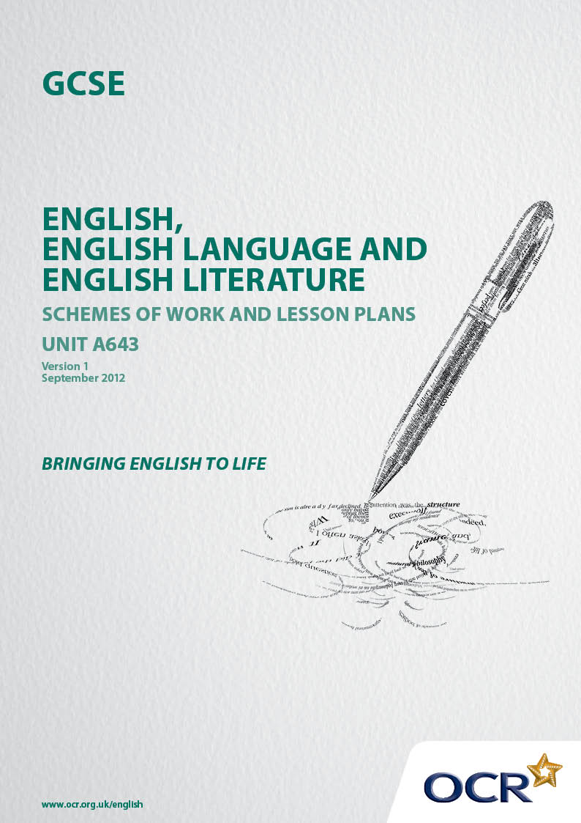
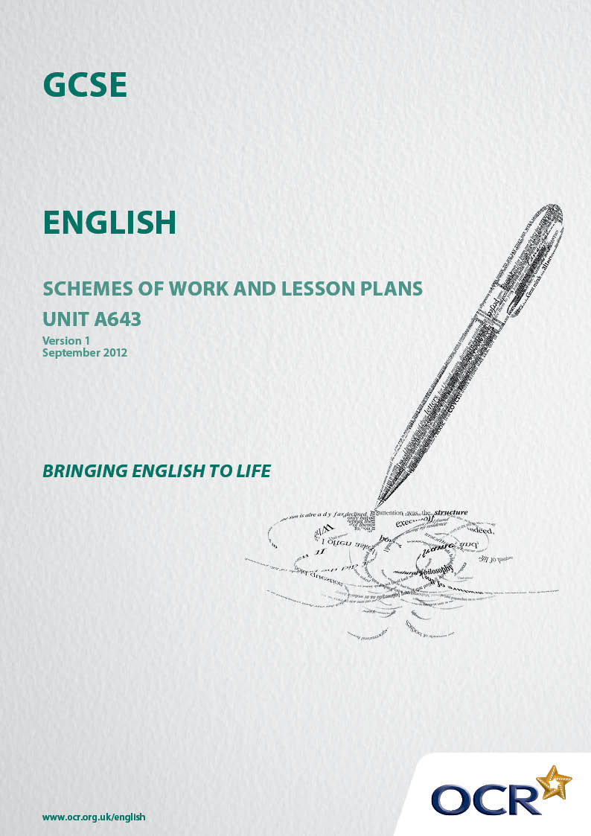

Contents
Contents 2
Introduction 3
Sample Schemes of Work: OCR GCSE English Unit A643: Speaking and listening 5
Sample Lesson Plan: OCR GCSE English Unit A643: Speaking and listening 12

Introduction

Background
Following a review of 14 – 19 education and the Secondary Curriculum Review, the Qualifications and Curriculum Development Agency (QCDA) has revised the subject criteria for GCSEs, for first teaching in September 2010. This applies to all awarding bodies.
The new GCSEs have more up-to-date content and encourage the development of personal, learning and thinking skills in your students.
We’ve taken this opportunity to redevelop all our GCSEs, to ensure they meet your requirements. These changes will give you greater control of assessment activities and make the assessment process more manageable for you and your students. Controlled assessment will be introduced for most subjects.
From September 2012, assessment tasks may be undertaken at any point between release of the task and the examination series for which the task must be submitted. Centres must ensure that candidates undertake a task that is valid for submission in the year in which the candidate intends to submit it.
OCR has produced a summary document, which summarises the changes to English. This can be found at www.ocr.org.uk, along with the new specification.
In order to help you plan effectively for the implementation of the new specification we have produced these Schemes of Work and Sample Lesson Plans for English. These Support materials are designed for guidance only and play a secondary role to the Specification.

Our Ethos
OCR involves teachers in the development of new Support materials to capture current teaching practices tailored to our new specifications. These Support materials are designed to inspire teachers and facilitate different ideas and teaching practices.
Each Scheme of Work and set of sample Lesson Plans is provided in Word format – so that you can use it as a foundation to build upon and amend the content to suit your teaching style and students’ needs.
The Scheme of Work and sample Lesson plans provide examples of how to teach this unit and the teaching hours are suggestions only. Some or all of it may be applicable to your teaching.
The specification is the document on which assessment is based and specifies what content and skills need to be covered in delivering the course. At all times, therefore, this support material booklet should be read in conjunction with the specification. If clarification on a particular point is sought then that clarification should be found in the Specification itself.

A Guided Tour through the Scheme of Work

= Innovative Teaching Idea
This icon is used to highlight exceptionally innovative ideas.


= ICT Opportunity
This icon is used to illustrate when an activity could be taught using ICT facilities.

OCR GCSE English Unit A643: Speaking and listening
Suggested teaching time | 3-4 hours | Topic | Drama Focussed Activity  Making a radio or television interview of a famous historical figure, celebrity from the past or literary character
Topic outline |  | Suggested teaching and homework activities |  | Suggested resources | Points to note
Exploring a range of interviews for different purposes. |  | - Watch clips from a range of interviews  - Consider how spoof interviews use genuine interviewing techniques for comic purposes.  - Compare the two interviews with David Tennant – how are their purposes different? How do their audiences differ? What impact do the differing audiences have on the tone of the interview and the questions asked?  - Discuss the style of the Bashir interview. How does the status of the interviewee effect the questions posed and the way that they are asked? |  | Looking at a range of interviews for different purposes:  For example:  Spoof TV-AM Royal Expert – French and Saunders http://www.youtube.com/watch?v=g-8mESIK98Q&feature=related  Spoof - Alistair McGowan interviews Jenny Bond  http://www.youtube.com/watch?v=UqbFYnKhVxM  Compare to serious interview with royal correspondent  http://www.youtube.com/watch?v=kEliHNS3gU8&feature=channel  Spoof TV-AM Financial Expert - French and Saunders http://www.youtube.com/watch?v=rCWc3VSkInI&feature=related  Compare to genuine GMTV Financial advice interview  http://www.youtube.com/watch?v=cpNZT1hJd10  Radio Interviews:  Kirsty Young and David Tennant, Desert Island Discs  http://www.youtube.com/watch?v=wRGGFblCPQM  Steve Wright and David Tennant on Radio 2  http://www.youtube.com/watch?v=GnTH06nswx0  Martin Bashir’s interview with Diana, Princess of Wales  http://www.youtube.com/watch?v=4kqIJdWooMM  This could be compared to an interviewer who is deliberately disrespectful to the interviewee for entertainment purposes. For example, Mrs Merton or Dame Edna. | - This links to the students’ preparation for their Controlled Conditions task for English Language Unit A652 Section B. A2: The study of the spoken language of a particular interviewer.  - Students will already have studied how to identify the features of interviews and analysed a variety of interviewers’ styles.
Role Play -  Student A – interviewer  Student B - interviewee |  | - In pairs students will prepare an interview  EITHER  In the style of one of those that they have studied  OR  A spoof interview, imitating another interviewer’s style to create comedy. |  | Transcripts of interviews to help inspire their questions
Research and preparation |  | - Using the transcripts and recordings students should identify the features of their chosen interviewer and how questions are used – whether planned or spontaneous. They should also look at the vocal tone, facial expression and body language of the interviewer, as well as the language used.  - The pairs should decide the identity of their interviewee: a famous historical figure, celebrity from the past or literary character.  - The students should work individually on their role as interviewer or interviewee.  - In their pairs the interviewers hot-seat the interviewees to consolidate their factual knowledge and practise their performance skills as the character.  - Students should prepare the interview and rehearse it, focusing on developing convincing roles through their use of language, vocal and physical skills. |  | Video/audio clips of the chosen interviewer  Students may be provided with a worksheet grid to identify the features and how they may use them in their own interview.  The students should undertake research on their chosen figure to devise appropriate questions. Discuss possible suggestions that link to work completed in other subjects – Queen Victoria, Shakespeare, John Lennon, Henry VIII, Romeo or Juliet, Marilyn Monroe, J F Kennedy etc etc....  The interviewee should prepare a ‘press release’ for their interviewer with details about their life and experiences.  The interviewer should prepare a list of questions for the interview. | - Ideally the students will need access to a laptop to replay their clips.  - The criteria for the chosen interviewee should be that they are no longer living, but instantly recognisable.  - The interviews should not be over-rehearsed as they need to have an element of spontaneity. More preparation should therefore go into the devising of the questions than rehearsing the answers –emphasis should be on improvisation rather than scripting.
Controlled Assessment Task  10-15 minutes |  | - Students perform their interviews to the class. |  | The interviews should be performed live to the class but could be recorded on DVD or audio as appropriate.

OCR GCSE English Unit A643: Speaking and listening
Suggested teaching time | 4-5 hours | Topic | Individual Extended contribution:  Prepared Talk and Questions  Teaching and explaining a conspiracy theory or an unexplained mystery to the class.
Topic outline |  | Suggested teaching and homework activities |  | Suggested resources | Points to note
Introduction  Presentational skills |  | - Introduce the concept of delivering a prepared talk – how you say something is as important as what you say.  - Discuss the intended audience and how that affects the language and tone the students should use.  - In pairs the students should practise introducing themselves to one another formally as a speaker. |  | The teacher’s introduction to the lesson.  Clips from news presenters introducing the programme, presenters introducing documentaries etc where teacher can focus on successful presentational skills and use of language.  For example:  http://www.youtube.com/watch?v=2nk2JLfAJFI  David Attenborough’s introduction to the 200th anniversary of Charles Darwin BBC documentary  Clips of unsuccessful presentational skills:  http://www.youtube.com/watch?v=01o5C02DweA  A news reel in German where the presenter is completely reliant on the script.  http://www.youtube.com/watch?v=beqRHZDQBZA  A presenter who is unprepared and stumbles/giggles constantly. | - The teacher can deliberately demonstrate poor presentational skills at the beginning of the lesson and ask students for feedback.  - The choice of clips could relate to the students’ preparation for the English Language Spoken English Unit A652 Section B.  - The fact that it is in a foreign language allows the teacher to emphasise the lack of eye-contact and its effect on the audience.
Choosing a topic:  Examples:  The Lunar Landings  9/11  JFK  The Marie Celeste  The Bermuda Triangle  Crop Circles  Area 51 |  | - Discussion and introduction of conspiracy theories.  - Discussion of well-known mysteries.  - Group activity: students discuss their favourite conspiracy theory/mystery and offer their own explanations. |  | Useful websites:  http://www.telegraph.co.uk/news/newstopics/howaboutthat/3483477/The-30-greatest-conspiracy-theories-part-1.html  http://www.world-of-lucid-dreaming.com/unexplained-mysteries.html | - Students will have many ideas and suggestions about common conspiracy theories and unexplained mysteries.  - Many students will find their own more obscure topics.
Research and information gathering |  | - Students spend some time researching and choosing their own topic for homework  - Two lessons should be spent in a resource centre where students can gather information on their topic  - Homework could involve carrying out a survey of people’s attitudes to their chosen topic – this incorporates a ‘real-life context’ into their assessment. |  | The students should produce a list of questions for their survey that require simple yes/no responses. | - How the students gather resources will depend on the centre’s access – ideally students should have access to the internet and a library
Organisation and practice  Peer review |  | - When research is complete students should focus on the information they wish to present and organise it logically, developing either bullet pointed cards OR a power-point presentation.  In pairs students should practise their presentations, offering one another feedback and advice. |  | A worksheet on organising their talk into sections could be useful. Also, suggestions of how their presentation can be varied through use of PowerPoint, diagram/display materials or showing clips/still pictures.  Students could record aspects of one another’s talk and, if laptops are available, play back the DVD to illustrate points and ideas. | - Organisation and selection of material is key to the success of their talk.  - This will focus on the use of listening skills and allow students to prepare for possible questions from their audience.
Controlled Assessment Task  10 – 15 minutes |  | - Students present their prepared talks to the class and answer questions. |  | A screen and projector should be available for students opting to use PowerPoint, or who may wish to show clips/pictures.

OCR GCSE English Unit A643: Speaking and listening

Drama-focussed activity - Making a radio or television interview of a famous historical figure, celebrity from the past, or literary character
OCR recognises that the teaching of this qualification above will vary greatly from school to school and from teacher to teacher. With that in mind this lesson plan is offered, as a possible approach but will be subject to modifications by the individual teacher.

This is the fifth lesson in this scheme of work and focuses on the structure and language of a radio news item.

Lesson length is assumed to be one hour,

Learning Objectives for the Lesson
Objective 1 | To understand the different styles and purposes of interviews
Objective 2 | To use creative and dramatic approaches to exploring ideas in improvised work
Objective 3 | To present and listen to information and ideas through role-play

Recap of previous experience and prior knowledge

Students will previously have studied a range of interviews, discussing the different features used by interviewers in preparation for their Spoken Language Controlled Conditions Assessment. They will also have studied and discussed a variety of interview clips and transcripts for this assessment focusing on the interviewers’ techniques and styles.

Working in pairs they will now begin research and preparation to create their own interview for television or radio through role-play.

Content
Time | Content
5 minutes | Remind the class of the various interviewers that they have studied with a question and answer session on the previous lesson.
10 minutes | Divide the class into pairs. If there needs to be a three they can interview a pair.  Outline the choice of task:  EITHER:  Prepare a spoof interview in the style of an interviewer of their choice (examples studied in the previous lesson include GMTV presenters, royal correspondents or Kirsty Young on Desert Island Discs.  OR  Prepare an interview imitating the style of the interviewer of their choice.  The interviewee MUST be a famous historical figure, celebrity from the past or a literary character (i.e. not living)  Discuss possible names of interviewees and the criteria for selection – possible links with History, RE, English Literature, Classical Civilisation or Drama. Suggest that they select a figure of whom they have some prior knowledge.
20 minutes | The students discuss their ideas in their pairs and decide on the interviewer and the interviewee of their choice, completing a worksheet grid to identify the appropriate features of an interview that they should use. They should make notes on language choice, the balance of pre-planned and spontaneous questions, vocal variation, body language and facial expression specific to their chosen interviewer.
15 minutes | Working individually, Student A (the interviewer) should refer to the clips or transcripts of their chosen interviewer to prepare a list of possible questions appropriate for their choice of interviewee. Student B (the interviewee) should carry out research on their chosen figure using the library or internet, providing a ‘press release’ for the interviewer with details of their life and experiences. These tasks should be completed for homework.

Consolidation
Time | Content
10 minutes | Plenary: Teacher explains that preparation and rehearsal will continue next lesson, beginning with a hot-seating session between the interviewer and interviewee. Students briefly share their initial ideas with the rest of the class in a discussion and offer feedback.

OCR GCSE English Unit A643: Speaking and listening

Individual extended contribution: prepared talk and questions - Introducing presentational skills
OCR recognises that the teaching of this qualification above will vary greatly from school to school and from teacher to teacher. With that in mind this lesson plan is offered, as a possible approach but will be subject to modifications by the individual teacher. This is the first lesson in this scheme of work and focuses on gathering evidence for the feature article that students will be writing.

Lesson length is assumed to be one hour,

Learning Objectives for the Lesson
Objective 1 | To identify good presentation skills when conveying information to an audience
Objective 2 | To learn to adapt talk appropriately to situation and audience.

Recap of previous experience and prior knowledge
This is an introductory lesson

Content
Time | Content
10 minutes | When the teacher introduces the lesson, he/she should fail to use eye-contact, adopt an unvaried vocal tone and read from a sheet using no gesture or facial expression. This should be followed by inviting comments from the class on the effectiveness of the introduction and the importance of relating to and acknowledging your audience though a range of vocal and physical techniques.
15 minutes | The teacher should then show clips of poor presentation skills (for example, http://www.youtube.com/watch?v=01o5C02DweA, which shows a news reader who is over-reliant on script or http://www.youtube.com/watch?v=beqRHZDQBZA , which demonstrates an unprepared presenter who stumbles and giggles) Other clips could be used to demonstrate different problems.  Then show a clip of a successful presenter (for example, http://www.youtube.com/watch?v=2nk2JLfAJFI, David Attenborough’s introduction to the BBC documentary on the 200th anniversary of Charles Darwin or http://www.youtube.com/watch?v=4VzCyDJyGMo, CBBC’s Newsround’s report on Barak Obama’s election victory).  Following each clip the class should suggest specific aspects of the presenters’ techniques which were positive or negative for the audience/listener. How important is careful preparation and why? How do the presenters on CBBC adapt their language and techniques for a younger audience? How does  Attenborough communicate his knowledge and enthusiasm for his subject? A list should be drawn up from the discussion.
15 minutes | Group activity: in groups of three, the class should discuss and draw up a shortlist of the three most serious presentational shortcomings in the clips and their choice of the three most essential presentational skills – one from each category – use of voice, use of language and use of physical skills (posture/gesture/body language/facial expression).
10 minutes | Continuing in groups of three, in turn the students should practise introducing themselves to the group as a speaker who has been invited to talk to the class about the importance of contributing fully to school life. They should focus on using appropriate vocal tone, language and physical skills. The group members should offer feedback and advice to improve the introduction.

Consolidation
Time | Content
10 minutes | Plenary session: take feedback from the class – what have they learnt about presenting their ideas through speech? What considerations would they have to make to allow for different audiences in terms of choice of language, vocal tone and physical skills?

