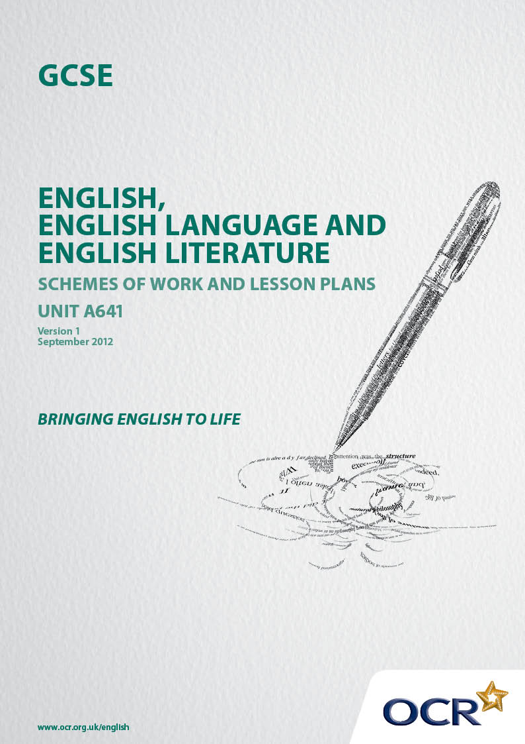
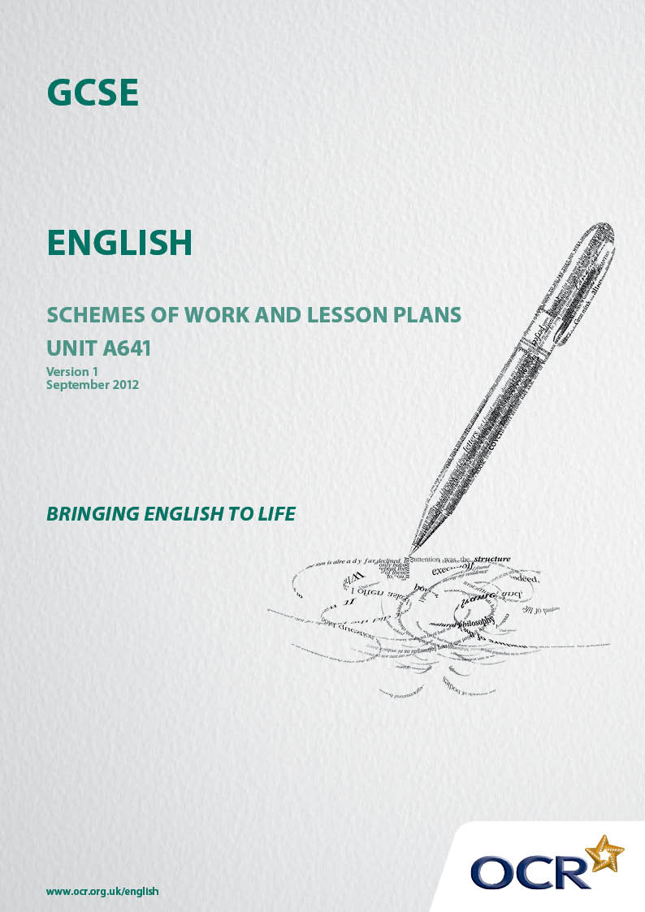

Contents
Contents 2
Introduction 3
OCR GCSE English Unit A641: Reading Literary Texts
Sample Scheme of Work – Themed Tasks for centre’s own choice of text 5
OCR GCSE English Unit A641: Reading Literary Texts
Sample Scheme of Work – Shakespeare Julius Caesar 11
OCR GCSE English Unit A641: Reading Literary Texts
Sample Scheme of Work – The Poems of Wilfred Owen 21
OCR GCSE English Unit A641: Reading Literary Texts
Sample Lesson Plan – Generic Themed Task 30
OCR GCSE English Unit A641: Reading Literary Texts
Sample Lesson Plan – wilfred Owen: linking the poems to the assessment objectives 32

Introduction

Background
Following a review of 14 – 19 education and the Secondary Curriculum Review, the Qualifications and Curriculum Development Authority (QCDA) has revised the subject criteria for GCSEs, for first teaching in September 2010. This applies to all awarding bodies.
The new GCSEs have more up-to-date content and encourage the development of personal, learning and thinking skills in your students.
We’ve taken this opportunity to redevelop all our GCSEs, to ensure they meet your requirements. These changes will give you greater control of assessment activities and make the assessment process more manageable for you and your students. Controlled assessment will be introduced for most subjects.
From September 2012 assessment tasks may be undertaken at any point between release of the task and the examination series for which the task must be submitted. Centres must ensure that candidates undertake a task that is valid for submission in the year in which the candidate intends to submit it.
OCR has produced a summary document, which summarises the changes to English. This can be found at www.ocr.org.uk, along with the new specification.
In order to help you plan effectively for the implementation of the new specification we have produced these Schemes of Work and Sample Lesson Plans for English. These Support Materials are designed for guidance only and play a secondary role to the Specification.

Our Ethos
OCR involves teachers in the development of new support materials to capture current teaching practices tailored to our new specifications. These support materials are designed to inspire teachers and facilitate different ideas and teaching practices.
Each Scheme of Work and set of sample Lesson Plans is provided in Word format so that you can use it as a foundation to build upon and amend the content to suit your teaching style and students’ needs.
The Scheme of Work and sample Lesson plans provide examples of how to teach this unit and the teaching hours are suggestions only. Some or all of it may be applicable to your teaching.
The Specification is the document on which assessment is based and specifies what content and skills need to be covered in delivering the course. At all times, therefore, this Support Material booklet should be read in conjunction with the Specification. If clarification on a particular point is sought then that clarification should be found in the Specification itself.

A Guided Tour through the Scheme of Work

= Innovative Teaching Idea
This icon is used to highlight exceptionally innovative ideas.


= ICT Opportunity
This icon is used to illustrate when an activity could be taught using ICT facilities.

OCR GCSE English Unit A641: Reading Literary Texts
Suggested teaching time | 12 hours |  | Topic | Themed tasks for centre’s own choice of text
Topic outline |  |  | Suggested teaching and homework activities |  |  | Suggested resources |  | Points to note
Introduction |  | - Reading the text: ensure that the text chosen is suitable for their abilities and the assessment objectives |  |  | - The texts: any relevant radio/film/TV dramatisation |  | - This scheme of work is designed on the premise that students will have already done a first reading of the text  - Use the internet for associated resources
Background |  | - Work in text based groups to research the background of the writer and the chosen work. Report back to the class |  |  | - Relevant dedicated websites |  | - Work towards and generic sense of how writers respond to their experiences of social and cultural influences in their work
The texts: overview and detail (1). |  | - How does the writer bring the text to a convincing conclusion? Prepare for homework. Work in groups to produce five well supported aspects of the writer’s handling of closure. Go round to each group and discuss, prompt, suggest as appropriate  - Plenary feedback to compare and contrast the strongest points |  |  |  |  | - Make sure the time constraints/ limits are clearly understood and ration teacher/student time accordingly  - In these two sessions “opening” and “conclusion” are whatever the teacher and class decide they are going to be. The opening of “Great Expectations could be the first experiences of Pip in the churchyard or the first book which culminates in his removal to London

OCR GCSE English Unit A641: Reading Literary Texts
Suggested teaching time | 12 hours |  | Topic | Themed tasks for centre’s own choice of text
Topic outline |  |  | Suggested teaching and homework activities |  |  | Suggested resources |  | Points to note
The texts: overview and detail (2) |  | - How does the writer’s opening prepare the reader for what is to happen in the story? What are the five most significant aspects of this?  - Methodology as above
The texts: overview and detail (3) |  | - (Apart from the conclusion) which episode/ segment/ moment do you regard as the climax of the novel and why?  - Methodology as above |  |  | - Depending on what is available you could compare the original prose text with a filmed version of the segment and discuss the differences ensuring that the emphasis is always on the writing |  | - See the sample lesson plan  - In “Great Expectations” for example this might be the return of Magwitch
The Setting |  | - Depending on the numbers in each text the class work individually or in pairs on aspects of the setting. Separate the social/ cultural/ historical aspects of the setting and add in the topographical/ geographical/other relevant aspects |  |  | - The OUP Guide |  | - See the sample task  - In “Great Expectations” for example this might be the contrasts of attitude, speech, way of life etc on the marshes and in the city

OCR GCSE English Unit A641: Reading Literary Texts
Suggested teaching time | 12 hours |  | Topic | Themed tasks for centre’s own choice of text
Topic outline |  |  | Suggested teaching and homework activities |  |  | Suggested resources |  | Points to note
- Give clear direction and support to each part of the work
- And give a concise report back to the class……. so as to pool useful shared points of the ways in which writers make important uses of the setting to develop their concerns

The characters (1): heroes and heroines |  | - Plenary: what is your conception of a “hero”? Consider rival interpretations of the term. What make a character a hero/ine?  - Give a thumbnail portrait of the leading character/ one of the leading characters in the novel to the class and discuss the ways in which they might be considered a hero  - Go on to compare and contrast the ways in which the writers of the texts have developed a hero/heroes and the uses to which they have been put in the novel as a whole |  |  | - The OUP Guide |  | - In “Great Expectations” for example Estella is certainly a leading character: whether and in what ways she is a heroine is a knotty discussion topic

OCR GCSE English Unit A641: Reading Literary Texts
Suggested teaching time | 12 hours |  | Topic | Themed tasks for centre’s own choice of text
Topic outline |  |  | Suggested teaching and homework activities |  | Suggested resources |  | Points to note
The characters (2): minor players |  |  | - Use much the same structure/ methodology as above: what defines a minor character and what is their importance?  - Link this back to aspects of the setting of the novel you looked at earlier |  |  |  | - In “Great Expectations” Trabb’s boy appears only twice but on each occasion with unique effect
What’s the theme; the big idea/ideas here? |  |  | - This will need a brainstorming session in groups with, again judicious teacher support to each text/group  - Report back to the class: what are the similarities and differences in the writers’ essential concerns? |  | - The OUP Guide
Linking the study of the text to the assessment objectives |  |  | - Put the relevant assessment objectives on the board and get the students to note them down. They are:  - Read and understand texts, selecting material appropriate to purpose, making comparisons and cross-references as appropriate  - Develop and sustain interpretations of writers’ ideas and perspectives |  |  |  | - Give a detailed, relevant and effectively supported response to the task  - Interpretation first: what is your response to….. and then go on to different possible interpretations

OCR GCSE English Unit A641: Reading Literary Texts
Suggested teaching time | 12 hours |  | Topic | Themed tasks for centre’s own choice of text
Topic outline |  |  | Suggested teaching and homework activities |  |  | Suggested resources |  | Points to note
 |  | - Explain and evaluate how writers use linguistic, grammatical and structural features to achieve effects and to engage and influence the reader  - Understand texts in their social, cultural and historical contexts  - Working individually, get each student to note three examples of each of these  - Then work in text groups to compile a list of the best five examples. And then go on to share the example with the rest of the class  - Finally get each individual to compile the most relevant, promising five points for each the AOs |  |  |  |  | - For example, in “Great Expectations” what is your response to Dickens’ portrait of Jaggers and the response he draws in the “Jolly Bargemen” and the forge?  - Look at the construction of a scene/ episode etc and comment on the writer’s use of language and its effects  - Compare and contrast the meanings of the word “gentleman” in “Great Expectations” and the connotations the word has today
Linking the text and assessment objectives to the task |  | - Moving on from the previous lesson/s link as many of the concluding links between the texts and the assessment objectives to the task |  |  | - The OUP Guide |  | - Relevance to the task and concision throughout the written response are of the essence  - Remember that the tasks focus the candidates on a specific aspect of the text in the first instance and then to the text as a whole

OCR GCSE English Unit A641: Reading Literary Texts
Suggested teaching time | 12 hours |  | Topic | Themed tasks for centre’s own choice of text
Topic outline |  |  | Suggested teaching and homework activities |  |  | Suggested resources |  | Points to note
 |  | - Then go on to plan and shape the essay: this should be done individually with judiciously timed teacher consultation and support |  |  |  |  | - For example, in “Great Expectations” an essay on Dickens’ development of the setting might start with an analysis of Satis House on Pip’s first visit and go on to consider its place in the novel as a whole  - Remember that this is one of three assignments in this Unit and each has a word limit of 1000 words

OCR GCSE English Unit A641: Reading Literary Texts
Suggested teaching time | 12 hours | Topic | Section C Drama :Shakespeare: “Julius Caesar”
Topic outline |  | Suggested teaching and homework activities |  | Suggested resources | Points to note
The genre |  | - For homework research the term “tragedy” and an example of it (other than JC)  - Report back, briefly to the class with some comments on definitions, other examples and a sense of the way the word is used colloquially  - Record three or more of the most relevant definitions/examples  - Debate the sort of tragedy that Julius Caesar is (or might be, given a synopsis) and who the contenders for the label “tragic hero” (or, heroine) might be  - For homework look at the murder of Caesar with special attention to the way the characters speak..... |  | - Dictionaries  - Glossaries of literary terms | - Internet downloads

OCR GCSE English Unit A641: Reading Literary Texts
Suggested teaching time | 12 hours |  | Topic | Section C Drama :Shakespeare: “Julius Caesar”
Topic outline |  |  | Suggested teaching and homework activities |  |  | Suggested resources |  | Points to note
The power of oratory and public opinion |  | - Give an outline of/briefly revise Act 3 Scene 1 to establish the respective positions of Anthony and the conspirators  - Read Act 3 scene 2 in class with all the students (other than the principal readers) speaking the citizens’ lines  - Establish and record exactly what has happened in the course of the scene……………  - And why: discuss and record five examples of the ways in which Anthony manipulates the crowd  - Go back to Brutus’s speech to the crowd and make (up to) five comparisons between this and its effects and what has been recorded about Anthony  - Go back to Act 1 scene 1 and agree on five points that introduce us to the role of the plebeians  - Conclusion: what are the differences between the reception this would have received in theatres then and now? |  |  | - BBC Shakespeare “Julius Caesar” Cedric Messina 1979  www.screenonline.org.uk/tv/id  - “Julius Caesar” Joseph L. Mankiewicz 1953  - “Julius Caesar” Stuart Burge 1970.  - Although older, the 1953 film is the most helpful |  | - There are many more downloads available on the internet  - Helpful websites:-  www.drbrillorg.com  www.alljuliuscaesar.bravehart.com

OCR GCSE English Unit A641: Reading Literary Texts
Suggested teaching time | 12 hours |  | Topic | Section C Drama ::Shakespeare: “Julius Caesar”
Topic outline |  |  | Suggested teaching and homework activities |  |  | Suggested resources |  | Points to note
Idealism and political reality |  | - Research and agree on the definition of these terms: and record them  - Revisit Anthony’s final words in Act 3 scene 2 and go on to look at his conversation with Octavius in Act 4 scene 1  - Note five things he says which show us a very different side to his character  - Work in groups of three or four. Look again at the conclusion of Act 3 scene 1: with clearly supported textual evidence rank the characters, going from the most idealistic to the most politically astute. A compelling profile should result  - Look again at Act 2 scene 1 up to line 190. Work in groups of 3/4/5 to explore Shakespeare’s presentation of Brutus and Cassius and the other conspirators (one member of the group per character) to draw out the contrasts between Brutus and the way others react to him |  |  | - See the sample lesson plan |  | - Produce a bulleted PowerPoint to share with the class

OCR GCSE English Unit A641: Reading Literary Texts
Suggested teaching time | 12 hours |  | Topic | Section C Drama :Shakespeare: “Julius Caesar”
Topic outline |  |  | Suggested teaching and homework activities |  |  | Suggested resources |  | Points to note
Personal and patriotic loyalties |  | - Go back to the first topic and make a judgement on Brutus’s tragic potential here  - Brutus and Cassius: look again at their exchanges in Act 1 scene 2. Concentrate in pairs on their respective tone of voice: work in fours to provide constructive peer assessment of the interpretation of each of them  - Cassius (with Casca) in Act 1 scene 3  - Brutus’s soliloquy, Act 2 scene 1  - Brutus, Cassius and the conspirators later in 2/1 |  |  | - To prepare for this identify which of these three you are most and least sympathetic towards and why |  | - Make an audio or DVD recording of the best exchanges: use further peer assessment to provide further commentary on the nature of the exchanges

OCR GCSE English Unit A641: Reading Literary Texts
Suggested teaching time | 12 hours |  | Topic | Section C Drama :Shakespeare: “Julius Caesar”
Topic outline |  |  | Suggested teaching and homework activities |  |  | Suggested resources |  | Points to note
 |  | - Distinguish three (or more) points at which personal and patriotic loyalties are clearly stated and three or more when they are confused, noting carefully what is said, the reasons for this and the messages received by the others  - Brutus & Cassius; Act 4 scene 3: a blazing row  - Concentrate in pairs on their respective tone of voice: work in fours to provide constructive peer assessment of the interpretation of them  - Conclusion: whatever our judgements of Caesar, both Brutus and Cassius are compromised by the mixture of loyalties they claim to possess  - Note five points of comparison between what is said in the first and second exchange |  |  |  |  | - Make an audio or DVD recording of the best exchanges: use further peer assessment to provide further commentary

OCR GCSE English Unit A641: Reading Literary Texts
Suggested teaching time | 12 hours |  | Topic | Section C Drama :Shakespeare: “Julius Caesar”
Topic outline |  |  | Suggested teaching and homework activities |  |  | Suggested resources |  | Points to note
Public and private selves: the role of the female characters. (Two sessions) |  | - Caesar and Calphurnia: Act 1 scene 2 and Act 2 scene 2  - Act 1 scene 2: First impressions of Caesar: to what extent does he confirm or challenge your preconceptions of his character?  - Act 2 scene 2: work in mixed gender pairs to trace the development of Caesar’s reactions to the way Calphurnia persuades him….and the ways in which Decius changes his mind  - Conclusion: how has Shakespeare used male and female psychology here to show Caesar making a fateful decision?  - Brutus and Portia: Act 2 scenes line 234  - Work in different mixed gender pairs to trace exactly what Portia says to provoke Brutus to promise a full revelation of the conspiracy  - Work in groups of four to produce a list (of five or more) comparisons and contrasts between these two relationships. |  |  | - Prepare for this by revising the text and using a variety of evidence from two or more of the films listed above to look at the different ways these two relationships have been portrayed

OCR GCSE English Unit A641: Reading Literary Texts
Suggested teaching time | 12 hours |  | Topic | Section C Drama :Shakespeare: “Julius Caesar”
Topic outline |  |  | Suggested teaching and homework activities |  |  | Suggested resources |  | Points to note
 |  | - Look briefly at Portia in Act 2 scene 4. Conclusion: what assumptions did Shakespeare have about married relationships when he wrote the play and how are they different from your assumptions?  - Brutus: Act 4 scene 3. Brutus gives two completely contrasting accounts of the death of Portia and his reactions to it  - Consider what, exactly, is said, in what circumstances and to whom to explain the contrast  - And, finally make five links between the “inner” and “outer” man here and in the scenes you have just been working on. Is Anthony’s final judgement of Brutus in Act 5 scene 5 correct? |  |  | - You could use a variety of evidence from two or more of the films listed above to look at the different ways these two relationships have been portrayed |  | - You could concentrate your thoughts by producing a bulleted PowerPoint to share with the class

OCR GCSE English Unit A641: Reading Literary Texts
Suggested teaching time | 12 hours |  | Topic | Section C Drama :Shakespeare: “Julius Caesar”
Topic outline |  |  | Suggested teaching and homework activities |  |  | Suggested resources |  | Points to note
Omens and portents; interpretations and misreadings |  | - Look gain at the soothsayer; Act 1 scene 2 and Act 2 scene 4 and Act 3 scene 1  - The night before the murder of Caesar: Act 1 scene 3 and Act 2 scene 1  - Calphurnia’s dream; Act 2 scene 2  - The ghost of Caesar; Act 4 scene 3  - Cassius and the birds of prey; Act 5 scene 1  - Divide the class into five groups to work on one of the above: feedback to the whole class and record:  1 What exactly is stated  2 What it tells us about the characters involved  3 What it tells us about the arrogance of power and the justifications for rebellion |  |  | - The 1953 film is helpful here

OCR GCSE English Unit A641: Reading Literary Texts
Suggested teaching time | 12 hours |  | Topic | Section C Drama :Shakespeare: “Julius Caesar”
Topic outline |  |  | Suggested teaching and homework activities |  |  | Suggested resources |  | Points to note
Fate and free will; the consequences of rebellion against established order |  | - “Men at some time are masters of their fates; The fault, dear Brutus, is not in our stars, But in ourselves, that we are underlings…”  (Cassius)  - “Cowards die many times before their deaths;  The valiant never taste of death but once.  Of all the wonders that I have yet heard,  It seems to me most strange that men should fear,  Seeing that death, a necessary end,  Will come when it will come”  (Caesar)  - Make sure you understand the terms that are being used here. Prepare and stage a class debate on the rival claims of the two for responsibility for the events of the play |  |  | - You could make comparisons with contemporary political figures to develop your arguments and use video/DVD footage to help you |  | - You can download several versions of the scenes from the internet

OCR GCSE English Unit A641: Reading Literary Texts
Suggested teaching time | 12 hours |  | Topic | Section C Drama :Shakespeare: “Julius Caesar”
Topic outline |  |  | Suggested teaching and homework activities |  |  | Suggested resources |  | Points to note
Betrayal and death |  | - Look again at the deaths of Caesar in Act 3 scene 1, Cassius in Act 5 scene 3 and Brutus in Act 5 scene 5  - Look again at the notes made in the first section of work on the play  - Work in groups of four or five to make a rank order of which of them dies the most and least tragic death and why  - Debate the outcomes of those conclusions with the rest of the class |  |  | - Look again at as many cinematic accounts of the deaths as possible

OCR GCSE English Unit A641: Reading Literary Texts
Suggested teaching time | 12 hours |  | Topic | Section D Poetry: The Poems of Wilfred Owen
Topic outline |  |  | Suggested teaching and homework activities |  |  | Suggested resources |  | Points to note
Wilfred Owen: his life and times and his death in 1918; social, cultural and historical background |  | - Divide his life and career into five segments and the class into five groups to research each segment  - Family background and education  - Early career and poetry  - Joins the Army: earlier war poetry  - Invalided to Craiglockhart: meets Sassoon and Graves  - Returns to the front: dies October 1918  - Report back to the class: decide and record the ten most important things you have learnt |  |  | - Go to Wilfred Owen on your search engine. Amongst the more helpful sites are:-  www.firstworldwar.com/poetsandprose/owen  www.bbc.co.ukhistory/historicfigures/owen  - Both departmental and School libraries will have plenty of printed material  - Use the OUP students and teacher resource books throughout |  | - Clear guidance needed as to what sort of detail will support and enhance the study of the poems
Different styles of poetry |  | - Have a first look at:  - The Letter  - Anthem for Doomed Youth  - Futility  - Then research five points on  - Narrative (or Ballad)  - Sonnet  - Lyric |  |  | - www.poemhunter.com

OCR GCSE English Unit A641: Reading Literary Texts
Suggested teaching time | 12 hours |  | Topic | Section D Poetry: The Poems of Wilfred Owen
Topic outline |  |  | Suggested teaching and homework activities |  |  | Suggested resources |  | Points to note
- In pairs discuss which features you have found are present in these three poems
- Report back to the class and list/record five of features of each sort of poetry Owen uses

Going to the Front |  | - Look at:-  - “The Send Off”  - “The Parable of the Old Man and the Young”  - “Sonnet”  - List (1) The ideas and the attitudes the poems have in common and which contrast. And  - (2) The shared and contrasting ways of writing  - Judgement call: which of these three poems would you feel most comfortable writing about and why? |  |  | - www.hcu.ox.ac.uk/ww1lit |  | - Introduce/revise poetic style and technique incrementally insisting that all that is of value is to understand why the words have the effect that they do  - A checklist is included with the sample lesson plan  - No credit is given for spotting and listing different rhetorical devices

OCR GCSE English Unit A641: Reading Literary Texts
Suggested teaching time | 12 hours |  | Topic | Section D Poetry: The Poems of Wilfred Owen
Topic outline |  |  | Suggested teaching and homework activities |  |  | Suggested resources |  | Points to note
At the Front (1) |  | - Look at:  - “At a Calvary near the Ancre”  - “Inspection”  - “Exposure”  - A variety of activities:  - Research and understand what Owen is referring to when he talks of “A Calvary” and what its importance is  - In groups of three rehearse reading a stanza each. Discuss how you think they should be read, where the emphasis falls and so on. Get three or four groups to read the poem to the class: and discuss the differences of tone, emphasis in the reading and the understanding of the poem that has led to these |  |  | www.users.fullads.be/spb1667/cultural/owen  - Making an audio recording of the reading for the readers and the class to assist in making judgements can enhance this activity

OCR GCSE English Unit A641: Reading Literary Texts
Suggested teaching time | 12 hours |  | Topic | Section D Poetry: The Poems of Wilfred Owen
Topic outline |  |  | Suggested teaching and homework activities |  |  | Suggested resources |  | Points to note
 |  | - Re-write the narrative of “The Inspection” as a prose (or even poetry) drama script: rehearse and perform the script for the class  - Download (or find a recording) of the famous song “Keep the Home Fires Burning”. Play it; sing it around the class; discuss its tone, attitude and mentality  - Now: read “Exposure” to the class. Split them into eight groups to discuss each verse: each group elects one reader; the rest comment and advise on what the verse is saying and how it should be read. Read the poem (more than once if it works well) |  |  | - Use the OUP students and teacher resource books throughout  - See the sample lesson plan  - www.wilfredowen.org.uk/poets/exposure  - Again, getting the class to listen to a recording of their reading is very constructive |  | - Make a video/DVD recording of three or four of the performances to make judgements about different views and interpretations of the poem

OCR GCSE English Unit A641: Reading Literary Texts
Suggested teaching time | 12 hours |  | Topic | Section D Poetry: The Poems of Wilfred Owen
Topic outline |  |  | Suggested teaching and homework activities |  |  | Suggested resources |  | Points to note
- Now: list the ways in which the poem is a rebuttal of “Keep the Home Fires Burning” concentrating on the rhythm and imagery Owen has chosen

- In these six poems look at, compare and record the use Owen makes of references to god and religious practice and belief

At the Front (2) |  | - Look at:  - “Dulce et Decorum Est.  - “Futility”  - “Anthem for Doomed Youth” |  |  | - www.1914-18.co.uk/owen/dulce |  | - Make sure that the students understand:  - The quotation from Horace and the context it comes from  - The use of poison gas by both sides in the war  - The ways in which Field Ambulances operated in WW1  - The rituals of the Anglican funeral service

OCR GCSE English Unit A641: Reading Literary Texts
Suggested teaching time | 12 hours |  | Topic | Section D Poetry: The Poems of Wilfred Owen
Topic outline |  |  | Suggested teaching and homework activities |  |  | Suggested resources |  | Points to note
 |  | - Most of the ideas outlined above can be used with these (indeed, all of the) poems. In addition students should now be ready to self-start on them. Divide the class into six groups (of, say three students). Allot one of each of the poems to two groups and ask them to prepare a presentation on it thus  - Analyse the conclusion  - Link this to title and opening line  - Analyse the ways in which Owen gets from one to the other  - Score (and record) the points they make and give a prize to the best one  - Judgement call: which of these poems do you feel most and least comfortable writing about and why? |  |  | - Brief extracts from the Britten “War Requiem” are relevant here

OCR GCSE English Unit A641: Reading Literary Texts
Suggested teaching time | 12 hours |  | Topic | Section D Poetry: The Poems of Wilfred Owen
Topic outline |  |  | Suggested teaching and homework activities |  |  | Suggested resources |  | Points to note
Narrative Voices |  | - Make a list of the different narrative voices in the poems and Owen’s reasons for adopting them  - Have a competition to see who can impersonate the speaker of “The Letter” most successfully |  |  | - Use the OUP students and teacher resource books throughout  - www.wilfredowen.org.uk |  | - This will need some background on shell shock and the ways it was regarded and treated at the time compared with the present
God, religious faith and the church |  | - Trace the Owen’s changing attitudes to these in the course of the poems  - How does he use the concept of sacrifice in them?
The reversal of norms in man and nature |  | - Throughout his work Owen saw the war as reversal of all that human beings could and should expect in nature and in their own humanity. For example his constant references to clay/dirt/earth  - Pick five of your favourite examples and learn a quotation which embodies them

OCR GCSE English Unit A641: Reading Literary Texts
Suggested teaching time | 12 hours |  | Topic | Section D Poetry: The Poems of Wilfred Owen
Topic outline |  |  | Suggested teaching and homework activities |  |  | Suggested resources |  | Points to note
Physical and psychological outcomes of the war |  | - Look at:  - “Insensibility”  - “Disabled”  - “Mental Cases”  - Planning the controlled conditions assessment  - “How does Wilfred Owen present the effects of war in any two of the poems?”  - Take copies of the two chosen poems and mark up the ways in which Owen has developed the pictures he paints and the attitude he takes to those pictures. Note what is emphasised strongly and how that relates to the title and the conclusion of each  - Undertake any research that is needed to clarify the social/historical/cultural background to the poems.  (And so on) |  |  | - Listen to readings of the poems on www.youtube.com

OCR GCSE English Unit A641: Reading Literary Texts
Suggested teaching time | 12 hours |  | Topic | Section D Poetry: The Poems of Wilfred Owen
Topic outline |  |  | Suggested teaching and homework activities |  |  | Suggested resources |  | Points to note
- Now look carefully at the Assessment Objectives. Note very carefully the need to:
- Make comparisons and cross- references; develop interpretations of the writers’ ideas and perspectives; explain the ways in which the writer has used structure, grammar and language to engage and persuade you; and show that you understand the text in its social/cultural/historical context
- Now plan the essay: you need to think about the most comfortable structure for saying what is important to you in each poem and how you are going to compare ideas and poetic techniques

OCR GCSE English Unit A641: Reading Literary Texts

Generic Themed Task
OCR recognises that the teaching of this qualification above will vary greatly from school to school and from teacher to teacher. With that in mind this lesson plan is offered, as a possible approach but will be subject to modifications by the individual teacher.
Lesson length is assumed to be one hour.

Learning Objectives for the Lesson
Objective 1 | To explore the essay title and the ways it can be interpreted.
Objective 2 | To develop a means of evaluating the most appropriate aspects of the text and establish what they are and why.
Objective 3 | To recap on the relevant assessment objectives.
Objective 4 | To link the AOs with text and task.

Recap of Previous Experience and Prior Knowledge
The class have read a novel of their choice (but approved by the centre and the board as appropriate for this specification). The texts range from “Kes” to “Tess of the Durbervilles”. They have completed relevant worksheets on the texts which been marked and edited.

Content
Time | Content
5 minutes | Question and answer to establish the meaning of “setting”. Besides the physical, geographic sense of place there are the social, cultural and historical settings to go through and move on from.
10 minutes | Decide on what is the most dramatic/exciting/momentous moment in the novel (for example the moment in Kes when Billy discovers that Jud has killed the kestrel). List between five things about the setting that make it a special moment.
5-10 minutes | Put the Assessment Objectives on the screen (or whiteboard): and ask the class to link the points they have recorded to the first two objectives.
15 minutes | Go round the class asking individuals to give a brief outline of the novel, of the momentous moment and the points abut the setting and the links they have made with the AOs.
10 minutes | Go back to the individual texts and get the class to find another moment and go through the same process.

Consolidation
Time | Content
15 minutes | Do the same presentation as previously.

OCR GCSE English Unit A641: Reading Literary Texts

Section D Poetry:Wilfred Owen: linking the poems to the assessment objectives
OCR recognises that the teaching of this qualification above will vary greatly from school to school and from teacher to teacher. With that in mind this lesson plan is offered, as a possible approach but will be subject to modifications by the individual teacher.
Lesson length is assumed to be one hour.

Learning Objectives for the Lesson
Objective 1 | To enable the class to understand the assessment objectives.
Objective 2 | To increase familiarity and confidence with the text.
Objective 3 | To encourage students to make judgements about the poems they feel most comfortable with.
Objective 4 | To link their responses to the poems to the assessment objectives.
Objective 5 | To look forward to preparing the controlled conditions assignment.

Recap of Previous Experience and Prior Knowledge
The students have looked in detail at all the poems EXCEPT “Disabled”, “Mental Cases” and “Insensibility” i.e. the poems that are principally concerned with the physical and psychological outcomes of the war. They have prepared “Exposure”, “At a Calvary near the Ancre” and “Inspection” prior to the lesson.

Content
Time | Content
5 minutes | Question and answer session on what they have read.
10 minutes | Give out the text of “Keep the Home Fires Burning” (www.firstworldwar.com/audio/keepthehomefiresburning.htm )and ask the class to read through it. Play the song to the class. Get them to respond to and note key features of the ways in which the lyrics work.
15 minutes | Split into six groups, two groups per poem: come up with the differences (and any similarities) between Owen and the writers of the song in terms of what is said and how. (Meanwhile, put the assessment objectives on the whiteboard).
15 minutes | Plenary report back to the class and record the most lucid and analytical points about each of the poems.
10 minutes | Now: link the outcomes of the lesson so far to each of the assessment objectives, working singly. (For example the song is much more typical of its time than any of the poems: it is forgotten, they are not: why?)

Consolidation
Time | Content
10 minutes | Go over what has been learnt about each poem and put the three in a rank order of the degree to which the students are comfortable with them as material for the assignment.
5 minutes | Compare their responses.

