SATs Writing Test
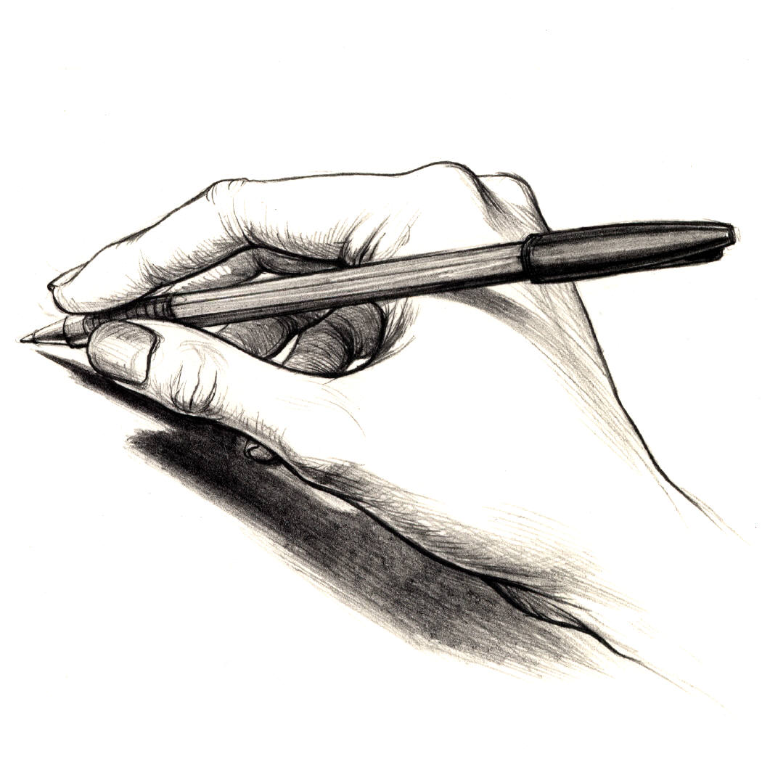

SATs Preparation
2008

What is the SATs Writing Test?

- The SATs Writing Paper is 1 hour 15 minutes long.

- There are two tasks on the Writing Paper.

- Section A is the longer writing task – you should spend 45 minutes on this section and it is worth 30 marks.

- Section B is the shorter writing task – you should spend 30 minutes on this section and it is worth 20 marks.

What will I have to write?

In Section A you will have to write a text that either:

- persuades the audience to think or do something.
- argues a point of view
- advises the audience how to do something.

In Section B you will have to write a text that either:

- imagines that you are in a particular role.
- explores an imagined situation.
- entertains that audience

What will I get marks for?

- Writing imaginative and interesting texts

- Writing texts which are suitable for their audience and purpose.

- Writing texts that are well organised in paragraphs and carefully linked together.

- Writing texts where you have used different sentence lengths and language for effect.

- Writing texts where the spelling and punctuation are accurate.

Section 1: Audience and Purpose

Audience and Purpose are the two most important things to consider before you begin writing any text. If you understand these two key points before you write, then your text will be successful.

AUDIENCE

The AUDIENCE of a text is the person or group of people that the text is written for.

PURPOSE

The PURPOSE of a text is the reason that it has been written by the writer.

Before you start to write any text, you need to be clear who (audience) you are writing for and what (purpose) you are trying to achieve in the text.

If you understand these two things then your text will be a success!

Section 1: Audience and Purpose

- In the table below are a series of texts, you need to match the texts with the possible audiences and purposes that are in the grid at the bottom of the page.

Audience and Purpose
Text | Audience | Purpose
Anti-Smoking Leaflet
Advert for a Nokia Mobile Phone in Cosmo Girl Magazine
Letter to the Council to Protest Against Sport Centre Closure

The School Newsletter
A Fire Exit Sign

AUDIENCE
Parents Teenage Girls Smokers Local Politicians
The General Public
PURPOSE
To inform To persuade To advise To entertain To instruct

Section 1: Audience and Purpose

- Complete the charts below writing on the different audiences each text might have.

A Harry Potter novel
Leaflet from your local Leisure Centre
Section 1: Audience and Purpose

- Complete the charts below writing all the different types of text that could have each purpose.

To inform

To Persuade

Section 1: Audience and Purpose

To entertain

To instruct

Section 1: Audience and Purpose

- Look at the different texts in the tables below and write down who you think the audience is and what the purpose is.

Text | Audience | Purpose
Letter to the Head about the state of the Girls’ Toilets

Leaflet about the dangers of Mobile Phone use
NME Guide to the Ten Top Festivals of 2008
Instructions on how to construct an ACER desktop PC
Match day programme from Arsenal-Manchester United.
Sugar article on a new range of cosmetics

SATs Writing Test

Section 2
The Longer Writing Task

The Longer Writing Task

- You will plan this section for 15 minutes.

- You will then write your response in 45 minutes.

- You will write a text that is to persuade, argue or advise the audience.

- This section is marked out of 30.

Writing to Persuade, Argue, Advise

What do we do when we write to PERSUADE?

When we write to persuade we are trying to make the audience do or think something that they had not originally intended to. In other words, we are trying to change someone’s mind. Therefore, we have to use language carefully to make sure that they come to agree with us.

What do we do when we write to ARGUE?

When we write to argue, just like when we write to persuade, we are aiming to convince the reader of a particular point of view. We may still be trying to get them to think or do something, but in this situation we are trying to promote a particular point of view. However, just like when we write to persuade, hopefully, by the time the audience have finished reading our text, they will agree with us.

What do we do when we write to ADVISE?

When we write to advise, we are offering advice to the reader so that they can make an informed decision about something. This is similar to the previous two types of writing because we might hope that by giving the reader particular advice, they will then come to share our point of view.

Feature of Language | Example | Explanation | Per | Arg | Adv | Your Own Example
Emotive Adjectives | Outrageous, horrific, unbelievable, fantastic, breathtaking | These are adjectives that appeal to the reader’s feelings and emotions
Powerful Verbs | Must, stop, act, believe, think, do | These are verbs that demand action from the reader
Exaggeration | This will be the single greatest mistake you will ever make. | This helps to show the reader the importance of acting upon what is written.
Triple Adjectives | This was one of the most brutal, cold and barbaric acts I’ve ever seen. | This helps to add emphasis to a point that is being made.
Personalisation | ‘You’ ‘We’ ‘Us’ ‘They’ | If you use words like this it helps to make the reader feel like they are being included and valued.
Rhetorical Question | How would you react if this was your only chance? | Rhetorical questions help to make the audience think about what has been written.
Feature of Language | Example | Explanation | Per | Arg | Adv | Your Own Example
Facts and Statistics | A recent survey found that 75% of people thought this was a terrible idea. | Using facts and statistics like this helps to persuade the reader because it makes the writing seem factually true.
Alliteration | Britain’s best bargains | This is effective because it is memorable. The repetition of the same sound makes the words stick in the mind.
Connectives | Therefore, Moreover, As a result, Firstly/ Secondly/ Thirdly | Connectives help to make the text seem logical, this helps to the reader to follow the argument you are making.
By using the features of language in the table above, you can make sure that you’re writing is carefully organised and persuasive.

Writing to Persuade, Argue, Advise: Practice Tasks

The government has decided that serious crime in Britain has become such a problem that they are going to consider reintroducing the death penalty for murder. You and your group of friends have been discussing this news. You have been nominated by your friends to write a letter to the government to outline your different points of view about the death penalty.

You have heard some of the following comments made by your friends about the death penalty:

If they reintroduce the death penalty, at least then people will get properly punished rather than just being locked up for a few years!
We can’t bring back hanging! It’s cruel and doesn’t help to solve the real problems! I think it’s a bad idea. We have got to help criminals learn to lead better lives!
What if they get the wrong man? We can’t bring people back once they’ve been killed can we? The risk is far too great!

It will be a good deterrent! Criminals will think twice before they commit a crime, especially if they know that it might cost them their lives!

Write a letter to the Justice Minister, Jack Straw, informing him of the different views held by you and your friends.

You should outline both sides of the debate and suggest alternative points of view where appropriate.

You should present your letter with consideration given to layout.

Tick off the different features in the checklist below when you have included them in your letter:

Addresses |  | Rhetorical Questions
Date |  | Personal Pronouns
Strong Opening |  | Emotive Adjectives
Strong Conclusion |  | Facts and Statistics
Paragraphs |  | Connectives
Appropriate Closing |  | Spelling

PLANNING SHEET

Use the spaces below to organise your ideas

Arguments for the Death Penalty

Arguments Against the Death Penalty

Introducing Your Letter
(Plan what you will write when you open your letter)

Closing Your Letter
(Plan what you will write when you conclude your argument)

You and your friends have noticed a steady decline in the quality of school dinners recently and are most concerned. You have decided that you will write a letter on behalf of your group of friends to the Head complaining about the quality of the food and to make suggestions on how this might be improved in the future.

You have heard the following comments made by your friends:

There used to be so much choice and now it’s always the same! I’m bored with school dinners; I’d rather go into town so I can have more choice!
The prices have gone up so much! It used to cost a lot less for better food and now it costs me a bigger chunk of my allowance for food I don’t even like!
I know it’s important to be healthy, but I want to be able to have chips more regularly, and what happened to all the chocolate cakes?

When we go in last for lunch, there’s hardly anything left, and what is there isn’t very appetising: it’s cold, dry and tastes like cardboard!

Write an article for the school newspaper arguing for an improvement in the quality of school dinners .

Tick off the different features in the checklist below when you have included them in your letter:

 |  | Rhetorical Questions
 |  | Personal Pronouns
Strong Opening |  | Emotive Adjectives
Strong Conclusion |  | Facts and Statistics
Paragraphs |  | Connectives
Appropriate Closing |  | Spelling
PLANNING SHEET

Use the spaces below to organise your ideas:

Concerns about School Dinners:

Suggestions for Improving School Dinners:

Save Our Sports Centre
(Past SAT Task)

Your local Sports Centre is going to be closed down. People have been told they can use another centre 20km away.

You want to start a campaign to save the Sports Centre. You decide to write a letter to everyone who lives in the area, arguing that the Sports Centre should be saved and persuading them to get involved in the campaign.

You have heard people say:

Our Sports Centre has clubs and classes for people of all ages so that they can keep fit.
Getting to the other Sports Centre will be difficult.
I meet my friends in the coffee shot while our children swim.
What can I do to help save the Sports Centre.

Write a letter to local people persuading them to join the campaign to save the Sports Centre.

Do not include an address.

30 marks.

Planning Page

- Reasons why the Sports Centre is important to local people of all ages.

- Different ways in which people could help with the campaign.

SATs Writing Test

Section
The Shorter Writing Task

The Shorter Writing Task

- You will write your response in 30 minutes.

- You will write a text that is to imagine, explore or entertain.

- This section is marked out of 20.

Writing to Imagine, Explore or Entertain

The shorter writing task essentially asks you to use your imagination and write in a thoughtful and inventive way. You need to show the examiner that you can use language in an inventive and imaginative way in this section of the exam paper.

Types of Writing to Imagine, Explore or Entertain Tasks

- An article about an imagined event at your school
- The opening of a novel
- A description of a particular experience

Complete the chart on the following pages to think about the features of this kind of writing.

Feature of Language | Example | Explanation | Per | Arg | Adv | Your Own Example
Similes
Metaphors

Personification
Strong Adjectives

Dialogue

Feature of Language | Example | Explanation | Per | Arg | Adv | Your Own Example
Different Sentences Lengths for Effect

Connectives to link the Events

A clear narrative voice
Carefully linked paragraphs

Planning your Response

When you are writing your response, you could use a chart like the one below to organise your ideas.
Put your ideas in paragraph order:
Jot down some ideas about the type of language that you will use:

PLAN

Make a list of the connectives that you will use:
Add any extra information that you will need to write your piece:

Writing to Imagine, Explore and Entertain
Practice Tasks

Imagine that a well-known person has just opened a new food technology room in your school. You had to look after the visitor while other Year 9 pupils demonstrated their cooking skills.

The Head of Year sends you a note:

You did a good job looking after the visitor – particularly when the pizzas got burnt…

We need an entertaining article about the visit for the school website. I’m sure parents will enjoy reading about it.

Write the article about the visit, for parents to read.

20 marks including 4 marks for spelling.

Writing to Imagine, Explore and Entertain
Practice Tasks

Imagine that you work for a health food company. Your company has been working on a new brand of healthy soft drink in different fruit flavours. Your company wants to sell the product in school vending machines.

The Head of Production has sent you this note:

The fruit drink is now ready to go into schools. Before it does can you let us know if there are any last minute improvements or changes that need to be made to the product.

Have your report on my desk by this afternoon.

Write the report about the drink for your Head of Production.

20 marks including 4 marks for spelling.

Writing to Imagine, Explore and Entertain
Practice Tasks

Imagine that you are a writer. You have been reading the local newspaper and found a story about a strange animal that is roaming across the North Yorkshire Moors in the middle of the night. Many people claim to have seen the animal, some even say that it has tried to attack them.

You receive this note from your publisher.

This wild animal is causing a real stir.

We want to make the most of this. We want you to write the opening chapter of a mystery novel featuring the mysterious wild animal.

Can you give particular attention to describing the animal, its behaviour and what it does when approached by human beings.

Send your first chapter by the end of the week.

Write the opening chapter of the novel.

20 marks including 4 for spelling.

