Character: Boxer Novel: Animal Farm
Important page refs:

Background:

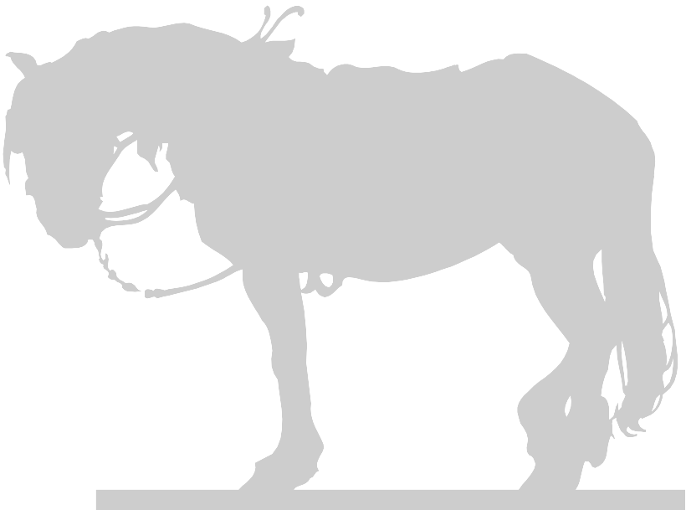

Appearance:

Things he says:

Actions (things he does)

Things others say about him:

Represents:

Things others do around or to him:

Relationship with others:

What happens to him and changes (if any) to his character:

Best ten quotes for Boxer:

Character: Mollie
Important page references:

Background:

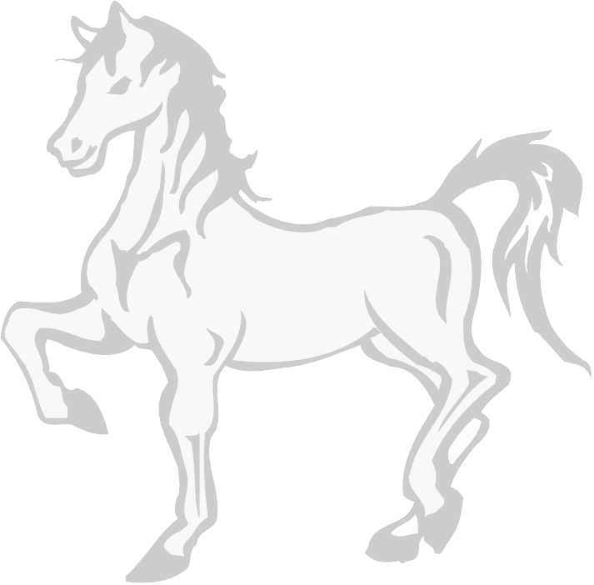
Appearance:

Things she says:

Actions (things she does):

Things others say about her:

Represents:

Novel: Animal Farm

Things others do around or to her:

Relationship with others:

What happens to her and changes (if any) to character:

Best five (ten) quotes for Mollie:

Character: Snowball
Important page references:

Background


Appearance:

Things he says:

Actions (things he does):

Things others say about him:

Represents:

Novel: Animal Farm

Things others do around or to him:

Relationship with others:

What happens to him and changes (if any) to character:

Best ten quotes for Snowball:

Character: Squealer
Important page references:

Background:

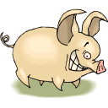
Appearance:

Things he says:

Actions (things he does):

Things others say about him:

Represents:

Novel: Animal Farm

Things others do around or to him:

Relationship with others:

What happens to him and changes (if any) to character:

Best ten quotes for Squealer:

Character: Napoleon
Important page references:

Background:

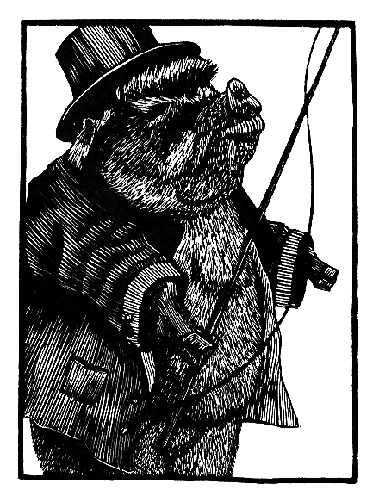
Appearance:

Things he says:

Actions (things he does):

Things others say about him:

Represents:

Novel: Animal Farm

Things others do around or to him:

Relationship with others:

What happens to him and changes (if any) to character:

Best ten quotes for Napoleon:

Character: Benjamin
Important page references:

Background:



Appearance:

Things he says:

Actions (things he does):

Things others say about him:

Represents:

Novel: Animal Farm

Things others do around or to him:

Relationship with others:

What happens to him and changes (if any) to character:

Best ten quotes for Benjamin:

Character: Mr. Jones
Important page references:

Background:

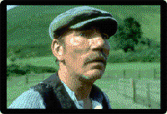
Appearance:

Things he says:

Actions (things he does):

Things others say about him:

Represents:

Novel: Animal Farm

Things others do around or to him:

Relationship with others:

What happens to him and changes (if any) to character:

Best ten quotes for Mr. Jones:

Character: Old Major
Important page references:

Background:

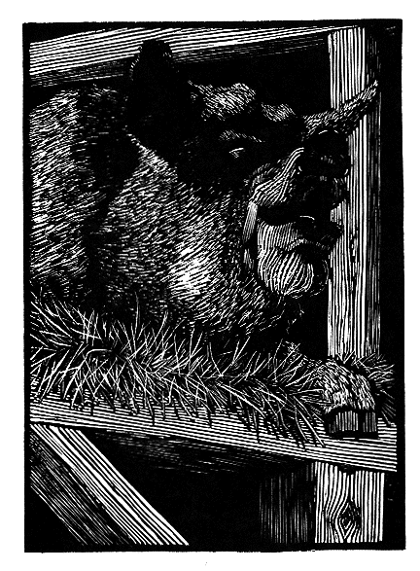
Appearance:

Things he says:

Actions (things he does):

Things others say about him:

Represents:

Novel: Animal Farm

Things others do around or to him:

Relationship with others:

What happens to him and changes (if any) to character:

Best ten quotes for Old Major:

Character: Moses
Important page references:

Background:

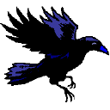

Appearance:

Things he says:

Actions (things he does):

Things others say about him:

Represents:

Novel: Animal Farm

Things others do around or to him:

Relationship with others:

What happens to him and changes (if any) to character:

Best (five) ten quotes for Moses:

Character: Muriel
Important page references:

Background:

Appearance:

Things she says:

Actions (things she does):

Things others say about her:

Represents:

Novel: Animal Farm

Things others do around or to her:

Relationship with others:

What happens to her and changes (if any) to character:

Best five (ten) quotes for Muriel:

Character: Clover  Important page refs:  Key Moments: |  |  | Key Quotation(s):
Character: The Cat  Important page refs:  Key Moments: |  |  | Key Quotation(s):
Character: The Dogs  Important page refs:  Key Moments: | 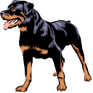 |  | Key Quotation(s):
Character: The Sheep  Important page refs:  Key Moments: |  |  | Key Quotation(s):
Character: Whymper  Important page refs:  Key Moments: |  | Key Quotation(s):
Character: Mr. Frederick  Important page refs:  Key Moments: |  | Key Quotation(s):
Character: Mr. Pilkington  Important page refs:  Key Moments: |  | Key Quotation(s):

