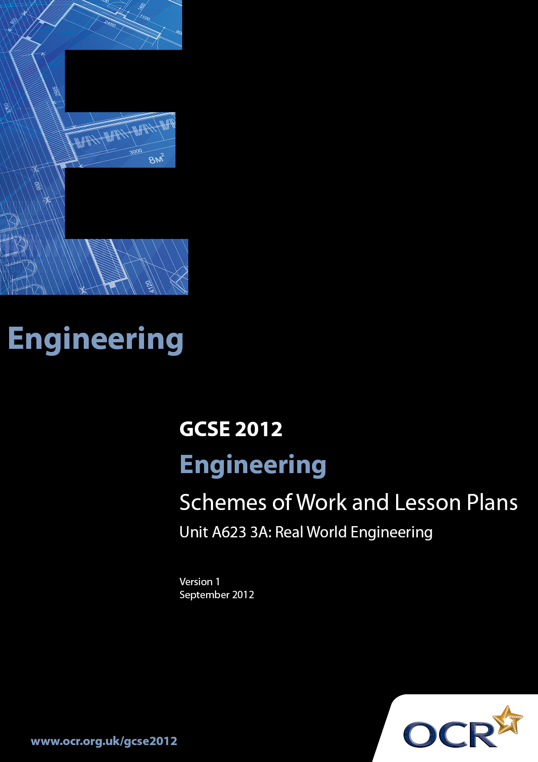

Contents
Introduction 3
Sample Scheme of Work: OCR GCSE Engineering J344 Unit A623 3A:
Real World Engineering 5
Sample Lesson Plan: OCR GCSE Engineering J344 Unit A623 3A:
Real World Engineering 9

Introduction

Background
OCR has produced a brochure, which summarises the changes to Engineering. This can be found at www.ocr.org.uk along with the new 2012 specification.
In addition and in response to reforms announced by the Government and in response to Ofqual mandated changes to GCSEs, unitised assessment of this qualification is being replaced by linear assessment from September 2012. This means that candidates commencing a two year course from September 2012 will take all of their GCSE units at the end of the course in June 2014.
In order to help you plan effectively for the implementation of the specification we have produced these Schemes of Work and Sample Lesson Plans for Engineering. These Support Materials are designed for guidance only and play a secondary role to the Specification.

Our Ethos
OCR involves teachers in the development of new support materials to capture current teaching practices tailored to our new specifications. These support materials are designed to inspire teachers and facilitate different ideas and teaching practices.
Each scheme of work and sample Lesson Plans are in Word format to be used as a foundation to build upon and amend the content to suit your teaching style and students’ needs.
The scheme of work and sample Lesson Plans provide examples of how to deliver these units and suggested teaching hours which could be applicable to your teaching.
The Specification is the document on which assessment is based and specifies what content and skills need to be covered in delivering the course. At all times, therefore, this Support Material booklet should be read in conjunction with the Specification. Any clarification should be found in the Specification.

A Guided Tour through the Scheme of Work

= Innovative Teaching Idea
This icon is used to highlight exceptionally innovative ideas.


= ICT Opportunity
This icon is used to illustrate when an activity could be taught using ICT facilities.

OCR GCSE Engineering J344 Unit A623 3A: Real World Engineering
Suggested teaching time | 40 hours | Topic | Real world engineering
Topic outline |  | Suggested teaching and homework activities |  | Suggested resources | Points to note
Unit Overview: Candidates will study the engineering of a product. The engineering of the product could be observed through ‘real-life’ experiences such as industrial visits or work experience. Alternatively the product could be researched using commercially or centre-produced resource materials.
This Controlled Assessment unit is one section of Unit A623 (Part A) and both sections (parts A and B) must be completed and entered for moderation at the same time.
In this unit, candidates will consider:
- stages in engineering a product
- production details and constraints
- material and constraints
- systems and control technology
- modern technologies
Indicate the stages in engineering a product  Candidates should be able to:  - identify and fully explain all the stages in engineering the product  Consider production details and constraints  Candidates should be able to identify and fully explain the production details and constraints to include:  - labour;  - available technology;  - quality standards;  - handling and storage.  Identify materials and constraints  Candidates should be able to:  fully consider the identified product giving detail, and justify all materials and components and their constraints through their availability, form and supply  Consider systems and control technology  Candidates should be able to:  identify and fully explain systems and control technology, and to organise, monitor and control production of the product |  | - Candidates are required to undertake the study of an engineered product from the first stage of production through all the associated stages up to the completed item being delivered to the client.  - The course should be structured in an integrated way to avoid students being presented with disjointed activities.  - For this unit the different aspects of each topic should be addressed but a centre based mapping exercise would need to be undertaken to ensure full and re-enforced coverage.  - Product analysis or reverse engineering (the process of learning how a product is made by taking it apart and examining it) is the key approach to this unit but with hands on being most desirable.  - The careful selection of various studied used in various lessons should result in the full coverage of all the topics in this unit (see lesson plan as an example)  - The careful selection of various products studied over a period of time during set lessons should result in the full coverage of all the topics in this unit (see lesson plan as an example)  - A centre generated bank of questions to be asked during disassembly / reverse engineering activities, industrial visits, technical and other videos experienced by students should be designed to encourage an analytical interest in engineered products.  - An open ended method to suit the centre to enable students to establish what things are made from, how they are made and why was that process used should form the basis of this unit. Natural extensions of the impacts of the products and production methods (including materials) should be built in.  Student expectations  - Students should expect to become analytical by nature and seek to ask questions themselves and obtain answers making value judgements as to their quality and relevance.  - Group Product Analysis is both permissible and desirable for non controlled assessment work. |  | - Charts and flow diagrams on teaching room walls may serve to provide a holistic view of the course or unit. These would need to be centre generated to be centre and sector specific resources.  - To avoid problems with the Ofqual controlled Assessment requirements products listed on page 53 can be modified to allow practise activities where teachers can support and feed back prior to the actual controlled assessment activity taking place. Some examples are:  Products listed in specification = Modified for teaching  Aluminium saucepan = stainless steel flying pan  Artificial limb = hearing aid  Calculators = hand held spell checker  Climbing frame = child’s swing  Computer mouse = satnav  Dehumidifier = electric heater  Dental accessories = opticians equipment  Digital cameras = mobile phones  Domestic iron = vacuum cleaner  Electric kettle = infrared grill  Electric plug top = domestic light fitting  Electric toaster = hand blender  Electronic door locking systems = car alarm  Garage doors = loft door  Garden gate = child’s stair safety gate  Other resources:  - www.engineering.com/Videos/tabid/4624/Default.aspx  - http://www.mechanicalengineering.tv/  - http://videos.howstuffworks.com/science/engineering-videos.htm  - http://www.teachers.tv/engineering  - Hodder Education Design & Technology ISBN 978-0-340-96634-1 | - This Controlled Assessment unit is divided into two sections (A and B) and both sections must be completed and entered for moderation at the same time.  - Candidates must select one of the products listed as a starting point for the activity. Through investigating the product, candidates, working in teams, can devise their own particular starting point.  Controlled Assessment  - Task Setting will have a:  High level of control  - A number of controlled assessment tasks are available in the engineering specification document  - Tasks may be adapted  - Tasks must not be used as practice material and then carried forward as live material  - Task Taking will have a:  Medium level of control  - Authenticity – Centre must be able to authenticate the work  - Centre can feedback/monitor progress, supervise practical work, ensure work meets OCR specification requirements  - Time - to be completed within the specified time limit  - Collaboration – all work must be completed/evidenced individually  - Resources – provide access to the most appropriate tools and equipment  - Candidates may access resources, commercial processes available outside the Centre environment  - Sensible restrictions should be in place on the use of internet material  - Task Marking will have a:  Medium level of control  - All controlled assessed units are marked by the Centre  - Postal moderation/e-moderation will apply  -  Centres may wish / allow students to undertake a practise or trial run using one of the products from the list as but are advised that the QCA (Ofqual) regulations on controlled assessment will apply. The important issue is “Tasks must not be used as practice material and then carried forward as live material” Therefore the work carried out for assessment must be clearly separated from any practise activities to avoid any compromise of assessment for an individual student or the centre as a whole.  - If this approach is taken by centres care should be taken to avoid products which have too much common content for example Electronic door locking systems and Mortise locks. Such combinations are not prohibited but the above bullet point must be strictly adhered to.

OCR GCSE Engineering J344 Unit A623 3A: Real World Engineering

Extrusion
Using a product from Appendix B: uPVC window. (Therefore not to be used by students for their assessable submission)
OCR recognises that the teaching of this qualification above will vary greatly from school to school and from teacher to teacher. With that in mind this lesson plan is offered as a possible approach but will be subject to modifications by the individual teacher.
Lesson length is assumed to be one hour.

Learning Objectives for the Lesson
Objective 1 | Students to understand the principle of extrusion
Objective 2 | Students to understand the advantages and disadvantages of extrusion process
Objective 3 | Students to know an appropriate range of plastics and metals which can readily extruded
Objective 4 | Students to be able to give a fully detailed and justified explanation of the extrusion process and the materials used
Objective 5 | Students to relate (various) topics from the SOW during this study for example “labour”, “quality standards” and “materials availability and form”.

Recap of Previous Experience and Prior Knowledge
- Lesson on injection Moulding undertaken as part of Unit A621 A

Content
Time | Content
5 minutes | Recap on injection moulding from lesson 2 unit A621A.
10 minutes | Quick “fun” demonstration of extrusion. Use of icing bag or toothpaste tube. Icing is liquid an will set during the lesson. This allows for the cutting into sections of the icing and distribution to students to eat (H&S being considered). An excellent “lesson reminder for the future.  Explanation of what extrusion is in an industrial sense  Explanation of relationship between injection moulding and extrusion
5-10 minutes | Video, CD-ROM or film of an industrial situation could be used to support a more detailed explanation of the process.  This might be followed by questions form students.
15 minutes | Handling by students of a number of extruded products including a section of uPVC window frame. Other examples: electric cabling, pins from electric plug tops, plastic drinking straws, hosepipe, door handles, brass hinges, aluminium window frames, some plastic pens, biro refills. The range should include Brass, Aluminium and plastics product to cover the readily extrudeable range of engineering materials.
10 minutes | Teacher input and discussion of the advantages of extrusion: indefinite lengths of a profile, easy modification to profiles by die modification, cost effective manufacture for complex shapes (plug top pins) for mass production, co-extrusion opportunities

Consolidation
Time | Content
5 minutes | Recap on lesson content and the materials capable of being extruded and the advantages of extrusion with questions and answers
10 minutes | Homework. Students to identify one different extruded product or component to the ones covered in the lesson. Product analysis of that product to include alternative methods of manufacture, alternative materials and modifications to extend the usage or reduce the production costs. Format: sketched drawing of component / product with detailed annotations

