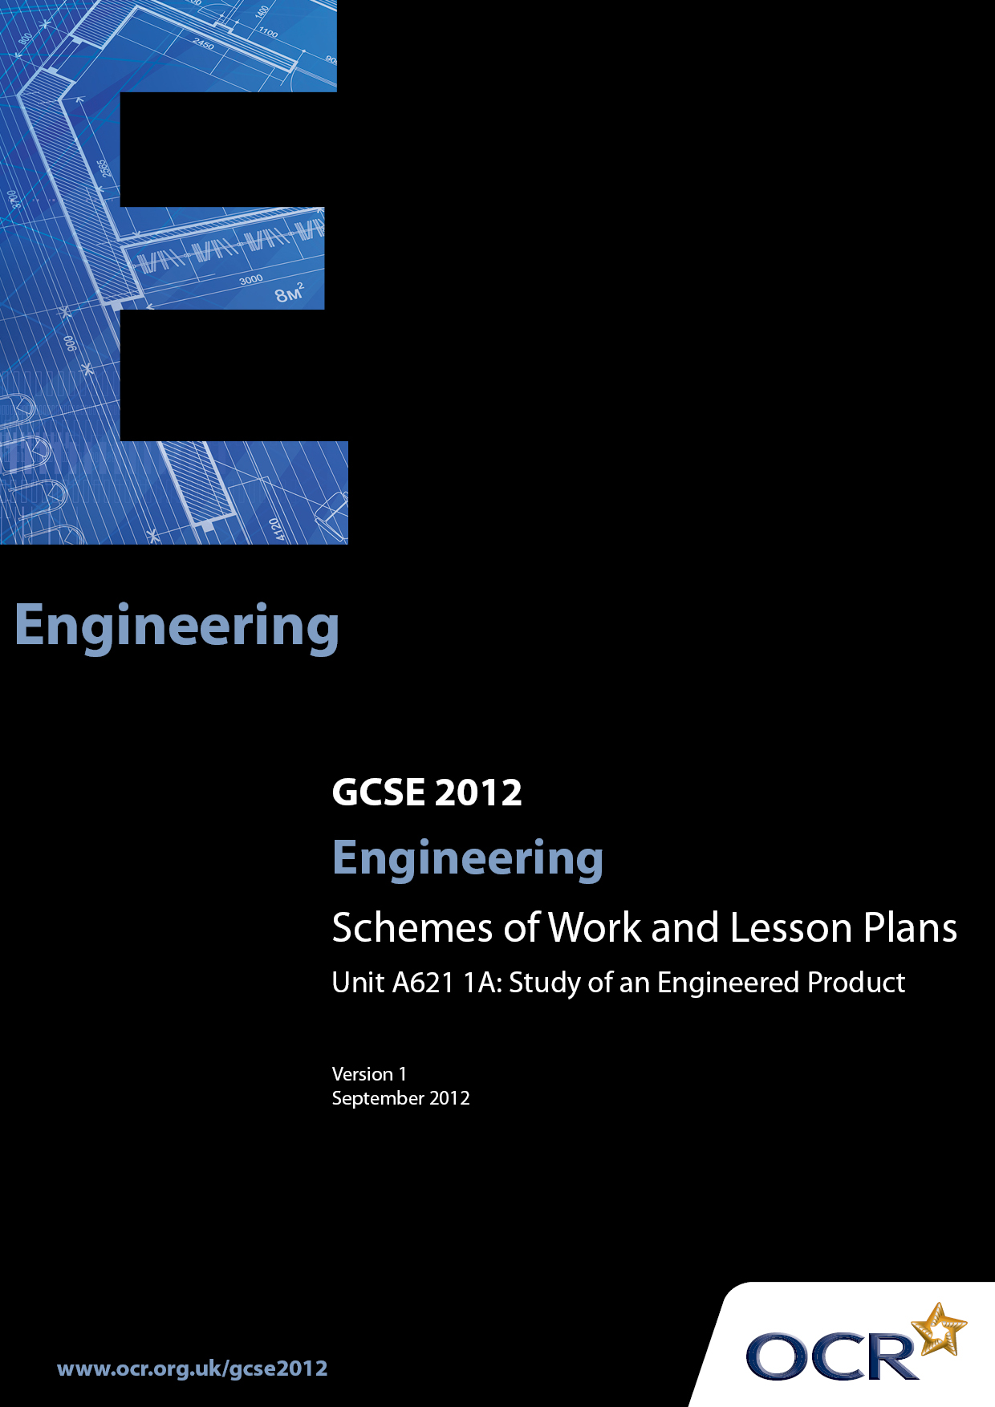

Contents
Introduction 3
Sample Scheme of Work: OCR GCSE Engineering J322 J344: Unit A621:
1A: Study of an Engineered Product 5
Sample Lesson Plan: OCR GCSE Engineering J322 J344: Unit A621: 1A:
Study of an Engineered Product 9

Introduction

Background
OCR has produced a brochure, which summarises the changes to Engineering. This can be found at www.ocr.org.uk along with the new 2012 specification.
In addition and in response to reforms announced by the Government and in response to Ofqual mandated changes to GCSEs, unitised assessment of this qualification is being replaced by linear assessment from September 2012. This means that candidates commencing a two year course from September 2012 will take all of their GCSE units at the end of the course in June 2014.
In order to help you plan effectively for the implementation of the specification we have produced these Schemes of Work and Sample Lesson Plans for Engineering. These Support Materials are designed for guidance only and play a secondary role to the Specification.

Our Ethos
OCR involves teachers in the development of new support materials to capture current teaching practices tailored to our new specifications. These support materials are designed to inspire teachers and facilitate different ideas and teaching practices.
Each scheme of work and sample Lesson Plans are in Word format to be used as a foundation to build upon and amend the content to suit your teaching style and students’ needs.
The scheme of work and sample Lesson Plans provide examples of how to deliver these units and suggested teaching hours which could be applicable to your teaching.
The Specification is the document on which assessment is based and specifies what content and skills need to be covered in delivering the course. At all times, therefore, this Support Material booklet should be read in conjunction with the Specification. Any clarification should be found in the Specification.

A Guided Tour through the Scheme of Work

= Innovative Teaching Idea
This icon is used to highlight exceptionally innovative ideas.


= ICT Opportunity
This icon is used to illustrate when an activity could be taught using ICT facilities.

OCR GCSE Engineering J322 J344: Unit A621: 1A: Study of an Engineered Product
Suggested teaching time | 40 hours | Topic | Study of an engineered product
Topic outline |  | Suggested teaching and homework activities |  | Suggested resources | Points to note
Unit Overview: This Controlled Assessment unit is divided into two sections (A and B) and both sections must be completed and entered for moderation at the same time.
Candidates will investigate a variety of engineered products detailed by OCR that have been developed through the use of modern technology. The impact of modern technology on design and production will be assessed across products from a range of engineering industries.
Candidates will then focus on a particular product selected from a list provided in the OCR specification together with two more modern equivalents of the same product. They will evidence their research for inclusion within a portfolio, which may be completed electronically or in printed format.
In this unit, the candidate will consider:
- the impact of modern technologies;
- production details (materials and components, available technology);
- engineering processes;
- design solutions
Impact of modern technologies  Candidates should be able to give a fully detailed description of:  - the impact of modern technologies, smart materials and components on their development  - the advantages and disadvantages that the use of modern technology has brought to society  Production details (materials and components, available technology)  Candidates should be able to give a fully detailed and justified explanation of the use of materials and components and their:  - properties;  - characteristics;  - performance;  - cost  Engineering processes  Candidates should be able to give a fully detailed and justified explanation of the engineering processes used.  Design solutions  Candidates should be able to suggest and explain in detail:  - design solutions;  - sustainability issues |  | - Through regular Product Analysis - now referred to as “reverse engineering” (the process of learning how a product is made by taking it apart and examining it) and other supportive activities a broad body of knowledge and understanding will be acquired to enable candidates to explain why products are like they are and the effects and impacts they have during their manufacture, use and disposal.  - Candidates are required to undertake the study of an engineered product from the first stage of production through all the associated stages up to the completed item being delivered to the client.  - The course should be structured in an integrated way to avoid students being presented with disjointed activities.  - For this unit the different aspects of each topic should be addressed but a centre based mapping exercise would need to be undertaken to ensure full and re-enforced coverage.  - The careful selection of various products studied over a period of time during set lessons should result in the full coverage of all the topics in this unit (see lesson plan as an example)  - A centre generated bank of questions to be asked during disassembly / reverse engineering activities, industrial visits, technical and other videos experienced by students should be designed to encourage an analytical interest in engineered products.  - An open ended method to suit the centre to enable students to establish what things are made from, how they are made and why was that process used should form the basis of this unit. Natural extensions of the impacts of the products and production methods (including materials) should be built in.  Student expectations  - Students should expect to become analytical by nature and seek to ask questions themselves and obtain answers making value judgements as to their quality and relevance.  - Group Product Analysis is both permissible and desirable for non controlled assessment work. |  | - 1920s Window Frames  - 1940s Cooking Pans  - 1900s Camera  - 1940s Lawn Mower  - 1950s Crown Cap  - 1960s Car radio  - 1960s Moped  - 1950s Toothbrush  - 1950s Ironing Board  - 1950s Mini Cooper  - 1980s Mobile Phone  - 1920s Wheelbarrow  - 1920s Vacuum Cleaner  - 1920s Iron  - 1980s Printer  - 1900s Lamp Post  - 1950s Sports Equipment  - 1940s Spitfire Aircraft  Other resources:  - www.engineering.com/Videos/tabid/4624/Default.aspx  - http://www.mechanicalengineering.tv/  - http://videos.howstuffworks.com/science/engineering-videos.htm  - http://www.teachers.tv/engineering  - Hodder Education Design & Technology ISBN 978-0-340-96634-1 | - Candidates should select one of the products from Appendix B, page 51 (shown in suggested resources column) of the specification, as a starting point for the controlled assessment project.  - When analysing the product they will need to identify two similar products that have been subsequently developed using modern technology.  - Any number of the products listed  may be used as teaching vehicles but the list is not prescriptive.  - Care should be taken to avoid using products in the teaching activity which the candidates might select for the completion of their controlled assessment. The list  in the resources column comprises of a number of products which are similar in nature and would be ideal for pre-assessment activity. See below.  - The important issue is “Tasks must not be used as practice material and then carried forward as live material” Therefore the work carried out for assessment must be clearly separated from any practice activities to avoid any compromise of assessment for an individual student or the centre as a whole.  - Teachers to capitalise on local industries, personal knowledge, students’ interests, topical events or sporting events. Even something as simple as School Sports Day and the Javelin event is an opportunity for working through the materials and technologies used in the production of javelins; from wood to the modern powder coated shafts made from high quality hardened aluminium alloy, duraluminium, fibreglass or carbon fibre with steel tips.

OCR GCSE Engineering J322 J344: Unit A621: 1A: Study of an Engineered Product

Product Analysis: Focus: Injection Moulding
OCR recognises that the teaching of this qualification above will vary greatly from school to school and from teacher to teacher. With that in mind this lesson plan is offered as a possible approach but will be subject to modifications by the individual teacher.
Lesson length is assumed to be one hour.

Learning Objectives for the Lesson
Objective 1 | Students to understand the principle of product analysis
Objective 2 | Students to understand the strengths and weaknesses of various products
Objective 3 | Students to know an appropriate range of plastics materials, and their properties which can be injection moulded
Objective 4 | Students to be able to give a fully detailed and justified explanation of the injection moulding process and the materials used

Recap of Previous Experience and Prior Knowledge
Moulding: Known methods of moulding. E.g. vacuum forming
Strengths and weaknesses of method
Processes: vacuum forming, mould making principles, drape, no undercut edges, breather holes
Safety: Appropriate care with any physical disassembly. Risk assessing product e.g. A microwave oven would be a complete non starter for physical disassembly but acceptable for virtual disassembly. Use of tools, disposal of component parts safely, consideration of others
Re-enforcement Activities: Clear understanding of the follow up activity of recording the events of the session e.g. The use of a partially printed sheet with images of important stages and space for student annotations.

Materials and Equipment required for demonstration: | Method 1: Clear, informative images of a familiar product e.g. food mixer, hand blender, telephone. Dyson educational CD-ROM  Method 1: OHP, LCD projection, networked or standalone computers dependant on centre recourses  Method 2: Products which can readily and safely disassembled e.g. toaster, CPU, printers,  Method 2: Hand tools:- screwdrivers, pliers, spanners, Allen keys, star keys, punches, drifts, small ball pein hammer, scissors, craft knives
Materials and Equipment required for student practical: | As above in appropriate class sets.

Content Method 1: Lawn Mower
Time | Content
 | Register of students and collection of previous session’s homework
15 / 20 minutes | Product Analysis:  Image of eclectically operated lawn mower projected on the wall / screen  T Question to students “tell me about this product please”  S Probable response “it’s a lawnmower”.  T Fine, can you tell me anything about it?  S It’s got wheels!  T Good, so what? What about the wheels?  S They are quite big for the size of the lawnmower!  T Good, Why do you think that is then?  S So it can roll easily over rough ground?  T Yes – the bigger the wheel i.e. the larger the diameter (opportunity to introduce or re-enforce new vocabulary) the easier it will be to cope with undulations in the ground. A very small wheel would have to roll up and then down but a bigger wheel simply goes over the top of the humps and bumps. Anything else about the wheels?  S They are quite wide aren’t they?  T Yes – anyone think of why they are so wide?  S So they don’t sink in the ground if it’s been raining. (Opportunity later to capitalise on rain – water – electricity – safety)  T Excellent. Don’t know if I would want to cut the grass if it’s been raining but… anyway anything else about the wheels?  S Probably silence or slow response so prompting might be needed to get some comment about them being hollow.  T They are hollow which means they are lighter and so take less energy to push around. Any ideas of how they might be made?  And this then leads the teacher into blow moulding / rotational moulding and another theory input for another session.  The careful selection of products to analyse will structure the content of the course to cover the desired elements.  T Okay then the wheels are big in diameter because……………………..  They are wide because…………..  They are made by……………….  They are made from………………..  The problem with……………… is that…………………disposal………………….ultraviolet…………….And so on  T Now let’s look at other components of the lawnmower and why they are like they are.  The shell, handle, motor, axles, blades, switch, cord, etc. can all be explored and lead onto theory inputs of different types
Information point | Recording information:  Pre – printed part drawn image of the lawn mower can be produced as a class resource. This can be issued at the end of the lesson as a homework sheet. If there are labels and spaces to write notes and annotations this will re-enforce the learning during formal class disassembly
5 minutes | Explanation of the reasons for and value of Product Analysis outlined.  Students broken down into pairs and given quality (perhaps laminated for repeated use) images of various products which would be familiar.  The students are then asked to “disassemble and make Three lists of responses.  List 1 points of information that they factually know are correct  List 2 points that they are pretty sure of but need confirmation and an additional “link” given to them and a  List 3 will be a list of questions which they need answering.  Example: Product: hand blender  List 1 would probably include: comes apart for cleaning, needs no tools to take it apart, all smooth corners edges so easy to clean and dry after washing, electrically operated so safety is an issue in use and storage – dangling cords.

