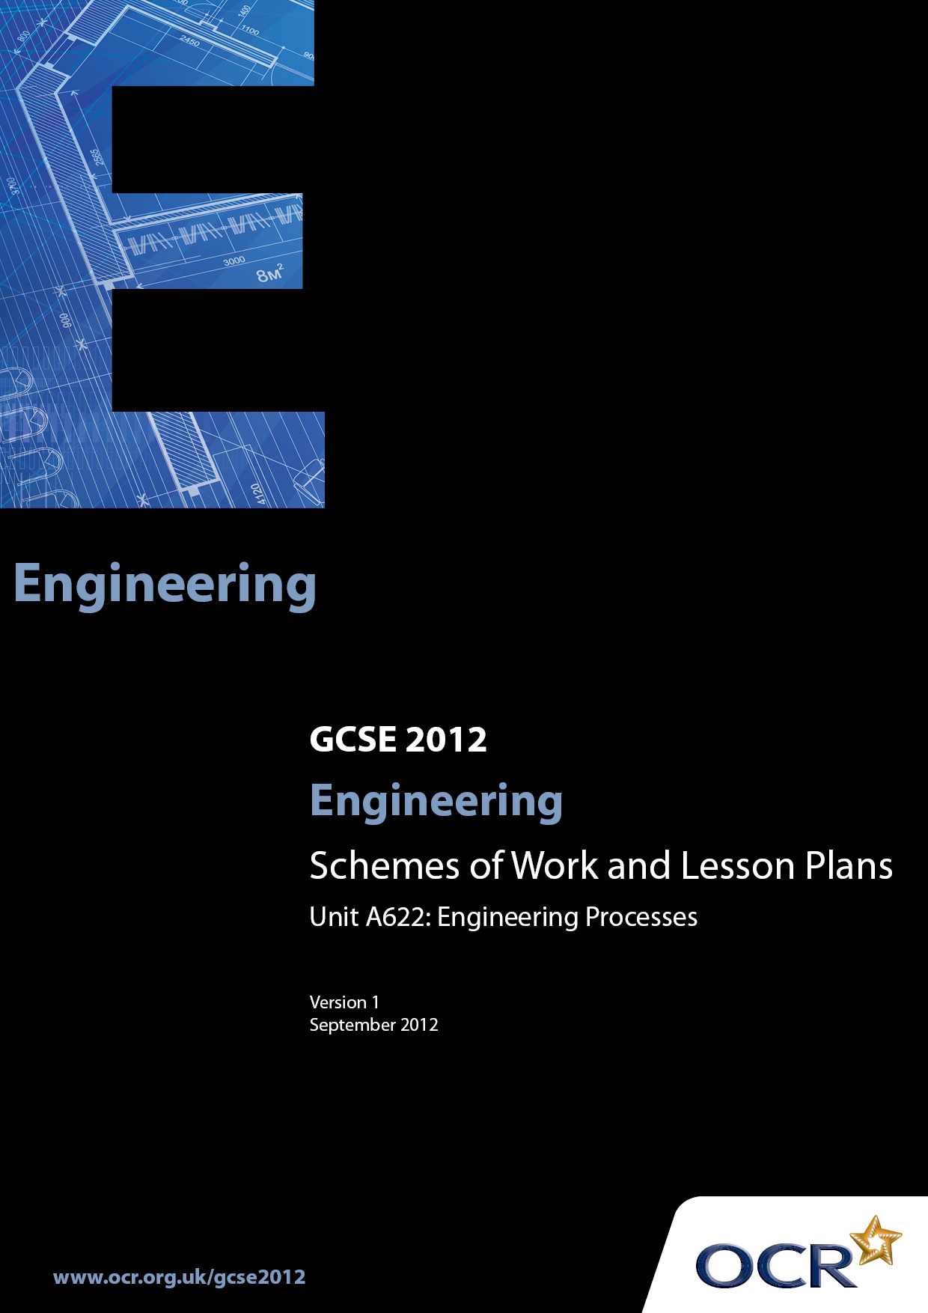

Contents
Introduction 3
Sample Scheme of Work: OCR GCSE Engineering J322 J344 Unit A622:
Engineering Processes 5
Sample Lesson Plan: OCR GCSE Engineering J322 J344 Unit A622:
Engineering Processes 15

Introduction

Background
OCR has produced a brochure, which summarises the changes to Engineering. This can be found at www.ocr.org.uk along with the new 2012 specification.
In addition and in response to reforms announced by the Government and in response to Ofqual mandated changes to GCSEs, unitised assessment of this qualification is being replaced by linear assessment from September 2012. This means that candidates commencing a two year course from September 2012 will take all of their GCSE units at the end of the course in June 2014.
In order to help you plan effectively for the implementation of the specification we have produced these Schemes of Work and Sample Lesson Plans for Engineering. These Support Materials are designed for guidance only and play a secondary role to the Specification.

Our Ethos
OCR involves teachers in the development of new support materials to capture current teaching practices tailored to our new specifications. These support materials are designed to inspire teachers and facilitate different ideas and teaching practices.
Each scheme of work and sample Lesson Plans are in Word format to be used as a foundation to build upon and amend the content to suit your teaching style and students’ needs.
The scheme of work and sample Lesson Plans provide examples of how to deliver these units and suggested teaching hours which could be applicable to your teaching.
The Specification is the document on which assessment is based and specifies what content and skills need to be covered in delivering the course. At all times, therefore, this Support Material booklet should be read in conjunction with the Specification. Any clarification should be found in the Specification.

A Guided Tour through the Scheme of Work

= Innovative Teaching Idea
This icon is used to highlight exceptionally innovative ideas.


= ICT Opportunity
This icon is used to illustrate when an activity could be taught using ICT facilities.

OCR GCSE Engineering J322 J344 Unit A622: Engineering Processes
Suggested teaching time | 20-30 hours | Topic | Engineering Processes
Topic outline |  | Suggested teaching and homework activities |  | Suggested resources | Points to note
Unit Overview: This is an examined unit using computer based testing. Questions will be a mix of short answer and free response styles, and will require candidates to demonstrate practical application of knowledge related to engineered products and engineering environments they have studied.
Candidates will consider:
- engineering materials and their properties
- the function of components
- the properties, characteristics and features of materials
- engineering processes
- quality control techniques and
- engineering a product
with knowledge and understanding being gained in a variety of ways during the course and also from final examination preparation.
Candidates could concentrate on one engineering sector and should study a range of products but study of more than one engineering sector and associated products would clearly advantage students.
Candidates will demonstrate knowledge and understanding of the following:  Engineering materials and their properties in the following groups:  - ferrous and non-ferrous metals and alloys;  - polymers;  - ceramics;  - composites that combine the properties of different materials  Function of components:  - mechanical components;  - electrical/electronic components;  - pneumatic/hydraulic components  The properties, characteristics and features of materials that affect their:  - ability to be shaped and formed  - ability to be treated  - ability to be given a surface finish  - ease of handling  - cost implications  - availability, form and supply  Engineering processes:  - material removal  - shaping and manipulation  - joining and assembly  - heat and chemical treatment  - surface finishing  Quality control techniques:  - checking task outcomes against design brief  - sampling  - comparing results with intended results  - action to be taken  New technology used in and by the engineering industries:  - information, communications and digital technologies – research, digital communication with clients, suppliers  - modern and smart materials and components – which are used in products manufactured in a chosen sector  - systems and control technology to organise, monitor and control production – basic control systems and technology in terms of input/output (IO) and feedback  Impact of modern technologies:  - when manufacturing an engineered product – impact on workforce, company and local environment  - on engineered products – to end user  - on engineering industries – sustainability  Stages in manufacturing an engineered product:  - design  - marketing  - production planning  - material supply and control  - processing and production  - assembly and finishing  - packaging and dispatch  - disposal  Advantages and disadvantages that the use of modern technology has brought to society including:  - redundancy  - working conditions  - cost  - availability of products  - impact on the environment  - training  - transport  - lifestyle  - Health and Safety  Engineered products:  - a variety of engineered products that use modern technology  - the impact of modern technology on the design and production of a range of engineered products  Designing a product:  - analysing client design briefs for engineered products  - producing, using and modifying design specifications for engineered products  - generating design solutions for engineered products  - reading, understanding and creating a range of appropriate engineering drawings to current industry standards  - presenting a design solution for engineered products  responding to client feedback  Engineering a product:  - producing and using production plans  - selecting and using a range of appropriate materials, parts and components  - selecting and using appropriate processes  - applying quality control techniques  - selecting and using appropriate tools and equipment  - applying health and safety procedures  - analysing and revising the completed product, taking into account how it could be improved |  | - It is suggested that the SOW for this unit has two parts.  Part A: the topic content is fully interwoven with that of unit A 621 parts A and B if candidates are undertaking the Single Award and A621 parts A and B, plus A623 parts A and B for candidates undertaking the Double award. For these candidates, integration of some of the necessary preparation for A 624 may also be included.  Part B: will consist of the “top up” topic content which, for each centre, has not been covered in their individual Part A.  - So a centre based structured plan, building on students existing experience gained at KS3 should be prepared by each centre orientated to either the Single Award J322 or the Double Award J344.   - These plans will differ dependent on the teacher(s) delivering the specification, centre resources and arrangements (e.g. links with other establishments) and the centres actual timetables and teacher contact times.  - It is anticipated that rather than “theory” dealing with each of the topics in turn many will naturally link together to gradually complete a matrix of taught content. For example a lesson when some product analysis - now referred to as “reverse engineering” (the process of learning how a product is made by taking it apart and examining it) on a component or a simple artefact could draw together a number of the taught topics in a natural and holistic way. ❶  - Areas where knowledge is new (i.e. has not been covered during previous teaching or candidates controlled assessment activity) should include: demonstrations, media support – CD-ROMs, videos, industrial visits – should all be re-enforced with a practical or visual duplication of information. ❷  - Ideally the majority of the topics will be addressed at least once during the “controlled assessment” activities and those activities which precede them. ❸  - Support can also be gained by linking directly with activities in Unit A621 A Study of an Engineered Product where the work students are engaged in has this unit in mind. ❹  - Support can also be gained by linking directly with activities undertaken in Unit A 621B Engineering a Product: Acquisition of practical skills ❺ with teachers naturally extending their teaching input to encompass the topics needing to be covered by this unit and checked off against the centre mapping.  - It is strongly suggested that centres produce some form of mapping, possibly a spreadsheet, with sector specific “topic content” cross referenced to:  - the practical pre-“controlled assessment” activities students will undertake  - KS3 experiences  - controlled assessment activities, A621 Parts A&B, for Single Award students and also A623 Parts A&B for the Double Award students  - This will then reveal topic areas which have not naturally been covered which will then need specific “theory” inputs for final examination preparation.  - Sample Assessment materials should be used initially and then past papers as they become available following each examination sitting ❼ as a template for centres generating their own worksheets and homework sheets for fortnightly exposure to all students. The structure of the questions should be copies and should not be changed, a range of different mark responses should be incorporated to give all students regular experience of what the papers will look and feel like and the types of things they will be asked to respond to.  - If centres generate sector specific questions for preparation to this unit they should be given the style and feel of the sample assessment materials and past papers which is an important “familiarisation” exercise and one which should not be underestimated.  - Where these work sheets and homework sheets are used there should be group and/or individual feedback on the responses made by students to identify:  - Common misunderstandings  - Gaps in the teaching groups knowledge  - Types of questions which students respond to poorly  - Use of the “un-rewardable” generic responses ❽  - Examination techniques e.g. marks allocations in brackets [4] ❾  - Time management  - Reading the whole question paper through before stating to answer  - Legibility  - Use of technical terms  - Quality of written communication  - Understanding and use of the Computer based software  - Remedial input for any of the areas identified should then be incorporated into the SOW and form part of the preparatory content for any subsequent SOW |  | - Resources will vary greatly from engineering sector to engineering sector.  - Sample Assessment materials available for this qualification at http://www.ocr.org.uk/Data/publications/assessment_  materials/GCSE_Engineering_SAM_Unit_A622.pdf  - Past papers from examination sittings in this qualification. | -  Care should be taken by centres to ensure they correctly prepare students (candidates) for the specification content for either the Single Award J322 or the Double Award J344. Unit contents are specific to each award.  - It is expected that preparation for this unit will be an on-going activity and not a final “theory” input immediately prior to the examination.  - Where possible, links should be made with an engineering company to allow candidates access and exposure to ‘real-life’ engineering practice.  - Candidates could concentrate on one engineering sector and should study a range of products for example:  Aerospace  - wing  - rotors  - passenger aircraft doors  Automotive  - wheels  - glass (privacy, quick-clear, laminated)  - safety features  Chemical & Process  - coatings (paint, plastics)  - cement  - shampoo  Computers, Communication and IT  - portable data storage  - webcams  - radio  Electrical and Electronics  - electric toothbrush  - smoke alarm  - radio-controlled car  Medical and Pharmaceutical  - blister packs  - wheelchairs  - monitors (heart, blood pressure)  Rail and Marine  - passenger information systems  - power sources (wind, electricity, fossil fuels, human, solar)  - safety features  Structural and Civil  - tunnels  - artificial environment domes (e.g. eco-domes, arboretum, leisure, winter sports domes)  - wind power generators  - Alternative Products: Candidates may well be fully exposed to all of the topic areas required by investigating Passenger Seating in the Aerospace Sector or Crude Oil refining in the Chemical & Process Sector. However centres are advised that students need to investigate the products which are indentified on the Sector list of the specification) as there will be questions specifically about the products and sectors listed (see Sample Assessment Materials) which should be addressed during teaching by centres. Study of other products in the sector will significantly advantage candidates but they must be sure to respond to the questions set and not relating their responses to a different product which they might have studied.  - Some questions will be asked in a generic way which allows candidates the opportunity to respond accordingly with information based on their individual studies  - ❿There is overlap content with the Double Engineering Award (A624) for the following areas:  - engineering materials and their properties  - the function of components  - the properties, characteristics and features of materials  - engineering processes  - quality control techniques and  - engineering a product  - However centres can expect different questions in both the January and June sittings for any overlap content. i.e. the questions will not be the same for the Single Award A622 paper and the Double Award A624 paper for the common content.  - ❶ Analysis of a screwdriver blade offers a range of teaching opportunities and will cover a number of the taught topics in a natural and holistic way.  - What material is it made from? = ferrous and non-ferrous metals and alloys  - How was the shape of the component achieved? = ability to be shaped and formed  - Why is the end harder than the shaft? = ability to be treated  - How was the end of the blade made harder than the shaft? = heat and chemical treatment  - What surface finish is present? = ability to be given a surface finish  - Two screwdriver blades are identical. How is this achieved? = sampling.  - and so on…  - ❷ The theory of the hardening of silver steel for the blade of a screwdriver might be explained using traditional methods of white board sketches and reference to equipment the student is familiar with. i.e. the teacher “draws the picture using whatever graphical and written style is preferred”.  This could then be re-enforced by a quick demonstration of the process, showing a video of the process as it is in industry (“the real world”) and, even more effective a short “hands on” practical where possible where students engage in the process themselves.  In this way, when undertaken constantly, all the different types of learners are supported and the whole learning process becomes more effective for all learners.  - ❸ A focused skills based practical task in an early part of the course might be the cutting a screw thread where each student is provided with a short length of mild steel bar and a rectangle of 4mm thick steel strip.  In addition to the skills and knowledge gained by: turning the bar down to the correct diameter, chamfering the end, bluing, marking out – to include measuring-, centre punching and drilling a specific diameter hole, de-burring, holding the work pieces correctly, applying trefolux, assembling the tap and die set, cutting the threads making adjustments to the die and correct disposal of waste materials there are numerous opportunities to relate each of these activities to the real world in support of the “theory” needed for this unit.  - ❹ A centre generated bank of questions to be asked during disassembly or “reverse engineering” (the process of learning how a product is made by taking it apart and examining it) activities, industrial visits, technical and other videos experienced by students should be designed to encourage an analytical interest in engineered products.  - ❺…a series of short highly focused “teaching by demonstration activities” with immediate student’s “hands on” practice activities. It is not important that the practical activities result in the production of an engineered product or part of a product but that the process is experienced, understood and recorded by the student.  - ❽ In written examinations candidates should be advised to avoid responses such as:  cheap / very cheap / cheaper, strong / stronger / very strong, light / very light / lighter, tough / very tough / tougher, unless they are qualified in some way.  - ❾ Guidance should be given as to the length and breadth of responses expected in an examination question. For example if a question has three marks [3] there is an expectation of a three “bits” to their response. This might be two different points with some extension of a point of one point with several points of extension / explanation.

OCR GCSE Engineering J322 J344 Unit A622: Engineering Processes

A two-part materials teaching input being lesson 1 = Part 1 and Lesson 2 = Part 2:

Part 1: Ferrous Engineering materials and their properties in the following groups: ferrous and non-ferrous metals and alloys
OCR recognises that the teaching of this qualification above will vary greatly from school to school and from teacher to teacher. With that in mind this lesson plan is offered as a possible approach but will be subject to modifications by the individual teacher.
Lesson length is assumed to be one hour.

Learning Objectives for the Lesson
Objective 1 | Students to understand the terms ferrous and non-ferrous
Objective 2 | Students to understand the term alloy (Clear focus on sector specific alloys if appropriate)
Objective 3 | Students to general properties of ferrous materials
Objective 4 | Students to know a range or non-ferrous metals (Clear focus on sector specific non-ferrous if appropriate)
Objective 5 | Students to be able to identify a range of ferrous and non-ferrous metals and alloys

Recap of Previous Experience and Prior Knowledge
Metals: Known metals irrespective of category
Knowledge of any properties of those metals
Uses of: Students recall and apply knowledge and understanding of known uses of given metals
Identification: Students describe colouring, weight, malleability, hardness etc. for the known metals

Materials and Equipment required for demonstration: | Method 1: White board, OHP, chalk board or equivalent  Method 2: Laptop with LCD projection  Methods 1 and 2: samples of stock metals and alloys E.g. Brass, mild steel, copper… in 25mm squares. (Some will be able to be re-used again for repeat lessons. Some won’t so very quick input might be made at end of lesson about sustainability)  Methods 1 and 2 examples of the same metals but in the form of an artefact. E.g. Electric plug top, gate latch, 15mm plumbing pipe  Method 1 and 2: Hand tools:- screwdrivers / scribers for scratching, pliers / vice for bending, H2O to test for rusting, scales for weighing, test meter to measure electrical resistance  Method 1 and 2: Samples of same metals in glass jar which were prepared in advance
Materials and Equipment required for student practical: | As above in appropriate class sets.

Content
Time | Content
5 minutes | Introduction. Explanation of proposed lesson structure: Great, today we are going to widen our knowledge of engineering materials. By the end of this lesson you will all know eight different metals, some of their properties, for example how good each metal is at conducting electricity and, this is the good bit you’ll be able to identify them just by looking and feeling them.  What we are going to do to start is you are going to tell me which metals you actually know at the moment. I’m going to write them down on the chalk board / white board / laptop as you tell me what you know. But… you need to watch where I write them down okay. You’ll see what I mean as we go through.
5 minutes | Student Activity: Students, in controlled, measured fashion indicate the few metals that they know. As they do the teacher writes them down, spelt correctly in one of three columns (four if the sector demands it). The columns do not have headings on them. This is important!  As the students identify each of the known metals the teacher will categorise them in columns of Ferrous, non-ferrous and alloys. If the sector demands it then the steels can also be categorised in to pure metals and alloys. See example below  When students have exhausted their knowledge the headings are added  to enable the students to begin to see that they are in fact categories or families. The teacher will add, different colour additional general engineering ferrous, non-ferrous and alloys and others dependant on the sector being studied.
10 minutes | Descriptions of the terms ferrous (best done 1st), non-ferrous are then given. The term alloy is then introduced and explained. In this way there are just 3 headings / categories for students to remember.
20 minutes | Practical Activity: Either on a pre-prepared list – in the same format as used above – this is important students will then scratch, bend, weigh and test for resistance the range of metal samples of stick materials given. They will also be asked to give a visual description of the materials. They record their findings on the sheet provided. Possibility of team work in pairs exists here. The samples in water from pre-prepared sample will then be introduced and student’s observations of each sample noted on their sheets.
5 minutes | Tidying up, reforming into teaching positions with individual work sheets at the ready.
10 minutes | A pre-prepared worksheet will then gradually be unveiled by the teacher (ideal use of ICT) comparing the teacher information (previously obtained) to student’s findings. They can tick them off, change their responses to get a correct copy of the necessary data, and are basically “marking” the accuracy of their findings.

Consolidation
Time | Content
5 minutes | Home work: To collect and or identify two engineered components or artefacts made with metals using the agreed list of engineering materials identified during the lesson.  Needed for next lesson.
Part 2 (2nd lesson) of this unit of work will follow a format as follows:
- Previous knowledge form Part 1 tested in some way.
- Key properties of those materials explored in more detail
- Applications of the materials indentified in a similar way to the first parts of the lesson Part 1
- Reasons why material suitable for the application
- Good, sector based examples then provided by teacher 
- Consolidation by a test to re-enforce the learning of Parts 1 & 2

Non-ferrous | Example of use | Other details:
Copper | Plumbing Pipes | Technical Properties: Does not rust, easily shaped, excellent conductor of electricity (and heat) etc.
 |  | Physical Properties: medium weight, brown in colour, scratches, soft - dents and bends easily etc.
 |  | Other uses: electric wiring and components etc.
Extension and link work: Alternative materials for given application explored and implications of the change established
Engineering processes: for each or some material and for each of the given applications investigated
Quality control techniques: for each or some engineering processes explored

