Edexcel GCSE 2009 Drama


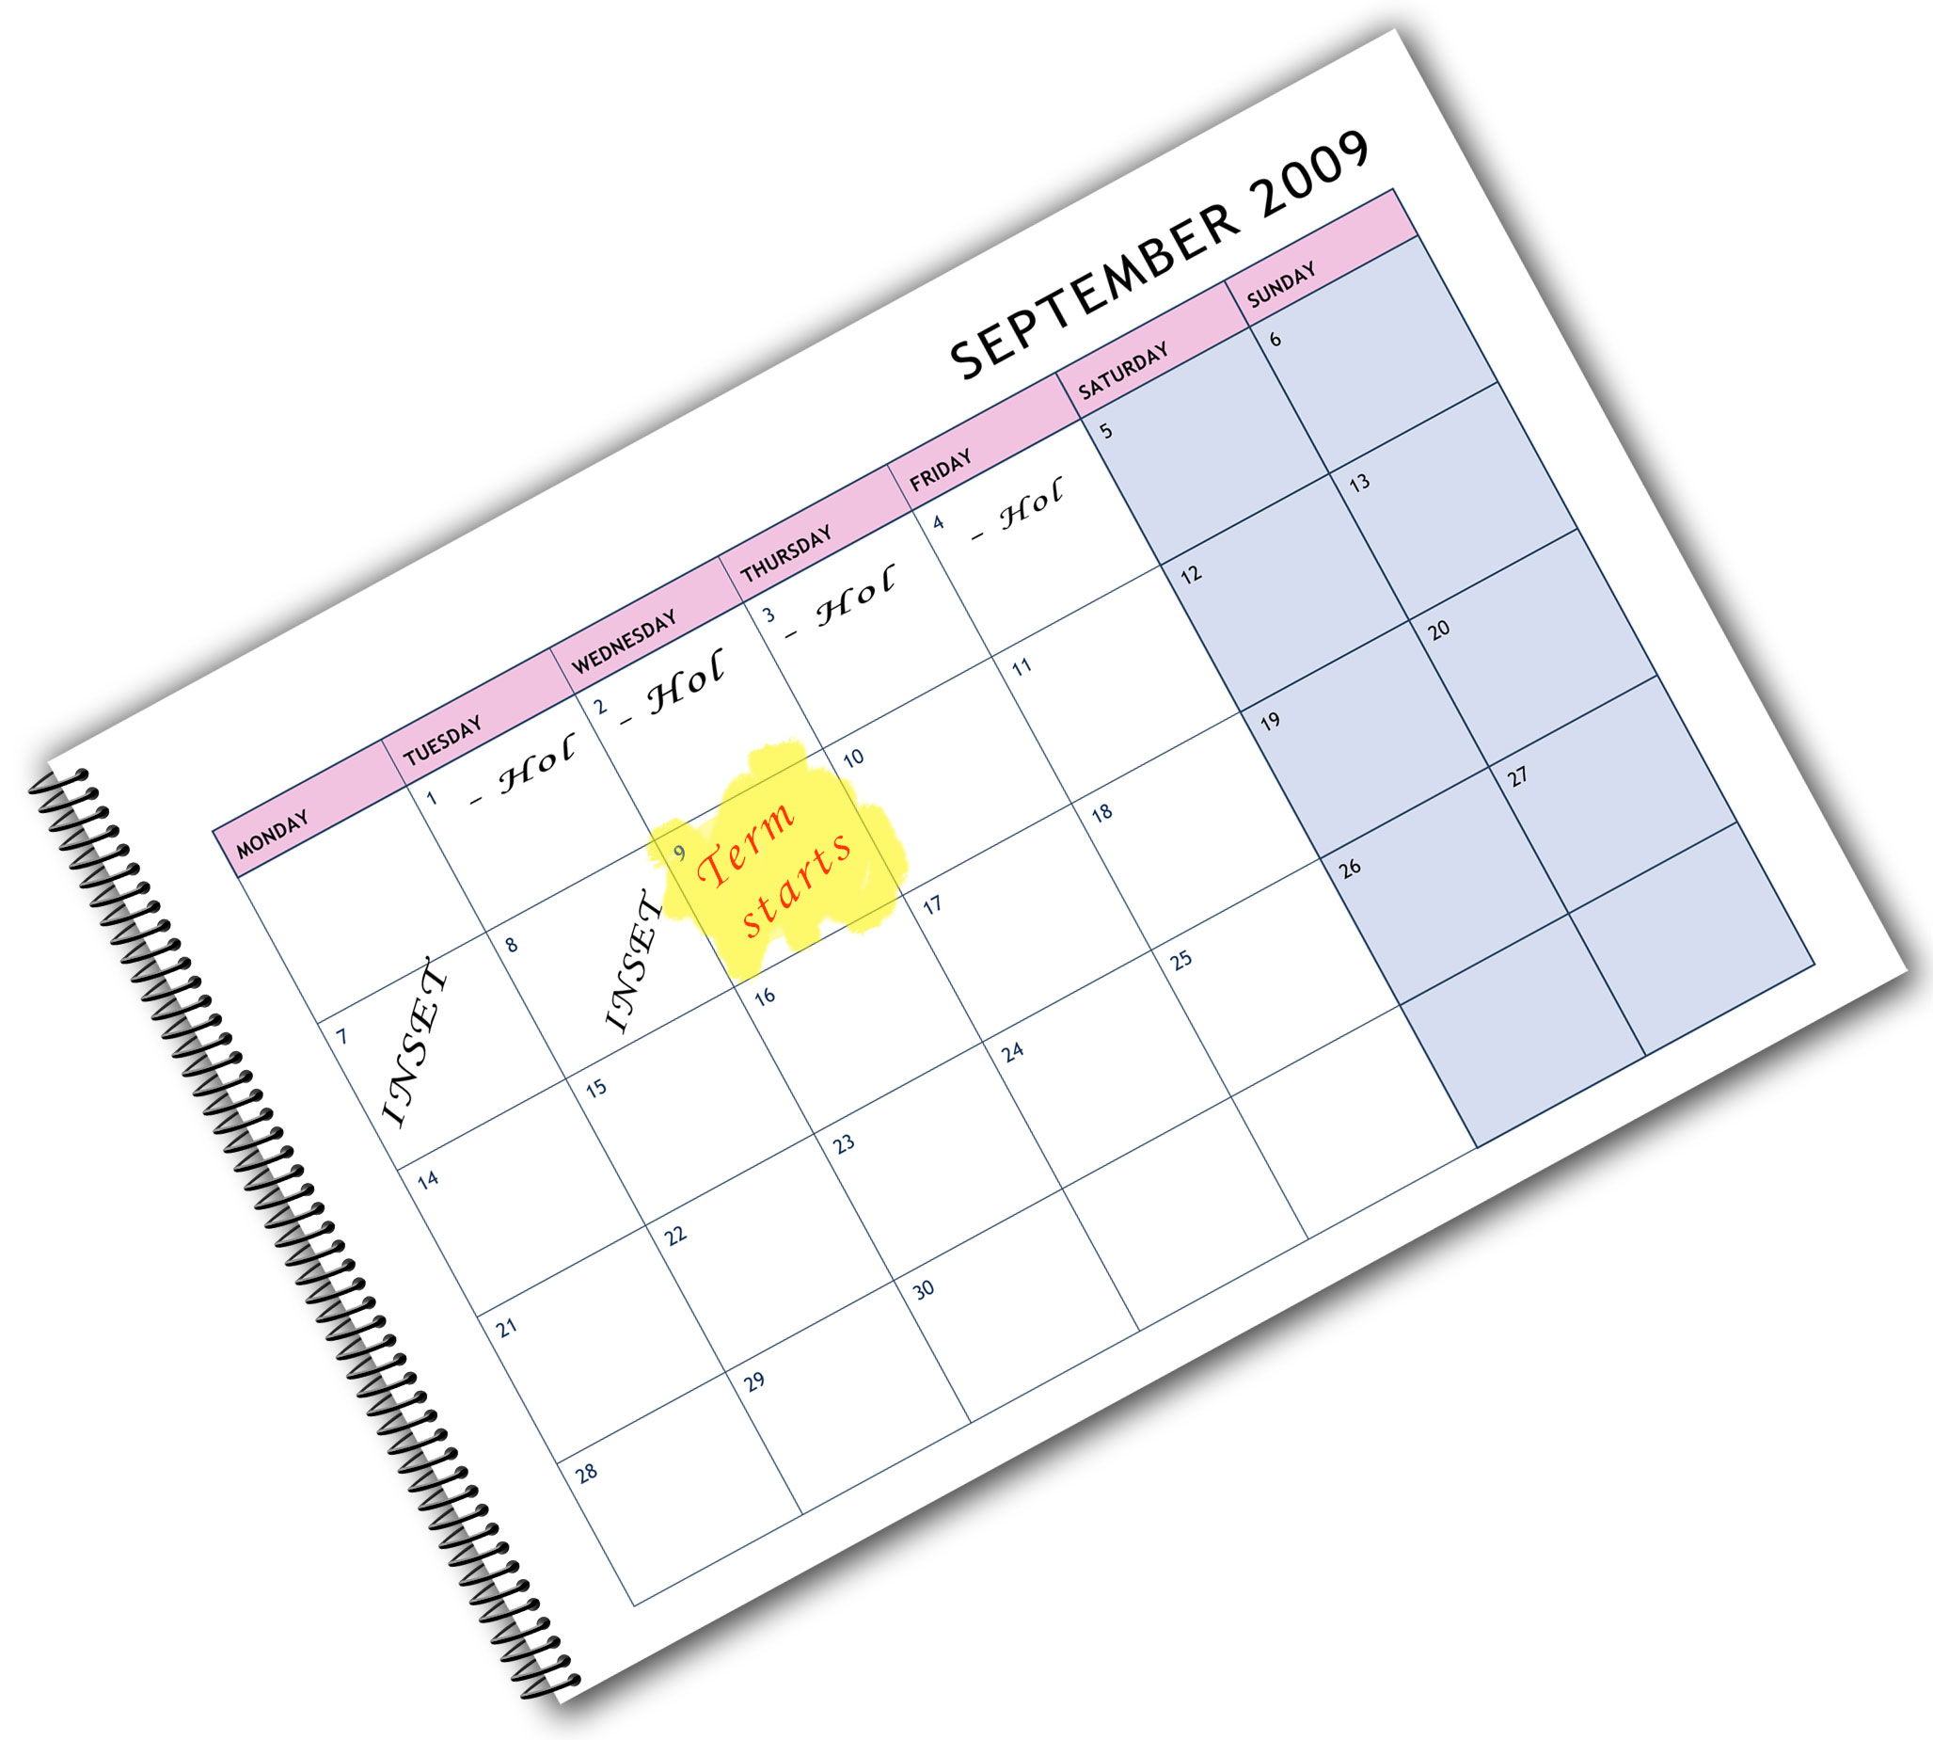
We are happy to provide this course planner for you to
amend and adapt to suit
your teaching purposes.
We hope you find
this useful.
Editable course planner

Practical support to help you deliver this Edexcel specification
Course planner
This course planner has been produced to help you implement this Edexcel specification. It is offered as an example of one possible model that you should feel free to adapt to meet your needs and is not intended to be in any way prescriptive. It is in editable word format to make adaptation as easy as possible.
Other course planning support
You will find other support for planning the course in the Teacher’s Guide and editable Scheme of Work. This is a free downloadable resource that you can access at www.edexcel.com/gcse2009
Teaching resource exemplars
The course planner contains suggestions for resources that you can use to support your teaching. These are suggestions only of material you may find useful and you are encouraged to use a wide range of resources that suit the needs of your students.
Other Edexcel teaching resources
Pearson Education produce a wide range their own teaching resources including:
- Student books — full colour textbooks matched to the specification.
You’ll find details of all of these at www.edexcel.com/gcse2009
- We are also working with a range of Publishers to support you, textbooks have been produced to support this subject by Routledge Publishing and Hodder Education.
Edexcel Additional Support
- Ask the Expert — puts you in direct email contact with over 200 of our senior subject experts
- Edexcel's community — these message boards are designed to enable you to access peer-to-peer support from fellow Edexcel teaching and delivery staff in schools and colleges.

Editable course planner — GCSE 2009 Drama
These course planners offer several possible approaches to delivering the course.
In all four examples, the first year begins with an introduction to the Programme of Study, forming an induction to the course. The amount of time spent on this is likely to depend on students’ previous drama experience and their familiarity with the main strategies, elements and medium. Each approach has different benefits, and centres will need to consider which approach best works for them.
For example, placing Unit 3 last could be motivating, providing a sense of occasion for the end of the GCSE year with the visiting examiner. For others, placing Unit 3 in term 2 of the second year could have benefits of completing the exam before other subject exams start, and it might also be easier to get performance space in some centres.

In Example 1, the Programme of Study is followed by practice for Unit 1, Unit 2 and then Unit 3, using the whole of Year 1 for work on the Programme of Study and practice for the assessed units. Year 2 begins with Unit 1, followed by Unit 2, completing the practical workshops and documentary evidence in the first term, leaving term 2 to focus on preparation for Unit 3 and the Unit 3 examination in the summer term.
Year 1 | Term 1 | Programme of Study: introduction
Year 1 | Term 2 | Programme of Study: leading to practice of Unit 1 and 2
Year 1 | Term 3 | Programme of Study: leading to practice of Unit 3
Year 2 | Term 1 | Unit 1 assessment: practical and documentary evidence  Unit 2 assessment: practical and documentary evidence
Year 2 | Term 2 | Preparation for Unit 3
Year 2 | Term 3 | Unit 3 Examination

Example 2 focuses on one of the exploration units, with practice and then assessment of Unit 1 or Unit 2 taking place in Year 1. The summer term of Year 1 finishes with practice for Unit 3. Year 2 begins with practice and assessment of Unit 1 or 2 in term 1, leaving Terms 2 and 2 for Unit 3 preparation and exam.
Year 1 | Term 1 | Programme of Study: introduction
Year 1 | Term 2 | Programme of Study: leading to practice of Unit 1 or Unit 2
Year 1 | Term 3 | Programme of Study: assessment of Unit 1 or Unit 2  Practice for Unit 3
Year 2 | Term 1 | Programme of Study: leading to practice of Unit 1 or Unit 2  Assessment of Unit 1 or Unit 2
Year 2 | Term 2 | Preparation for Unit 3
Year 2 | Term 3 | Unit 3 Examination
Example 3, like Example 1, devotes the whole of Year 1 to practice work in preparation for the assessed units. Year 2 begins with assessment of Unit 1 or Unit 2. Term 2 is dedicated to Unit 3, leaving Term 3 for the practice and assessment of the remaining unit (Unit 1 or Unit 2).

Year 1 | Term 1 | Programme of Study: introduction
Year 1 | Term 2 | Programme of Study: leading to practice of Unit 1 or Unit 2
Year 1 | Term 3 | Programme of Study: leading to practice of Unit 3
Year 2 | Term 1 | Programme of Study: assessment of Unit 1 or Unit 2
Year 2 | Term 2 | Preparation for Unit 3  Unit 3 Examination
Year 2 | Term 3 | Programme of Study: leading to practice of Unit 1 or Unit 2  Assessment of Unit 1 or Unit 2

Example 4 again devotes the whole of Year 1 to the Programme of Study, with assessment of Unit 1 or Unit 2 in the first term of Year 2. In Term 2, preparation for Unit 3 is the focus, leading up to the exam at the end of term. Term 3 is then dedicated to practice and assessment of Unit 1 or Unit 2.

Year 1 | Term 1 | Programme of Study: introduction
Year 1 | Term 2 | Programme of Study
Year 1 | Term 3 | Programme of Study
Year 2 | Term 1 | Programme of Study: assessment of Unit 1 or Unit 2
Year 2 | Term 2 | Preparation for Unit 3  Unit 3 Examination
Year 2 | Term 3 | Programme of Study: leading to practice of Unit 1 or Unit 2  Assessment of Unit 1 or Unit 2

2061sb230309S:\LT\PD\Scheme of work\Drama Course Planner.doc.1-2/1
This grid is for you to create your own course planner if needed.

Year | Term | Programme of Study: introduction

