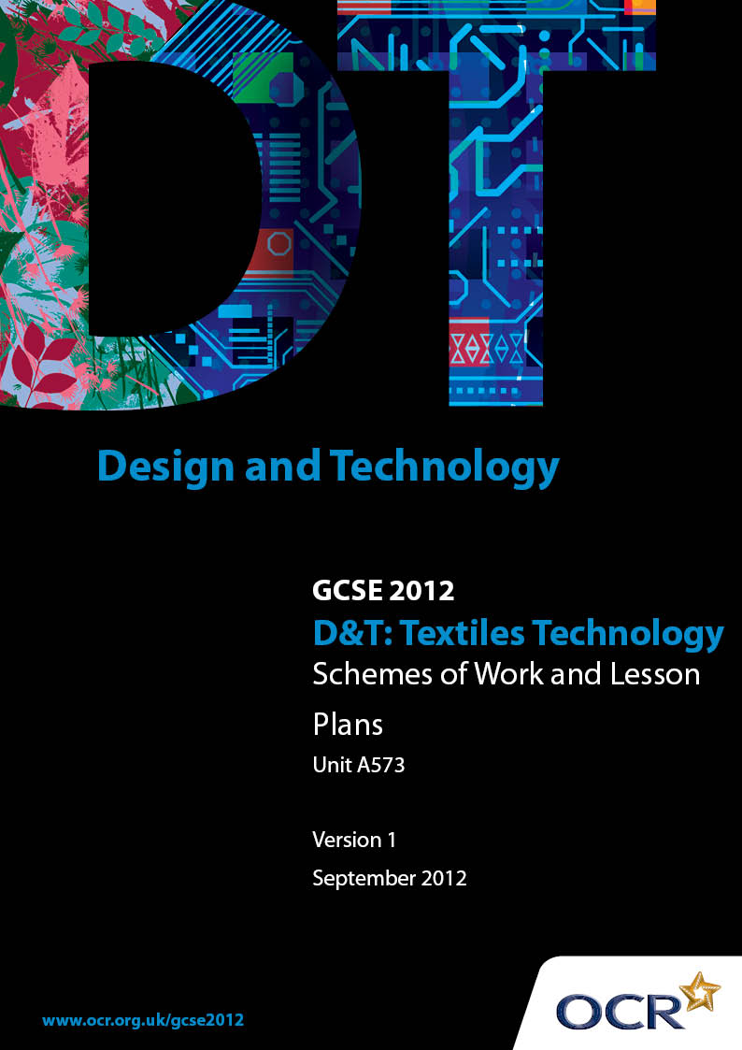

Contents
Contents 2
Introduction 3
OCR GCSE Design & Technology Textiles Technology: Sample Scheme of Work 5
OCR GCSE Design & Technology Textiles Technology: Sample Lesson Plan 17

Introduction

Background
OCR has produced a summary brochure, which summarises the changes to Design & Technology. This can be found at www.ocr.org.uk, along with the 2012 specification.
In order to help you plan effectively for the implementation of the new specification we have produced these schemes of work and sample lesson plans for Design & Technology. These support materials are designed for guidance only and play a secondary role to the specification.

Our Ethos
OCR involves teachers in the development of new support materials to capture current teaching practices tailored to our new specifications. These support materials are designed to inspire teachers and facilitate different ideas and teaching practices.
Each scheme of work and set of sample lesson plans are provided in Word format to be used as a foundation to build upon and amend the content to suit your teaching style and students’ needs.
The scheme of work and sample lesson plans provide examples of how to deliver these units and suggested teaching hours which could be applicable to your teaching.
The specification is the document on which assessment is based and specifies what content and skills need to be covered in delivering the course. At all times, therefore, this support material booklet should be read in conjunction with the specification. Any clarification should be found in the specification.

A Guided Tour through the Scheme of Work

= Innovative Teaching Idea
This icon is used to highlight exceptionally innovative ideas.


= ICT Opportunity
This icon is used to illustrate when an activity could be taught using ICT facilities.

OCR GCSE D&T Textiles Technology Unit A573: Making quality products
Suggested teaching time | 2 hours | Topic
Topic outline |  | Suggested teaching and homework activities |  | Suggested resources | Points to note
To understand the links between the principles of good design and technological knowledge. |  | - Ask the students to explore the starting point and look at how existing textile products have been influenced by the theme, e.g. what is meant by contemporary design? Explore the influence of Indian textiles on contemporary design.  - For example, students could work in pairs or groups to explore the possibilities of the theme and work independently to produce a range of information sheets showing their ideas and responses.  - Recap methods used to display ‘first thoughts’ in Unit A571 and methods of research.  - Research and gathering of information can be continued as homework’s and can be developed through educational visits to museums, exhibitions etc  Language & learning when researching information:  - Ask students to work in pairs/small groups to analyse and discuss the theme from a series of image and text responses.  - Ask the students to formulate at least three questions they need to ask to find out about how the products are influenced by changing trends and technologies within society.  Key words:  - ‘Consider’ , ‘Influence’ and ‘Analyse’ |  | Use of ICT:  - There is an opportunity for students to use CAD for presentation of the information sheets and research internet providers when identifying information about existing products and theme.

OCR GCSE D&T Textiles Technology Unit A573: Making quality products
Suggested teaching time | 3 hours | Topic
Topic outline |  | Suggested teaching and homework activities |  | Suggested resources | Points to note
How to analyse data and research in order to write a design brief. |  | - Discuss methods that could be used to find out user choice and needs.  - Ask the students to identify a suitable way to gather information, in order to identify a user group and analyse what factors influences choice.  - For example, questionnaires, consumer surveys etc.  - Students need to start to formulate a questionnaire or survey.  - Homework: completion of questionnaires.  - Ask the students to look at the evidence they have gathered and consider ways to collate and present the data. Recap possible methods of data presentation used in Unit A571.  - Students to start to collate and present their data and write a design brief.  Language & learning when formulating a questionnaire:  - Ask students to work in pairs/small groups to consider suitability of questions they have used for their questionnaire. What formats have been used already in unit A571 that have worked well?  Key words:  - ‘Creativity’, ‘Flair’ and ‘Appropriate’. |  | Use of ICT:  - There is an opportunity for students to use databases within this activity.

OCR GCSE D&T Textiles Technology Unit A573: Making quality products
Suggested teaching time | 1 hour | Topic
Topic outline |  | Suggested teaching and homework activities |  | Suggested resources | Points to note
To produce a detailed specification. |  | - Recap with the students what is meant by the term ‘specification’.  - Ask the students to identify specific points that they think worked well in their last specification for Unit A571 – what could be improved?  - For example, students could work in pairs or groups to explore the characteristics of good design practiced in their last unit specification. Consider ways to present these points constructively, creatively and in detail.  - Students to write their own detailed specification linked to their brief and research analysis.  - Homework: To complete their specification. |  | Use of ICT:  - There is an opportunity for students to use databases within this activity.

OCR GCSE D&T Textiles Technology Unit A573: Making quality products
Suggested teaching time | 4 hours | Topic
Topic outline |  | Suggested teaching and homework activities |  | Suggested resources | Points to note
To produce creative and original ideas by generating, developing and communicating designs using appropriate strategies. |  | - Show students example work completed by designers/students who have used different methods of presenting design ideas; free-hand sketches, CAD, digital technologies, ICT presentations, working drawings, scanned images with manipulated areas etc. These could be drawn from Unit A571.  - Recap with students ways to create innovative ideas using body stencils, CAD, graphic media, different presentation techniques etc. let them experiment with different styles, methods etc to create a concept book of sketches and ideas.  - Recap and demonstrate to the students how to ‘model’ specific details and areas of interest to support design ideas, using specialist equipment and a range of techniques such as the embroidery machine, Photoshop illustrator etc  - Organise a range of activities that give the students an opportunity to investigate further into different techniques; consider how to prototype different features; name materials and investigate and explain processes.  - Organise a range of peer assessment activities to help students to identify their final design proposal through reasoned decision making.  Health and Safety:  - Correct procedures should be followed when working with machinery and testing materials. Students should be taught how to manage their working environment to ensure their own and others’ safety.  Key words:  - ‘Creativity’ and ‘Innovate’ |  | Use of ICT:  - There is an opportunity for students to use CAD/digital technologies for presentation of their design ideas related to the theme.

OCR GCSE D&T Textiles Technology Unit A573: Making quality products
Suggested teaching time | 8 hours | Topic
Topic outline |  | Suggested teaching and homework activities |  | Suggested resources | Points to note
To plan and organise activities; select appropriate materials, hand and machine tools.  To work skilfully and safely.  To make a quality final product. |  | - Outline to the students how to organise and plan using a real time record of progress (action plan) showing the key stages of production.  - Each of these stages should be photographed.  - Demonstrate key skills and techniques for making to students as lessons progress.  - Explain that it is important to demonstrate a thorough understanding and ability in solving problems effectively and efficiently as they arise.  - Students to work independently on the completion of their final quality product with teacher guidance where needed.  Health and Safety:  - Correct procedures should be followed when working with specialist machinery.  - Students should be taught how to manage their working environment to ensure their own and others’ safety.

OCR GCSE D&T Textiles Technology Unit A573: Making quality products
Suggested teaching time | 1 hour | Topic
Topic outline |  | Suggested teaching and homework activities |  | Suggested resources | Points to note
To critically evaluate the finished product against the specification |  | - Recap critical evaluation and analysis with students and show examples of how this information can be linked to the specification.  - Ask the students to work in pairs to evaluate each others newly designed product against their specification points. Consider the following questions: What will they need to consider about each point? How can they justify each point? Have they considered all factors – theme, environmental issues, cost, user, purpose, suitability of techniques, materials, production method, time management etc.  - Students to present their evaluation of their specification points using a range of techniques and presentation styles to suggest effectiveness of each point considered. i.e. charts, radar diagram, written text, visual examples of specific details etc. |  | Use of ICT:  - There is an opportunity for students to use CAD/digital technologies for presentation of their evaluation.

OCR GCSE D&T Textiles Technology Unit A573: Making quality products
Suggested teaching time | 1 hour | Topic
Topic outline |  | Suggested teaching and homework activities |  | Suggested resources | Points to note
How to undertake detailed testing and present meaningful conclusions leading to proposals for modifications to improve the product. |  | - Recap with the students how to evaluate a textile product through testing, how to predict and review materials, components and processes and how to explore and modify effectively. Example materials could be useful to highlight good practice to the students from their first unit. What worked well and why?  - Students to design a questionnaire/survey for their user group to establish what aspects make the product suitable for use and what modifications could be suggested to improve the making process.  - Does the final product need to be modified – why/why not? How can you ensure that these modifications are creative and environmentally friendly? Outline realistic and detailed modifications to your work and explore alternatives solutions to problems encountered in the making process.  - Add at least two digital images of your final product in use. |  | Use of ICT:  - There is an opportunity for students to use CAD for data presentation and digital imagery.

OCR GCSE D&T Textiles Technology Unit A573: Making quality products

Educational Toys
OCR recognises that the teaching of this qualification above will vary greatly from school to school and from teacher to teacher. With that in mind this lesson plan is offered as a possible approach but will be subject to modifications by the individual teacher.
Lesson length is assumed to be one hour.

Introduction
This activity is designed for one lesson (60 minutes) and one homework. The lesson plan is flexible and is based on one of the published OCR themes. It is designed to be the first lesson in a series, to introduce the students to the concept of critical evaluation and how to successfully evaluate their final product against their specification and undertake detailed and meaningful testing leading to proposals for modifications.

The activity includes:
Lesson One: What is meant by critical evaluation and how to evaluate a product against a specification.

Overview
This lesson could be part of a focused practical task (FPTs) exercise developed to give students the opportunity to develop and practice their skills in critically evaluating a textile product or could form part of their actual controlled assessment unit.
It includes: Reviewing the meaning of critical evaluation? How to critically evaluate a textile product against the specification and how to successfully test and present meaningful conclusions, leading to proposals for modifications to improve the product.

Learning Objectives for the Lesson
Students will have the opportunity to develop the knowledge, skills and values listed below:
Objective 1 | An understanding of how to evaluate specific materials, equipment and processes for specific tasks.
Objective 2 | An understanding of how to identify improvements to design, materials and processes.
Objective 3 | An understanding of successful testing to determine fitness for purpose.
Objective 4 | An understanding of product evaluation against the needs of the user.

Recap of Previous Experience and Prior Knowledge

Content
Time | Content
5 minutes | Starter  To introduce the theme of critical evaluation show a picture of a child’s textile toy. Ask the students to consider the image on their own and list at least three key words that could be used to form the basis of an evaluation for this product. For example, explore, test, predict, analyse, identify, consider, reflect, modify etc. Teacher based Q&A to list all the words thought of by the students into a word bank.  Teacher to state what is meant by ‘critical evaluation’ and give dictionary examples to discuss. How close where the thoughts of the students to the meaning of critical evaluation?
35 minutes | Activity 1  This activity is a detailed investigation into the finished item. Working on their own, students need to complete a presentation piece either using an IT programme such as PowerPoint, verbal or visual feedback.  The student will need to consider each of their specification points and using the word bank from the starter activity alongside other available resources, critically evaluate each point. The information needs to be presented in a creative and concise manner.  Example of critical evaluation against the specification - testing and specification links. Jpeg versions
15 minutes | Plenary  Encourage peer assessment at this stage; group students into teams of four and allow each student to present their thoughts/evaluation ideas back to the group. Each group identifies the piece which shows the best practice (the most thorough critical analysis and most effective presentation style).  The finalists present their pieces to the whole class – teacher led discussion, which presentation best demonstrates critical evaluation, why? What factors ‘make-up’ a creative presentation? How was the evaluation ‘word bank’ useful?  Explain what will be covered in the next few lessons – ways to test products effectively and how to present meaningful conclusions and modifications.
5 minutes | Homework  Review and develop their evaluation against the specification and present in neat.

Skills
- Research and evaluation techniques.
- Communication and thinking skills.
- Textile technology enquiry skills.
- Critically evaluate existing products, their own work and that of others.
- Recognise the strengths and limitations of a range of technologies and appreciate which are appropriate for particular situations.

Values
- Appreciating differences and similarities between people, environments, cultures and lifestyles.
- Can be creative, flexible and show perseverance.
- Apply value judgements of an aesthetic, economic, environmental, moral and technical nature.

