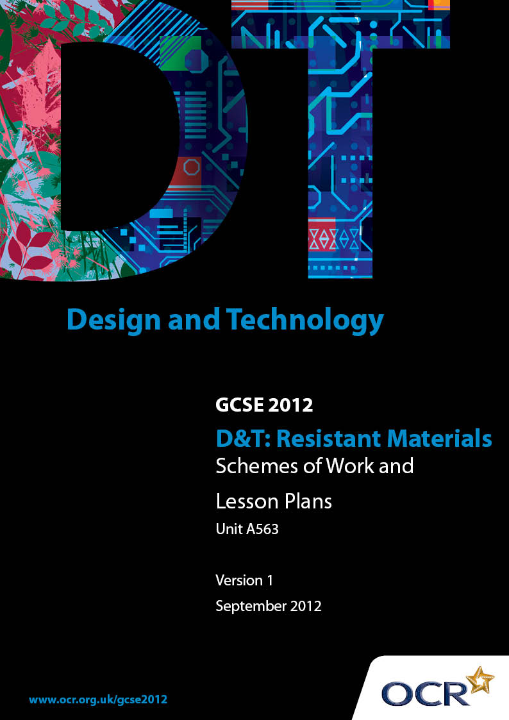

Contents
Contents 2
Introduction 3
OCR GCSE Design & Technology Resistant Materials: Sample Scheme of Work 5
OCR GCSE Design & Technology Resistant Materials: Sample Lesson Plan 11

Introduction

Background
OCR has produced a summary brochure, which summarises the changes to Design & Technology. This can be found at www.ocr.org.uk, along with the 2012 specification.
In order to help you plan effectively for the implementation of the new specification we have produced these schemes of work and sample lesson plans for Design & Technology. These support materials are designed for guidance only and play a secondary role to the specification.

Our Ethos
OCR involves teachers in the development of new support materials to capture current teaching practices tailored to our new specifications. These support materials are designed to inspire teachers and facilitate different ideas and teaching practices.
Each scheme of work and set of sample lesson plans are provided in Word format to be used as a foundation to build upon and amend the content to suit your teaching style and students’ needs.
The scheme of work and sample lesson plans provide examples of how to deliver these units and suggested teaching hours which could be applicable to your teaching.
The specification is the document on which assessment is based and specifies what content and skills need to be covered in delivering the course. At all times, therefore, this support material booklet should be read in conjunction with the specification. Any clarification should be found in the specification.

A Guided Tour through the Scheme of Work

= Innovative Teaching Idea
This icon is used to highlight exceptionally innovative ideas.


= ICT Opportunity
This icon is used to illustrate when an activity could be taught using ICT facilities.

OCR GCSE D&T Resistant Materials Unit A563: Making quality products
Suggested teaching time | 11 hours | Topic | Making quality products - Designing
Topic outline |  | Suggested teaching and homework activities |  | Suggested resources | Points to note
Writing a specification  1 hour |  | - See exemplar SoW in Unit A561  - Use product analysis of simple product s to demonstrate that consumer choice is based on criteria for decision making |  | - Exemplar specifications  - Style sheets for testing communication | - Students are to recognise that good decision making is fundamental to good design and manufacture, and consequently to effective use and marketability of a product
Writing a design brief  20 mins  Research planning to support a specification and design  40 mins |  | - Working from a theme which does not resemble those supplied for Unit A563, demonstrate how various briefs might be generated by considering different needs and user groups  - Students independently to write two briefs from a theme  - Working from a given design brief, use Q&A to plan what research would be needed to support writing an effective specification and hence to generate quality design proposals  - Students independently to plan research |  | - Sample themes not resembling those supplied by OCR for Unit A563  - Sample design briefs | - This exercise might be completed where candidates will be working to their own brief, or reduced/omitted where candidates will work from a supplied brief and research material.  - Dependent on teaching demands, candidates may be asked to complete their own research and analysis, revisiting skills developed in prior learning.
Controlled Assessment  Writing a specification  1 hour |  | - Candidates produce a detailed specification for the product as a result of analysis |  | - Research materials – either provided by the teacher but not analysed or by the student  - Basic communication software eg Word, Powerpoint  - Printer | - Timed activity  NB This time is given for guidance only within the 20 hour allocation to this assessed unit.
Generating ideas  1 hour |  | - Review of work done in Unit A561 and prior learning  - Use exemplar student work to show creative ideas and a range of communication skills  - Group activity; use 4x4 method to stimulate interaction, evaluation, modification and use of a variety of graphic skills  - Challenge students to sketch solutions to a simple brief using three different materials, working to a time limit |  | - Exemplar student work  - 4x4 design sheets  - Range of graphic media | - Students should be encouraged to work quickly using a range of media.  - They should evaluate their own and each others’ work objectively.  - Encouraging students to consider a variety of materials forces them to consider alternative methods for manufacture and varied designs.
Controlled Assessment  Generating ideas  2hour30mins |  | - Candidates to generate ideas using a range of strategies and media |  | - Range of graphic media including CAD | - Timed activity  NB This time is given for guidance only within the 20 hour allocation to this assessed unit.
Detailed design drawing  2 hours |  | - Review of work done in Unit A561 and prior learning  - Practice activities on drawing accurately, dimensioning, exploded drawing, annotation, CAD |  | - Sample drawing activities, worksheets  - Range of graphic media including CAD | - This activity is likely to be a review of prior learning. For full teaching the time would need to be extended.
Controlled assessment  Detailed design drawing  2 hours |  | - Candidates to set out the detail of chosen design idea |  | - Range of graphic media including CAD | - Timed activity  NB This time is given for guidance only within the 20 hour allocation to this assessed unit.

OCR GCSE D&T Resistant Materials Unit A563: Making quality products
Suggested teaching time | 13 hours | Topic | Making quality products - Making
Topic outline |  | Suggested teaching and homework activities |  | Suggested resources | Points to note
Planning  1 hour |  | - Students to reflect on previous experiences of manufacture, considering time taken, materials ordering, planning needs etc  - Focus on healthy and safe practice  - Discussion of quality assurance and quality control  - Teacher to model methods of communicating manufacturing record using previous students’ work – discussion of media and concise communication  - Opportunity for students to make notes on planning, concurrently questioning teacher to seek advice and review knowledge and skills  - Extended discussion on time breakdown of time allocated for making; students should be able to recognise time needed for planning, preparation, making, finishing, recording, slippage |  | - Range of graphic media including appropriate communication software eg Word, Powerpoint  - Digital cameras, leads  - Printer  - Previous student exemplar work | - Students should consider the range of issues required for effective planning and strategies for rapid, concise and clear communication of the manufacturing process as it happens.
Controlled assessment  Making  12 hours |  | - Candidates plan, organise and manufacture a high quality product  - Candidates record the key stages in making the product |  | - Range of construction materials  - Workshop facilities and equipment  - Range of graphic media including appropriate communication software eg Word, Powerpoint  - Digital cameras, leads  - Printer | - Timed activity  This part of the assessment will take place over more than one session. Rules on supervision applied by OCR must be followed. Candidates are required to reach their own judgements and conclusions. Though general advice might be offered this should not relate directly to improving performance in the assessment criteria, nor preempt decision making by candidates.  - Teacher supervision is essential to ensure compliance with Health & Safety criteria.  - NB This time is given for guidance only within the 20 hour allocation to this assessed unit.

OCR GCSE D&T Resistant Materials Unit A563: Making quality products
Suggested teaching time | 3 hours | Topic | Making quality products – Critical evaluation
Topic outline |  | Suggested teaching and homework activities |  | Suggested resources | Points to note
Critical evaluation  1 hour |  | - Review of specification writing activities at the start of this unit; teacher to have retained the specifications written for some of the example products  - Students to produce written statements evaluating the products against each specification criterion  - Discussion of the need for testing and strategies for doing so  - Simple product testing with discussion of outcomes |  | - Sample specifications and products  - Exemplar work from previous students | - This is an opportunity to revisit the circular nature of design, showing how the end and the beginning of the process are linked.  - Students should be encouraged towards objective evaluation; to this end qualitative evaluation is generally superior to quantitative methods at this level.
Controlled assessment  Critical evaluation  2 hours 30 mins |  | - Candidates critically evaluate their product against the specification, testing where appropriate |  | - Basic communication software eg Word, Powerpoint  - Printer | - Timed activity  NB This time is given for guidance only within the 20 hour allocation to this assessed unit.

OCR GCSE D&T Resistant Materials Unit A563: Making quality products

Planning of Making
OCR recognises that the teaching of this qualification above will vary greatly from school to school and from teacher to teacher. With that in mind this lesson plan is offered as a possible approach but will be subject to modifications by the individual teacher.
Lesson length is assumed to be one hour.

Learning Objectives for the Lesson
Objective 1 | Students to recognise the key factors in planning – adequate time, slippage, use of alternative strategies etc
Objective 2 | Students to be able to use valid planning techniques to sequence and time activity
Objective 3 | Students to be confident in clear concise recording and communication of making

Recap of Previous Experience and Prior Knowledge
- Planning from KS3 D&T activities and from prior learning in this programme of study. Strategies for planning eg flowchart, GANTT chart, pictorial. Quality assurance and quality control. Communication strategies.

Content
Time | Content
5 minutes | Starter exercise. As students settle down exercise on board asks them to list three reasons why plans for activity may fail. Alternatively this could be a group exercise with groups of up to four in discussion.
15 minutes | Introduction of lesson objectives: teacher led discussion/quiz.  What does or doesn’t make a plan successful?  Teacher asks various students each to contribute one reason why plans may fail. A scribe can be appointed to write these on the board or using a computer to display.  As each reason is spoken teacher asks for the reasoning behind it and stimulates brief discussions with the class. This can be done as a quiz show type exercise in which students have to match a list prepared by the teacher but hidden.
5 minutes | Quality assurance and quality control: didactic  This opportunity should be used to reinforce previous lessons on ensuring quality outcomes through sound design and planning, and regular checking of processes.

15 minutes | Planning techniques: teacher led discussion.  Review of communication styles for planning, eg flow charts, GANTT charts, tables, pictorial guides etc. Students to analyse which styles are most effective for planning. Reminder that plans can begin as drafts and evolve; slippage. Discussion should generate a relative time allocation for the main stages of making eg preparation, making, finishing etc.
20 minutes | Recording key stages of manufacture: group exercise.  Working in groups of up to four students analyse work from a previous project, looking at clarity, sequence, use of media etc – does it tell the story of making? (5 minutes)  Each group presents its analysis to the class (5 minutes)  Individually students bullet list key advice to themselves on recording (5 minutes)  Teacher advice on media, camera etc – students add to notes (5 minutes)
5 minutes | Plenary.  Opportunity for students to ask questions about planning and recording.

