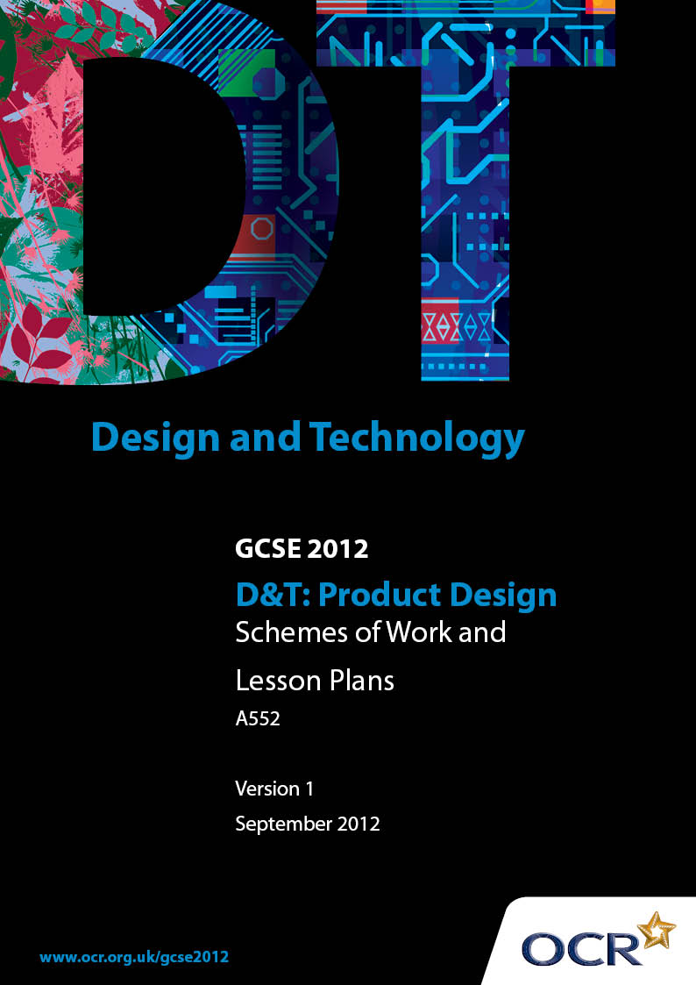

Contents
Contents 2
Introduction 3
OCR GCSE Design & Technology Product Design: Sample Scheme of Work 5
OCR GCSE Design & Technology Product Design: Sample Lesson Plan 13

Introduction

Background
OCR has produced a summary brochure, which summarises the changes to Design & Technology. This can be found at www.ocr.org.uk, along with the 2012 specification.
In order to help you plan effectively for the implementation of the new specification we have produced these schemes of work and sample lesson plans for Design & Technology. These support materials are designed for guidance only and play a secondary role to the specification.

Our Ethos
OCR involves teachers in the development of new support materials to capture current teaching practices tailored to our new specifications. These support materials are designed to inspire teachers and facilitate different ideas and teaching practices.
Each scheme of work and set of sample lesson plans are provided in Word format to be used as a foundation to build upon and amend the content to suit your teaching style and students’ needs.
The scheme of work and sample lesson plans provide examples of how to deliver these units and suggested teaching hours which could be applicable to your teaching.
The specification is the document on which assessment is based and specifies what content and skills need to be covered in delivering the course. At all times, therefore, this support material booklet should be read in conjunction with the specification. Any clarification should be found in the specification.

A Guided Tour through the Scheme of Work

= Innovative Teaching Idea
This icon is used to highlight exceptionally innovative ideas.


= ICT Opportunity
This icon is used to illustrate when an activity could be taught using ICT facilities.

OCR GCSE D&T Product Design Unit A552: Design and making innovation challenge
Suggested teaching time | 25-30 hours | Topic | School Sports Day
Topic outline |  | Suggested teaching and homework activities |  | Suggested resources | Points to note
Use collections of existing products as a stimulus for innovative design. |  | - Organise the students into small groups, giving each group an item from the collection to analyse and discuss function, form, aesthetics, durability and target users  - Each group to make a short presentation about their item (alternatively this could be done as a whole class discussion)  - For homework the students can write about a pair of trainers they own |  | - Handling collection consisting of items associated with sports day and other items that may be of interest  - A range of solutions for transporting drinks and snacks can be obtained from fast food outlets  - A worksheet could be devised to support this activity | - Students should be able to handle the items  - Key words will need explaining
Think with an ‘open’ mind about a design situation.  On a school sports day, not all students participate in the sporting events. The opportunities for these students still to be involved and support the event and the arrangements for the event are numerous. |  | - Set the scene by introducing the Design Situation  - Look at the video/photographs where available  - Allow the students time to look at/handle the resources  - Discuss with the students what could be designed. Use a mind map to record initial thoughts  - Using notes and sketches, students produce their own ideas of what could be made |  | - A starter activity could be devised to make the students aware that they need to be thinking ‘outside the box’ away from their ‘comfort zone’  - Photographs/video from school sports day  - Handling collection | - Possible items that could be made include; - a mobile first aid system/device, a healthy, refreshing drink and snack, a drinks/ snacks transportation system, a portable time keeping device, an accurate easy to operate measuring system, safe storage for javelins between events, etc  - Students will need to produce and keep a paper-based portfolio of their work
Respond in ways which might appear at first ‘unrealistic’ yet, after consideration, provide a unique, valuable contribution to designing |  | - Explain/discuss the exemplar ideas  - Working in small groups students pool their ideas and identify examples that they consider predictable, look like they are ‘wacky’ or creative and those ideas that are surprising and different  - Class discussion and teacher questions to ensure understanding  - For homework the students are to identify their three best ideas, explaining why they have chosen them  - Explain what a design brief is (using the examples as appropriate)  - Discuss/brainstorm what designers mean by ‘user groups’. Record the responses on the board  - Students write up the brief they consider to have the potential for creative design, explain who the users are and what their specific needs will be, and describe the context in which the design will be used  - Explain what a specification is  - The students select items from the collection and write up a specification using bullet points. This could be an individual or paired activity  - Students write a design specification relating to their design brief, user needs and context in which the design will be used |  | - A set of exemplar ideas to help explain the difference between, predictable, wacky and challenging (surprising)  - A collection of design briefs showing examples, which are too narrow, and ones that allow scope for creativity  - Writing frames  - Collection of small familiar products (pencil sharpeners, calculators mp3 players, pencil cases etc)  - Exemplar design specifications to show the difference between those that are generic and could be applied to anything and those that clearly identify the key features of the product to be designed | - In the actual exam supplementary information will be included which the candidates need to take into account  - Briefs should not be too prescriptive but should be clear, precise and open enough to allow scope for creativity  - When discussing user groups be specific rather than general  - When writing a design specification for this unit it is preferable, for the purposes of clarity, to do so in bullet point form
Record thinking, innovation and flair |  | - Discuss/brainstorm ways in which ideas can be presented and enhanced  - Practice the techniques through a series of closed focussed exercises to build up individual skill levels. This should take place in the classroom and also be set for homework |  | - Worksheets to allow students to re-visit and practice presentation techniques | - At KS3 students will have learnt how to present their ideas in 2D and 3D using a range of recognised techniques (isometric, oblique etc) and how to render, use thick and thin line, colour, overlays etc
Demonstrate the ability to focus thoughts and be decisive within a set, limited time frame |  | - Start designing. Using the 4x4 method to develop ideas  - Identify problems, the best idea and the most unusual idea |  | - Stopwatch or timer (when using the 4x4 method)  - Worksheet for recording responses | - Page 5 of the candidate workbook for this unit (Traffic Light Zone) could be adapted into a suitable worksheet for students to record their responses
Reflect and record ideas as they develop |  | - Students add notes to their designs, make simple paper or card models and use photographs to show progress  - If necessary students should be shown how to capture and process images to support their work |  | - Digital cameras | - As the work progresses it is essential that students use the presentation and enhancement techniques previously taught
Seek opinions of others and react accordingly  Present to a group and acknowledge feedback |  | - Working in groups of 4 each student presents their idea to the others carefully describing how their design works  - Record action points to improve or modify their idea  - Update designs based on the feedback |  | - Exemplar material produced by other students | - This activity can be found in the Student Workbook under ‘Reflect and Record’
Identify good design ideas worthy of further development and reject those of less value |  | - Students finalise their designs giving reasons for why a design is worthy of further development or why it is rejected |  |  | - To access the higher marks in the exam students will need to be able to provide detailed analysis along with justification for the rejection of ideas in favour of ones worthy of further development  - Students need to also use technical language
Use modelling materials adeptly. |  | - Show the students how to produce prototypes, models and mock ups using a range of materials. This could include making part of a product e.g. an unusual hinge mechanism  - Discuss health and Safety  - The students should be given time to practice these techniques |  | - Suitable materials can include foam, foam board, card, balsa, modelling clay, mechanism kits, polymorph, polypropylene, etc  - An online health and safety quiz could be devised | - Construction kits and scrap materials are allowed  - Where the work is taking place in a Food area then appropriate ingredients need to be available
Plan the use of materials and equipment |  | - Students produce a list of materials/ingredients they need to make the prototype of their design  - Students write up how they are going to join the materials  - Brainstorm how CAM can be used to produce the design in quantity. Record the responses on the board |  | - A table of appropriate modelling materials needs to be available | - Materials such as pine, MDF, plywood and acrylic sheet are not appropriate. (Principal Examiner January 2008)
Make a prototype of their design proposal.  Record progress using sketches and photographs |  | - Students make their own prototypes from the modelling materials available  - The portfolio should be updated with photographs and additional notes and sketches  - Capture images of good practice to show to the whole class  - Students collate all their work |  | - Availability of digital cameras so that students can record evidence of their own progress  - Access to a colour printer  - Technician support if available  - Bluetooth phone with camera, computer, projector and screen | - The time allowed for this should be reflected in the planning  - The objective is to produce ‘prototype products’ not final outcomes
Sum up progress and identify possible further design development. |  | - Evaluate the work completed  Working in groups of 4 students look at each other’s portfolio. On a worksheet they record one thing they like about the design, something they think could be improved and a question about the design. At the end of the exercise this will provide individuals with feedback to help with their evaluation  - Students evaluate their own design on a suitable worksheet |  | - Worksheet (for each portfolio) to record peer comments and questions  - Page 11 of the Candidate Booklet can be adapted into a suitable worksheet for the evaluation | - To access the higher marks in the exam students will need to show evidence of detailed analysis throughout the portfolio
Reflection |  | - Review of their ideas |  | - Page 2 of the Candidate Booklet (Time to Reflect) | - 30 minutes should be allowed if this is done under exam conditions

OCR GCSE D&T Product Design Unit A552: Design and making innovation challenge
OCR recognises that the teaching of this qualification above will vary greatly from school to school and from teacher to teacher. With that in mind this lesson plan is offered as a possible approach but will be subject to modifications by the individual teacher.
Lesson length is assumed to be one hour.

Learning Objectives for the Lesson
Objective 1 | Students to understand the difference between a good specification, one that is too general and one that is vague.
Objective 2 | Students to compare different styles of presenting a specification
Objective 3 | Students to be able to write a design specification

Recap of Previous Experience and Prior Knowledge
- Students have been working on the Sports Day theme. By now they will have recorded in their portfolio initial thoughts, written a design brief, identified the users and where the intended design will be used. The next step is to write the design specification.

Content
Time | Content
10 minutes | Starter Activity:  - Ask the students to select an item from a handling collection consisting of familiar products. E.g. pencil sharpeners, calculators’ mp3 players, pencil cases etc.  - Give each student a card with a specification written on it. Some cards will have a specification with all the key points listed, others will be vague and others will be generic (i.e. applicable to any product).  - They then find the person who has the product that best fits the specification on their card.  - List the products on the board then ask the students to comment on whether the specification given was, too general, vague or specific to the product. Summarise this by explaining what a specification is and why designers use them.
10 minutes | - Using ICT or more traditional methods introduce the students to exemplar specifications written using paragraphs and bullet points. ICT  - The examples used should ideally be based on familiar products. E.g. a pair of trainers or mobile phone.  - The material chosen should make it clear to the students that using bullet points provides much greater clarity.

10 minutes | - Students select a different item from the handling collection.  - They write down what they think the original designer would have put in the design specification for that product.  - Working in pairs each student comments upon one another’s specification as to whether it is good, general or vague.
20 minutes | - Students work independently on their own product specification.  - Their initial attempt should be shared with a partner, modifying it based on feedback given.

Consolidation
Time | Content
10 minutes | - Class discussion about the written task supplemented with teacher questions to establish understanding.
 | Homework: Students write up the amended specification in their portfolio.

