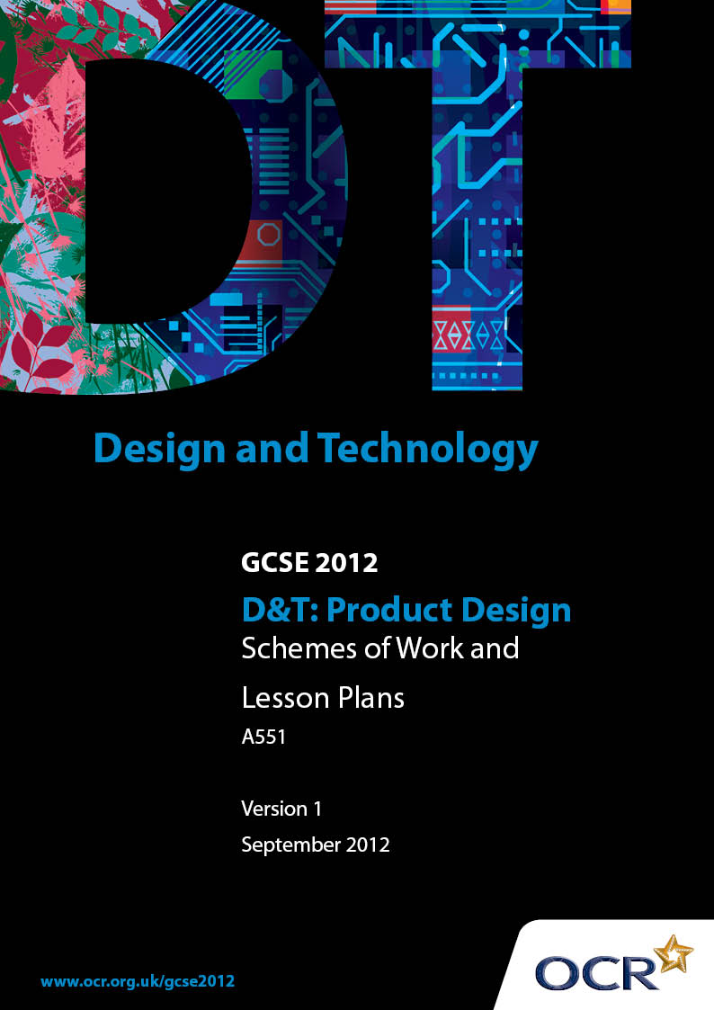

Contents
Contents 2
Introduction 3
OCR GCSE Design & Technology Unit A551: Sample Scheme of Work 5
OCR GCSE Design & Technology Unit A551:Sample Lesson Plan 17

Introduction

Background
OCR has produced a summary brochure, which summarises the changes to Design & Technology. This can be found at www.ocr.org.uk, along with the 2012 specification.
In order to help you plan effectively for the implementation of the new specification we have produced these schemes of work and sample lesson plans for Design & Technology. These support materials are designed for guidance only and play a secondary role to the specification.

Our Ethos
OCR involves teachers in the development of new support materials to capture current teaching practices tailored to our new specifications. These support materials are designed to inspire teachers and facilitate different ideas and teaching practices.
Each scheme of work and set of sample lesson plans are provided in Word format to be used as a foundation to build upon and amend the content to suit your teaching style and students’ needs.
The scheme of work and sample lesson plans provide examples of how to deliver these units and suggested teaching hours which could be applicable to your teaching.
The specification is the document on which assessment is based and specifies what content and skills need to be covered in delivering the course. At all times, therefore, this support material booklet should be read in conjunction with the specification. Any clarification should be found in the specification.

A Guided Tour through the Scheme of Work

= Innovative Teaching Idea
This icon is used to highlight exceptionally innovative ideas.


= ICT Opportunity
This icon is used to illustrate when an activity could be taught using ICT facilities.

OCR GCSE D&T Product Design Unit A551: developing and applying design skills
Suggested teaching time | 15 hours | Topic | Communication
Topic outline |  | Suggested teaching and homework activities |  | Suggested resources | Points to note
Candidate activity 20 hours (Full Course) 40 hours (short course)
Unit Overview: Candidates are required to produce a design portfolio, responding to A551 Internal Assessment Objectives 1, 2 and 3. This will be presented in either a paper or electronic format which matches that published in the specification. Guidance for the production of an electronic portfolio can be found in the OCR specification.
Candidates will work within a context to identify a design need to enable the collection of research, the generation of a specification and wide range of ideas which will lead to the development and modelling of a final solution. Candidates should demonstrate a wide range of design skills, and MUST include the use of ICT and modelling to help support the communication and development of their ideas.
Identifying a need or opportunity  3.1.1 Developing and writing a Design Brief  Candidates should be able to:  - Produce a detailed description of the design need using various means of communication  - Extract from verbal, visual and statistical information the essential problems to be solved  - Identify the range of users and the market for which the product is intended  - Develop a design brief for a marketable product which is innovative and might involve some degree of risk taking |  | - The suggested teaching time assumes prior knowledge of the design process and the concept of identifying and addressing needs.  - Gaining interest:  - Coursework (C/W) A game of charades/Cranium type activity – discuss the aspects of communication used in the game, skills needed for effective communication, problems arsing – could give candidates option to use drawing, modelling, writing to achieve same idea  - Guess the sound/object range of recorded sounds and objects – focus on importance of Aesthetics – visual, audio aspects of designs that enable the user to recognise them  - C/W Bullet point as many methods of communicating – could draw upon influences from historical, inventions, cultures, designers, eras, iconic products – individual, pairs, groups – feedback to group – teacher record or play ‘pass the paper’ to encourage new ideas  - Watch Nokia Morph concept video – discuss  - How do students communicate with each other? – feedback/ record/ discuss and conclude  - Candidates to focus on one aspect or product that they relate to for communication – make as many observations based on Safety, Aesthetics, Function and Ergonomics  - Teacher to support candidates through questioning – using the same product as above - what are the problems and opportunities for development in the method or product?  - Consider different users needs in relation to the same device – highlight problems, modifications  - What are the opportunities for developing a new product from the general theme?  - C/W or Homework (H/W) Case study innovations or iconic products in communication devices – what opportunities are there here?  - C/W or H/W Create a timeline for communication in the future – as human beings what are some of the needs of specific groups of people for the future? What are the new possibilities for communicating? What if?.  - H/W Cartoon strip/story/digital diary – a day in the life of the user  - C/W – Present their A551 concept to peers – generate a question to ask about the product  - H/W - Present their A551 concept to the intended user group – obtain feedback/ideas  - H/W Provide students with an A3 sheet of information (words and pictures) on a familiar product related to the theme – present key aspects to develop page layout skills  - Seek links with industrial product designers to provide support in how product development is undertaken  - Develop a number of questions that have been generated from the Design Influences to find out how products are developed in an industrial context  - Invite a professional into the learning environment to present the product that they work with – ask them to focus on production methods, batch production, sustainability, marketing, environmental factors, ergonomics and anthropometrics of the designs  - To help support understanding of specification content – students working in pairs to focus on a Design Influence (3.4) and create a visual aid for display for future use in supporting specification writing and work for A553 |  | - Helpful Teaching Resources 3.1.1:  - GCSE Product Design Text Book  - Prepared cards – objects, words  - Powerpoint outlining key developmental stages of communication technology - history  - Laptop with video downloaded or access to internet in classroom  - Pictures of Iconic Products  - Understanding of the concept of Board Game - ‘Cranium’  Sound/Visual clips of familiar product noises/features – Ring tones, logos etc.  - Access to the OCR specification  - Previously taught and practised activities should include:  - Writing a design brief for a marketable product  - Designing to meet users needs  - Freehand sketching both 2D & 3D  - Mind mapping techniques  - Internet Search Engines  - Use of Websites and conducting a search  - Use of a digital camera  - Downloading pictures  - Useful Websites:  - www.msn.com – Tech and Gadgets section provides up to date information on technological developments and has quirky products and technology  - www.news.bbc.co.uk search Nokia Morph – Information on the new concept phone from Nokia – 5 minute video clip can be used to inspire students  - www.nokia.com – up to date news on new nano-technology and products  - www.vertu.com – luxury phones and concepts | - Task Taking:  - OCR expects teachers to supervise and guide candidates who are undertaking Controlled Assessment. It is important that teachers do not direct candidates in any particular direction. The degree of teacher guidance in candidates’ work will vary according to the kinds of work being undertaken. However it should be remembered that candidates are required to reach their own judgements and conclusions  - As with all Controlled Assessment, the teacher must be satisfied that the work submitted for assessment is the candidate’s own work  - This is a Controlled Assessment which means that for task setting, centres could choose from a number of theme based tasks offered by OCR for minimal or more relevant adaptation by the centre  - Controlled Assessments should not put at risk the opportunity for candidates to meet the Assessment Criteria  - Task Setting:  - Teachers should support candidates with the use of the Controlled Assessment themes as a starting point for A551  - When investigating the opportunity for a design need, candidates could focus on a specific client, design era or designer, personal interests, enterprise, industrial practice or work undertaken in other units  - Task Taking:  - IAO1 It is advised that candidates should generate their own project briefs as a result of their own investigations from the initial Controlled Assessment theme  - IAO1 the appropriateness of the task is important to ensure that all candidates have the best opportunity possible of addressing the assessment criteria – please refer to FAQ’s on appropriate tasks for assessment  - IAO1 It is essential that candidates develop a detailed and concise deign brief for a marketable product  - Centres should develop their own practice material that best supports the Controlled Assessment task  - Centres should avoid the generic inclusion of work that has been done as a whole class activity or work of a preparatory nature in the project portfolio
3.1.2 Research and Drawing up a specification  Candidates should be able to:  - Identify and collect relevant data about the user(s)  - Examine the intended purpose of the intended product  - Identify and collect other data relevant to the product and its users  - Examine the intended purpose of existing products  - Identify opportunities for developing new and innovative products to improve upon the weakness of existing products  - Understand the issues that expand the design brief  - Detail the requirements of the product  - Demonstrate an ability to express the results of research and analysis in the form of a suitably detailed specification  3.1.3 Generation of design proposals  Candidates should be able to:  - Generate and record the development of design proposals that are innovative and show flair and imagination  - Consider user needs and issues when developing ideas  - Consider aesthetics, ergonomics, function and the other design influences  - Appraise design ideas for suitability, value and consequence  - Identify, with reasons for selection/rejection, the chosen design proposal/s for prototype manufacture  - Use suitable communication techniques, including ICT, to develop and model design proposals and production systems  - Use modelling to check on the feasibility of design ideas  - Check that the design proposal meets the legislative standards, and consider patents and copyrights  - Control the development of the product for manufacture, and identify within the design proposals the resources needed for the prototype to be realised  - Consider, using examples, those aspects of the design which could most easily be manufactured in quantity  - Produce a final product specification  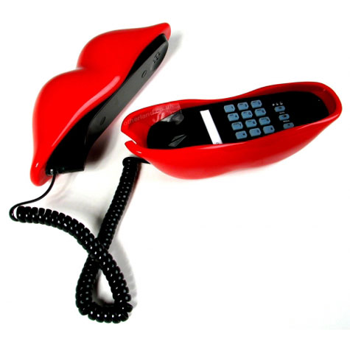  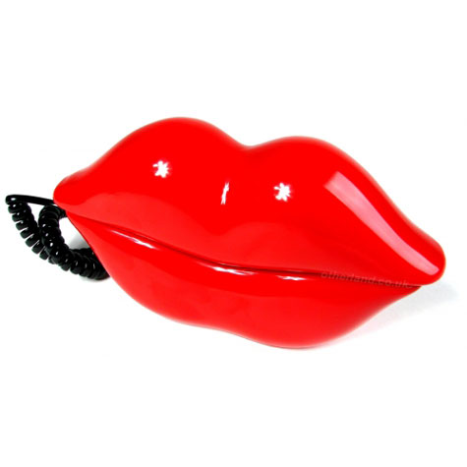 |  | - C/W Analysis of an existing product focus specifically on Ergonomic needs of the specific user – encourage students to interact with device, take photos of key features, evaluate the product against ergonomic criteria etc could focus on any ergonomic product  - H/W Sketch or model (ICT) ergonomic improvements  - C/W H/W Arrange students into groups present them with a number of familiar products and word processed headings of some or all of the Design Influences groups to develop a presentation that outlines how the product meets or not these factors – could be Power Point, talk, posters of key features, bullet points, photos etc  - C/W H/W Use existing products to determine what data would have been collected for development and production of them  - Write a specification for familiar products – use the Design Influences (3.4) to help support content  - Match the products – present students with the pictures or products and mix up the specs for them – pupils have to use the specs to match it to the correct project  - C/W H/W Generate a range of class/user group data – focus on collection of specific measurements – measure hands, take finger prints of finger tips to obtain measurements for the developments of buttons etc  - Present the results in a range of charts and graphs  - H/w Investigate the legislative laws and standards that protect designers, users and manufacturers  - Develop a simple shape for a potential communication device using CAD modelling – ask students to add key features  - Turning one thing into something else - Provide students with a theme/existing product that is nothing to do with communication theme – support students in developing ideas directly inspired by the theme/product for communication purposes  - Beetle drive Ideas – group students and encourage the development of ideas by each adding on their own ideas for – key features  - Work in small groups to develop a product suitable for marketing – present ideas to group as a sales pitch covering aspects from AO 1,2 and 3 (support work from Unit A553)  - Set a specific range of criteria for students to design to – ask students to develop their product with these criteria in mind and evaluate how exactly they have met these – suggest three improvements – use sketches  - Provide students with a range of modelling materials including CAD – provide a set amount of time – ask the students to make a model of their design to show clear details of their idea/s – photograph the final product  - Whilst modelling – ask students to obtain feedback on how their design could be developed to best meet Ergonomics, Function and Aesthetic features  - Encourage students to create a manufacturing diary of the modelling process – supporting work from A553 – tools, equipment, materials, problems that arose and solutions  - Case study the manufacture of a similar product – focus on the aspects that have been made as separate components for later assembly – how can the students apply this to their ideas?  - After modelling – encourage students to reflect upon the Design Influences – create a final specification for the product that they have developed – could other students take turns to offer peer feedback |  | - Helpful Teaching Resources 3.1.2:  - Digital camera  - Selection of interesting existing products – real life examples and picture gallery perhaps on a Power Points, laminated sheets or an inspiration table  - Descriptions of the Design Influences displayed around the learning environment  - Light modelling materials  - Designs that are specifically Ergonomic, Aesthetic or Functional as their main design focus  - Previously taught and practised activities should include:  - Writing and using a design specification  - Some understanding of the factors that influence design  - Presentation of data using charts and graphs  - Image editing and adjustment  - Useful Websites:  - www.technologystudent.com – good general resource that includes a range of technical and theoretical information – RM, Graphics and Electronics  - www.designandtech.com – pupil and teacher friendly resource that is regularly updated covering all material areas  - www.design-technology.info – information portal covering all material areas  - www.design-technology.org – general resource for Technology with information relating to designers and eras  - www.lboro.ac.uk/departments/cd - samples of product design work  - www.ergonomics4schools.com – promotes the teaching and learning of ergonomics  - www.designmuseum.org – Design Museum in London web link  - www.coolest-gadgets.com – examples and links to innovative products  - Helpful Teaching Resources 3.1.3:  - 2D Design, Solid Works, Google Sketch-Up, Pro-Desktop  - Light modelling materials – for all material strands  - Inspirational products  - Design Influences and definitions  - Prepared sheets for Beetle Drive  - Access to Power Point  - Worksheet for Legislative standards for all material disciplines  - Previously taught and practised activities should include:  - Orthographic/Isometric Projection  - Graphical enhancement techniques with mixed media to include, rendering using shade, tone and texture  - Designing and modelling with a range of light production materials  - CAD and ICT applications – subsequent CAM applications  - Modelling techniques – ICT and 2D/3D  - ICT modelling packages  - Evaluation against a specification  - Useful Websites:  - www.wikipedia.com – search ‘Beetle (game)’ rules explained for the game of Beetle Drive!  - www.topblogposts.com/tags/phone - source for concept designs for phones  - www.sketchup.google.com – downloadable 3D software tool that combines a tool-set with an intelligent drawing system. Enables to place models using real-world coordinate | - Task Taking:  - IAO2 Research that is undertaken by the candidate should be relevant and concise to the specific brief of the design activity should be suitably concluded to demonstrate clear learning  - IAO2 Candidates should develop their own relevant and justified specification based upon the design need, subsequent research and Design Influences  - IAO2 The data that is collected should be directly relevant to the project focus  - Task Taking:  - IAO3 Centres are advised that ideas developed and evaluation should relate to the design need and specification  - IAO3 Ideas should be those of the candidate  - IAO3 Candidates should ensure that their designs are directly influenced by Ergonomics, Aesthetics and Function  - AO3 Modelling is an essential aspect of this objective to help support development – the use of ICT is an integral part of the assessment criteria and should be used to develop and assist the progress of the idea and not as a presentation tool  - Task Marking:  - All internally assessed work (Units A551 and A553) is marked by the teacher and internally standardised.  - Centres are advised to read all of Section 5 Controlled Assessment. This includes information on:  - Using Controlled Assessment 5.2.2  - Task Taking 5.3  - Appendix B: Marking Criteria for Controlled Assessment  - Appendix C: Guidance for the Production of Electronic Controlled Assessment

OCR GCSE D&T Product Design Unit A551: Developing and applying design skills

Using the Design Influences for product analysis
OCR recognises that the teaching of this qualification above will vary greatly from school to school and from teacher to teacher. With that in mind this lesson plan is offered as a possible approach but will be subject to modifications by the individual teacher.
Lesson length is assumed to be one hour.

Learning Objectives for the Lesson
Objective 1 | To define the term ‘Design Influences’
Objective 2 | To identify specific Design Influences in familiar products – Aesthetics, Ergonomics and Function
Objective 3 | To explain how the existing products are influenced by these factors

Recap of Previous Experience and Prior Knowledge
- Concepts: Pupils will need to have had some prior knowledge and experience of the design process and have an appreciation for the analysis of existing products.
- They will need to be able to recognise that products are designed with the specific needs of their users in mind.
- It would be beneficial if pupils were familiar with the specific terms of Aesthetics, Ergonomics and Function prior to the lesson. Content

Teachers Materials and Equipment
- Access to Interactive White Board (IWB), Suitable PowerPoint with inspirational, iconic, quirky or theme related products.
- Alternatively to an electronic presentation - laminated pictures of products or inspiration table with products displayed. Worksheet for starter activity.
- Design Influence Cards in sets – Heading and definition
Teachers are advised to consider the logistics of all activities suggested below
Pupils could work individually, in pairs or in small groups

Student Materials and Equipment
A3 paper, Pencils, coloured paper

Contents
Time | Content
5 minutes | - Starter: Make a quick freehand isometric sketch of the product, list 5 features that you think are important about the product (on table, on sheet, on screen if presented to the students this could be a reveal activity – guess the product/s)  - Teacher to take register and deal with administration
10 minutes | - Teacher/Student Activity: Quick round the room feedback – what is your product?  - What does it do?  - What is the specific term used to describe the purpose of a product? (FUNCTION)  - Introduction of lesson objectives to students.
5-10 minutes | - Teacher/Student Activity: Re-cap Q+A what can we learn from existing products?  - What do you think influences the way in which products are designed?  - Introduce concept of Design Influences – display sentence “Factors that are considered when designing and that influence the way in which a product is designed to meet needs”
15-20 minutes | - Hand out Design Influence cards – heading and definition  - Student Activity: Pupils to refer to the 5 observations made in the starter activity – What Design Influence best fits their observation?  - Using the Design Influences left over – make an observation based upon these factors in relation to the product
5 minutes | - Focus on Aesthetics, Function and Ergonomics – develop the observations made about these factors – How exactly does your product consider these Design Influences? Explain the initial observation - Why is it important for them to have been considered?

Consolidation
Time | Content
5 minutes | - What if you could make the design better?...  - Using Aesthetics, Ergonomics or Function – sketch or write about at least 2 improvements you could make to the product  - Why would you make them? What exactly would this to do to improve your product?
10 minutes | - Students to work on developing their product – specifically focussed on Aesthetics, Ergonomics or Function  - Feedback to group on learning – presentation of work from lesson or teacher guided Q+A  - Why do we need specific criteria when designing products?  - How do the Design Influences help?

Homework | Using the 17 Design Influences – collect an example which best meets each of the factors in the way in which it has been designed.  Pupils to focus on a specific product – iconic, novel etc and prepare a 2/3 minute presentation outlining its success or not as a well designed product – using the influences.
Total 60 minutes | Lesson Ends

