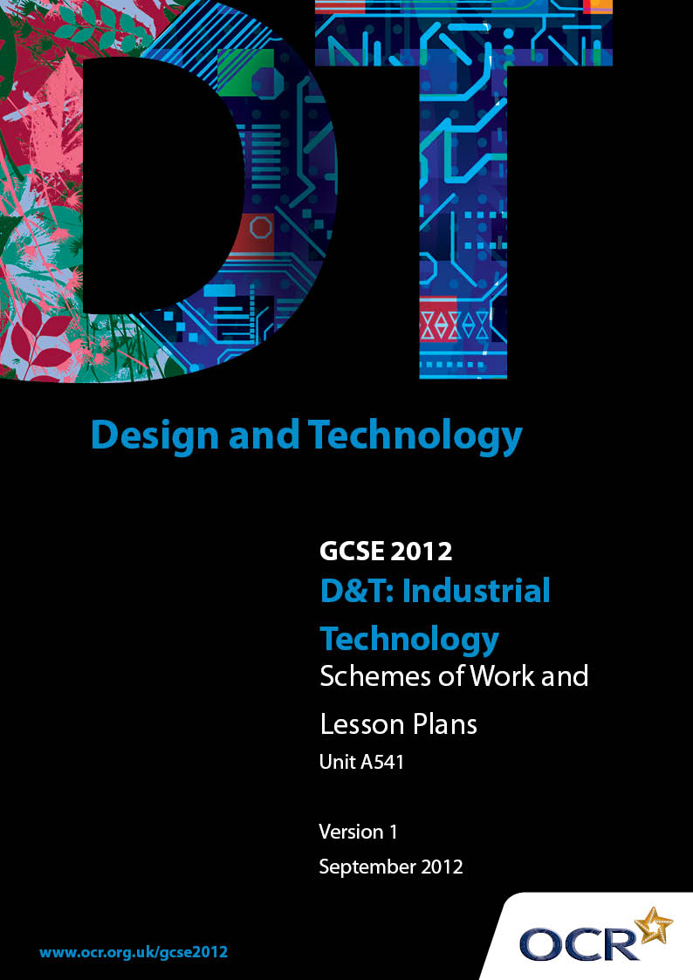

Contents
Contents 2
Introduction 3
OCR GCSE Design & Technology Industrial Technology: Sample Scheme of Work 5
OCR GCSE Design & Technology Industrial Technology: Sample Lesson Plan 10

Introduction

Background
OCR has produced a summary brochure, which summarises the changes to Design & Technology. This can be found at www.ocr.org.uk, along with the 2012 specification.
In order to help you plan effectively for the implementation of the new specification we have produced these schemes of work and sample lesson plans for Design & Technology. These support materials are designed for guidance only and play a secondary role to the specification.

Our Ethos
OCR involves teachers in the development of new support materials to capture current teaching practices tailored to our new specifications. These support materials are designed to inspire teachers and facilitate different ideas and teaching practices.
Each scheme of work and set of sample lesson plans are provided in Word format to be used as a foundation to build upon and amend the content to suit your teaching style and students’ needs.
The scheme of work and sample lesson plans provide examples of how to deliver these units and suggested teaching hours which could be applicable to your teaching.
The specification is the document on which assessment is based and specifies what content and skills need to be covered in delivering the course. At all times, therefore, this support material booklet should be read in conjunction with the specification. Any clarification should be found in the specification.

A Guided Tour through the Scheme of Work

= Innovative Teaching Idea
This icon is used to highlight exceptionally innovative ideas.


= ICT Opportunity
This icon is used to illustrate when an activity could be taught using ICT facilities.

OCR GCSE D&T Industrial Technology Unit A541: Introduction to designing and making
Suggested teaching time | 15 hours | Topic | CAD CAM design
Topic outline |  | Suggested teaching and homework activities |  | Suggested resources | Points to note
It is necessary for items of clothing to be hung inside cupboards and on doors. A small hook is required to fulfil this purpose. The finished item will be made in 3mm acrylic using a CAM milling machine and strip heater. It should be suitable for batch production. |  | - Look at and allow students to verbally make decisions about purpose and effectiveness of a range of hooks.  - Ideally each student to have a hook or one between two. Students should then sketch a front view and side view of the hook they have.  - Highlight concept of view and need to keep to a scale (1:1)  - Introduce the design brief  - Discuss the specification of the hook  Suggested homework  - Write up a specification for a hook to meet the requirements of the brief |  | - Examples of coat hooks, stick on hooks, small door hooks.  - Samples of 3mm acrylic suitable for CAM Milling  - Perspective grids might be useful for some students
Designing and developing drawing techniques and skills |  | - Students should come up with three simple ideas for a hook  - The emphasis should be on quality of hand drawn graphics and presentation  - Annotations, sizes should be in accordance with accepted conventions. |  | - Perspective grids might be useful for some students
Chosen design |  | - Students choose a design suitable for manufacture in 3 mm acrylic using CAD CAM.  - Students should provide a reasoned justification for their choice.  - A simple card model should be made and tested. Adjustments to design made as appropriate or reasons why design is acceptable.
CAD |  | - Using suitable CAD programme to draw hook ready for machining  - Highlight conservation of materials and reduction of waste by nesting  Suggested homework  - Find out the advantages of CAD over traditional hand-drawn drawings. |  | - 2D Design Tools.  - ProDESKTOP | - If using ProDESKTOP, or similar programme, 3D rendered drawings can be drawn
CAM |  | - As CAD work is complete CAM machines can be used to machine a small number of hooks for each student.  Suggested homework  - Find out the advantages of CAM in industrial settings |  | - CAM milling machines  - Laser cutter
Line bending |  | - Edge finishing of acrylic, especially if using “day glow” colours with high edge refraction. Emphasise quality of product finish.  - Line bending, suitable bending jig should be manufactured to ensure consistency of repeated bends  Suggested homework  - What is the difference between a jig and a template? |  | - Suitable off-cuts of softwood and line bending equipment.
Process |  | - Each student should create a plan for manufacture/process flow chart of the hook from CAD to finished product  - Emphasise correct use of flow chart symbols and accurate layout and quality of presentation. |  | - Word processing could be used to aid presentation
Evaluation |  | - Students should carry out an evaluation of the manufacturing processes  - An evaluation of the product and suggest improvements.  Suggested homework  - Complete folder of work.

CAD/CAM Design Exercise

Material: Acrylic 3 mm thick 200 mm x 80 mm maximum size
Process: CAD/CAM
Design and make:
It is necessary for items of clothing to be hung inside cupboards and on doors. A small hook is required to fulfil this purpose. The finished item will be made using a CAM milling machine and strip heater. It should be suitable for batch production.

Details:
- Include fixing by screw, double sided tape or adhesive.
- Facility to hang one or two items of clothing should be considered.
- A number of items should be machined in the same process, by “nesting” repeated copies.

Example:
60° Bend

Remember:
- function of the item  - Specification of product  - 3 simple designs  - chosen design | - Card model  - orthographic and perspective views with colour rendering  - CAD drawings | - process flow chart/plan of making  - quality and finish of making and product.  - correct and safe use of equipment  - evaluation of product

OCR GCSE D&T Industrial Technology Unit A541: Introduction to designing and making

Product Analysis
OCR recognises that the teaching of this qualification above will vary greatly from school to school and from teacher to teacher. With that in mind this lesson plan is offered as a possible approach but will be subject to modifications by the individual teacher.
Lesson length is assumed to be one hour.

Learning Objectives for the Lesson
Objective 1 | Students to investigate a commonplace product.
Objective 2 | Students to be able to recognise good design features of a product
Objective 3 | Students to have an awareness of fitness for purpose
Objective 4 | Students to recognise the importance of ergonomics and the use of materials in products
Objective 5 | Students to be able to make a critical appraisal of products in common use

Recap of Previous Experience and Prior Knowledge
- Students could provide their own products for analysis. However, a collection of a particular type of commonly used products (like a kettle, iron, mobile phone, craft knife, makeup set) is invaluable, this should include older products as well as newer styles so that design progression can be seen.

Starter
Time | Content
5 minutes | Introduce the idea of analysing products for a variety of reasons.  Encourage students to explain why they would analyse or compare a product. e.g.: choosing to buy, looking at areas to re-design, finding out how to improve a product, market research, testing a new product etc.  From student feedback discover aspects of a product they should analyse or compare e.g.: appearance; ergonomics; performance; cost; health and safety etc

Content
Time | Content
5 minutes | - If possible provide a product per student  - Use a pre-printed sheet for the work (an A3 sheet with appropriate boxes and pre-printed titles)  - What is the intended market for the product?  - Briefly describe the product: its overall size, colour scheme, fashion/style, main features and materials used. Explain its primary (intended) use. Explain any secondary uses (e.g. kettle used for watering house plants)
20 minutes | - An opportunity to practise sketching using a variety of methods. All students to choose their main form of sketching  - Sketch the product  - orthographic views (front, end, plan) sizes included  - isometric or perspective, coloured, labelled parts  - Sketch details  - exploded or sectioned views  - detailed drawings, logo, buttons, hinges, mechanisms, lenses, winders, switches, handles or grips, decoration, dials
5 minutes | - Ask students to explain the term “ergonomics”.  - On the worksheet students should show how ergonomics has been considered in the product they are analysing e.g. are handles comfortable, is it easy to hold, do the grip and buttons suit the hand, are symbols recognisable, are dials or gauges easily read
5 minutes | - Identify the main parts of the product, their functions, materials and manufacturing processes used. Some support and reminder of main process of manufacture is needed! A blank parts table can be added to the worksheet with headings Parts, Function, Material, Manufacturing process
5 minutes | - What health and safety has been included in the product e.g. electrical safety, British Standard, copyright

Consolidation
Time | Content
5 minutes | Summarise the reasons for product analysis. Feedback from students on aspects of their finding so far.
Homework | Look at the range of similar products. Make a paste-up of a number of other similar products with basic comments, costing and assessment of success of product

