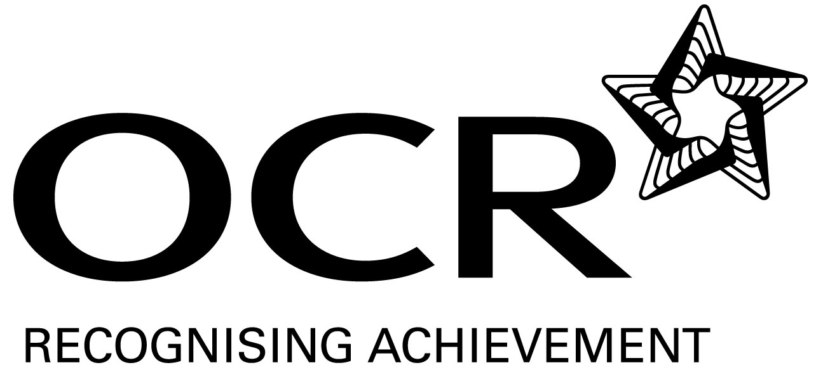
Sample Schemes of Work and Lesson Plans
GCSE D&T: Product Design
OCR GCSE in D&T: Product Design:
Unit A554: Design Influences

This Support Material booklet is designed to accompany the OCR GCSE Design and Technology: Product Design specification for teaching from September 2009.

Contents
Introduction 3
OCR GCSE Scheme of Work Product Design Unit A554: Design Influences 5
OCR GCSE Lesson Plan Product Design Unit A554: Design Influences 11
Ergonomics explained 13

Introduction

Background
Following a review of 14 – 19 education and the Secondary Curriculum Review, the Qualifications and Curriculum Authority (QCA) has revised the subject criteria for GCSEs, for first teaching in September 2009. This applies to all awarding bodies.
The new GCSEs have more up-to-date content and encourage the development of personal, learning and thinking skills in your students.
We’ve taken this opportunity to redevelop all our GCSEs, to ensure they meet your requirements. These changes will give you greater control of assessment activities and make the assessment process more manageable for you and your students. Controlled assessment will be introduced for most subjects.
OCR has produced a summary brochure, which summarises the changes to Product Design. This can be found at www.ocr.org.uk, along with the new specification.
In order to help you plan effectively for the implementation of the new specification we have produced these Schemes of Work and Sample Lesson Plans for Product Design. These Support Materials are designed for guidance only and play a secondary role to the Specification.

Our Ethos
OCR involves teachers in the development of new support materials to capture current teaching practices tailored to our new specifications. These support materials are designed to inspire teachers and facilitate different ideas and teaching practices.
Each Scheme of Work and set of sample Lesson Plans is provided in Word format – so that you can use it as a foundation to build upon and amend the content to suit your teaching style and students’ needs.
The Scheme of Work and sample Lesson plans provide examples of how to teach this unit and the teaching hours are suggestions only. Some or all of it may be applicable to your teaching.
The Specification is the document on which assessment is based and specifies what content and skills need to be covered in delivering the course. At all times, therefore, this Support Material booklet should be read in conjunction with the Specification. If clarification on a particular point is sought then that clarification should be found in the Specification itself.

A Guided Tour through the Scheme of Work

= Innovative Teaching Idea
This icon is used to highlight exceptionally innovative ideas.


= ICT Opportunity
This icon is used to illustrate when an activity could be taught using ICT facilities.

OCR GCSE D&T Product Design Unit A554: Design Influences
Suggested teaching time | 6 hours | Topic | Ergonomics and Anthropometrics
Topic outline |  | Suggested teaching and homework activities |  | Suggested resources | Points to note
Lesson one: Introduction to Ergonomics and Anthropometrics |  | - Starter activity: Paired discussion and 25 word definition of ergonomics and anthropometrics  - Bring in a large array of old clothes – largely adult and infant (i.e they will not fit the students)  - Divide students into groups of 4. Their task is the clothe one of the group (insists on the groups finding the best fitting clothes  - Carry out fashion parade – vote for best dressed student  - 10 minutes for this activity  - Evaluation of activity 1: Self, Pair Share activity  - Self: Student thinks of the purpose of this activity  - Students pair up and discuss – pair agree key purpose  - Pairs share with groups (5 or 6) and agree  - Teacher goes around the groups in turn to ascertain opinions |  | - Selection of used adult and children’s clothes | - The purpose here is to get students to understand that clothes need to be made to fit the individual
The difference between Ergonomics and Anthropometrics  Lesson two – applying understanding of ergonomics and anthropometrics  Focusing upon ergonomics  Private study 30 – mins  Lesson three  Towards a definition of Ergonomics  Remainder of lesson three and lesson four  Ergonomics design task  2 hours  Lesson five  Anthropometrics – (revisited)  Lesson 6  Anthropometrics activity: Measure the foot size, lower leg, upper leg (from under knee to back in sitting position) for each student in the class. |  | - Student Activity  - Split the class into 3 groups  - Group 1: Using the internet, find a definition of ergonomics – prepare a 3 minute lesson for the remainder of the class about what ergonomics is  - Group 2 Using the internet, find a definition of anthropometrics – prepare a 5 minute lesson for the remainder of the class about what anthropometrics is  - Group 3 (the class) compile a list of questions (with teacher’s help that you are going to ask of the groups  - In turn groups 1 and 2 present to class.  - After each presentation group 3 ask their questions to the presenters to test their understanding  - Consolidation and Plenary  - Homework  - In no more than 50 words, answer the following:  - The difference between ergonomics and anthropometrics is:  - Introductory activity: Students (pick 3 or 4 at random) read their 50 words to class  - Learning objectives s and key question shared  - Watch a video of a person carrying out a task such as making the dinner. Record all the movements they make on the plan. Try to time (in seconds) how long each activity takes. For example, how long in seconds it takes to move from the cooker to the fridge, open it and remove an item, close it and go back to the cooker  - In the lesson present your findings to your group. One student from each group is to be chosen to present to the class (max 5 presentations)  - Each student needs to use the group as a sounding board to come up with 3 recommendations to improve the layout/performance of the worker  - Upto 3 students chosen to present their findings to the class  - Class evaluation: What does this tell us about Ergonomics  - Activity:  - Take the following definition, and give it to each group as separate words. (ie on printed paper). The groups task is to assemble it into the correct form:  - ‘Ergonomics involves the study of how people interact with their environment. By studying the way that people work, rest and play we can use ergonomics to make them work more efficiently’  - Produce a design proposal in model form for a ergonomic range of cutlery  - Recap on the initial clothes activity: What did it tell us about anthropometrics  - Snowballing Activity:  - First teacher puts class into five groups and numbers each student 1 – 5  - As an individual write down one thing you know about anthropometrics  - After this, students to get up and change places so that all the 1s, together, all the 2s etc. They then have to discuss what every other student has and add it to their list  (if different). 5 mins  - They then go back to their original group and share – again adding to their list. In this way every student will have contributed to the list  - T: Choose one student to present to whole class. Students to evaluate the list and place into priority order. They will do this by individually choosing the three most important. Teacher will then facilitate a voting exercise which will eliminate all but the three most important  - Define roles for each group of 5:  - Spreadsheet writer + assistant (will get information from recorder)  - Measurer  - Recorder  - Checker  - Tasks to do:  - Spreadsheet design  - All spreadsheet writers to meet for 5 mins to discuss layout of spreadsheet. Suggest name, gender, measurements etc  - Remainder of groups to work out how they are going to do the measurements  - Once data has been collected:  - Add data to spreadsheet  - Whilst this is being done, remaining students to take key measurements from standard class chair  - Key questions  - What is the average measurement for:  - Girls  - Boys  - Plot graph against size for each measurement (suggest bar chart)  - Work out 5% and 95%  - Teacher input:  - The importance of the 5 and 95 percentiles  - Students to produce a Powerpoint presentation on  - Ergonomic and Anthropomtrics  - Each group to present – best presentation given to all students for their notes |  | - Access to internet  - Teacher needs to prepare this video in advance together with a plan of the kithcen  - Provide enough modelling clay or similar materials for students to experiment with handle shapes  - Styrofoam blocks and modelling materials  - Standard knife forks and spoons or initial analysis  - Tape measures (enough for each group)  - Computers with excel spreadsheet software or equivalent  - Standard chairs  - Pens paper etc | - Try not to give groups 2 and 3 any help  - The key thing here is for the students to find out through independent study that ergonomics is really about efficiently. Thus work study is a key part of the ergonomicists trade because by studying and then analysing how people work in their environments, we can re-design them in order to make them more ergonomic.  - OCR Graphic Products for GCSE  - (Heinemann)  - OCR D+T Product Design (Hodder)  - For this task, students have to produce only 1 page of concept design ideas and a concept model  - Presentation and evaluation will be through peer assessment

OCR GCSE D&T Product Design Unit A554: Design Influences
OCR recognises that the teaching of this qualification above will vary greatly from school to school and from teacher to teacher. With that in mind this lesson plan is offered as a possible approach but will be subject to modifications by the individual teacher.
Lesson length is assumed to be one hour.

Learning Objectives for the Lesson (1 of 6)
Objective 1 | By the end of the lesson all students will know at one difference between ergonomics and anthropometrics
Objective 2 | By the end of the lesson most students will know that ergonomics is a study and anthropometrics is the use of data
Objective 3 | By the end of the lesson some will be able to write a concise answer to the question what is the difference between ergonomics and anthropometrics
Key Question: How do designers meet human need?

Content
The content for this topic is drawn from the specification, section 3.4 page 20, specifically:
Ergonomics & Anthropometrics   N | The interaction between people and the products they use; human size and its influence on designing; the application of anthropometric data to solve practical problems in the made world.

Time | Content
5 minutes | Quick starter activity: Discuss with the person next to you what you think the difference between ergonomics and anthropometrics is. Agree a joint description and write it in no more than 25 words on the post it note provided.
5 minutes | Introduction and sharing of learning objectives
10 minutes | - Activity 1: Bring in a large array of old clothes – largely adult and infant (i.e they will not fit the students)  - Divide students into groups of 4. Their task is the clothe one of the group (insist on the groups finding the best fitting clothes.  - Students parade in clothes – vote for best dressed student!
5 minutes | Evaluation of activity 1: Self, Pair Share activity  Self: Student thinks of the purpose of this activity  Students pair up and discuss – pair agree key purpose  Pairs share with groups (5 or 6) and agree  Teacher goes around the groups to ascertain opinions.

Consolidation
Time | Content
5 minutes | Consolidation: Teacher input on the key purpose of the activity – drawing out that individuals differ, one size fits all model does not work. Introduce key question how do designers meet human need?
12 minutes | Activity 2  Split the class into 3 groups  Group 1: Using the internet, find a definition of ergonomics – prepare a 3 minute presentation for the remainder of the class about what ergonomics is  Group 2 Using the internet, find a definition of anthropometrics – prepare a 5 minute lesson for the remainder of the class about what anthropometrics is  - Group 3 (the class) compile a list of questions (with teacher’s help that you are going to ask of the groups
15 minutes | In turn groups 1 and 2 present to class.  After each presentation group 3 ask their questions to the presenters to test their understanding  Teacher assessment opportunity
1 minute | Plenary: Go back to original post it note and compare what you used to know with what you now know.  Assessment for learning – self assessment
2 minutes | Testing understanding:  Teacher chooses 2/3 students to share what they have learned.  Teacher assessment opportunity

Ergonomics and anthropometrics

Ergonomics explained
Whenever you design anything that is going to be used by humans, you must consider ergonomics. Ergonomics is the study of how people work (rest and play) in their environment, which could be an office, school, factory or even at home. In simple terms ergonomics is about how to make people more efficient at what they do.

A good example of how a product is ergonomically designed is a mobile phone. The phone has rounded edges to make it comfortable, the distance between the microphone and the speaker fits the distance between the average adults ear and mouth and the buttons are well spaced and easy to use. Notice also that the buttons use a bold typeface that is easy to read.
Rounded corners make the phone comfortable to hold

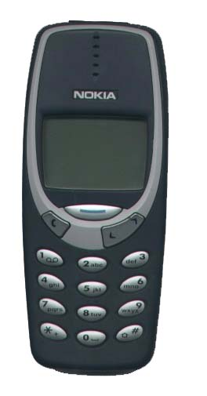

Correct distance between the ear and mouth

Easy to use buttons – well spaced

Sans serif typeface used on buttons – easy to read

The efficient environment
So, ergomonics is about making things the right shape, size and weight for humans. But what if the room that you are working in is too hot or too cold? People work best at ‘room temperature’ which is about 20⁰ C. You cannot work efficiently if you are too hot or too cold. Ergomics also considers noise, vibration, light, and smell. In fact if your senses are uncomfortable you will not work efficiently.

Take a look at the picture below. The person is sitting at a work desk that has been ergonomically designed. The heating, lighting and noise are carefully controlled in offices so that people are comfortable and work at their best.

Offices are carefully designed so that people can work efficiently

Ergonomic graphics
Look at the sign below which is written in an old english style.



This style of very decorative writing is poorly designed from an ergonomic point of view. It is difficult to read and takes time to work out what it is saying. When designing signs and posters it is important that people can quickly and easily ‘get the message’.

Size is important
Look at the writing below. Which ones are difficult to read?

Can you read this
The size of the text is very important. If the writing is too small people will have to strain their eyes to read it.
Can you read this

Can you read this

Can you read this

Can you read this

Can you read this

Style and colour
Some typefaces are easier to read than others. It is important that the one you choose can be easily read. This is particularly important for emergency signs where clarity is very important.
Which style would you choose for the sign?

DO NOT ENTER

DO NOT ENTER

The way colour is used can greatly affect how efficient a graphic product is. Good ergonomic design requires colour contrasts such as red and white.
Nice and clear
Colour combinations are important always try to achieve contrast

Not so clear

Anthropometrics

Anthropometrics is always used with ergonomics. Antro means humans and metrics is measurement. Anthropometrics is therefore about human measurements.
Anthropometric data sheets contain information about the range of human dimensions and sizes for all ages.

If you measured the nose length of 10,000 18 year old men, you would find that the graph produced follows a bell shaped curve.
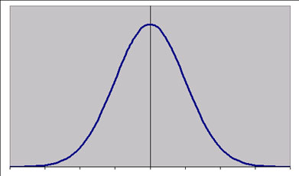

At the left hand end of the graph are people with small noses. At the right hand end are people with large noses. The percentages help us to work out how many of the 10,000 people have small, large or average length noses. The vast majority of people are close to the average. Usually when we design things we try to consider 90% of the population.

Anthropometric data is produced in a series of tables that can be found in most libraries.

Main point
Ergonomics is the study of how people work, rest and play in their environment – ergonomics is about making people more efficient at what they do.

Ergonomics is linked to the use of anthropometric data. Anthropometric data provides statistics of human measurements and is used by designers to decide on the most appropriate sizes for their products.
Question
Explain, giving three examples how a designer has taken ergonomics into account in the design of a pencil.

