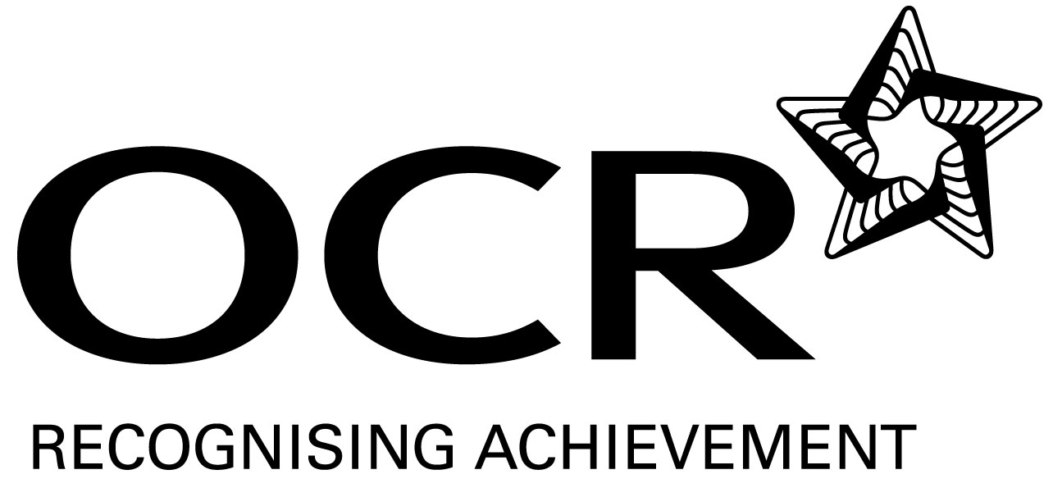
Sample Schemes of Work and Lesson Plans
GCSE D&T: Product Design
OCR GCSE in D&T: Product Design: J305
Unit: A553 Making, Testing and Marketing Products

This Support Material booklet is designed to accompany the OCR GCSE Design and Technology: Product Design specification for teaching from September 2009.

Contents
Contents 2
Introduction 3
Sample Scheme of Work: GCSE Design and Technology: Product Design 5
Sample Lesson Plan: GCSE Design and Technology: Product Design 16

Introduction

Background
Following a review of 14 – 19 education and the Secondary Curriculum Review, the Qualifications and Curriculum Authority (QCA) has revised the subject criteria for GCSEs, for first teaching in September 2009. This applies to all awarding bodies.
The new GCSEs have more up-to-date content and encourage the development of personal, learning and thinking skills in your students.
We’ve taken this opportunity to redevelop all our GCSEs, to ensure they meet your requirements. These changes will give you greater control of assessment activities and make the assessment process more manageable for you and your students. Controlled assessment will be introduced for most subjects.
OCR has produced a summary brochure, which summarises the changes to Design and Technology. This can be found at www.ocr.org.uk, along with the new specification.
In order to help you plan effectively for the implementation of the new specification we have produced these Schemes of Work and Sample Lesson Plans for Design and Technology. These Support Materials are designed for guidance only and play a secondary role to the Specification.

Our Ethos
OCR involves teachers in the development of new support materials to capture current teaching practices tailored to our new specifications. These support materials are designed to inspire teachers and facilitate different ideas and teaching practices.
Each Scheme of Work and set of sample Lesson Plans is provided in Word format – so that you can use it as a foundation to build upon and amend the content to suit your teaching style and students’ needs.
The Scheme of Work and sample Lesson plans provide examples of how to teach this unit and the teaching hours are suggestions only. Some or all of it may be applicable to your teaching.
The Specification is the document on which assessment is based and specifies what content and skills need to be covered in delivering the course. At all times, therefore, this Support Material booklet should be read in conjunction with the Specification. If clarification on a particular point is sought then that clarification should be found in the Specification itself.

A Guided Tour through the Scheme of Work

= Innovative Teaching Idea
This icon is used to highlight exceptionally innovative ideas.


= ICT Opportunity
This icon is used to illustrate when an activity could be taught using ICT facilities.

OCR GCSE D&T Product Design Unit A553: Making quality products
Suggested teaching time | 15 hours | Topic | Unit A553: Making, Testing and Marketing Products
Topic outline |  | Suggested teaching and homework activities |  | Suggested resources |  | Points to note
Unit Overview: Candidates are required to produce a portfolio, responding to A553 Internal Assessment Objectives 4 and 5. This will be presented in either a paper or electronic format which matches that published in the specification. Guidance for the production of an electronic portfolio can be found in Appendix C of the OCR specification.
This unit requires the candidate to either develop further the work undertaken in either Unit A551 or Unit A554 or develop an existing product or new product of the candidates choosing.
Produce a design concept page, which includes details of the prototype product to be made and a related detailed specification |  | - Use the themes outlined in the specification and explore possible options.  - Develop work from either Units 1 or 2.  - Use a product analysis activity to create a product.  - Produce a specification and improvement to a KS3 project.  - Use the examination theme as a stimulus to make a product in the style of.....  - As homework activity identifies areas within the home that would benefit from a new product.  - Watch a TV programme like ‘Dragons Den’ and from the product pitched identify opportunities to create your own product.  - Explore a website like ‘IWOT’ I want one of those and identify opportunities to develop and make a new novelty product.  - Discuss local and national issues and identify opportunities to make products that could solve these problems.  - Use a competition as the focus for a product. ie Silverstone Design Competition |  |  | - GCSE Product Design Text Book  Previously taught and practised activities should include:  - Freehand sketching both 2D & 3D  - orthographic projections  - isometric projection  - CAD and ICT applications  - writing and using a design specification  - Mind mapping and brain storming techniques  - Modelling techniques  - ICT web research  - Television programmes | - The starting point for this will be crucial to how you start off the project.  - Students should be allowed to be flexible in their approach to making and allowed to use a variety of materials.
Make a 3D artefact in the form of a prototype product capable of evaluation |  | - Create a working 3D product  - Show a range of skills to produce a quality product  - This will require teachers to monitor the making of a product; the arrangements for this will vary in centres.  - Opportunities to make a variety of products in different materials and combinations of materials. |  |  | - GCSE Product Design Text Book  Previously taught and practised activities should include:  - a range of marking out skills  - a range of practical making skills  - a range of finishing skills  - a range of materials  - appropriate working environment | - Try to encourage a multi media approach to this unit. Remember this is Product Design and candidates can combine as many materials as necessary.
Complete a production log of the stages of making the product; |  | - This should be approached like filling out a weekly log and is ideal as a homework opportunity each week. Candidates are required to take ownership of what and how they are doing things and record this in detail. This must be done using photograph/images of them completing the practical elements.  - Areas to consider for inclusion in the log are:  - select and use the appropriate tools, equipment and processes effectively and safely to make products that match the specification;  - use of tools & techniques to achieve precision;  - use CAM where appropriate;  - purposefully deploy a range of skills and techniques appropriate to the task, (CAD/CAM is a single skill), including those necessary to ensure realism of the prototype product;  - economically prepare and use materials;  - select and use appropriate pre-manufactured components;  - be prepared to adapt working procedures in response to changing circumstances;  - demonstrate clear understanding of safe working practices. |  |  | - GCSE Product Design Text Book  Previously taught and practised activities should include:  - annotation  - analysis  - justification  - organisational skills and  - presentation skills  - creating photographic evidence  - problem solving  - using appropriate presentation techniques  - Using PowerPoint, inserting text, video, images and sound. | - It is important that this is an ongoing piece of work and should be completed on a regular basis, either at the end of a week or lesson, or during the lesson.  - Candidates need to take ownership of what they are dong and take regular image of their work (an opportunity to use mobile phones if school rules allow it)  - At no point should a centre create a bank of photos for student use.  - Drawn image are not acceptable at this stage, it should be a current ‘live’ explanation of events, not a plan of making.  - Detail, range of skills and techniques, ownership and quality images are key to success in this unit.
Evidence of testing and evaluation of the prototype product by a user / user group against the Design criteria; |  | - Justified evaluation of the design specification  - Target market group evaluation  - Testing the product in context  - Create an interview with someone using the product.  - Create a video of the product being used.  - Give students opportunity to evaluate things on a regular basis.  - Create an exhibition of students work and obtain feedback.  - You online opportunities to gain feedback through a blog, wiki, forum or VLE.  - Allow students to present their work to peers or teachers to gain constructive feedback |  |  | - GCSE Product Design Text Book  Previously taught and practised activities should include:  - annotation  - analysis  - gaining target market group feedback, interviews, questionnaires etc  - justification  - evaluation  - presentation skills | - The ability to create a detailed and justified specification will make answering this aspect easier.  - It is possible to test the product thoroughly, even through to destruction, providing the finished product has been photographed.  - Opportunities to use video and sound as a way of gaining feedback.  - Students should be encouraged to be critical about all things around them. Reflect on current issues and how it might affect the development of their product.
Details of any review processes and necessary modifications to improve the final prototype product |  | - From feedback, analyse and suggest modifications / improvements to the finished product;  - Regular product analysis and sketching opportunities of modifications to everyday products.  - Challenge current issues like the 6 R’s on products they have made or own.  - Challenge students to think, complete and essay or piece of research on topics like..... life without trainers.....life without fast food outlets......life without mobile phones.  - The above could be a cross curricular exercise completed in English or ICT.  - Look at products through time and why they have changed.  - Use the design theme to show how products can be influenced by era’s, designers and fashion. |  |  | - GCSE Product Design Text Book  Previously taught and practised activities should include:  - Freehand sketching both 2D & 3D  - annotation  - analysis  - justification  - evaluation  - presentation skills | - Students should be encouraged to be critical about all things around them. Reflect on current issues and how it might affect the development of their product.  - This is a design exercise and students should show through sketching and annotation how the product could be modified and improved.  - Awareness and understanding of the design influences.
Details of how the design prototype could be manufactured in quantity by either batch, repetitive flow, continual flow or other production system in the ‘real world’; |  | - Students should have an understanding of how things are made. Regular lesson starters watching clips from ‘How it’s made’  - Research how similar products are made in the ‘Real World’  - Visits to local manufacturing companies.  - Speakers into school who could advise on how things are made.  - Business mentors/governing body |  |  | - GCSE Product Design Text Book  Previously taught and practised activities should include:  - Research  - annotation  - analysis  - justification  - presentation skills  - knowledge of mass production techniques  - knowledge of ‘Globalization’  - advantages and disadvantages of CAD/CAM  - Television programmes like ‘How it’s made’  - Discovery Channel / YouTube etc  - Work Experience opportunities. | - Students are required to explain how their product is to be made in a manufacturing environment and need to be specific in saying how parts could be made or sourced.
The marketing presentation - ‘Sales Pitch’ – should be candidates explanation and production of an interesting way of bringing the product to the attention of either:  - a prospective manufacturer;  - a supplier;  - a company buyer;  - a retailer;  - an end user / user group; or  - a consumer. |  | - Explore ways in which product are  - bought to the attention of the chosen target group.  - What makes a successful advert? Why do we remember some adverts better than others?  - Allow students opportunities to sell/pitch ideas to a variety of different audiences.  - Explore radio, magazine, TV advertisement.  - Identify places where products are bought to the attention of the public – underground, bill boards, sandwich boards sides of vehicles, TV, radio, magazines, web, junk mail, catalogues, shop windows, newspapers, menus, word of mouth, sponsorship deals, and endorsements.  - What are the advantages and disadvantages of different type of advertising?  - Present to your peers you favourite advert explaining why it is successful to you.  - Appreciation of iconic products and what makes them successful.  - Encourage students to question the need for products |  |  | - GCSE Product Design Text Book  Previously taught and practised activities should include:  - annotation  - analysis  - justification  - presentation skills  - Use of PowerPoint  - Ability to create quality videos and advertisements  - Use of appropriate ICT packages i.e. 2D design tools, coral draw, Photoshop etc.  - TV, magazines, internet  - School visits – Design Museum, Museum of packaging etc.  Useful Websites:  - www.technologystudent.com – good general resource that includes a range of technical and theoretical information – RM, Graphics and Electronics  - www.designandtech.com – pupil and teacher friendly resource that is regularly updated covering all material areas  - www.design-technology.info – information portal covering all material areas  - www.design-technology.org – general resource for Technology with information relating to designers and eras  - www.lboro.ac.uk/departments/cd - samples of product design work  - www.ergonomics4schools.com – promotes the teaching and learning of ergonomics  - www.designmuseum.org – Design Museum in London web link  - www.coolest-gadgets.com – examples and links to innovative products  - See A553 Coursework Check list | - Students are required to present their product to a chosen target market.  - This section should allow students to show flair and innovative ways to do this.  - Creativity, think outside the box. Advertising jackets for sheep!!!!!  - Work needs to be professional. Use appropriate software or scissors to cut out quality images of the finished product so they can be superimposed into different scenarios.  Task Taking:  - OCR expects teachers to supervise and guide candidates who are undertaking Controlled Assessment. It is important that teachers do not direct candidates in any particular direction. The degree of teacher guidance in candidates’ work will vary according to the kinds of work being undertaken. However it should be remembered that candidates are required to reach their own judgements and conclusions.  - When supervising Controlled Assessment tasks, teachers are expected to:  - offer candidates advice about how best to approach such tasks generally;  - exercise continuing supervision of work in order to monitor progress and to prevent plagiarism;  - ensure that the work is completed in accordance with the specification requirements and can be assessed in accordance with the specified marking criteria and procedures.  - Controlled Assessment should be completed in the course of normal curriculum time and supervised by the teacher. Some of the work, by its very nature, may be undertaken outside the centre e.g. research, testing etc.  - As with all Controlled Assessment, the teacher must be satisfied that the work submitted for assessment is the candidate’s own work.  Task Marking:  - All internally assessed work (Units A551 and A553) are marked by the teacher and internally standardised by the centre.  - The Assessment Criteria for this unit can be found on Pages 55-57 of the OCR Specification. The teacher should be totally familiar with this prior to the commencement of the Controlled Assessment Activity.  - Candidates must observe certain procedures in the production of Controlled Assessment.  - Tables, graphs and spreadsheets may be produced using appropriate ICT. These should be inserted into the report at the appropriate place.  - Any copied material must be suitably acknowledged.  - Quotations must be clearly marked and a reference provided wherever possible.  - Work submitted for moderation or marking must be marked with the:  - centre number;  - centre name;  - candidate number;  - candidate name;  - specification code and title;  - assignment title.  - Work submitted for moderation or marking must be secured by treasury tags.  - There should be clear evidence that work has been attempted and some work produced.  - If a candidate submits no work for an internally assessed component, then the candidate should be indicated as being absent from that component on the mark sheets submitted to OCR. If a candidate completes any work at all for an internally assessed component, then the work should be assessed according to the internal assessment objectives and marking instructions and the appropriate mark awarded, which may be zero.

OCR GCSE D&T Product Design Unit A553: Making quality products

Making quality products
OCR recognises that the teaching of this qualification above will vary greatly from school to school and from teacher to teacher. With that in mind this lesson plan is offered as a possible approach but will be subject to modifications by the individual teacher.
Lesson length is assumed to be one hour.

Learning Objectives for the Lesson
Objective 1 | How familiar products have developed and why the need to improve them might have been necessary
Objective 2 | Show how to improve and modify products through sketching or modelling
Objective 3 | Be able to suggest a range of improvements that could be made to familiar products
Objective 4 | An understanding of Sustainable Design and how to apply the 6 R’s

Recap of Previous Experience and Prior Knowledge
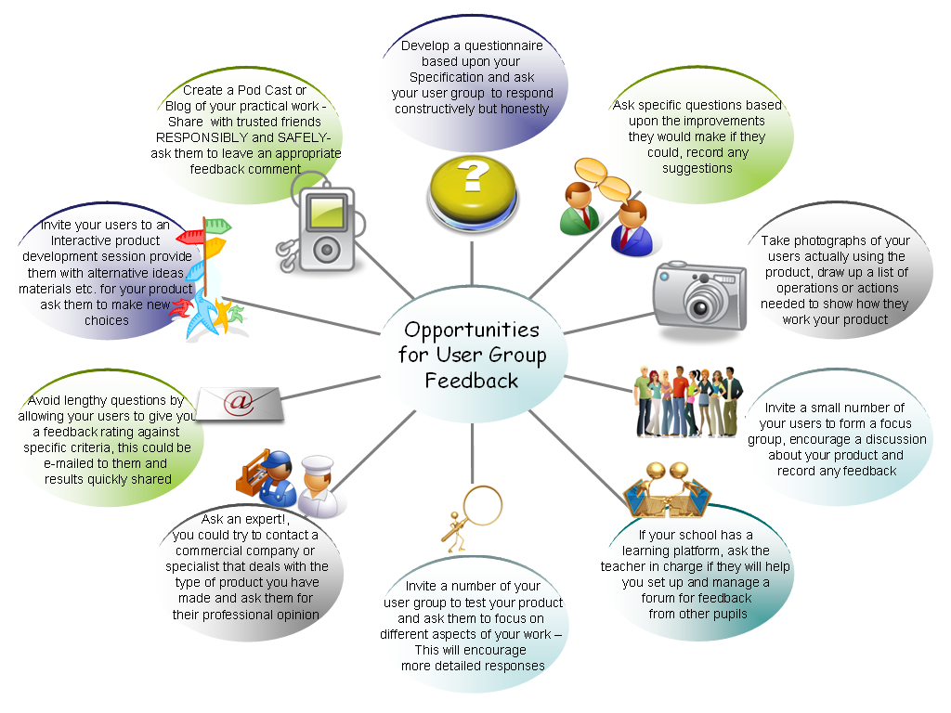
Students should be familiar with specification and how to evaluate them thoroughly
Remind students nothing is perfect and that’s a good thing to be able to recognise, things can only get better!
Encourage students to make meaningful points and to be honest about the changes that you have made and that you would make. It will help when you come to improve and modify your design.
Students should be able to analyse the effectiveness of products through the testing and user group feedback they have carried out.

Content
Time | Content
 | Register of students.
10 minutes | Examples of products that have developed over time. Give students opportunity to look at the products and discuss in groups.  (This would work well if real products are used)
5 minutes | In small groups get them to identify a further modification or improvement they think could be made to the product.
15 minutes | Give students a small amount of time to sketch their proposed improvement or modification. (5 minutes)  (this could be done on flip charts or white boards)  A representative from the group should then explain the modification/improvement to the class (1 minute each)  The class should decide on the best improvement or modification.
15 minutes | Introduce a Design Influence  Sustainable design imperatives and design tools.  Designing products in a way that reduces environmental impact by the use of renewable resources. The use of sustainable design tools such as life cycle assessment and life cycle energy analysis to judge the environmental impact or "greenness" of various design choices.  RETHINK How can your product do the job better? Is your product energy efficient? Has your product been designed for disassembly?  REUSE Which parts of your product could be used again? Has your product got another use without having to process it again?  RECYCLE Is your product easy to take apart? What parts of your product could be used again? Would it take much energy to reprocess your product?  REPAIR Which parts might need to be replaced in your product? Which parts might fail with use or over time? How easy would it be to replace parts?  REDUCE Are there any parts in your product that you really do not need? Do you really need to use the amount of material that you have? How could you simplify your product?  REFUSE Is your product really needed? Have you thought about the people who might be making your product – are they treated fairly (pay, living and working conditions etc.)
10 minutes | Using the questions in the table above.  In small groups students are to create a mind map of opportunities for improving or modifying the design. Encourage students to be innovative and think outside the box.

Consolidation
Time | Content
5 minutes | Through question and answer reinforce students understanding of the 6 R’s. Draw out some of the points they came up with for the product they had modified.  Even better if? Encourage students to challenge and an appreciation everything can be improved.
5 minutes | Home learning  Think about an everyday product. Think of ways this could be improved, enhanced or modified. Try to be innovative in the way you do this.  Consider sustainability – can your product be modified or improved using the 6 ‘R’s? You could refer back to the design influences or your specification.  If you could repeat the activity what would you do differently to make your product even better if…..  As a design type activity – use notes and sketches, photographs or CAD modelling to show how the product could be modified or improved.  Refer to any evaluations or user group feedback – do these highlight opportunities for improvement?  Present a piece of work to show you findings.
Total 60 minutes | Lesson ends.

