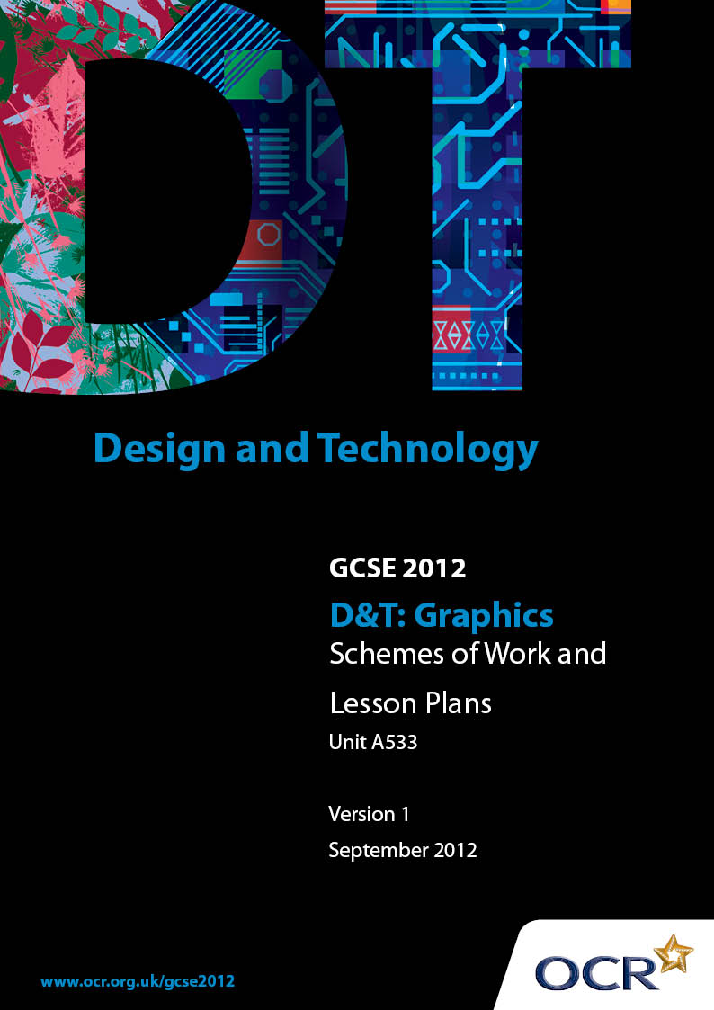

Contents
Contents 2
Introduction 3
OCR GCSE in Design and Technology Graphics: Sample Scheme of Work 5
OCR GCSE in Design and Technology Graphics: Sample Lesson Plan 30

Introduction

Background
OCR has produced a summary brochure, which summarises the changes to Design & Technology. This can be found at www.ocr.org.uk, along with the 2012 specification.
In order to help you plan effectively for the implementation of the new specification we have produced these schemes of work and sample lesson plans for Design & Technology. These support materials are designed for guidance only and play a secondary role to the specification.

Our Ethos
OCR involves teachers in the development of new support materials to capture current teaching practices tailored to our new specifications. These support materials are designed to inspire teachers and facilitate different ideas and teaching practices.
Each scheme of work and set of sample lesson plans are provided in Word format to be used as a foundation to build upon and amend the content to suit your teaching style and students’ needs.
The scheme of work and sample lesson plans provide examples of how to deliver these units and suggested teaching hours which could be applicable to your teaching.
The specification is the document on which assessment is based and specifies what content and skills need to be covered in delivering the course. At all times, therefore, this support material booklet should be read in conjunction with the specification. Any clarification should be found in the specification.

A Guided Tour through the Scheme of Work

= Innovative Teaching Idea
This icon is used to highlight exceptionally innovative ideas.


= ICT Opportunity
This icon is used to illustrate when an activity could be taught using ICT facilities.

OCR GCSE in D&T Graphics Unit A533: Making quality products
Suggested teaching time | 30 hours | Topic |  | Making quality products
Topic outline |  |  | Suggested teaching and homework activities |  | Suggested resources | Points to note
Introduction |  |  | - Consider the themes in the specification  - Arrange students into groups. Write each theme on a large sheet of paper and give out one to each group  - Ask students to discuss the theme for 5 minutes and think of some products that they could make, using the theme as a starting point. Write the ideas on the sheet of paper in the form of a scatter diagram  - Ask each group to feedback their theme and suggestions to the rest of the class. Encourage the rest of the group to make other suggestions. Write these on the diagram  - Pose the question: Which themes and/or ideas do they think have potential? Ask each student to draw up a short list of possible projects |  | - Page 53 of the specification - list of themes  - Photographs of products used in OCR training | - Students must use the suggested themes from page 53 of the specification as a starting point for their project  - Students can link the project to their own interests  - The teacher must balance the centres material and equipment resources when deciding on appropriate projects  - The chosen project should allow students to satisfy the requirements of the course and access the full range of marks  - Teachers must ensure that students do not choose the same theme for their work as intended or submitted for unit A531

OCR GCSE in D&T Graphics Unit A533: Making quality products
Suggested teaching time | 30 hours | Topic |  | Making quality products
Topic outline |  |  | Suggested teaching and homework activities |  | Suggested resources | Points to note
- Discuss suggestions to come up with shortlist of themes and projects for the class
- Students decide on their chosen project task
- Students are now ready to start the project
- Give the class a brief overview of the different tasks involved in the project
- Explain the work involved in the first section and set students a target date for completion of this section
- Students write a short design brief explaining exactly what they are intending to produce
Designing |  |  | - Show students a current product. Explain the concept of a specification. Ask students to suggest some things that the product must satisfy eg it must be lightweight or it must be waterproof |  | - Examples of products such as a football boot, ceramic bowl, chocolate box or disposable biro | - It is important to show some innovative and creative designs at this stage to inspire the students  - Ask students to consider why each product was designed and who it was designed for

OCR GCSE in D&T Graphics Unit A533: Making quality products
Suggested teaching time | 30 hours | Topic |  | Making quality products
Topic outline |  |  | Suggested teaching and homework activities |  | Suggested resources | Points to note
 |  |  | - Give out to students a range of different products. Explain that each product will have started with a design brief and a specification  - Ask students to write a specification for the product they have been given  - Feedback and present student work to the rest of the class  - Pose suitable questions: Do all the products meet the specification? Can a product satisfy the brief but not the specification? Is it always possible to meet all of the specification?  - Students then write a specification for their own chosen project theme  - Students to work in pairs to discuss each others specification and suggest improvements and changes |  | - www.co-design.co.uk/dpg/pds/pdshome.htm explains how to write a specification, suggests what to include. It also includes links to examples from a specification written by a group of students who were specifying the design of a lawn-edge trimmer

OCR GCSE in D&T: Graphics Unit A533: Making quality products
Suggested teaching time | 30 hours | Topic |  | Making quality products
Topic outline |  |  | Suggested teaching and homework activities |  | Suggested resources | Points to note
- Review point 1 - check the work of all students. Make sure all specifications are detailed enough, clear and realistic in terms of what the students can achieve with the time and resources available
- Give help and guidance to students who may need to improve or modify their specifications
- Provisionally award marks out of 4 for the first part of designing (use the marking grids)
- Introduce the next part of the project ‘designing’
- Give the class a brief overview of the different tasks involved in the project
- Explain the work involved in this section and set students a target date for completion of the section

OCR GCSE in D&T Graphics Unit A533: Making quality products
Suggested teaching time | 30 hours | Topic |  | Making quality products
Topic outline |  |  | Suggested teaching and homework activities |  | Suggested resources | Points to note
 |  |  | - Talk to group about what makes a good design. Use examples of design icons to demonstrate this. Eg The Austin Mini, the Dyson vacuum cleaner, the Apple iPod, The Fender Stratocaster guitar, The Ducati 916 motorcycle, the Sony Walkman or the Nike tick logo  - Encourage students to be creative, and innovative. Give examples of innovative ideas such as the clockwork radio or iPhone, ask students to try and be wacky and think ‘outside the box’ |  |  | - Encourage students to sketch in two point perspective, using a range of graphical techniques eg shading, thick and thin line technique or using colour  - It is not the intention that students should carry out a lengthy evaluation of each their initial ideas against all the points in their specification. A brief summary of their thoughts and the reasons for their decisions is adequate

OCR GCSE in D&T Graphics Unit A533: Making quality products
Suggested teaching time | 30 hours | Topic |  | Making quality products
Topic outline |  |  | Suggested teaching and homework activities |  | Suggested resources | Points to note
- Emphasize the need for designers today to create products which are sustainable, recyclable and environmentally friendly

- Encourage and give opportunities for students to use existing designs and other information sources to inspire them and help inform their initial ideas

- Demonstrate how to sketch quickly and ‘brainstorm’ ideas
- Give out pencils, paper, colours etc. Give students 10 minutes or so to come up with a page full of sketched ideas

OCR GCSE in D&T Graphics Unit A533: Making quality products
Suggested teaching time | 30 hours | Topic |  | Making quality products
Topic outline |  |  | Suggested teaching and homework activities |  | Suggested resources | Points to note
 |  |  | - Ask some students to show and explain their ideas to the rest of the group. Use innovative ideas to encourage the group  - Give students time to come up with a range of individual ideas. Go round class and give help/direction/suggestions where necessary  - Ask students to look back at the specification and brief. Using these ask them to evaluate their initial ideas and pick out the ideas worthy of further development  - Demonstrate to students how to take an initial idea and develop it further. Show examples to help get across the procedure |  |  | - Get across the need for knowing critical sizes and dimensions of items before the final design for a product which uses them is completed. Eg before designing a point of sale display you must know the size of the items going on display. Before designing the packaging for an iPod you must know the size of the iPod and all the other items which will be packaged along with it (charger, leads, headphones etc)  - To collect critical information needed, students can source an actual item and measure it, or look up information using product specifications published in handbooks or on manufacturer’s websites  - Where ‘real life’ models are produced in the development of ideas, these should be photographed as evidence and included in candidate’s design folder

OCR GCSE in D&T Graphics Unit A533: Making quality products
Suggested teaching time | 30 hours | Topic |  | Making quality products
Topic outline |  |  | Suggested teaching and homework activities |  | Suggested resources | Points to note
 |  |  | - Ask students to develop their best idea(s) further by adding more information, well proportioned drawings, with notes, and close up views of particular features  - At this stage students should be encouraged to model part or all of their designs to test whether their ideas are feasible  - ‘Real life’ and ICT based models can be produced by students to develop their design work and get them to a final design idea |  |  | - The use of computer modelling should be encouraged wherever possible. Screen shots showing the progression of the design should be included as evidence in the students design folder

OCR GCSE in D&T Graphics Unit A533: Making quality products
Suggested teaching time | 30 hours | Topic |  | Making quality products
Topic outline |  |  | Suggested teaching and homework activities |  | Suggested resources | Points to note
- Pose the questions: What is a working drawing? What information is necessary to create a working drawing? What critical information do the students need to know before they can finalise their designs and produce a working drawing? How can we get this information?

- Demonstrate and suggest ways that students can find out the information needed
- Students to collect information needed to finalise their designs

OCR GCSE in D&T Graphics Unit A533: Making quality products
Suggested teaching time | 30 hours | Topic |  | Making quality products
Topic outline |  |  | Suggested teaching and homework activities |  | Suggested resources | Points to note
Scale drawings |  |  | - Explain what is meant by a scale drawing method  - The following scale drawing methods may be used/taught:  1 Third angle orthographic views  2 Sectional views  3 Assembly drawings  4 Isometric drawing  5 Perspective drawing |  | - http://www.bbc.co.uk/schools/gcsebitesize/design/graphics/drawingformalrev1.shtml gives a good overview of the scale drawing methods | - Individual schools should adjust the degree of difficulty of the drawing exercises to the ability/experiences of the students. Many students will have produced scale drawings in preparation for unit A534, so they may only need to recap at this stage

OCR GCSE in D&T Graphics Unit A533: Making quality products
Suggested teaching time | 30 hours | Topic |  | Making quality products
Topic outline |  |  | Suggested teaching and homework activities |  | Suggested resources | Points to note
Enhancing and presenting |  |  | - Explain what is meant by an enhancement technique  - The following enhancement techniques should be taught through a series of drawing exercises:  1 Application of tone  2 Thick and thin lines  3 Rendering  4 Colour theory |  | - A range of drawing exercises  - http://www.bbc.co.uk/schools/gcsebitesize/design/graphics/drawingsketchingrev1.shtml gives good examples of enhancement techniques | - Individual schools should adjust the degree of difficulty of the drawing exercises to the ability/experiences of the students. Many students will have used enhancement techniques in preparation for unit A534 so they may only need to recap at this stage

OCR GCSE in D&T Graphics Unit A533: Making quality products
Suggested teaching time | 30 hours | Topic |  | Making quality products
Topic outline |  |  | Suggested teaching and homework activities |  | Suggested resources | Points to note
Design presentation |  |  | - Students are required to produce a selection of appropriate scale drawings which fully communicate their chosen final idea  - Review point 2 - check the work of all students. Make sure all designs are detailed enough, clear and realistic in terms of what the students can achieve with the time and resources available  - Give help and guidance to students who may need to improve or modify their designs accordingly  - Provisionally award marks out of 12 for last two parts of designing (refer to marking grids)  - Introduce the next part of the project - ‘making’ |  |  | - It is important to demonstrate a range of skills during this task. Students are encouraged to use a mixture of hand and ICT skills to produce a set of drawings. Eg orthographic working drawings produced on CAD, along with some perspective or isometric ‘artist’s impressions’ drawn by hand and rendered using appropriate enhancement techniques

OCR GCSE in D&T Graphics Unit A533: Making quality products
Suggested teaching time | 30 hours | Topic |  | Making quality products
Topic outline |  |  | Suggested teaching and homework activities |  | Suggested resources | Points to note
- Give the class a brief overview of the different tasks involved in the project
- Explain the work involved in this section and set students a target date for completion of the section
Planning |  |  | - Split students into groups and give them a product which requires assembling (do not give out the instructions)  - Explain to students that they have a set amount of time to assemble the item  - Pose the question: Why was the task so difficult? What would have made the task much easier?  - Draw out why we need to plan and the importance of having a clear plan to follow through group discussion |  | - Products such as a jigsaw puzzle (without the picture on the front of the box) to something like a simple ‘Airfix’ model or piece of Ikea furniture (minus the assembly instructions) would be suitable for this planning activity  - http://www.ganttchart.com/Examples.html shows examples of different types of Gantt charts

OCR GCSE in D&T Graphics Unit A533: Making quality products
Suggested teaching time | 30 hours | Topic |  | Making quality products
Topic outline |  |  | Suggested teaching and homework activities |  | Suggested resources | Points to note
 |  |  | - Explain the two stages of:  1 Choosing and preparing materials  2 Planning work to make best use of materials, components, equipment and resources  - Explain the essential points of a good plan are detail and order  - Show examples of different ways and types of planning eg Gantt charts, flow diagrams, written instructions, diagrams, materials/equipment lists etc  - Students produce a plan to make their chosen product |  |  | - Plans can be produced by hand or using ICT as appropriate  - When choosing and preparing materials, candidates should be encouraged to use smart materials and look for opportunities to use materials in innovative and unusual ways

OCR GCSE in D&T Graphics Unit A533: Making quality products
Suggested teaching time | 30 hours | Topic |  | Making quality products
Topic outline |  |  | Suggested teaching and homework activities |  | Suggested resources | Points to note
 |  |  | - Group to consider each plan in terms of detail (is there sufficient to make the product?) and order (are the stages in the correct order?). Using the working drawing and plan, could another person follow them and correctly make the product?  - Students are to refine their plans accordingly to a point where they are ready to make  - Review point 3 - check the work of all students. Make sure all plans are detailed enough, clear and realistic in terms of what the students can achieve with the time and resources available  - Give help and guidance to students who may need to improve or modify their planning  - Introduce the main ‘making’ part of the project  - Give the class a brief overview of the different tasks involved in the project |  |  | - Emphasize that this section is the main part of the project (and carries the most marks)

OCR GCSE in D&T Graphics Unit A533: Making quality products
Suggested teaching time | 30 hours | Topic |  | Making quality products
Topic outline |  |  | Suggested teaching and homework activities |  | Suggested resources | Points to note
 |  |  | - Explain the work involved in this section and set students a target date for completion of the section
Making |  |  | - Students to source and gather together the materials and equipment needed for their project  - Students to follow their plans and commence making their product  - Students to record key stages in the making process  - Students to add appropriate surface graphics (designed earlier) to their product using appropriate methods |  |  | - This is the main part of the task for this unit and carries the most marks. (24 out of the 60 available). It is intended therefore that candidates will spend approx. 8 hours on making alone  - Students are to photograph the process and stages of making  - Any changes or modifications to the design should be recorded and justified
 |  |  | - Teacher to supervise students during the making process and ensure that all work is carried out within the guidelines laid out in the specification  - Teachers to encourage skilful selection and use of materials, to make a high quality product which fully meets the specification  - Students are to take a minimum of 2 digital images/photographs of the finished product in use showing the front and back  - Review point 4 - check the work of all students. Make sure practical work is well made, detailed enough, and has high quality surface graphics  - Give help and guidance to students who may need to improve or modify their product further |  |  | - Notes, diagrams, photographs, and video clips can be used to record the key stages of the making process  - Traditional hand drawn graphics, computer designed and printed graphics can be used  - CAM and CNC can be used in the manufacture of the product and the surface graphics  - The product can be a 2D or 3D outcome

OCR GCSE in D&T Graphics Unit A533: Making quality products
Suggested teaching time | 30 hours | Topic |  | Making quality products
Topic outline |  |  | Suggested teaching and homework activities |  | Suggested resources | Points to note
- Provisionally award marks out of 24 for the making (and planning)
- Introduce the evaluation part of the project.
- Give the class a brief overview of the different tasks involved in the project
- Explain the work involved in this section and set students a target date for completion of the section
Evaluation |  |  | - Pose the question: What is the purpose of evaluation?  - Explain that we live in a ‘new improved society’. Everyday we are bombarded with new improved products. Why is this?  - Draw out and explain that the reason for this is that all products are evaluated, modified and improved in a constant design cycle |  | - Examples of improved products such as washing powder, toothpaste, tinned foods or cleaning products

OCR GCSE in D&T Graphics Unit A533: Making quality products
Suggested teaching time | 30 hours | Topic |  | Making quality products
Topic outline |  |  | Suggested teaching and homework activities |  | Suggested resources | Points to note
 |  |  | - Show examples of some ‘new improved products’  - Pose the question: How do the manufacturers of the example items evaluate their products?  - Draw out different methods of evaluating products and discuss which are the most effective  - Students to test their products by using them ‘in situ’ for their intended purpose  - Students to critically evaluate their product against the specification  - Students to record the comments from the intended users |  |  | - Students are to photograph their products in use as evidence of testing for their evaluation  - If students use surveys as a means of evaluation these must be with the intended audience/users of the product

OCR GCSE in D&T Graphics Unit A533: Making quality products
Suggested teaching time | 30 hours | Topic |  | Making quality products
Topic outline |  |  | Suggested teaching and homework activities |  | Suggested resources | Points to note
- Students to analyse their findings from the evaluation, and draw meaningful conclusions

- Students to suggest ways their product could be improved further, modified and refined to make it better
- Final review - check all the work of all students. Make sure all work is in correct order and in a well presented design folder
- Ensure that photographic evidence of making is included in the folder
- Give help and guidance to students who may need to help putting together a well presented folder and taking good quality close up photographs
- Award final marks for all sections of the folder

OCR GCSE in D&T Graphics Unit A533: Making quality products
Suggested teaching time | 30 hours | Topic |  | Making quality products
Topic outline |  |  | Suggested teaching and homework activities |  | Suggested resources | Points to note
- Total marks to get a final mark out of 60
- Fill in candidate authentication forms, centre authentication form and submit final marks
- Safely store all candidates’ practical and folder work in a safe place

OCR GCSE D&T Graphics Unit A533: Making quality products

Making quality products
OCR recognises that the teaching of this qualification will vary greatly from school to school and from teacher to teacher. With that in mind this lesson plan is offered as a possible approach though it will be subject to modifications by the individual teacher.

Lesson length is assumed to be one hour.

Learning Objectives for the Lesson
Objective 1 | Students to understand what is meant by a specification.
Objective 2 | Students to be able to understand the importance of a clear specification.
Objective 3 | Students to be able identify ‘user needs’ and ‘fit for purpose’.
Objective 4 | Students to write a specification for an existing product.
Objective 5 | Students to write a detailed specification for a product they have chosen to design for a specific purpose and user.

Recap of Previous Experience and Prior Knowledge
- Prior to this lesson students will have decided on a theme from the list given in the specification, identified a design need and written a clear design brief.

Content
Time | Content
5 minutes | Starter activity: What is it? Give out ‘What is it?’ worksheets as students enter the room. This is an example of reverse engineering - students have the specification but need to guess the product. Ask students to read the specification and decide what the product is. Depending on the range of abilities you may wish to pair up or group students for this exercise. After 3 minutes ask students to suggest answers.
5 minutes | Pose the questions: What is a specification? What is the purpose of a specification? Draw out answers by questioning and explain that before we design a product we must be very clear about what we want the product to do.  A specification is a list of requirements that a product must satisfy if it is to be successful (meet the brief).
10 minutes  10 minutes | Divide class into small groups. Give each group a large sheet of paper, pen and a current everyday product such as a football boot, ceramic mug, chocolate box or disposable biro. Explain that each product will have started with a Design brief and a specification.  Ask students to write a specification for the product they have been given.  Groups to then feedback their specification to the rest of the group, giving reasons for their choices. Pose suitable questions: Do all the products meet the specification? Is it always possible to meet all of the specification? Are the products ‘fit for purpose’? Who are the intended users?

Time | Content
20 minutes | Working individually students write a specification for their own chosen project theme. Teacher to move around room giving assistance and direction as appropriate.
5 minutes | Working in pairs students are to explain the specification they have written to their partners, discuss each others specification and suggest improvements and further points that could be added.

Consolidation
Time | Content
5 minutes | Draw the class back together. Share good examples of work. Pose suitable questions: Why is a clear concise specification important? Revisit the objectives and reflect on the learning and work completed.
Homework | Locate an existing product similar to the one you are designing. Evaluate the product against your specification. Are there products on the market which already fulfil your specification? Based on what they discover, students may wish to modify and refine the criteria in their specification.

