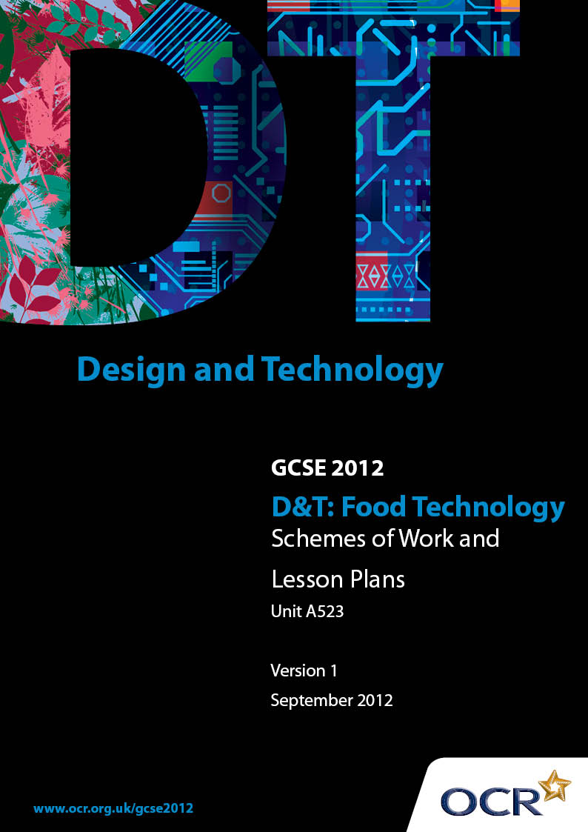

Contents
Contents 2
Introduction 3
OCR GCSE D&T Food Technology – Sample Scheme of Work 5
OCR GCSE D&T Food Technology – Sample Lesson Plan 13

Introduction

Background
OCR has produced a summary brochure, which summarises the changes to Design & Technology. This can be found at www.ocr.org.uk, along with the 2012 specification.
In order to help you plan effectively for the implementation of the new specification we have produced these schemes of work and sample lesson plans for Design & Technology. These support materials are designed for guidance only and play a secondary role to the specification.

Our Ethos
OCR involves teachers in the development of new support materials to capture current teaching practices tailored to our new specifications. These support materials are designed to inspire teachers and facilitate different ideas and teaching practices.
Each scheme of work and set of sample lesson plans are provided in Word format to be used as a foundation to build upon and amend the content to suit your teaching style and students’ needs.
The scheme of work and sample lesson plans provide examples of how to deliver these units and suggested teaching hours which could be applicable to your teaching.
The specification is the document on which assessment is based and specifies what content and skills need to be covered in delivering the course. At all times, therefore, this support material booklet should be read in conjunction with the specification. Any clarification should be found in the specification.

A Guided Tour through the Scheme of Work

= Innovative Teaching Idea
This icon is used to highlight exceptionally innovative ideas.


= ICT Opportunity
This icon is used to illustrate when an activity could be taught using ICT facilities.

OCR GCSE D&T Food Technology Unit A523: Making quality products
Suggested teaching time | 11 hours | Topic | Developing designing skills for controlled assessment
Topic outline |  | Suggested teaching and homework activities |  | Suggested resources | Points to note
Produce a detailed design specification for the chosen design brief |  | - Decide on the theme and design brief  - Analyse the design brief to develop general criteria (design specification) that products can be evaluated against |  | - Exemplar student work  - Power point presentation  - Teacher Notes for guidance | - The Theme must be chosen from the current OCR Specification  - The design brief must include a target group so trialled products (design ideas) ideas can be tested and evaluated  - Exemplar work to show students how to present their work  - Power point along with teachers notes to explain requirements of the work
Record creative design ideas using appropriate methods of presentation |  | - Use a wide range of techniques when presenting information about the products to be trialled – word processing, photographs, tasting charts  - Show consideration of the nutritional focus of the design brief when designing ideas |  | - Exemplar student work  - ICT – computer, printer, digital camera  - ICT – nutritional analysis programmes
Use appropriate modelling/trialling techniques  Use ICT/nutritional analysis to support design development |  | - Using results from research – questionnaire, recipe books etc, select 4 products (design ideas) to trial which are appropriate to the design brief and which show a variety of practical skills.  - Produce a week by week/lesson by lesson plan showing all the work that will be carried out during the trialling process (forward planning)  - For each product (design idea) to be trialled  - list ingredients  - Describe modifications/adaptations to the original recipe  - Give reasons for the modifications/adaptations  - Carry out nutritional analysis if this is relevant to the brief or design specification  - Make each product  - Show evidence of testing by 3 tasters  - Evaluate each product against the design specification |  | - Recipes  - Exemplar student work  - Exemplar student work  - Power point presentation  - Teacher Notes for guidance  - ICT – nutritional analysis programmes  - Digital camera  - Kitchen equipment, ingredients etc | - Teacher support to check that ideas chosen will allow students to demonstrate a wide range of practical skills and are appropriate to the design brief  - Marks for the week by week/lesson by lesson plan are awarded to the making section of the assessment criteria  - Remember the products should be creative and innovative and if the brief or design specification shows reference to nutrition, nutritional analysis should be carried out for each product (design idea)  - Provide photographic evidence of each product  - Use tasting charts, star profiles etc.  - Products should be evaluated against each point in the design specification. Reference should be made to the nutritional content of the product if relevant to the design brief/specification  - NB marks for making of the products are awarded to the making section of the assessment criteria

OCR GCSE D&T Food Technology Unit A523: Making quality products
Suggested teaching time | 11 hours | Topic | Developing designing skills for controlled assessment
Topic outline |  | Suggested teaching and homework activities |  | Suggested resources | Points to note
Select chosen design idea as a result of evaluation |  | - Explain reasons for the chosen trialled product (design idea) and reasons why the other 3 trialled products (design ideas) are rejected |  | - Exemplar student work  - Power point presentation  - Teacher Notes for guidance

OCR GCSE D&T Food Technology Unit A523: Making quality products
Suggested teaching time | 8 hours | Topic | Demonstrate making skills for controlled assessment
Topic outline |  | Suggested teaching and homework activities |  | Suggested resources | Points to note
Use trialling procedures during product development |  | - Two developments. For each development:  - List ingredients  - Cost ingredients  - Reasoned decisions for the changes made to each product  - Carry out nutritional analysis if this is relevant to the brief or specification  - Make the products  - Show evidence of testing by 5 tasters  - Evaluate each development |  | - Exemplar student work  - Power point presentation  - Teacher Notes for guidance  - ICT – nutritional analysis programmes  - Digital camera  - Kitchen equipment, ingredients etc | - Remember the products should be creative and innovative and if the brief or specification shows reference to nutrition, nutritional analysis should be carried out for each trialled product  - Show consideration to the comments made when the product (design idea) was originally trialled and the comments made by testers during development work  - Provide photographic evidence of each product  - Use tasting charts, star profiles etc.  - Explain how effective the changes have been and the further changes that need to be made according to tester’s comments.  - Reference should be made to the nutritional content of the product if relevant to the design brief/specification

OCR GCSE D&T Food Technology Unit A523: Making quality products
Suggested teaching time | 8 hours | Topic | Demonstrate making skills for controlled assessment
Topic outline |  | Suggested teaching and homework activities |  | Suggested resources | Points to note
Make decisions about the ingredients and equipment for the final product |  | - List each ingredient and state its function  - Cost ingredients  - List the equipment and state the job it will be used for |  | - Exemplar student work
Design a Product Specification |  | - Develop specific criteria (product specification) that the final product can be evaluated against |  | - Exemplar student work | - Consider the design specification and the results during product development when designing the Product Specification
Plan and organise activities |  | - Design an effective order of work for making the final product e.g. flowchart |  | - Exemplar student work | - Power point along with teachers notes to explain requirements of the work.  - Plan should be detailed and accurate
Select and use appropriate ingredients and equipment safely and hygienically |  | - During all practical sessions: -  - Selecting and using appropriate ingredients and equipment  - Working safely and hygienically |  | - Digital camera  - Kitchen equipment, ingredients etc | - When awarding marks consideration should be given to the trialling of products (design ideas), trialling during product development and the production of the final product

OCR GCSE D&T Food Technology Unit A523: Making quality products
Suggested teaching time | 8 hours | Topic | Demonstrate making skills for controlled assessment
Topic outline |  | Suggested teaching and homework activities |  | Suggested resources | Points to note
Prepare, shape, form, mix, assemble and finish products |  | - During all practical sessions: -  - Work skilfully and effectively showing consideration of waste.  - Demonstrate an understanding of the methods and techniques used in the making of practical products.  - Use a wide range of skills |  | - Digital camera  - Kitchen equipment, ingredients etc | - When awarding marks consideration should be given to the trialling of products (design ideas) and the production of the final product
Produce quality outcomes |  | - Standard of finished products and level of precision |  | - Digital camera  - Kitchen equipment, ingredients etc | - When awarding marks consideration should be given to the trialling of products (design ideas), trialling during product development and the production of the final product

OCR GCSE D&T Food Technology Unit A523: Making quality products
Suggested teaching time | 1 hour | Topic | Demonstrate critical evaluation skills for controlled assessment
Topic outline |  | Suggested teaching and homework activities |  | Suggested resources | Points to note
Evaluate through detailed testing against the Product Specification |  | - Show evidence of testing by 5 tasters  - Critically evaluate the final product against the Product Specification and design brief |  | - Exemplar student work  - Power point presentation  - Teacher Notes for guidance  - ICT – computer and printer | - Use tasting charts, star profiles etc  - It is a good idea to ask tasters how the product can be improved  - The final product should be evaluated against each point in the Product Specification
Present meaningful conclusions leading to suggestions for possible improvements |  | - Give conclusions and suggest modifications to improve the product |  | - Exemplar student work  - Power point presentation  - Teacher Notes for guidance  - ICT – computer and printer | - Comments need to show how successful the product is in terms of the Product Specification and design brief  - Comments from tasters should support views and provide evidence when offering conclusions
Use of spelling, punctuation and grammar |  |  |  |  | - Use of spelling, punctuation and grammar are assessed throughout the entire controlled assessment portfolio

OCR GCSE D&T Food Technology Unit A523: Making quality products
OCR recognises that the teaching of this qualification above will vary greatly from school to school and from teacher to teacher. With that in mind this lesson plan is offered as a possible approach but will be subject to modifications by the individual teacher.
Lesson length is assumed to be one hour.

Learning Objectives for the Lesson
Objective 1 | To understand how results from star profiles are used to modify/adapt food products
Objective 2 | To use results from a star profile to develop a product by means of an annotated drawing

Recap of Previous Experience and Prior Knowledge
- Ask students to explain: -
What is meant by an annotated drawing.
What is a star profile.

Content
Time | Content
5 minutes | Show students the results of a star profile from a chosen product – ask them how these results could be used to develop the product further’
10 minutes | Using a previously prepared annotated drawing show and discuss with the students how results from the star diagram have been used to develop the product further by carrying out modifications to the product.
35 minutes | Using results of a star profile for a different product, students produce a coloured annotated drawing to show the modifications required.  Explain the reasons for the suggested modifications.

Consolidation
Time | Content
10 minutes | Class discussion to share ideas – Some of the students to show and explain their annotated drawings

