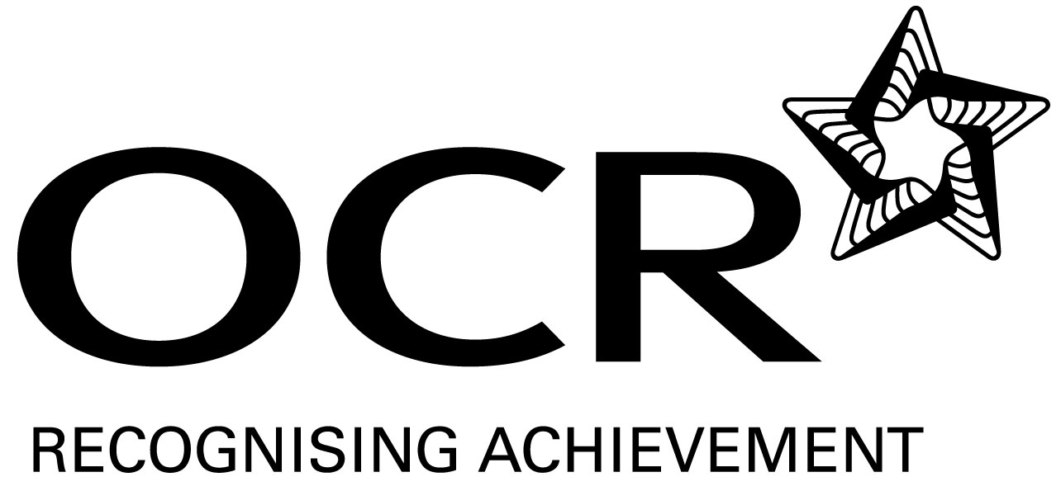
Sample Schemes of Work and Lesson Plans
GCSE D&T: Food Technology
OCR GCSE in D&T : Food Technology: J302/J032
Unit A522: Sustainable design

This Support Material booklet is designed to accompany the OCR GCSE Design & Technology: Food Technology specification for teaching from September 2009.

Contents
Introduction 3
OCR GCSE D&T Food Technology – Sample Scheme of Work 5
OCR GCSE D&T Food Technology – Sample Lesson Plan 11

Introduction

Background
Following a review of 14 – 19 education and the Secondary Curriculum Review, the Qualifications and Curriculum Authority (QCA) has revised the subject criteria for GCSEs, for first teaching in September 2009. This applies to all awarding bodies.
The new GCSEs have more up-to-date content and encourage the development of personal, learning and thinking skills in your students.
We’ve taken this opportunity to redevelop all our GCSEs, to ensure they meet your requirements. These changes will give you greater control of assessment activities and make the assessment process more manageable for you and your students. Controlled assessment will be introduced for most subjects.
OCR has produced a summary brochure, which summarises the changes to Design & Technology. This can be found at www.ocr.org.uk, along with the new specification.
In order to help you plan effectively for the implementation of the new specification we have produced these Schemes of Work and Sample Lesson Plans for Design & Technology. These Support Materials are designed for guidance only and play a secondary role to the Specification.

Our Ethos
OCR involves teachers in the development of new support materials to capture current teaching practices tailored to our new specifications. These support materials are designed to inspire teachers and facilitate different ideas and teaching practices.
Each Scheme of Work and set of sample Lesson Plans is provided in Word format – so that you can use it as a foundation to build upon and amend the content to suit your teaching style and students’ needs.
The Scheme of Work and sample Lesson plans provide examples of how to teach this unit and the teaching hours are suggestions only. Some or all of it may be applicable to your teaching.
The Specification is the document on which assessment is based and specifies what content and skills need to be covered in delivering the course. At all times, therefore, this Support Material booklet should be read in conjunction with the Specification. If clarification on a particular point is sought then that clarification should be found in the Specification itself.

A Guided Tour through the Scheme of Work

= Innovative Teaching Idea
This icon is used to highlight exceptionally innovative ideas.


= ICT Opportunity
This icon is used to illustrate when an activity could be taught using ICT facilities.

OCR GCSE D&T Food Technology Unit A522: Sustainable design
Suggested teaching time | 15 hours | Topic | 6R’s
Topic outline |  | Suggested teaching and homework activities |  | Suggested resources | Points to note
What are the 6 Rs |  | - Definition of the 6 R’s  - Have a sorting activity matching definitions of 6R’s with definitions  - In groups rank order the 6 R’s  - Discuss debate which is the correct order. Question is there a correct order?  - Write clear definitions / ideas of how Food technology can apply the 6 R’s to designing food products |  | - GCSE Food Technology Hodder published Sept 09 OCR endorsed  - The Sustainability handbook for D&T teachers Practical Action Publishing ISBN978-1-85339-670-0  - Definitions of 6 R’s to sort out | - Points need to be clearly related to food issues.  - The 6 Rs can then be looked at independently or linked as appropriate
Recycle – what is meant by recycling within food technology |  | - The choice of packaging materials – what is available  - How do you know its recyclable  - Investigate the different symbols found on different packaging materials.  - In groups discuss what are the advantages and disadvantages of the different types of packaging materials. Produce a chart to illustrate your findings  - What are producers and shops doing about packaging materials  - Composting – who does composting at home? Why is this useful? Investigate what foods can / cannot be composted |  | - Collection of different types of packaging  www.recyclenow.com  - GCSE Food Technology Hodder published Sept 09 OCR endorsed  - The Sustainability handbook for D&T teachers Practical Action Publishing ISBN978-1-85339-670-0 | - Be aware of new developments in technologies such as starch bases packaging which will decompose  - There are an increasing number of different symbols used linked to the recycling of food packaging
Reuse – Investigate how foods can be safely reused  Ways of reducing waste food |  | - Look in the fridge at home / ask parents / carers what foods typically get left at the end of the week and are thrown away  - Look at recipes and investigate how some of these foods could be reused and made in to attractive food products  - Produce a display of recipe ideas which show how left over foods can successfully be reused  - Analyse a Christmas dinner or other celebration meal – suggest how the left-overs could be reused |  | - Recipe books  - www.lovefoodhatewaste.com  - GCSE Food Technology Hodder published Sept 09 OCR endorsed  - The Sustainability handbook for D&T teachers Practical Action Publishing ISBN978-1-85339-670-0 | - Link to food safety with reference to reheating foods only once.  - Over £10 billion thrown away each year  - This can also be linked to reduce the amount of food waste
Reduce – clear reference to nutrition |  | - Use of the eatwell plate as a model for healthy eating and showing the proportions of each food group which should be eaten  - Prepare a range of dishes which show how fats, salt and sugar have been reduced. Compare the nutritional profile of these dishes  - Write guideline to inform consumers how recipes can be adapted to meet the requirements to reduce the salt, sugar and fat contents of our diets |  | - Use of the eatwell plate  - Nutritional programme  - Range of recipes  - www.nutririon.org.uk | - Link to work completed on nutrition or combine with this work
Reduction in the use of processed foods |  | - Investigate how foods are processed and what the alternatives are.  - Compare the nutritional value of processed foods with fresh foods  - Practical activity - compare dishes made using fresh ingredients with processed ingredients (convenience foods). Produce a chart to show the difference in tasting qualities, nutritional values and costs. |  | - Nutritional programmes  - Recipe books | - This can be linked to the eco footprint as well as the links to nutrition, additives, how foods are affected by processing
Reduce energy in methods of cooking |  | - Compare the length of time it takes to cook different foods by different methods. |  | - Variety of different recipes | - Look at the different methods of cooking. Particular reference to use of steaming.
Transportation of food and materials. Eco Footprint |  | - Look at the products in the fridge or store cupboard – where have they come from – plot on a map.  - Take one food product e.g. packet of sausages – look at the ingredients – where have they come from – how much transport has been involved in the making of them / how many factories have different parts of the product been through  - Investigate where local supplies of products can be purchased near to your home |  | - Map of the world  - www.carbontrust.co.uk | - Eco foot print is not just the transport of the product from the factory to the shop – it takes into account all the processes involved in making the product from where the different parts are produced, the energy involved in processing the food, harvesting the food etc
Organic food production |  | - What is meant by organic food production – write a clear definition  - Make a list of foods which can be produced organically  - Tasting activity – compare organic and non organic foods – is there a difference  - What are the key aspects of organic farming / food production – produce a chart or a mind map |  | - Foods to taste  - www.soilassociation.org  - www.food.gov.uk | - Processed organic foods use ingredients that were produced organically and organic ingredients must make up at least 95% of the food. There are only a limited number of additives used in organic food production.
Refuse - Issues relating to sustainable design in packaging – link this to Buy products with little or no packaging. |  | - Investigate different packaging materials. Where do they originate from? Do they come from sustainable sources?  - Investigate what biodegradable packaging is made from |  | - Range of packaging materials  - www.packagingenvironmental.co.uk
Refuse high fat, salt and sugar foods. |  | - Investigate the impact of a diet high in fat salt and sugar – produce a newspaper article to inform consumers of your findings |  | - www.food.gov.uk  - www.nutrition.org.uk | - Link this to other work on reducing the amount of processed foods we eat and reducing the amount of high fat, sugar salt we eat.
Rethink - the average UK high-fat diet  Examine the impact of food products on health. Rethink the use of healthy ingredients in creative designs |  | - Carry out a product analysis to compare different types of the same foods e.g. low fat, value range, luxury ready prepare meal.  - Using local ingredients prepare a range of dishes which will encourage a target group to reduce their fat intake. Produce a recipe leaflet that could be given away by a supermarket. |  | - Eatwell plate  - www.food.gov.uk  - www.nutrition.org.uk | - Link this to work completed on healthy diets / life styles
Repair - The function of nutrients in repairing and maintaining a healthy body. |  | - Investigate the functions of the different nutrients in the body. Produce a chart to show the functions and food sources of the different nutrients  - Prepare a range of dishes within the class to show how the different nutrients can be included in dishes which use local and seasonal foods |  | - www.nutrition.org.uk  - Eatwell plate  - Recipe books | - This work can clearly be linked to health sections of unit 524 – some teachers may teach it in this section – must ensure students know they will be examined on it in unit 522

OCR GCSE D&T Food Technology Unit A522: Sustainable design

Examine the impact of products on health - Carry out a product analysis to compare different types of the same foods e.g. low fat, value range, luxury ready prepare meal / snack / cake product
OCR recognises that the teaching of this qualification above will vary greatly from school to school and from teacher to teacher. With that in mind this lesson plan is offered as a possible approach but will be subject to modifications by the individual teacher.
Lesson length is assumed to be one hour.

Learning Objectives for the Lesson
Objective 1 | To examine the impact of products on health
Objective 2 | To understand the impact of a diet which is high in fats / sugars and salt
Objective 3 | To develop product analysis skills

Recap of Previous Experience and Prior Knowledge
- This forms part of the scheme of work on from the 6 R’s rethinking and the impact of food products on health. Students should have an understanding of the need to have a healthy diet.

Content
Time | Content
10 minutes | Introduction – mind map why there is a need to rethink our diets in relation to fats, sugars and salts
10 minutes | Discuss the wide range of ready prepared foods available for consumers to buy. What should you be looking at if you are buying these products – list on the board  Students to select which ones they are going to focus on – linked to ingredients, nutrition, cost, appeal to a target group
5 minutes | Pupils to put headings into a chart
15 minutes | Pupils to complete charts to show the information they have found out.  Remind students about how to carry out sensory analysis if this is appropriate
10 minutes | Discuss results with the class. Which was higher in fats / sugars? Which was better in terms of health?

Consolidation
Time | Content
10 minutes | Discuss what the impact of eating products such as those looked at every day how consumers can be made aware of the dangers of too much sugar and fat in the diet  How can they be encouraged to choose or produce ‘healthier’ alternatives?  Reference to the eatwell plate and where the products looked at fit.  Remember low in fat does not always mean low in calories – Importance of reading information on packaging
Extension work | To investigate the recommended amounts of energy obtained from fats and sugars consumers should have each day.  Look at the additives used in the products – investigate their functions.

Resources needed
Different types of one product (e.g. a dessert, main meal, or snack product). This should include abasic variety, healthy eating option, luxury version of a main meal product. Products chosen need to have at least one which is high in fats or sugars – the example given below is using a cake product
Three different types of the same cake product
Plates to put the products on and glasses and cold water for after tasting.
Chart to record the information on – for lower ability pupils these may have the headings on already. More able students to decide what they need to look at independently

