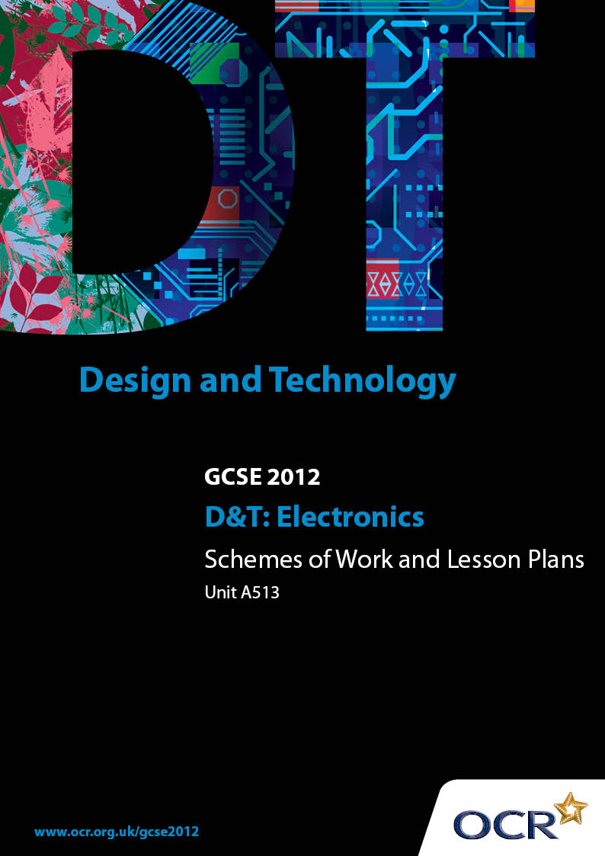

Contents
Introduction 3
Sample Scheme of Work: Unit A513 Making quality products 5
Sample Lesson Plan: Unit A513 Making quality products 9

Introduction

Background
OCR has produced a summary brochure, which summarises the changes to Design & Technology. This can be found at www.ocr.org.uk, along with the 2012 specification.
In order to help you plan effectively for the implementation of the new specification we have produced these schemes of work and sample lesson plans for Design & Technology. These support materials are designed for guidance only and play a secondary role to the specification.

Our Ethos
OCR involves teachers in the development of new support materials to capture current teaching practices tailored to our new specifications. These support materials are designed to inspire teachers and facilitate different ideas and teaching practices.
Each scheme of work and set of sample lesson plans are provided in Word format to be used as a foundation to build upon and amend the content to suit your teaching style and students’ needs.
The scheme of work and sample lesson plans provide examples of how to deliver these units and suggested teaching hours which could be applicable to your teaching.
The specification is the document on which assessment is based and specifies what content and skills need to be covered in delivering the course. At all times, therefore, this support material booklet should be read in conjunction with the specification. Any clarification should be found in the specification.

A Guided Tour through the Scheme of Work

= Innovative Teaching Idea
This icon is used to highlight exceptionally innovative ideas.


= ICT Opportunity
This icon is used to illustrate when an activity could be taught using ICT facilities.

OCR GCSE D&T: Electronics and Control Systems Unit A513: Making quality products
Suggested teaching time | 8 hours | Topic | Research and design before starting project A513
Topic outline |  | Suggested teaching and homework activities |  | Suggested resources | Points to note
Choosing the theme |  | - Provide a list of themes NOT based on the list in the specification  - Make a mind map to expand the theme – move outwards to at least three steps from the centre |  | - A school based theme  - Mind mapping software – www.freemind.sourceforge.net | - Can be paper based but better ICT version  - Can be a grouped activity to help think in a creative way
Research – situation |  | - Choose one of the strands to work with  - Produce research notes on the area  - Who are the users? |  | - ICT produced sheet | - Show the connection to theme  - Develop the need and user
Write Design Brief |  | - Write a detailed design brief  - Include a user  - Identify a problem area  - State a need |  | - ICT produced sheet | - Produce clear Problem area, User and Design Brief
Investigate the problem |  | - Create a mood board of images of users and situations  - Get detailed information of need  - Look for a similar product for analysis  - Gather data – sizes, ergonomics |  | - Use web searched images for user and situation | - Two similar products to compare function, ergonomics  - Data could be the specific components you are going to use
Detailed Design specification |  | - Make a summary of all research information  - Write a detailed specification  - Use headings from a product analysis |  | - Transfer product analysis headings to grid sheet with bullets points | - Try to include some sustainability points
Range of ideas – systems approach |  | - Use the systems headings: input –process –output  - Assemble blocks of functions ie reed switch timer, buzzer |  | - Have large sheet for group suggestions for all the system parts
Functional parts  appraisal |  | - Put systems together to make functional component units  - Give appraisal and comments for further improvements  - Develop and improve to match needs |  | - Use ICT modelling (live wire, PCB wizard) to create the functional parts and check | This should be a fully simulated function
Casing or structure |  | - Use a creative approach to look at a range of commercial cases and how they can be modified for systems use |  | - Use a 4 by 4 sheet to start ideas, then pass on to others in the group to produce one more in the set  - Notes and sketches can be made on a grey scale print out of real casings
selection |  | - Using product analysis headings evaluate the systems and the cases |  | - Use a prepared analysis sheet | - Select the headings to use for the analysis and print out or set up the headings for students to choose their own headings
Final design |  | - Quick sketch of the final selected circuit and casing  - Modelling of system  - Modelling of case |  | - Blank sheets to produce quick sketch of whole product | - This should include system and the case or structure
Detailed working drawing |  | - Final system detail drawing  - Final case drawing |  | - Use CAD methods for final drawings | - Fully dimension drawings to allow other people to make your product

OCR GCSE D&T: Electronics and Control Systems Unit A513: Making quality products

Systems Design Ideas
OCR recognises that the teaching of this qualification above will vary greatly from school to school and from teacher to teacher. With that in mind this lesson plan is offered as a possible approach but will be subject to modifications by the individual teacher.
Lesson length is assumed to be one hour.

Learning Objectives for the Lesson
Objective 1 | Students are able to relate Design Brief and specification to the required system
Objective 2 | Students can produce a list of possible Inputs
Objective 3 | Students to be able to explain the Process block required, with alternatives
Objective 4 | Students can suggest output devices
Objective 5 | Students can evaluate the system and make choices

Recap of Previous Experience and Prior Knowledge
- Looking at a product either bought in or a student project, identify the System. Record individually using cards or white boards. Share the information, then in groups identify the next stage in the development of the product.

Content
Time | Content
15 minutes | Warm up activity on Identify Systems then Future Gazing. As described above
10 minutes | Review the problem, design brief and specification – produce a mind map of ideas for the product. Could use ICT
15 minutes | Student activity: On a systems chart showing - Input, Process, Output - list all the possible blocks which could be used. This page could be set up on screen ready for adding the blocks. Good use of ICT
5 minutes | Student activity: use coloured pencil or lines to join system blocks into a strand to make a product
5 minutes | Follow 3 strands and evaluate against design brief

Consolidation
Time | Content
10 minutes | Student feedback to groups of 4/5 and notes comments
 | Homework: Evaluate against the specification and make a choice of which strand to develop further

