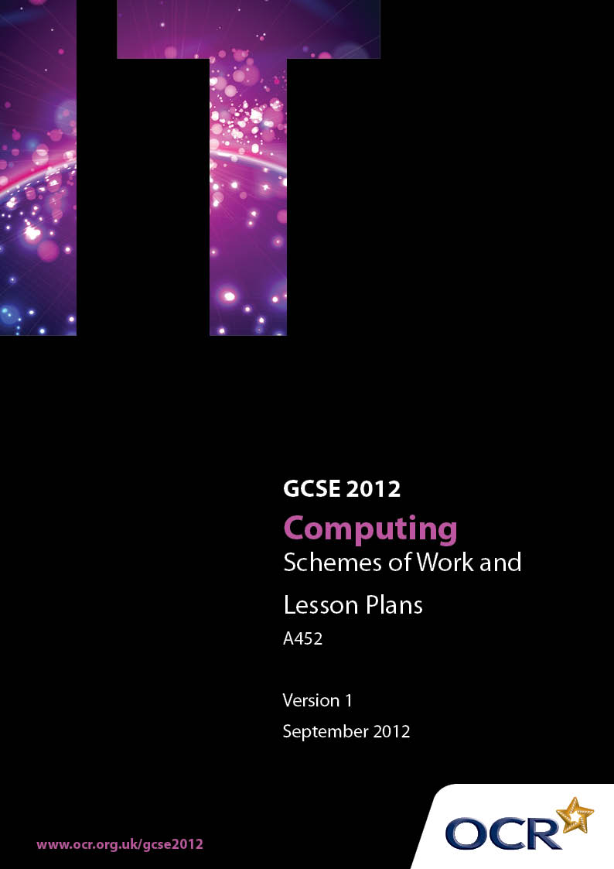

Contents
Contents 2
Introduction 2
Sample Scheme of Work: OCR GCSE Computing J275 Unit A452 2
Sample Lesson Plan: OCR GCSE Computing J275 Unit A452 2
Published Resources 2

Introduction
OCR has produced a summary brochure, which summarises the changes to Computing. This can be found at www.ocr.org.uk, along with the 2012 specification.
In order to help you plan effectively for the implementation of the new specification we have produced these schemes of work and sample lesson plans for Computing. These support materials are designed for guidance only and play a secondary role to the specification.

Our Ethos
OCR involves teachers in the development of new support materials to capture current teaching practices tailored to our new specifications. These support materials are designed to inspire teachers and facilitate different ideas and teaching practices.
Each scheme of work and set of sample lesson plans are provided in Word format to be used as a foundation to build upon and amend the content to suit your teaching style and students’ needs.
The scheme of work and sample lesson plans provide examples of how to deliver these units and suggested teaching hours which could be applicable to your teaching.
The specification is the document on which assessment is based and specifies what content and skills need to be covered in delivering the course. At all times, therefore, this support material booklet should be read in conjunction with the specification. Any clarification should be found in the specification.

Our Ethos
OCR involves teachers in the development of new support materials to capture current teaching practices tailored to our new specifications. These support materials are designed to inspire teachers and facilitate different ideas and teaching practices.
Each Scheme of Work and set of sample Lesson Plans is provided in Word format – so that you can use it as a foundation to build upon and amend the content to suit your teaching style and students’ needs.
The Scheme of Work and sample Lesson plans provide examples of how to teach this unit and the teaching hours are suggestions only. Some or all of it may be applicable to your teaching.
The Specification is the document on which assessment is based and specifies what content and skills need to be covered in delivering the course. At all times, therefore, this Support Material booklet should be read in conjunction with the Specification. If clarification on a particular point is sought then that clarification should be found in the Specification itself.

A Guided Tour through the Scheme of Work

= Innovative Teaching Idea
This icon is used to highlight exceptionally innovative ideas.


= ICT Opportunity
This icon is used to illustrate when an activity could be taught using ICT facilities.

OCR GCSE Computing J275 Unit A452
Suggested teaching time | 20 hours | Topic | Practical investigation
Topic outline |  | Suggested teaching and homework activities |  | Suggested resources | Points to note
Web based enquiry |  | - Research on machine language.  - Work on how machine language relates to assembly and high level languages.  - Use search engine to look up the term instruction set.  - Distinguish between opcode and operand.  - Homework to discuss what is meant by an instruction set and how it relates to high level programming.  - Revision and extension activities about registers. |  | - A computer with Internet access. | - Wikipedia provides some good background and despite criticisms, it remains a good starting point for further investigations.
Practical investigations with online resources |  | - Look at an implementation of LMC.  - Study the instruction set.  - Discuss how multiplication can be carried out by repeated addition.  - In some implementations, the program instructions can be placed directly in memory locations. This should be tried with a simple program.  - Input and output should be understood.  - Write a very simple program such as adding two numbers, using mnemonics.  - The behaviour of the registers should be noted by means of (i) running and (ii) stepping through a simple program.  - Labels should be used to direct control in the code and to locate data.  - Looping instructions should be experimented with, using all the possible branching instructions. |  | - A computer with Internet access. The Java runtime environment may be necessary in order to run certain implementations of LMC. | - Although the LMC has a very limited instruction set, it shows all the characteristics of a real processor.  - Getting familiar with the LMC is the priority here. Students need to become confident so that they can write their own simple programs.  - Programs written in assembly language should be created in a text editor or word processor then pasted into the LMC. This saves time re-entering code during debugging.  - Students should keep methodical notes of all code written plus explanations of what each part of a program does.
Further web based enquiry |  | - The range of instructions provided by modern processors could be looked up. |  | - The web sites of manufacturers such as AMD and Intel can be explored. | - The assessment will not require knowledge of any particular processors, but looking into how machine architecture affects computer development can enhance the learning experiences for the students and lead to better understanding of the software development process.
Contact with IT professionals / use industry publications |  | - Use search engine to find out how low level programming is still important in the world of business and commerce.  - Look up jobs for low level programmers. Notice that such programmers are still very much in demand.  - Suggest reasons for this.  - Look up interview questions for low level programmers.  - If possible arrange visit to organisation that uses low level programming. |  | - http://www.techinterviews.com/interview-questions-for-a-low-level-programmer | - It is intended that the work addressed in this syllabus is not studied in a vacuum. Students should be made aware that the creation of new systems in software and hardware form the basis of rewarding and stimulating careers.  - The rapid pace of development, particularly in mobile devices requires a great deal of low level creative work.
Controlled assessment |  | - At some stage, the students must address the tasks in the controlled assessment. This could be integrated with the learning stages or presented at the end of the preparation stages. |  |  | - It is intended that the students should be able to produce the programs required in the assessment with little or no help.

OCR GCSE Computing J275 Unit A452

Inside the machine
OCR recognises that the teaching of this qualification above will vary greatly from school to school and from teacher to teacher. With that in mind this lesson plan is offered as a possible approach but will be subject to modifications by the individual teacher.
Lesson length is assumed to be one hour.

Background
Unit A451 has a section relating to the fetching and execution of instructions from memory. This unit takes this topic further, giving the student practical experience of handling a simulated processor. It also provides useful background reinforcement for the programming elements of the specification.

From A451
Candidates should be able to define the term hardware and have an understanding of:
The Central Processing Unit (CPU) | Candidates should be able to:  - State the purpose of the CPU  - Describe the function of the CPU as fetching and executing instructions stored in memory  - Explain how common characteristics of CPUs such as clock speed, cache size and number of cores affect their performance.

Learning Objectives for the Lesson
Objective 1 | The student will understand what an instruction set is.
Objective 2 | The student will understand that even a limited instruction set can achieve useful results
Objective 3 | The student will be able to enter a simple program into the Little Man Computer as a series of assembly language statements
Objective 4 | The student will be able to compile, run and reset the LMC.

Recap of Previous Experience and Prior Knowledge
This lesson is intended to establish that processors are built with an instruction set that determines and limits their capability. It is assumed that the students have already been introduced to the particular version of the LMC that it is intended to use.

Materials required
Access to an implementation of LMC.
A list of the instructions available for that version of LMC.
A small sample program for LMC such as one that adds two numbers together.

Content
Time | Content
5 minutes | The nature of an instruction set is explained in terms of a set of primitive capabilities that the designers of a processor have built into it. The students have already been taught that a processor fetches instructions from memory and then decodes and execute them.
10 minutes | The students spend time exploring the features of LMC in order to establish where the memory locations, the registers and the controls are.
15 minutes | The sample program is entered as a set of mnemonics. The students copy and paste these into a text editor in case they need to enter them again.
10minutes | The program is compiled and run. Time will probably be needed for debugging.
10 minutes | Run the program again in step by step mode. The students make note of the contents of registers as the program progresses.

Consolidation
Time | Content
5-10minutes | Discuss how even entering mnemonics is easier than using native machine code. Point out that it is crucial to enter commands exactly and how even in assembly language, it is easy to make mistakes. Higher level languages were developed to make the process more human-friendly.

Published Resources
OCR offers centres a wealth of quality published support for new specifications with a fantastic choice of ‘Official Publisher Partner’ and ‘Approved Publication’ resources, all endorsed by OCR.

Publisher partners
We work in close collaboration with our three publisher partners; Hodder Education, Heinemann and Oxford University Press to ensure you have access to quality materials, written by experts, when you need it. The publisher partnerships are not exclusive (see Approved Publications below). All OCR endorsed resources undergo our thorough quality assurance process to ensure match to the specification.
Hodder Education is the publisher partner for OCR GCSE Computing.


Hodder Education is producing the following resources for OCR GCSE Computing for first teaching in September 2010.
Dynamic Learning Website. Authors - George Rouse, Agneau Belanyek, Sean O'Byrne - available September 2010.
A stand-alone Dynamic Learning subscription website, designed to be used by students and teachers in class and at home. It incorporates a lesson builder, search facility, VLE integration and electronic resources to support the course aims and objectives and includes automatically-marked interactive assessments.

Approved publications
OCR still endorses other publisher materials, which undergo a thorough quality assurance process to achieve endorsement. By offering a choice of endorsed materials, centres can be assured of quality support for all OCR qualifications.



