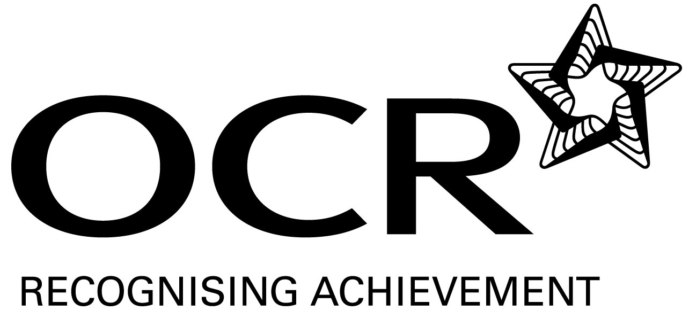
Sample Schemes of Work and Lesson Plans
GCSE Classical Greek
OCR GCSE in Classical Greek: J291/J091
Unit B404: Classical Greek Verse Literature

This Support Material booklet is designed to accompany the OCR GCSE Classical Greek specification for teaching from September 2009.

Contents
Contents 2
Introduction 3
Unit B404: Classical Greek Verse Literature – Sample Scheme of Work 5
Unit B404: Classical Greek Verse Literature – Sample Lesson Plan 13

Introduction

Background
Following a review of 14–19 education and the Secondary Curriculum Review, the Qualifications and Curriculum Authority (QCA) has revised the subject criteria for GCSEs, for first teaching in September 2009. This applies to all awarding bodies.
The new GCSEs have more up-to-date content and encourage the development of personal learning and thinking skills in your students.
We’ve taken this opportunity to redevelop all our GCSEs, to ensure they meet your requirements. These changes will give you greater control of assessment activities and make the assessment process more manageable for you and your students. Controlled assessment will be introduced for most subjects.
OCR has produced a summary brochure, which summarises the changes to Classical Greek. This can be found at www.ocr.org.uk, along with the new Specification.
In order to help you plan effectively for the implementation of the new specification we have produced these Schemes of Work and Sample Lesson Plans for Classical Greek B404. These Support Materials are designed for guidance only and play a secondary role to the Specification.

Our Ethos
OCR involves teachers in the development of new support materials to capture current teaching practices tailored to our new specifications. These support materials are designed to inspire teachers and facilitate different ideas and teaching practices.
Each Scheme of Work and set of sample Lesson Plans is provided in Word format – so that you can use it as a foundation to build upon and amend the content to suit your teaching style and students’ needs.
The Scheme of Work and sample Lesson Plans provide examples of how to teach this unit. The teaching hours are suggestions only. Some or all of it may be applicable to your teaching.
The Specification is the document on which assessment is based and specifies what content and skills need to be covered in delivering the course. At all times, therefore, this Support Material booklet should be read in conjunction with the Specification. If clarification on a particular point is sought then that clarification should be found in the Specification itself.

A Guided Tour through the Scheme of Work

= Innovative Teaching Idea
This icon is used to highlight exceptionally innovative ideas.


= ICT Opportunity
This icon is used to illustrate when an activity could be taught using ICT facilities.

Unit B404: Classical Greek Verse Literature
Suggested teaching time | 1 hour | Topic | Introduction to Homer and epic poetry
Topic outline |  | Suggested teaching and homework activities |  | Suggested resources | Points to note
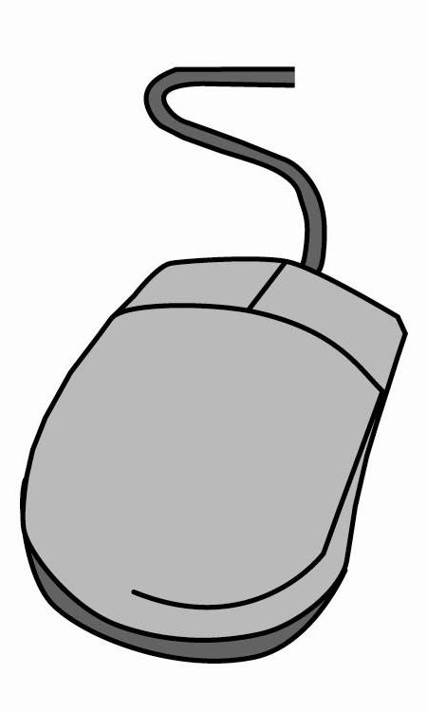  Life of Homer and issue of the Homeric question; brief outline of his works. Homeric Greek and comparison with Classical Greek of 5th century BC |  | - PowerPoint presentation by teacher on Homer.  - A basic summary of Homer’s works.  - Teacher-produced sheet on Homeric dialect and grammar.  - Nature of Oral poetry: play Chinese whispers game. Using a complicated story (perhaps with members of class as characters), whisper to first pupil and get them to pass it on to another and see what comes out at the end.  - Homework idea: pupils can create storyboards/comic strips of episodes they find most exciting from the Iliad and/or Odyssey. Alternatively they could produce character (Myspace or Facebook) profiles for chosen protagonists, such as Odysseus, Achilles, Agamemnon, Cyclops, Penelope etc. |  | - For teacher research:  - Griffin, J, Homer, OUP, 1980, chapters 1 and 2, for general introduction.  - Thorpe, M, Homer, BCP, 1973.  - Stanford, WB, Homer Odyssey I–XII, BCP, 1996, for grammatical introduction.  - Jenkyns, R, Classical Epic: Homer and Virgil, BCP, 1992.  - www.textkit.com for introduction to the language and verse of Homer by Thomas D. Seymour.  - For pupils, various websites which give book summaries of the Homeric epics:  - www.bookrags.com/notes/oed/  - www.mythweb.com/odyssey/  - www.cliffsnotes.com  - Guess the scene from the Odyssey depicted on these Greek pots:  - http://www.necessaryprose.com/vases.htm. | - Teachers should aim to keep information simple and concise at this stage so pupils do not feel overwhelmed or daunted by the unit. It will be important to relate the epics in a novel and exciting way so pupils can get a true flavour of Homer’s works and produce meaningful creative work.

Unit B404: Classical Greek Verse Literature
Suggested teaching time | 1–2 hours | Topic | Introduction to Odyssey VI
Topic outline |  | Suggested teaching and homework activities |  | Suggested resources | Points to note
The story of the Odyssey, narrative structure, what happens in Books I–VI, theme of hospitality |  | - Building on the knowledge from lesson 1 where pupils drew a broad outline of the narrative thread, teacher can embellish and expand on details of the epic.  - Narrative chronology of the Odyssey. It may be helpful for teachers to produce a timeline of events showing flashbacks since pupils will inevitably find this complex.  - Brief discussion of why Homer begins his epic with Telemachus rather than Odysseus. Theme of hospitality: compare Phaecians with Cyclops, Calypso, suitors etc.  - Teacher could play sections from the Penguin audio book (Book V, and VI if there is time).  - Homework: pupils to read Book VI in English and write a short summary of it. Know who the Phaecians are and perhaps draw a family tree of the royal family or use a mind-mapping programme like ‘Inspiration’. |  | - For teacher research:  - Tracy, SV, The Story of the Odyssey, Princeton University Press, 1990.  - Griffin, J, Homer, OUP, 1980.  - For lessons:  - The Odyssey (Penguin audio books), ISBN 0140861572.  - For pupils:  - Rieu, EV, Homer, The Odyssey, Penguin Classics, 2003.  - Baldwin, SP, Cliff's Notes on Homer’s The Odyssey, Wiley Publishing, New York, 2000.  - Sowerby, R, York Notes Advanced on the Odyssey, York Press, 2000. | - The Telemachy can be perused quickly since it does not have huge relevance to the set book but pupils may wish to know what has happened thus far. More detail required of book V so that they can contextualise book VI.  - Don’t assume the pupils will find it easy to read the text, albeit in translation! The Penguin Classics version of the Odyssey, translated by EV Rieu is very readable. It may be beneficial for pupils to keep a copy of the text in English translation whilst the unit is being taught and for revision purposes.  - If there is time pupils could list their agreements and disagreements to the statement ‘Nausicaa is an innocent and charming young girl.’

Unit B404: Classical Greek Verse Literature
Suggested teaching time | 1–2 hours | Topic | Odyssey VI lines 20–40
Topic outline |  | Suggested teaching and homework activities |  | Suggested resources | Points to note
Translation of lines 20–40 |  | - Begin lesson with a brief recap – what happens in lines 1–20 and how Homeric grammar differs.  - Show pupils how to use Perseus website, which they can use as an aid for homework.  - Lead the pupils through the translation of lines 20–28, putting the words in the correct order for them. May be helpful to project the text on the board and number each word in the correct order for translation. After pupils have translated these lines, the teacher should go through the lines slowly again for consolidation.  - Vocabulary should be provided to pupils to allow a lively pace through the material. It may also be helpful to provide a handout with a few grammar notes and pointers on difficult lines/phrases/words.  - Homework: prepare lines 28–40 by using the vocabulary list provided and reading the English translation. Have a rough idea of the translation for these lines to go over in the following lesson.  (The amount of text preparation given to puils to tackle solo will depend on the ability of the pupils. It may be necessary to plan to cover more translation in class and give fewer than 12 lines for homework). |  | - Edwards, G, Odyssey VI & VII, BCP, 1995.  - Odyssey text can be copied and pasted from the Perseus database – pupils may annotate this copy, highlighting rhetorical devices etc.  - Murray, AT, Odyssey volume 1, Loeb Classical Library, 1995, has Greek text with facing English translation.  - www.prosoidia.com/odys.html: website has Greek text, English translation and readings of the text.  - Vocabulary can be obtained from Terry Bird or www.classicalworkbooks.com or free of charge from Perseus’ online dictionary.  - For teachers’ notes:  - Jones, P, Homer’s Odyssey, BCP, 1998.  - Stanford, WB, Homer Odyssey I–XII, BCP, 1996, for commentary notes.  - Various translations of the Odyssey on the web: http://classics.mit.edu/Homer/odyssey.6.vi.html  - http://www.tonykline.co.uk/PITBR/Greek/Odyssey6.htm  - Perseus http://www.perseus.tufts.edu/hopper/ | - Teachers may want pupils to write down a translation in class or alternatively may prefer to provide a translation at the end of the section to ensure precision and accuracy and keep them focused solely on translating in class. In either case the teacher should stress that translations are fluid and there is no one correct answer.  - Give as much help as possible at this early stage with numbering of words, vocabulary and grammar. If homework task seems daunting, ask pupils to do fewer lines: quality not quantity is of paramount importance.

Unit B404: Classical Greek Verse Literature
Suggested teaching time | 1–2 hours | Topic | Odyssey VI lines 20–40: interpretation and consolidation
Topic outline |  | Suggested teaching and homework activities |  | Suggested resources | Points to note
Consolidation of lines 20–40 so pupils understand how the Greek fits with the English translation, appreciation of style and content and introduction to exam style questions |  | - Pupils to go over the translation of lines 20–40 again, with teacher giving assistance as required.  - Series of quick-fire, graded questions on what is happening in these lines (oral activity).  - Teacher may produce a sheet with questions on style and content, which could form the starting point of discussion on these lines. Pupils should keep thorough class notes.  - Pupils highlight Greek text to show where rhetorical devices lie and write brief annotations on their effectiveness.  - Discussion of kleos, marriage and the role of women in the Greek world and what light lines 20–40 shed on these topics.  - Teacher could produce an exam-style context question for class to work through together. |  | - OCR Classics members’ community area may have resources such as commentary and context questions on other GCSE set texts which can be used as models. http://community.ocr.org.uk/community/classics/home  - Blundell, S, Women in Ancient Greece, Harvard University Press, 1995. | - Teacher should get pupils into the habit of using evidence to support their views and encourage the use of quotations ad nauseam. It is advisable to tackle the first exam-style context question in class rather than ask pupils to do it for homework.

Unit B404: Classical Greek Verse Literature
Suggested teaching time | 1–2 hours | Topic | Odyssey lines 48–70
Topic outline |  | Suggested teaching and homework activities |  | Suggested resources | Points to note
Translation of Odyssey lines 48–70 |  | - Brief recap on what happened in lines 20–40. Perhaps ask pupils to write short summaries of these lines to see how much they have remembered.  - Read lines 40–47 in English to ‘fill in the gaps’ in the prescription.  - Pupils could translate lines 48–70 in pairs first (using a vocabulary list) and then teacher goes through the translation with the whole class.  - Class could be split up into 6 groups with each group focusing on different lines to translate and comment upon and then present their findings to the class: group 1 = lines 48–51; group 2 = 52–55; group 3 = 56–61; group 4 = lines 62–65; group 6 = lines 66–70.  - Homework: pupils could write a paragraph on how Nausicaa makes a persuasive speech to her father or describe the relationship between father and daughter. Encourage use of quotations to support views.  - Discuss stock epithets and ask pupils to find examples from the parts of the text which they have read. |  | - Terry Bird’s running vocabulary.  - Classical workbook on Odyssey VI.  - Edwards, G, Odyssey VI & VII.  - Rieu, EV, Homer, The Odyssey, (Penguin Classics) 2003, Introduction Peter Jones. | - Teachers will have to judge the tenor and ability of the class when deciding how to approach the translation of these lines. Confident and linguistically strong pupils will enjoy the challenge of translating without much assistance whilst weaker pupils may need more guidance and direction from the teacher.  - As the coverage of the rest of the prescription draws to a close, teachers should also look at overarching themes within the text.

Unit B404: Classical Greek Verse Literature
Suggested teaching time | 1–2 hours | Topic | Introduction to scansion and literary criticism
Topic outline |  | Suggested teaching and homework activities |  | Suggested resources | Points to note
Differences between poetry and prose. Explanation of dactylic hexameter and rules of scansion. Definitions and identification of rhetorical terms and devices |  | - Principles of scansion – explain and give handouts for pupils’ future reference. Pupils can practise in pairs and then teacher can ask individuals to show their working to the class on interactive whiteboards/tablet PCs.  - Homework: scan a few lines of the Odyssey (teacher to find easy lines in advance).  - Get pupils to make a list of common rhetorical devices which they may have already encountered from Latin and English literature study and build on this knowledge.  - Practice at spotting rhetorical devices in context (through a variety of texts) and discussion of their effectiveness. |  | - Muir, JV, Odyssey IX for scansion rules in the introduction, pages ix–xi.  - Glossary of rhetorical terms can be found on ‘silva rhetoricae’ at http://humanities.byu.edu/rhetoric/Silva.htm  - Pyrrha website (www.pyrrha.demon.co.uk/psound1.html) has audio files of Odyssey XXI and Iliad –not the set book but still useful in hearing oral poetry spoken aloud and appreciating the metric quality.  - If there is time pupils could analyse rhetorical devices in carefully chosen poetry such as Kubla Khan, Shakespeare sonnets or prose in translation like the Cyclops passage in Odyssey IX (lines 375–408 have fine examples of vivid narration and epic similes). | - Scansion is no longer required for GCSE but if there is sufficient lesson time, then pupils may enjoy doing it and gain a deeper appreciation of the nature (and restrictions) of epic poetry.  - Pupils may feel shy about showing their scansion working to the class so pair-work beforehand may add to their confidence.  - Low/middle-ability pupils may benefit from spotting rhetorical devices and considering their purpose in English first whilst high-ability pupils may not need this scaffolding approach.  - Pupils should be reassured that they will not be penalised in exam situations if they cannot remember the exact name of rhetorical devices but are still able to describe them clearly.

Unit B404: Classical Greek Verse Literature

Odyssey VI lines 20–40: consolidation and interpretation
OCR recognises that the teaching of this qualification will vary greatly from school to school and from teacher to teacher. With that in mind this Lesson Plan is offered as a possible approach but will be subject to modifications by the individual teacher.
Lesson length is assumed to be one hour.

Learning Objectives for the Lesson
Objective 1 | Pupils will have translated lines 20–40 again and understood how the Greek fits with the English.
Objective 2 | Pupils will begin to develop a sensitive and analytical approach to literature. They will have answered questions on style, language, content and context of lines 20–40.
Objective 3 | Pupils will have discussed issues of interpretation of these lines and made an informed, personal response to the material studied.
Objective 4 | Pupils will begin to develop an understanding of the cultural content and context of the literature, focusing specifically on women, marriage and kleos.

Recap of Previous Experience and Prior Knowledge
- Before attempting this (or a similar) lesson, pupils should know when the Odyssey was composed and by whom. Pupils should be aware that Homeric Greek is different from Classical Greek of the 5th century and be able to deal with forms and syntax when translating and analysing the set text. Some knowledge of the features of epic poetry (including metre and imagery) and poetry generally (e.g. rhetorical devices) is desirable.
- Make cross-curricular links wherever possible and draw upon knowledge pupils may have acquired from GCSE Classical Civilisation, Latin and/or English Literature.

Content
Time | Content
5 minutes | Settle class and outline content of today’s lesson. Warm-up activity to jog pupils’ memories of Homer and the period in which the Odyssey was composed. Ask pupils how they got on with the translation of lines 20–40 and what is different about Homeric Greek. Pupils could cite specific/general examples, which the teacher could write up on the board.
20 minutes | Student activity: go round the class, asking pupils to translate 1/2 lines which they have already prepared of lines 20–40. Pupils correct their own versions. Teacher checks that the translations are precise and accurate and briefly discusses word nuances/connotations and acceptable variations of translation.
10 minutes | Teacher distributes a worksheet with questions on lines 20–40. Questions can be graded, with some straightforward content questions (e.g. who is Nausicaa? where is Phaecia? etc.) whilst others require more insightful and discursive answers (e.g. what is kleos? What do we learn about marriage and women in lines X?). Pupils can discuss answers in pairs and make brief notes on worksheet/A4 paper/exercise books. Teacher circulates around the classroom, checking pupils are on task and giving assistance as required.
15 minutes | Teacher-led discussion, using the questions as a starting point. Ask pupils to volunteer their ideas and help pupils verbalise their understanding. Pupils to supplement the answers which they have begun writing in previous activity. Encourage use of evidence to support opinions and get pupils into the habit of using quotations.
10 minutes | Consolidation work (see below) and plenary. Set homework and orderly dismissal.

Consolidation
Time | Content
10 minutes | Teacher can project the text (lines 20–40) on board/screen. Highlight interesting words/phrases/lines on the board and ask pupils to comment on why they have been brought to attention. Annotate the text on the board with pupils’ contributions. Teacher could also highlight phrases which show interesting use of vocabulary, sound effects, word order etc. and ask pupils to comment again. Different rhetorical devices (e.g. alliteration, assonance, sibilance etc. could be colour-coded for clarity and to appeal to visual learners). This consolidation activity is aimed to draw together strands from discussion held in the lesson.

