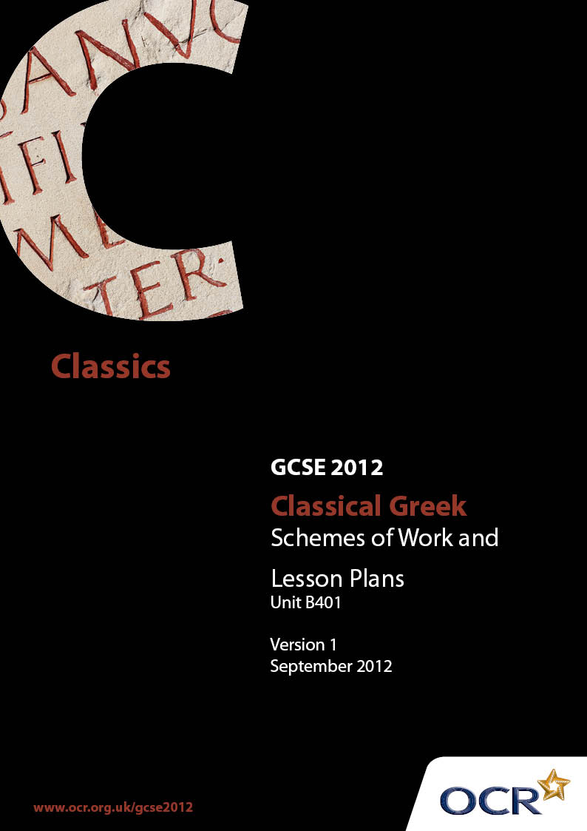

Contents
Introduction 3
Unit B401: Classical Greek Language 1 (Mythology and domestic life) – Sample Scheme of Work 5
Unit B401: Classical Greek Language 1 (Mythology and domestic life) – Sample Lesson Plan 19

Introduction

Background
OCR has produced a summary brochure, which summarises the changes to Classical Greek. This can be found at www.ocr.org.uk, along with the new Specification.
In addition and in response to reforms announced by the Government and in response to Ofqual mandated changes to GCSEs, unitised assessment of this qualification is being replaced by linear assessment from September 2012. This means that candidates commencing a two year course from September 2012 will take all of their GCSE units at the end of the course in June 2014.
In order to help you plan effectively for the implementation of the new specification we have produced these Schemes of Work and Sample Lesson Plans for Classical Greek B401. These Support Materials are designed for guidance only and play a secondary role to the Specification.

Our Ethos
OCR involves teachers in the development of new support materials to capture current teaching practices tailored to our new specifications. These support materials are designed to inspire teachers and facilitate different ideas and teaching practices.
Each Scheme of Work and set of sample Lesson Plans is provided in Word format – so that you can use it as a foundation to build upon and amend the content to suit your teaching style and students’ needs.
The Scheme of Work and sample Lesson Plans provide examples of how to teach this unit. The teaching hours are suggestions only. Some or all of it may be applicable to your teaching.
The Specification is the document on which assessment is based and specifies what content and skills need to be covered in delivering the course. At all times, therefore, this Support Material booklet should be read in conjunction with the Specification. If clarification on a particular point is sought then that clarification should be found in the Specification itself.

A Guided Tour through the Scheme of Work

= Innovative Teaching Idea
This icon is used to highlight exceptionally innovative ideas.


= ICT Opportunity
This icon is used to illustrate when an activity could be taught using ICT facilities.

Unit B401: Classical Greek Language 1 (Mythology and domestic life)
Suggested teaching time | 1 hour | Topic | Present Tense Indicative Active Verbs
Topic outline |  | Suggested teaching and homework activities |  | Suggested resources | Points to note
Familiarity with reading and transliterating Greek |  | - Students to read aloud a text in English containing some Greek words (which also have meaning in English, e.g. drama).  - Some of the Greek words introduced in the above text may be selected for class discussion about how their meaning has changed as they have passed into the English language.  - Written transliteration exercises for individual practice.  - Students to match the names of Greek gods and goddesses to their images. This can be done using an interactive whiteboard, so that the images can be portrayed to good effect. Initial letters should be in capitals and subject matter should be chosen which stimulates knowledge and understanding of appropriately selected aspects of the Classical world. |  | - Teach Yourself Greek, chapter 3 exercise 1.  - Taylor, John, Greek to GCSE, part 1, exercises 1.1, 1.2, 1.3.  - Smart notebook, IWB. Alternatively, the same exercise can be done on worksheets.  - Reading practice of mythological names is available in Wilding, LA, Greek for Beginners, exercise 2, and Taylor, 1.4, 1.5.  - Balme, M, and Lawall, G, Teacher’s Handbook for Athenaze I, OUP, 1991, introduction part III, gives proper names under the headings of Olympians, Muses, Graces and Fates. | - A basic knowledge of the alphabet is assumed, but no more. This exercise builds confidence and reading fluency in Greek. It also specifically introduces students to Greek words which have passed into the English language, either with unchanged or with new meanings, encouraging them to develop a sensitive and analytical approach to language generally.  - This encourages students to see connections between English words and their Greek roots and thereby to develop an awareness of the continuing influence of the Classical world on later times and of the similarities and differences between the Classical world and later times.  - This gives an opportunity to practise the less familiar capital letters. It also raises cultural awareness and is a valuable introduction to the mythological subject-matter required for B401.
Present tense indicative active regular verbs |  | - Draw attention to the uniform pattern of endings, rendering pronouns superfluous (unlike English). Links can be made with Latin and with Modern Foreign Languages.  - Written exercises: students apply endings to other verbs, in both Greek–English and English–Greek sentences. For variety, some answers can be given orally, to encourage reading fluency, others in writing. |  | - Taylor, John, Greek to GCSE, part 1, pages 8–9.  - Taylor, exercises 1.7, 1.8, 1.9.  - Wilding, exercises 4–7 are identical in format and also identical in vocabulary. | - For the first two and a half chapters, Taylor marks the division between stem and inflected ending for both verbs and nouns. This should be made clear to students, who may like to include the same markings in their Greek writing at this stage.
Building vocabulary awareness |  | - Introduce a select group of nouns from the first and second declensions. Words with clear English derivations may be introduced first, e.g. αγγελος, φωνη, νικη, before words such as εχω, δουλος, for which there are no evident English derivations. Students deduce the meaning of the Greek word from its derivations.  - New vocabulary may be introduced with pictures drawn from both the modern world (for example, a picture of a pylon accompanies the Greek πυλη – gate) and the ancient world (δουλος might be illustrated with pictures of slaves in the ancient world, taken from red-figure pottery to build familiarity with primary source material and the themes of mythology and domestic life required for B401).  Language-building games:  - 1. Students find as many English derivations as they can from a given Greek word. This could be played competitively, in teams  - 2. Students match pairs of Greek words to make an English compound word. Options include ιππος and ποταμος, μικρος and φωνη, βιος or γη and γραφω. |  | - Taylor has ten of each on pages 10 and 11. Alternatively or in addition, nouns could be selected from the Defined Vocabulary List.  - Peter Barker, The Greek we Speak, has several exercises building English words from Greek stems, especially on pages 6–11, some of which might be introduced at this stage.  - The word can be shown on screen, whiteboard or paper.  - This can be played in pairs or larger groups as a game of snap, with selected words written onto cards. | - This approach is not only beneficial to students mastering new vocabulary; it also prepares for the questions about the derivations of English words from Greek (B401). The deductive reasoning should enable students to develop as effective and independent candidates and as critical and reflective thinkers. It highlights for them an awareness of the continuing influence of the Classical world on later times.  - Taylor encourages this approach with his explanation of στρατηγος (p.11).  - Not all the words mentioned here appear in Taylor at this stage, and many are nouns rather than verbs, but any word rich in derivations could be used, and will encourage students to develop a sensitive and analytical approach to language generally, besides building confidence in dealing with unfamiliar vocabulary.  - At this point in the course, the students have to assimilate a large amount of new vocabulary. However, vocabulary-building exercises of this sort do not belong exclusively to this point and can be employed throughout the course.

Unit B401: Classical Greek Language 1 (Mythology and domestic life)
Suggested teaching time | 1 hour | Topic | First and Second Declension Nouns, Nominative and Accusative Singular
Topic outline |  | Suggested teaching and homework activities |  | Suggested resources | Points to note
First and second declension nouns: the concept of declension and nominative and accusative cases |  | - Oral exercise: students suggest English sentences and identify the subject and object in each other’s sentences.  - Explain that the nominative case is used to denote subject and the accusative case is used to denote object. Study the morphology of the endings and compare the first and second declensions.  - Touch-screen computer game: students draw words from a ‘bank’, identify their case and sort into declension and case. |  | - The students themselves think of sentences.  - Taylor, pages 10 and 11.  - Interactive whiteboard; smart notebook software.  - Without a smart board, the software will work for individuals or pairs of students using a PC and mouse. | - Key skills: ΩωΟ.  - For students unfamiliar with Latin, the notion of declension and case endings may be unfamiliar, though some may have encountered it through German.  - The ‘bank’ from which the words are pulled can be decorated appropriately with images relevant to the source material of B405, or Greek mythology or domestic life suitable to paper B401.
The definite article |  | - Written exercise: students select the correct form of definite article to accompany nouns in a given sentence. They then translate the completed sentence into English. |  | - Multiple-choice style options inserted into simple sentences. Taylor, exercise 1.10 could be adapted for this purpose, or the teacher could create another exercise along similar lines. | - The definite article is a suitable way to introduce gender.  - The meaning of a noun without definite article, and the use of the definite article for abstract nouns may also be introduced at this stage.
Construction of subject–verb–object sentences |  | - Game: working in groups, students are given a set of differently coloured cards. Students construct sentences by choosing one word of each colour. A simpler version has the definite article printed on the card with each noun.  - There is scope to extend the game for more confident students.  - The definite article may be included on separate cards (colour-coded according to case).  - Προς and εις may be included. |  | - Cards, each printed with one word. On cards of one colour, nominatives are written, on another, accusatives, on the third, verbs.  - Words can be drawn from vocabulary already encountered. If students are ready to expand their vocabulary at this stage, draw from the Defined Vocabulary List, selecting particularly from vocabulary on domestic life, which will be tested in B401. | - This introduces the students to composing Greek.  - Students will note that any word order is acceptable, but some, especially those with knowledge of Latin, may be encouraged to see how often Greek word order follows English.  - The emphasis on the subject–verb–object construction, and the use of technical terminology to accompany it, plays a vital role in introducing sensitivity to an inflected language, and is particularly important for students who have not already encountered the concept in Latin.
The negative ου, ουκ, ουχ |  | - Students turn positive sentences into negatives, choosing the correct form of negative.  - Students read the sentences aloud to help to appreciate the phonological rule applied here. |  | - Suitable positive sentences to use in this way are Taylor, 1.11, nbs 2, 4, 5, 10.  - It is also helpful to construct further sentences using the vocabulary from Taylor, page 15, which could allow students also to practise ουχ. | - This is an opportunity for students to appreciate how final letters can change to accommodate the initial sounds of an adjacent word. As this is a widespread phenomenon in Greek, it is worth devoting time to it. Such study contributes to the students’ development of a sensitive and analytical approach to language generally.

Unit B401: Classical Greek Language 1 (Mythology and domestic life)
Suggested teaching time | 1 hour | Topic | First and Second Declension Nouns, Nominative and Accusative Plural; the Verb ‘to Be’
Topic outline |  | Suggested teaching and homework activities |  | Suggested resources | Points to note
First and second declension nouns, nominative and accusative plural |  | - Revise the concept of the nominative and accusative cases and the two declensions met so far. Study the forms for the plural and draw attention to the parallel morphology of the first and second declensions.  - Written exercises, translating from Greek to English, from English to Greek, and converting singular forms to plural forms all develop competence and critical and reflective linguistic skills, and consolidate vocabulary. |  | - Taylor, 2.1–7, of which 3–6 are all consolidation of earlier material.  - Students may use exercises completed earlier in the course, and rewrite them in the plural. | - As the definite article in the plural is introduced at this stage, it is appropriate here to explain how it can be used for general classes of noun (see Taylor, page 21). Reference to the expression ‘hoi polloi’ brings another link with English.  - This presents no new conceptual difficulty, but will require time for consolidation, as students are now manipulating eight different noun types.
Present tense indicative of the verb ‘to be’ |  | - Students learn the paradigm.  - Students practise written exercises.  - Further exercises could be given in which students select the appropriate form of ειμι to complete the sentence.  - Oral question-and-answer exercises (τις ει; τι εστι) reinforce familiarity and provide an opportunity for group work.  - Students can ask each other ‘τις ει’; and also answer the questions ‘τις εστι’; ‘τινες εισι’; about pictures displayed on a screen or on handouts. |  | - Taylor, 2.8, 2.9.  - Pictures of gods, heroes, nouns which have already been encountered, either displayed on a screen or printed onto paper. | - Most students are probably aware that this is irregular in all languages and needs to be learned separately.  - This would require the introduction of some personal pronouns  - Some simple question words could be introduced (τις, τι) to allow students to practise this verb orally.  - The pictures of gods and heroes would reinforce the students’ knowledge and understanding of mythological themes, suitable for B401. Pictures could also be taken from red-figure vases, and even from the primary-source material prescribed for B405.  - Key skills: Wwo.
Connectives: και, τε ... και, αλλα |  | - Give students pairs of short sentences, on cards or on a worksheet.  - Students link the sentences choosing appropriate connectives.  - A more advanced option: present students with several short sentences. They have to decide which ones can be paired and add the connectives. |  | - Taylor, 2.10.  - Students work with sentences pre-prepared on cards, add the connectives and write out the completed sentences. | - Choosing between και and αλλα is relatively straightforward.  - Adding ‘τε’ is more sophisticated, requiring students to see a pairing, and to place the particle in the correct position.  - Using cards rather than a worksheet is better suited to kinaesthetic learners.

Unit B401: Classical Greek Language 1 (Mythology and domestic life)
Suggested teaching time | 1 hour | Topic | First Declension in Alpha; Expressions of Time
Topic outline |  | Suggested teaching and homework activities |  | Suggested resources | Points to note
First declension in alpha |  | - Study the nominative and accusative forms of nouns such as χωρα and compare with the nouns already encountered.  - Written exercises from Greek into English and switching from plural to singular forms to reinforce knowledge of the declension. |  | - Taylor, page 20.  - Wilding, page 22.  - Taylor, 2.11, 2.12. | - This is an opportunity to revise the eta- type first declension. The variant pattern is not difficult, and as most of the words introduced by Taylor on p.20 are rich in derivations, they should be quick to assimilate.  - Wilding introduces these nouns in conjunction with the sigma stems (μουσα). Since Taylor does not introduce the full declension yet, it is better, if following Taylor, not to introduce the sigma stems at this point.
Ordinal numbers 1–10 |  | - Provide a list for pupils. Numerals are particularly rich in English derivations. Links to other languages can also be made.  - Games:  - 1. Bingo: the teacher could either call out the numbers (to develop oral linguistic awareness) or write them on the board (for reading practice).  - 2. Find as many English words as possible incorporating Greek numerals. |  | - Pupils make their own Bingo boards | - Taylor does not introduce numerals until much later (chapter 6). At this stage, the fact that in Greek numbers 1–4 decline can be glossed over briefly.  - This specifically prepares pupils for questions about the derivations of English words from Greek (B401), develops a sensitive and analytical approach to language generally, and an awareness of the continuing influence of the Classical world on later times.
Overview of the accusative case and expressions of time |  | - Recall the uses of the accusative for direct object and following prepositions.  - Add a third use to explain time ‘how long’.  - Written exercises. |  | - Taylor, exercise 2.15.  - Further exercises can be added to give practice with more numerals.

Unit B401: Classical Greek Language 1 (Mythology and domestic life)
Suggested teaching time | 1 hour | Topic | Full First and Second Declensions, including Neuter Nouns, excluding First Declension Sigma Stems and Masculine Nouns
Topic outline |  | Suggested teaching and homework activities |  | Suggested resources | Points to note
Second declension neuter |  | - Display the nominative and accusative singular and plural forms of a model neuter noun such as δωρον on the board. Highlight the two salient features: (i) nominative and accusative are always the same for neuter nouns; (ii) in the plural these always end –α.  - Greek neuter nouns in English, which also have plural in –a (e.g. criteria, bacteria, phenomena) can be used as an example of the continuing influence of this aspect of the language and should help the students to remember the rule.  - Written exercises, both Greek into English and English into Greek (to develop more secure competence). |  | - Taylor, pages 22–23.  - Taylor, 2.16, 2.17. | - Where appropriate, comparison can be made with the Latin second declension neuter.  - Latin neuter plurals in English might also be mentioned in discussion.
Full declension of first and second declension nouns, and second declension neuter nouns |  | - Explain the uses of the cases. To students unfamiliar with an inflected language, the genitive case is probably most easily explained as equivalent to the English ‘s. Present the full declension of the definite article together with the nouns.  - Translate from and into Greek single phrases such as ‘of the word’. If students practise translating words in oblique cases in isolation first, they will have an opportunity to practise the function of the cases.  - Then add the prepositions εις, προς, απο, εκ / εξ.  - Then introduce full sentences for translation from Greek into English. |  | - Use vocabulary from the Defined Vocabulary List.  - Taylor, page 28.  - Taylor, 3.1, 3.2, 3.3. | - Students without knowledge of Latin will need more time to absorb this. Students with knowledge of Latin will probably note the absence of the ablative case and the rather broader application of the dative in Greek.  - The common genitive plural ending is worth bringing to students’ attention.  - The iota subscript is introduced for the first time at this stage.  - Taylor introduces the vocative only in a footnote. It will be used briefly later in the chapter, when imperatives are introduced, and can easily be omitted or glossed over at this stage.
Sandwich construction of the possessive genitive |  | - Explain to students the position of the possessive genitive between the article and noun. Draw attention to the fact that there will necessarily be two adjacent definite articles in the Greek sentence.  - Student activity: give the students a sentence to which they have to add a Greek article-and-noun pair denoting the possessive genitive. Students can physically place the genitive and its article within the article and noun at the appropriate point of the sentence. They then translate the sentence into English.  - Translation exercises from Greek to English and (to develop a more secure competence) from English into Greek. |  | - Taylor, page 29.  - This can be done on an IWB using smart notebook. Alternatively students can move word tiles into position on a desk.  - Taylor, 3.4, 3.5. | - The IWB option is better suited to whole-class teaching; the word tiles are appropriate for pair- or small-group work.

Unit B401: Classical Greek Language 1 (Mythology and domestic life)

Present tense indicative active verbs
OCR recognises that the teaching of this qualification will vary greatly from school to school and from teacher to teacher. With that in mind this Lesson Plan is offered as a possible approach but will be subject to modifications by the individual teacher.
Lesson length is assumed to be one hour.

Learning Objectives for the Lesson
Objective 1 | Students to gain competence and some level of fluency reading Greek script.
Objective 2 | Students to begin to develop an analytical approach to language, specifically, competence with verb forms.
Objective 3 | Students to develop awareness of the continuing influence of Greek and the Classical world on later times.

Recap of Previous Experience and Prior Knowledge
- Most schools will have no timetabled Greek before the start of the GCSE course. However, a basic knowledge of the alphabet has been assumed. Pupils unfamiliar with the Greek alphabet may need more time, and most will find a reference alphabet necessary. No prior knowledge of Latin is assumed, although it is an asset.

Content
Time | Content
10 minutes | Reading practice. Students read aloud a text in English containing some Greek words (which also have meaning in English) to gain fluency. Select some of the words to discuss their meaning in Greek and in English and to consider the heritage of the Greek language on English and other languages.
10 minutes | Introduce students to some proper names from Classical mythology, with the assistance of pictures drawn from primary sources. This affords the opportunity to practise capital letters and to introduce the mythological context and the nature of the source material and its limitations, which is ongoing throughout the course.
5 minutes | Display present tense on board, highlighting verb endings. Invite the students to observe similarities with other languages they have learned.
10 minutes | Student activity: the students practise applying the endings to different verb stems and attempt both Greek into English and English into Greek exercises, for a sound understanding.
5 minutes | Vocabulary-building exercise: introduce a select group of nouns from the first and second declensions, and invite the students to deduce their meanings by making connection with their English derivations or with the verbs already encountered. Διδασκαλος may be compared with διδασκω; γη may be combined with γραφω. Display the words on a screen using PowerPoint and allow the pupils to work out the connections before displaying the answers.
10 minutes | Students are given pairs of words, either on cards or displayed on the screen or board. They match pairs of Greek words to make an English compound word. Options include ιππος and ποταμος, μικρος and φωνη, βιος and γραφω.

Consolidation
Time | Content
10 minutes | Select some verbs which are unfamiliar to the students, but whose meaning could be deduced from derivations and which are regular, e.g. στρατευω, αγγελλω. Students in turn apply personal endings to these verbs. This consolidates both verb endings and vocabulary building and offers an opportunity for informal assessment.
 | Homework: students could be given a selection of brief exercises practising the skills of transliteration and translation of verbs, such as any from John Taylor, Greek to GCSE, part 1, 1.7–1.9 which have not been attempted in class.

