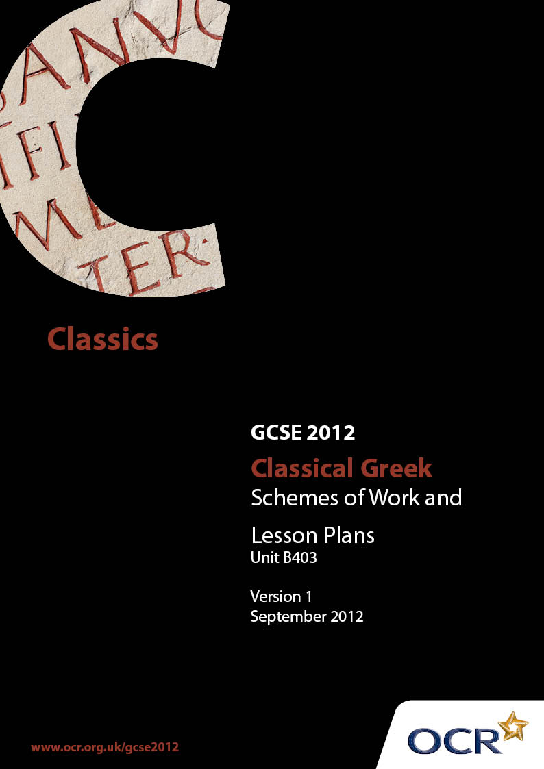

Contents
Contents 2
Introduction 3
Unit B403: Classical Greek Prose Literature – Sample Scheme of Work 5
Unit B403: Classical Greek Prose Literature – Sample Lesson Plan 14

Introduction

Background
OCR has produced a summary brochure, which summarises the changes to Classical Greek. This can be found at www.ocr.org.uk, along with the new Specification.
In addition and in response to reforms announced by the Government and in response to Ofqual mandated changes to GCSEs, unitised assessment of this qualification is being replaced by linear assessment from September 2012. This means that candidates commencing a two year course from September 2012 will take all of their GCSE units at the end of the course in June 2014.
In order to help you plan effectively for the implementation of the new specification we have produced these Schemes of Work and Sample Lesson Plans for Classical Greek B403. These Support Materials are designed for guidance only and play a secondary role to the Specification.

Our Ethos
OCR involves teachers in the development of new support materials to capture current teaching practices tailored to our new specifications. These support materials are designed to inspire teachers and facilitate different ideas and teaching practices.
Each Scheme of Work and set of sample Lesson Plans is provided in Word format – so that you can use it as a foundation to build upon and amend the content to suit your teaching style and students’ needs.
The Scheme of Work and sample Lesson Plans provide examples of how to teach this unit. The teaching hours are suggestions only. Some or all of it may be applicable to your teaching.
The Specification is the document on which assessment is based and specifies what content and skills need to be covered in delivering the course. At all times, therefore, this Support Material booklet should be read in conjunction with the Specification. If clarification on a particular point is sought then that clarification should be found in the Specification itself.

A Guided Tour through the Scheme of Work

= Innovative Teaching Idea
This icon is used to highlight exceptionally innovative ideas.


= ICT Opportunity
This icon is used to illustrate when an activity could be taught using ICT facilities.

Unit B403: Classical Greek Prose Literature
Suggested teaching time | 1-2 hours | Topic |  | Introduction to Herodotus and Prose Literature
Topic outline |  | Suggested teaching and homework activities |  |  |  | Suggested resources |  | Points to note
Life of Herodotus, his approach to historiography and subject matter of his Histories. Genre of history. |  |  | - Teacher explanation of who Herodotus was, a quick resume of his works, crucial differences between ancient and modern historiography.  - Handout comprising famous Herodotus quotes (in English) so pupils get a feel for the range and diversity of his works.  - Teacher could produce a timeline sheet of events in Herodotus’ life in one column and world/Greek events in another column so pupils have some idea of historical context.  - Read the introduction of Tales from Herodotus, asking questions to assess pupils’ understanding.  - Oral activity: analyse the prologue to Herodotus’ Histories and consider Herodotus’ aims, philosophy and subject matter of the Histories.  - Homework idea: pupils read through a worksheet prepared by teacher with excerpts from ancient travel writers (e.g. Pausanias, Herodotus – Egyptians, Ethiopians etc.). They could write a paragraph entitled ‘What makes effective travel writing’ and draw on modern writers such as Bill Bryson, Michael Palin, Bruce Parry or more generally on city guides and newspaper travel supplements.  - Pupil debate on Herodotus as historian: one side argue he is the father of history whilst other side argue he is the father of lies.  - Get pupils to make a list of common rhetorical devices which they may have already encountered from Latin and English literature study and build on this knowledge. |  | - Farnell, GS, and Goff, M, Tales from Herodotus, Duckworth/BCP, 2002.  - Prologue and introduction in Herodotus, The Histories (Penguin Classics), Longman, 2004.  - Dewald, Carolyn, The Cambridge Companion to Herodotus, Cambridge University Press, 2006.  - Oxford Classical Dictionary.  - http://en.wikipedia.org/wiki/Herodotus.  - http://www.livius.org/he-hg/herodotus/herodotus01.htm.  - http://www.quotationspage.com/quotes/Herodotus/. |  | - It may be worthwhile beginning this unit by asking pupils whether they know / remember anything about Herodotus. They may have come across him in language work – from unseens in John Taylor’s Greek to GCSE or Athenaze; they may also have come across him from popular culture like the film ‘300’.  - Pupils may find the inclusion of non-factual information such as digressions, hearsay, made-up speeches, mythology, use of the divine quite alien for history. The teacher should stress that modern standards should not be imposed but history for the ancients was first and foremost a highly literary genre.  - For the Herodotus quotes activity, try to pick a range which shows him as a historian, travel writer, ethnographist, journalist etc. Pick on Herodotus’ amusing anecdotes / bizarre stories to stimulate pupils’ interest.
Introduction to Cyrus the Great. Translation of part 1 |  |  | - Teacher explanation: bit of background information on Cyrus the Great. Show pupils where ancient Persia was on a map and empire of Cyrus. Draw a family tree showing his mother, father and maternal grandfather. Explain what happened in Astyages’ dream.  - Give pupils a vocabulary list and possibly grammatical notes for this section to allow swift translation of the passage.  - If lesson time is limited, split the class into groups and allocate several lines to each group to translate (especially since this passage is lengthy). Then bring the class together again to produce a translation for the whole section.  - Display the text on the board and number each word so pupils know what order to translate the sentence in.  - After translating the passage literally, read different translations to pupils and ask them which renditions they prefer of particular words/phrases/sentences and why.  - Homework: learn the vocabulary list to start the process of learning the translation. |  | - Vocabulary can be obtained from Terry Bird or www.classicalworkbooks.com or free of charge from Perseus’ online dictionary.  - Online translations.  - These passages re: Cyrus are taken from Herodotus, Histories, book 1, 108-123, 125-128, 130.  - http://www.sacred-texts.com/cla/hh/hh1030.htm  (has English translation and Greek text which can be copied and pasted).  - Perseus http://www.perseus.tufts.edu/hopper/  - www.iranchamber.com/history/herodotus (translated by George Rawlinson).  - www.losttrails.com/pages/Tales/Inquiries/Herodotus.html (translated by Shlomo Felberbaum).  - Godley, AD, Herodotus: the Histories, books I-II, Loeb Classical Library, 1989.  - http://www.fsmitha.com/h1/map10per.htm |  | - Try to stagger learning for pupils so they are not told to go away and learn the translation by rote for a single homework task. Discuss techniques of revising set texts and give them small tasks at a time (e.g. learn vocabulary first, then tackle 1 / 2 sentences at a time etc.) and build up their confidence gradually.  - There are lots of online translations for the Herodotus prescription but the most literal and clear ones are listed in the resource column.  - Although this does not foster independent study skills, giving pupils a correct translation of the text has the following benefits:  - In lessons pupils can concentrate solely on translating, rather than worrying about keeping a written record as well.  - Inevitably pupils make mistakes in their translation which they may reproduce in exam situation, costing them valuable marks.  - Lessons can be better paced and more time is left for discussing interpretation.
Appreciation and interpretation of infancy of Cyrus part 1 |  |  | - Teacher to produce PowerPoint on part 1. Slides could contain difficult lines from passage 1, grammar and interpretation questions directed at pupils.  - Follow up the above oral activity with a written exercise so pupils have adequate revision notes for future reference. Ensure they know who the Magi are and Harpagus. Perhaps get them to answer style and content questions on paper.  - Peer teaching idea. Split class into groups. Each group write several exam-style questions on this passage (can make them as hard as they like!). Pass round the set of questions clockwise and groups to answer the questions they have received. After discussion, groups in turn to feed back to the rest of the class.  - Class discussion on Harpagus’ predicament, examining what is said in lines 12–27 in detail. Ask them what they think will happen next!  - Attempt an exam-style context question in class. In the following lesson get pupils to do another context question (same passage but perhaps different lines) under test conditions to check they are developing good exam technique.  - Homework: give pupils a few web addresses of translations and get them to translate lines 1–5 of passage 2 for homework. |  | - Notes at the back of Tales from Herodotus (pages 76–77, page 157 under ‘Κυρος’).  - Notes in Classical Workbooks.  - Terry Bird’s running vocabulary.  - Online translations  - http://www.sacred-texts.com/cla/hh/index.htm  - http://www.losttrails.com/pages/Tales/Inquiries/Herodotus.html  - Perseus http://www.perseus.tufts.edu/hopper/ |  | - After the set text has been covered (and if time allows), pupils could be set a project to create similar PowerPoints to the one delivered in the lesson on the other passages
Translation of Cyrus part 2 |  |  | - If time is limited give pupils worksheets to help them arrive at a translation. Low ability pupils could be given a translation with sentences in the wrong order which they have to number; middle ability pupils could do a fill-in-the-blank sheet; high ability pupils could correct the deliberate mistakes.  - Teacher could produce a sheet, rearranging the words of passage 2 into the correct order to help pupils translate. For homework they could learn the translation of lines 1–5. The following lesson the teacher could assess their learning by giving them a translation test on these lines.  - Lesson in the ICT suite: pupils could produce a translation of part 2 by using Perseus and other online translations. By the end of the lesson the teacher should check that their translations are precise and accurate. |  | - Differentiated worksheets created by the teacher as described previously.  - Online translations  - http://www.sacred-texts.com/cla/hh/index.htm  - http://www.losttrails.com/pages/Tales/Inquiries/Herodotus.html  - Perseus http://www.perseus.tufts.edu/hopper/  - Farnell, GS, and Goff, M, Tales from Herodotus, Duckworth/BCP, 2002  - Terry Bird’s running vocabulary  - Classical Workbooks www.classicalworkbooks.com |  | - Be sensitive when giving pupils the differentiated sheets (might be an idea not to tell them which sheets are the easier / more difficult options).  - If allowing pupils to use online translations to produce their own, police this activity very carefully! Encourage them to be precise and as literal as possible and not purely to copy translations which they have access to online.
Revision of infancy of Cyrus part 1. Definitions and identification of rhetorical terms and devices. |  |  | - Give pupils guidance for revising set texts. Encourage a variety of learning techniques: isolating difficult sentences, learning hard vocabulary first, repeating the translation orally ad nauseam etc. with the aim that they can translate the passage fluently and be familiar with interpretation, background and stylistic features pertaining to the passages.  - Project the text onto the board in large font. Teacher can translate a sentence / clause at a time, showing pupils the mechanics of the Greek. Repeat several times and then ask individual pupils to repeat the translation back.  - Produce a handout with key rhetorical devices on it: alliteration, assonance, interesting word order etc. and leave gaps between each subheading for pupils to write in. Ask pupils (perhaps in pairs) to find examples of these devices from the Greek text, detailing the lines on the sheet and explaining its effectiveness.  - Board of choice: write up a list of unusual / difficult vocabulary on the board from passage 1 and ask each pupil in turn to pick one word and translate correctly.  - Series of quick-fire questions to remind pupils of content of these lines. |  | - Teacher could produce a sheet for pupils’ future reference: ‘How to revise set texts’. |  | - This lesson should be attempted after the prescription material has been covered. It could be delivered as the exam period approaches, possibly before pupils go on study leave or earlier in the academic year, before mock exams.  - It may be worthwhile using this passage to teach pupils how to revise set texts because it is a manageable length and can be learnt in a single lesson.

Unit B403: Classical Greek Prose Literature

Herodotus: the infancy of Cyrus part 1
OCR recognises that the teaching of this qualification will vary greatly from school to school and from teacher to teacher. With that in mind this Lesson Plan is offered as a possible approach but will be subject to modifications by the individual teacher.
Lesson length is assumed to be one hour.

Learning Objectives for the Lesson
Objective 1 | Pupils will have learnt about Cyrus the Great and developed an understanding of the cultural content and context of the literature.
Objective 2 | Pupils will have translated part 1 of the set text prescription and put grammatical and vocabulary knowledge into practice.
Objective 3 | Pupils will have discussed briefly the content of passage 1 and made a personal response to it.

Recap of Previous Experience and Prior Knowledge
- Students may have come across Herodotus in language work (John Taylor’s Greek to GCSE has adapted unseen passages from Herodotus and there is also some background information on him in Athenaze). It is advisable for pupils to have some knowledge of the scope of his works and the genre of history before launching into the set text.

Content
Time | Content
5 minutes | Background recapitulation: ask pupils who Herodotus was, when he was writing and what the subject matter of his Histories was.
10 minutes | PowerPoint presentation to introduce the set text. Slides could include a family tree for Cyrus, other legends about his parentage and childhood, Astyages and his dream, map of his empire and presentation of him as ideal ruler by Xenophon.
15–20 minutes | Give pupils a vocabulary list for part 1 to allow lively movement through the passage. Project lines 1–11 of the text in large font onto the whiteboard. Ask volunteers to translate a sentence / clause at a time, giving guidance as to word order and grammar. Briefly explain any proper nouns which crop up (e.g. the Magi). At the end of the paragraph, translate these lines again for the pupils slowly, for consolidation purposes.
20 minutes | Pupils translate lines 12–27 in pairs (orally), with the aid of the vocabulary sheet. The teacher should walk round the class to check pupils’ progress and give more help if necessary. The teacher should then bring the class together and ask pupils to translate the rest of this section. The teacher should then give out a typed translation of part 1 to each pupil.
10 minutes | Consolidation – questions and answers to ensure understanding of passage A and its background.

Consolidation
Time | Content
10 minutes | Teacher asks questions on the following:  - Who was Cyrus and what did he achieve in later life?  - What was Astyages’ relationship to Cyrus?  - What did Astyages see in his dream and how was it interpreted?  - Who was Harpagus and what task was given to him?  - How does Harpagus respond to this task (what does he reply to Astyages and then later to his wife)?

