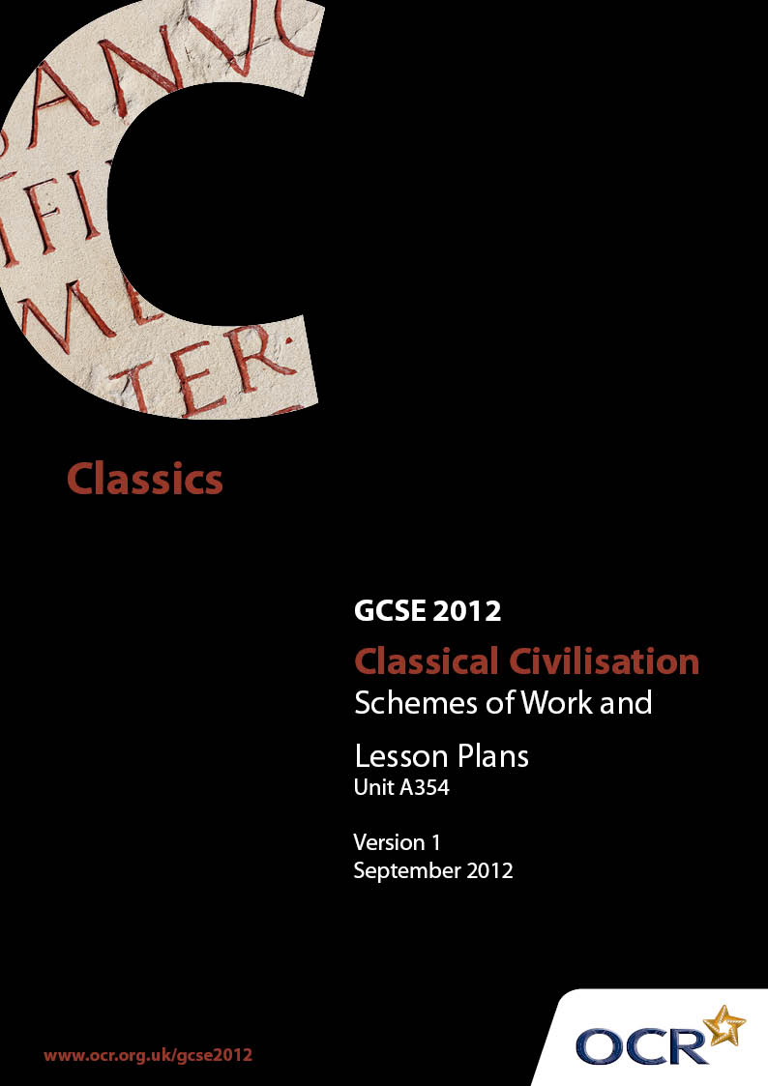

Contents
Contents 2
Introduction 3
Sample Scheme of Work: OCR GCSE Classical Civilisation/Unit A 354 5
Sample Lesson Plan: OCR GCSE Classical Civilisation/Unit A 354 7

Introduction

Background
OCR has produced a summary brochure, which summarises the changes to Classical Civilisation. This can be found at www.ocr.org.uk, along with the new specification.
In response to reforms announced by the Government and in response to Ofqual mandated changes to GCSEs, unitised assessment of this qualification is being replaced by linear assessment. This means that candidates commencing a two year course from September 2012 will take all of their GCSE units at the end of the course in June 2014.
In order to help you plan effectively for the implementation of the specification we have produced these schemes of work and sample lesson plans for classical civilisation. These support materials are designed for guidance only and play a secondary role to the Specification.

Our Ethos
OCR involves teachers in the development of new support materials to capture current teaching practices tailored to our new specifications. These support materials are designed to inspire teachers and facilitate different ideas and teaching practices.
Each scheme of work and set of sample lesson plans is provided in Word format so that you can use it as a foundation to build upon and amend the content to suit your teaching style and students’ needs.
The scheme of work and sample lesson plans provide examples of how to teach this unit and the teaching hours are suggestions only. Some or all of it may be applicable to your teaching.
The Specification is the document on which assessment is based and specifies what content and skills need to be covered in delivering the course. At all times, therefore, this Support Material booklet should be read in conjunction with the Specification. If clarification on a particular point is sought then that clarification should be found in the Specification itself.

A Guided Tour through the Scheme of Work

= Innovative Teaching Idea
This icon is used to highlight exceptionally innovative ideas.


= ICT Opportunity
This icon is used to illustrate when an activity could be taught using ICT facilities.

OCR GCSE Classical Civilisation
Suggested teaching time | See below | Topic | Research skills for controlled assessment
Topic outline |  | Suggested teaching and homework activities |  | Suggested resources | Points to note
As the Controlled Assessment task is 25% of the available marks for the course (50% for the short course), this is the maximum amount of time in the teaching allocation that should be set aside for it. The completion of the task must be done under controlled conditions, but there is no time limit for this. It is considered that 3-4 hours should be about the time allowed for the students to type up their piece of 2000 words but this is only suggested as guidance. It is not a time limit. This must be kept secure, as in the instructions given in the Specification.
The scheme of work herewith is only a suggestion of how the teaching may be approached. Many teachers have years of experience in guiding students through their coursework, and much of the advice they have given them remains the same. The difference is in the final presentation of the piece which must be done under supervision. Students will be able to take in their notes, references and plans, but not any part already written.
A section ‘Advice to Students’ is attached, which is not all-encompassing, but should be used to supplement any teacher led advice. It is intended as a check list of things not to forget in answering the set question.
Introduction to controlled assessment and how it will be monitored |  | - Whole class presentation |  | - Handouts | - School policy on CA may have been decided and sent home to parents
Methods of research:  books - how to use an index; internet - how to bookmark, store favourites etc. |  | - Tasks for research, in books and on web  - Pooling of information  - Discussion of detail, accuracy and usefulness of different material  - Start a log of books, sites etc. used and make sure it is kept up to date while they research for the CA task |  | - Library or departmental resources  - Internet
Introduction to topic chosen for CA |  | - Whole class presentation
CC literary topics |  | - Class reading and discussion of text |  | - Texts
CC society topics |  | - Introduction to use of sources, particularly archaeological |  | - Source material, literary, pictorial, archaeological |  | - This will be a reprise of what is done for the examined papers, but with more emphasis on sources
Context of topic to be studied for CA task |  | - Overview of society to be studied |  | - Reading lists  - Source material
Introduction of tasks  How to approach planning |  | - Information gathering |  | - Handout |  | - Check their activity by asking them to keep their log with dates and times noted
How to present finished task:  quotations; footnotes; bibliography; word count |  |  |  | - Handout
Assessment Objectives and Criteria |  | - Explanation of what each entails  - If time, write a short piece (200-300 words) and get the students to mark one or two examples |  | - Copy of Assessment Objectives and either the whole or an edited version of the criteria
Planning |  | - Students to assemble their material and write a detailed plan outlining their arguments and the sources/ facts to back it up |  |  |  | - Give advice on individual plans, but do not impose a uniform approach

OCR GCSE Classical Civilisation

Introduction to research skills
OCR recognises that the teaching of this qualification above will vary greatly from school to school and from teacher to teacher. With that in mind this lesson plan is offered as a possible approach but will be subject to modifications by the individual teacher.
Lesson length is assumed to be one hour.

Learning Objectives for the Lesson
Objective 1 | Students to consider where information can be found.
Objective 2 | Students to assess usefulness of different source’s information.
Objective 3 | Students to understand how to use different source’s information.

Recap of Previous Experience and Prior Knowledge

Content
Time | Content
5 minutes | Whole class  Present a topic, not necessarily one they will be using eg Themistocles.  A politician in Ancient Greece. Where might you look for information on him?
5-10 minutes | Pooling of ideas where information might be found.  - Books  - Internet  - Ancient sources  - Archaeology.
10-15 minutes | Small groups or pairs, then reporting back  Expand on each topic  - What kind of books?  - How useful might they be?  - How do you find the information – indices and how to use them  - How do you decide if a website is useful/trustworthy?  - What ancient sources are there?  - What is their provenance?

Time | Content
- Does this affect their usefulness?
- What kind of archaeology is available?
- How useful is it in this example?
(The last 5 bullet points will be revising the points made in work done for the examined units).
10 minutes | Whole class  Make a group list of all they come up with.
10-15 minutes | Book research and use of index  Individually or in pairs  If possible, using the same books;  - Find the pages; assess how much information on each.  - Work out how the index works  - Any ideas how to make this quicker?  - How you might be able to find the most relevant pages in another book?  - How useful was the book?  Report back to whole group.

Consolidation
Time | Content
Homework | Give a task to do the same with at least one other book. (Perhaps have a list of resources available on premises, and others they could look for in the public library?)  Make a note of title and author, and date of publication.  How useful was this book? How much information could you find?  And how quickly?

If an IT room is available, then a similar task could be set with a website or websites.

