Uses of Alcohols

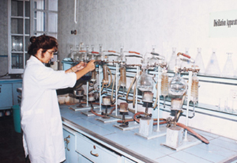
Alcohols have a variety of uses in the modern world. There are many different types of alcohols, and their different properties allow them to be used for different things. Altogether, there are innumerable uses of alcohols, so I have outlined the main uses of the simple alcohols.
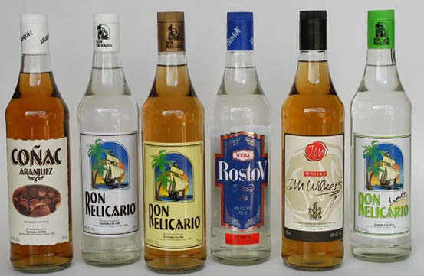
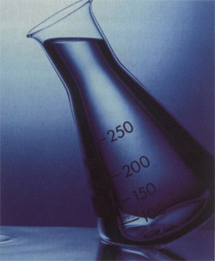
For example, the “alcohol” in alcoholic drinks is simply ethanol. IMS (Industrial Methylated Spirits) is also ethanol, but a small quantity methanol is added to stop people drinking it (methanol is poisonous). This is why it is also usually coloured, as drinking it can cause illness. Ethanol is very famous as a fuel as well, and is also mixed with petrol (gasoline) to produce “gasanol” which contains a mixture of 10-20% ethanol. Ethanol is a very good, safe solvent as well, and is widely used to dissolve many organic solvents that can’t be dissolved in water (this is useful as it can be used in perfumes and cosmetics).

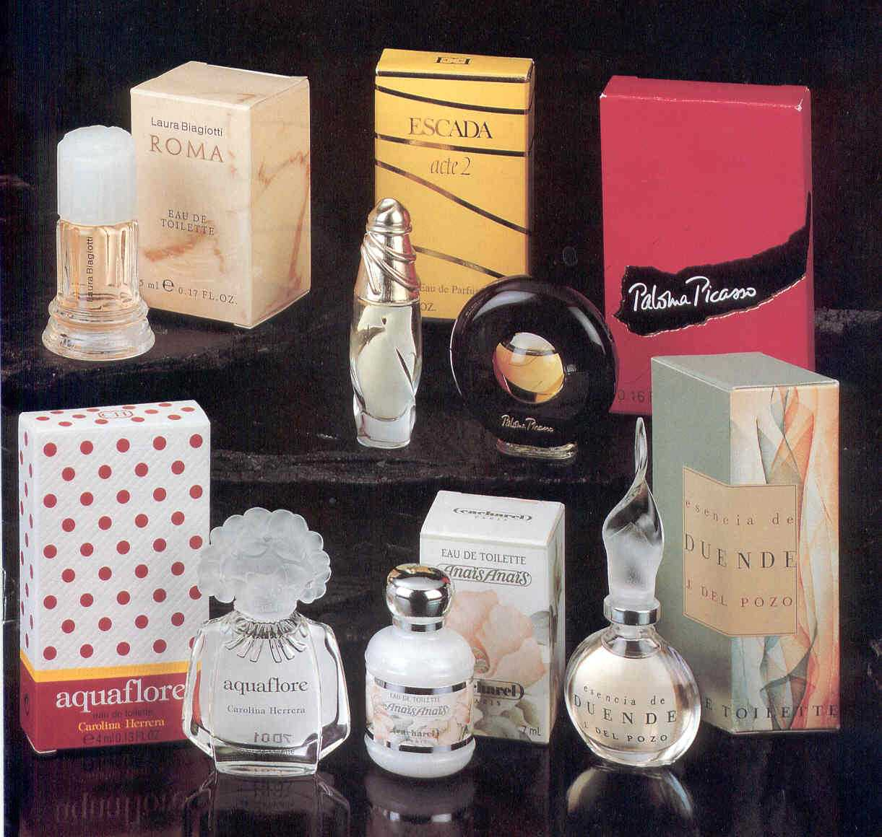
Methanol, another type of alcohol, is also used as a fuel; it is currently being used as a petrol additive (to help its combustion), but work is being done to use it as a fuel in its own right. It is also used as an ‘industrial feedstock’, used in the production of many substances such as methanal (formaldehyde), ethanoic acid and methyl esters of many acids.

Propanol is very very useful as a solvent, in particular the isomer propan-2-ol, which is used in an amazing number of different situations as a solvent.

