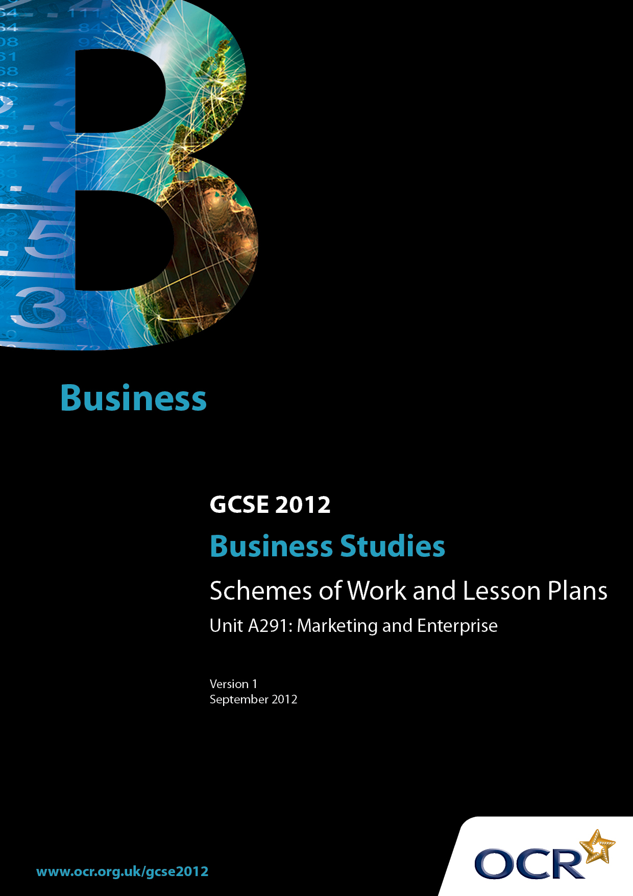

Contents
Contents 2
Introduction 3
Scheme of Work: OCR GCSE Business Studies Unit A291: Marketing and Enterprise 5
Sample Lesson Plan: OCR GCSE Business Studies Unit A291: Marketing and Enterprise - Introduction to Promotion 21

Introduction

Background
OCR has produced a summary brochure, which summarises the changes to Business Studies. This can be found at www.ocr.org.uk, along with the specification.
In addition and in response to reforms announced by the Government and in response to Ofqual mandated changes to GCSEs, unitised assessment of this qualification is being replaced by linear assessment from September 2012. This means that candidates commencing a two year course from September 2012 will take all of their GCSE units at the end of the course in June 2014.
In order to help you plan effectively for the implementation of this specification we have produced these Schemes of Work and Sample Lesson Plans for Business Studies. These Support Materials are designed for guidance only and play a secondary role to the Specification.

Our Ethos
OCR involves teachers in the development of new support materials to capture current teaching practices tailored to our new specifications. These support materials are designed to inspire teachers and facilitate different ideas and teaching practices.
Each Scheme of Work and set of sample Lesson Plans is provided in Word format – so that you can use it as a foundation to build upon and amend the content to suit your teaching style and students’ needs.
The Scheme of Work and sample Lesson Plans provide examples of how to teach this unit and the teaching hours are suggestions only. Some or all of it may be applicable to your teaching.
The Specification is the document on which assessment is based and specifies what content and skills need to be covered in delivering the course. At all times, therefore, this Support Material booklet should be read in conjunction with the Specification. If clarification on a particular point is sought then that clarification should be found in the Specification itself.

A Guided Tour through the Scheme of Work

= Innovative Teaching Idea
This icon is used to highlight exceptionally innovative ideas.


= ICT Opportunity
This icon is used to illustrate when an activity could be taught using ICT facilities.

OCR GCSE Business Studies Unit A291: Marketing and Enterprise
Suggested teaching time | 2.5 hrs | Topic | Analysing the Market
Topic outline |  | Suggested teaching and homework activities |  | Suggested resources | Points to note
Market segments  Socio-economic groups  Mass, niche and test markets |  | - Discussion on product and market orientation.  - Identification of the different ways of segmenting a market.  - Group work – using holiday brochures, produce a display showing how holidays are aimed at different market segments.  - Provide a variety of products or images of products and ask candidates to suggest the age of the most likely consumer.  - Choose a variety of other market segments, and candidates suggest five goods or services aimed at each market segment.  - Homework - introductory activity OCR endorsed textbook pages 2-3.  - Candidates investigate the area in which they live. Produce a PowerPoint presentation of the results.  - Activities 4, 5 and 6 pages 12-13 OCR endorsed textbook.  - Homework - any past exam question from old specification.  - Discussion of different types of markets, mass, niche and test.  - Assessment Activity page 14 OCR endorsed textbook. |  | - Holiday brochures could include: Families, Winter Sun, Ski, Premier, and Far Away Shores etc.  - Everyday items could include electrical items, CDs, DVDs, magazines, concerts, cars etc.  - Use the website www.upmystreet.com to find the information required. | If appropriate centres may wish to undertake the relevant task in the controlled assessment at this point. Please ensure that the task used is valid for the series in which the candidate will be certifying. This information is on the front cover of the task.

OCR GCSE Business Studies Unit A291: Marketing and Enterprise
Suggested teaching time | 3 hrs | Topic | Market Research and data collection
Topic outline |  | Suggested teaching and homework activities |  | Suggested resources | Points to note
Primary and secondary research  SWOT analysis  Unique Selling Point (USP) |  | - Discussion of what market research is and why businesses carry it out.  - Identification of the different methods of primary and secondary research.  - Discussion on the different sampling methods used in market research.  - Primary and secondary methods of market research flashcards.  - Activity 5 page 22 OCR endorsed textbook.  - Advantages and disadvantages of the different methods of market research- matching exercise.  - Homework - test advantages and disadvantages of market research methods.  - Homework - any past examination question on this topic.  - A SWOT analysis can be undertaken for the school or any other business that the candidates are familiar with.  - Assessment Activity page 25 OCR endorsed textbook.  - Discussion about what is a USP.  - Collect examples of business USP’s. |  | - Small whiteboards and pens for individual answers to be displayed.  - Small whiteboards and pens.  - A display of this work could be produced.  - These can be found easily in a local newspaper, where candidates can cut out examples. Alternatively the teacher can produce a collection of examples for the candidates to highlight the USP. | If appropriate, centres may wish to undertake the relevant task in the controlled assessment at this point. Please ensure that the task used is valid for the series in which the candidate will be certifying. This information is on the front cover of the task.

OCR GCSE Business Studies Unit A291: Marketing and Enterprise
Suggested teaching time | 1 hr | Topic | The Marketing Mix
Topic outline |  | Suggested teaching and homework activities |  | Suggested resources | Points to note
The marketing mix |  | - Discussion on the 4 Ps of the marketing mix.  - In groups examine a selection of businesses or products and discuss how the 4 Ps are used.  - ‘Supermarket football league’ activity. Associate a variety of supermarkets with each league. List the common features of the supermarkets in each league. List the ways in which the supermarkets in each league try to make themselves different from their competitors. List how the supermarkets use the marketing mix to attract customers.  - Activity 2 page 30 OCR endorsed textbook  - Investigate examples of how the marketing mix can go wrong, eg. the Sinclair C5. |  | - Candidates could report back to the rest of the class.  - Any football league the candidates are familiar with will be suitable for this activity. E.g. if the English Football League is used then use The Premier League, Championship, League One etc. | - ICT could be used to produce this work.  - ICT could be used to produce this work.

OCR GCSE Business Studies Unit A291: Marketing and Enterprise
Suggested teaching time | 2 hrs | Topic | The Marketing Mix - Price
Topic outline |  | Suggested teaching and homework activities |  | Suggested resources | Points to note
Price |  | - Discussion about the importance of price in the marketing mix. Show a variety of products and ask the candidates to price them.  - Discussion about the different pricing strategies which are available for businesses to use.  - Visit various websites to look at the ways in which pricing is used to promote businesses.  - Activity 2 page 40 OCR endorsed textbook.  - Using images of a variety of products the candidates must recommend with reasons the most appropriate pricing strategy.  - Homework - collect a variety of examples of how business use price in the marketing mix.  - Homework - any past examination question.  - Assessment Activity page 42 OCR endorsed textbook. |  | - Use any website where pricing is evident eg www.tesco.com www.bmibaby.com or a variety of magazines and newspapers. | If appropriate, centres may wish to undertake the relevant task in the controlled assessment at this point. Please ensure that the task used is valid for the series in which the candidate will be certifying. This information is on the front cover of the task.

OCR GCSE Business Studies Unit A291: Marketing and Enterprise
Suggested teaching time | 5 hrs | Topic | The Marketing Mix - Product
Topic outline |  | Suggested teaching and homework activities |  | Suggested resources | Points to note
Product |  | - Discussion about why businesses use research and development.  - Research businesses which use research and development.  - Show the candidates a selection of the product mix of a well known business, eg. Proctor and Gamble or Nestle and ask what all the products have in common.  - Branding quiz – candidates have to list the names of the businesses from the logo or symbol of the business.  - Activity 3 page 47 OCR endorsed textbook.  - Activity 8 page 50 OCR endorsed textbook.  - Using a blank product life cycle ask the candidates to complete it using the names of the five stages.  - On a piece of A3 paper draw a large product life cycle. Cut out a variety of products from magazines and place them on the appropriate stage of the product life cycle.  - Activity 5 page 48 OCR endorsed textbook.  - Homework - any past examination question  - Assessment activity Page 50 OCR endorsed textbook. |  | - Any business that the candidates are familiar with can be used.  - Encourage candidates to select products for all of the stages. The Internet could be used for this activity. | If appropriate, centres may wish to undertake the relevant task in the controlled assessment at this point. Please ensure that the task used is valid for the series in which the candidate will be certifying. This information is on the front cover of the task.

OCR GCSE Business Studies Unit A291: Marketing and Enterprise
Suggested teaching time | 2 hrs | Topic | The Marketing Mix – Place and E-commerce
Topic outline |  | Suggested teaching and homework activities |  | Suggested resources | Points to note
Place and e-commerce |  | - Discussion about the importance of where a business sells its products or services.  - Suggest a variety of examples and candidates decide which method of distribution would be used and give reasons for the choices they make.  - Discuss the importance of the Internet in marketing.  - Produce a leaflet showing the advantages and disadvantages of buying goods in shops and on the Internet.  - Activity in which candidates ‘buy’ specified goods on the Internet.  - Activity 6 page 60 OCR endorsed textbook  - Advantages and disadvantages to consumers of using e-commerce.  - Activities 7, 8, 9 and 10 pages 62-64 OCR endorsed textbook.  - Assessment Activity page 65 OCR endorsed textbook. |  | - The Apprentice BBC, Internet retail outlets, www.pricerunner.co.uk | - This activity can be undertaken as an Apprentice style activity. The winning team being the ones who spend the least amount of money on the specified goods.  If appropriate centres may wish to undertake the relevant task in the controlled assessment at this point. Please ensure that the task used is valid for the series in which the candidate will be certifying. This information is on the front cover of the task.

OCR GCSE Business Studies Unit A291: Marketing and Enterprise
Suggested teaching time | 7.5 hours | Topic | Promotion
Topic outline |  | Suggested teaching and homework activities |  | Suggested resources | Points to note
Introduction |  | - Identification of the different types of advertising.  - Discussion about the different types of goods and services that are advertised heavily.  - Identification of the different types of goods and services that are not advertised.  - Discussion on the role of the Advertising Standards Authority.  - Write up as chart/poster activity.  - Homework - introductory activity OCR endorsed text book, page 2.  - Activities 6 and 7 page 75 OCR endorsed textbook. |  | - White board/flip chart to help with collation of results.  - Collection of advertisements from magazines, newspapers etc. | - The introduction aims to get students thinking about the level and targeting of advertising and general promotions.  - Suitable categories for data to be decided when results are known. This may come from students, especially the more able.
Understanding methods of promotion (1) |  | - Group discussion about the aims of promotion - candidates to make notes in exercise books.  - Methods of promotion – link back to previous lesson to give names to particular activities.  - Write up of notes.  - Activity 1 page 68 OCR endorsed textbook.  - Activities 2 and 3 page 71 OCR endorsed textbook. |  | - “Requirements of the controlled assessment” page 4 OCR endorsed textbook.  - www.thetimes100.co.uk/theory | - Care is needed to make sure that candidates understand the basic terminology.
Understanding methods of promotion (2) - introduction |  | - General class discussion on promotion methods (as opposed to advertising from the introduction section).  - Candidates give group presentations promoting an everyday product (the product could be supplied from the list provided).  - Discussions about each presentation and whether or not the rest of the group is persuaded.  - Homework - individual write up of the promotional plan, including justified reasoning. |  | - Any everyday items from home – one item per group of four students. Suggested items include a bottle of coke, tin of baked beans, a book, washing powder etc. | - This could be done on a group basis or by individuals drawing the items blind from a sack and giving an ad lib presentation. The example given uses the group approach. Choose items to bring out the best in the group, and to identify different approaches to sales promotion.  - Save any material produced for work on advertising (see below).
To understand the importance of sponsorship |  | - Quiz on sports sponsorship. Premier League football and other sports.  - Identification of other sponsorship examples  - Discussion about why sponsorship is popular with businesses. Write up.  - Homework - notes/collage/poster on examples of promotion. |  | - Examples of sponsorship to show its diversity, especially outside sport (e.g. television programmes).  - OCR endorsed text book page 71.
Review of promotion |  | - Review methods of sales promotion.  - Activities 4 and 5 page 72 OCR endorsed text book.  - Review advertising media.  - Teacher led discussion on the growth of direct marketing.  - Activity 9 page 77 OCR endorsed textbook.  - Challenge Activity. Research work on how the teaching group reacts to different sales promotions and advertising media. Candidates to present results in form of a graph and a short report. |  | - OCR endorsed text book. | - Challenge activity may be extended homework time, or additional class time.  - If appropriate, centres may wish to undertake the relevant task in the controlled assessment at this point. Please ensure that the task used is valid for the series in which the candidate will be certifying. This information is on the front cover of the task.

OCR GCSE Business Studies Unit A291: Marketing and Enterprise
Suggested teaching time | 4 hrs | Topic | Marketing in the wider business environment
Topic outline |  | Suggested teaching and homework activities |  | Suggested resources | Points to note
Franchising as a marketing tool |  | - Discussion on how franchising works, including the advantage and disadvantages.  - Students investigate a franchise – either provide a list or focus on one business – eg. The Oggy Oggy Pasty Shop. The investigation should focus on becoming a franchise for that business.  - Bowton Water Franchise examination question (1951 specification question) |  | - http://www.oggyoggy.com | - The focus for franchising should be on how it is used to market a business. See page 33 OCR endorsed textbook for links with the marketing mix.
Customer Service |  | - What is good customer service? – discussion with students.  - Activity 3 page 32 OCR endorsed textbook.  - Watch episode of Watchdog or something like The Hotel Inspector (or at the extreme Fawlty Towers!). Students can then identify bad customer service and suggest/ recommend how to improve it.  - Role play with the scenarios identified of an inappropriate way to resolve it and an appropriate way to do so. |  | - Page 31-32 OCR endorsed textbook for information on customer service.  - OCR endorsed textbook – assessment activity pg 34 for an activity that draws all the topics in this section together. | - As with franchising, customer service needs to be linked to the marketing of a business.
Marketing and ethics |  | - Discussion on marketing and ethics – production, pricing, advertising.  - Look at Primark and child labour. Use the link to get information on the Panorama programme and there are links to the Primark statements.  - Students can then research banned advertisements form the ASA site. Why have they been banned? What do they think about the advertisements which have been banned? Do the banned advertisements impact upon the opinion of the companies/products? |  | http://news.bbc.co.uk/1/hi/programmes /panorama/7461496.stm  http://www.asa.org.uk/ | - Links to these areas can possibly be made when each of the 4P’s are studied.  - It is important to look at the Controlled Assessment context and see if there are links here.  - The focus for ethical behaviour in this unit is how it can help the marketing of a business. See page 34 OCR endorsed textbook for links to the marketing mix.

OCR GCSE Business Studies Unit A291: Marketing and Enterprise
Suggested teaching time | 8 hrs | Topic | Enterprise & the Entrepreneur/Business Planning
Topic outline |  | Suggested teaching and homework activities |  | Suggested resources | Points to note
What is enterprise? / Risk & Reward |  | - Students to investigate a range of entrepreneurs – use the Internet to find the skills and qualities they have (Qualities of an entrepreneur – risk taking, determination, decision maker, persuasive, ability to work with others, judgement, confidence). Use a range – the Dragons from “Dragon’s Den”, Lord Sugar, Stelios Haji Ioannou, Richard Branson, etc. The work could be presented or collated for a wall display.  - Students can assess their own entrepreneurship through questionnaire – link back to the skills.  - Activity 2 page 82 OCR endorsed textbook.  - Discussion on what are the risks and rewards for entrepreneurs (Rewards = financial, independence, self satisfaction, changing consumer habits. Risks = financial, health, strained relationship.)  - Develop the student’s written skills with an essay on risk and reward - An entrepreneur takes risks to try and gain a lot of rewards. Discuss the risks and rewards associated with entrepreneurship  - Homework - think of a business idea which could be opened in the local area. Make notes on the potential risks and rewards and the entrepreneurial skills needed to make it a success. |  | A questionnaire on enterprise skills can be found here https://www.enterprisecatalyst.co.uk/ (students do, however, have to register with the site).  - OCR endorsed textbook pages 82-83. | The assessment of this unit is though the controlled assessment so the emphasis for the tasks has been on developing their written style – teachers should use writing frames, key words etc to get students to develop their analytical and evaluative skills.
Business Plans |  | - Discussion on the need for and contents of a business plan.  - Discussion on particular importance of planning for a new business.  - Students could research different business plans from the banks/enterprise agencies.  - Take the business idea from the homework above and get students to write a business plan for their idea, linking business planning to marketing. |  | A simplified business plan could be provided for students to use or alternatively just use headings from generic plans researched - the idea, the people running it, market research, marketing, production, finance. | An alternative is to use the controlled assessment context instead of students own ideas.  This could be linked to the previous work on market research as students could research their idea.  - Further links to A293 Finance section on sources of finance, costs, cash flow and breakeven can be made to expand the project. The requirements in this unit are for a simple business plan with only brief reference to finance
Business Success and Failure/Support for Business |  | - Discussion on the reasons why businesses succeed or fail - planning, product, timing, experience, external factors.  - Students to then research the places where entrepreneurs can get help and support – use the Internet to research the bodies listed on page 85 of the OCR endorsed textbook. Add any local bodies too – Business Link, chamber of commerce, etc.  - Homework - essay title- Many sole proprietors fail within the first year of trading, others grow and become very successful. Discuss three possible reasons why some businesses succeed and others fail (16 marks). |  | - OCR endorsed textbook, page 86.  - The Internet. | - There may be a possibility to link to the controlled assessment context if relevant.
Marketing strategy |  | - Students to put together a marketing strategy for their business. Link back to the marketing work for the 4 Ps and how they can be used when the business is first established.  - Justification as to whether or not any element of the marketing mix should change over time.  - Work could be presented in a “Dragon’s Den” style as a pitch for their whole idea and marketing strategy with the teacher judging who’s idea is worth investing in. |  |  | - Students should be able to evaluate how a marketing strategy can affect a new business so link this work either to the controlled assessment context or to their own ideas they have worked on.  - This idea could be expanded over 2-3 lessons if they spend time developing each “P”.

OCR GCSE Business Studies Unit A291: The Marketing Mix - Introduction to Promotion
OCR recognises that the teaching of this qualification above will vary greatly from school to school and from teacher to teacher. With that in mind this lesson plan is offered as a possible approach but will be subject to modifications by the individual teacher.
Lesson length is assumed to be one hour.

Learning Objectives for the Lesson
Objective 1 | Learners will be able to understand why goods and services need promoting.
Objective 2 | Learners will appreciate that different goods need promoting in a different way.
Objective 3 | Learners will be able to formulate and evaluate a promotional strategy.

Recap of Previous Experience and Prior Knowledge
- Students will have been introduced to promotional methods through an overview of the marketing mix. They will have a general appreciation of the link between promotional activities and advertising.

Content
Time | Content
5 minutes | Visual start. Either a short clip of TV adverts for any household product showing examples of promotion (as opposed to simply advertising) OR collage, poster size showing examples of promotion taken from newspapers/magazines. Brief discussion/identification of methods being used. Class split into groups of four.
5 minutes | Introduction of task. Each group to choose one everyday item to develop a promotional strategy. (Reminder of terms.) Items picked blind from a sack (e.g. toothpaste, washing powder, lemonade etc.). Items chosen to bring out possible different approaches to promotion.
20 minutes | Group to work on a suitable promotional strategy for a 2 minute presentation. Chart paper etc. supplied.
15 minutes | Presentations

Consolidation
Time | Content
10 minutes | Groups to comment on the performance of others. Groups to note criticism for evaluation.
5 minutes | Review of methods used, in particular the use of correct terms. Strengths and weaknesses of strategies identified.  Homework: Write up of strategy and evaluation of likely success based on feedback.

