Fig. 5 is a diagram showing some of the structures and processes found in an animal.
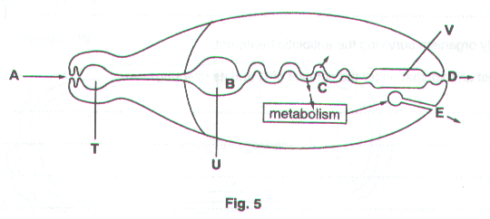
- Name structures T, U and V.

T…………………………………………………….……………………………………………………………………..

U…………………………………………………….…………………………………………………………………….

V…………………………………………………….……………………………………………………………...…..[3]

Some processes which occur in animals are shown by letters A to E in Fig. 5.

- Name the two characteristics of all living things which are represented in Fig. 5.

1…………………………………………………….……………………………………………………………………..

2…………………………………………………….…………………………………………………………………..[2]

- Name the processes which would occur in a living animal at A, B and C.

A…………………………………………………….…………………………………………………………………….

B…………………………………………………….……………………………………………………………………..

C…………………………………………………….……………………………………………………………...…..[3]

Villi are involved in the process which occurs at C.

- Explain how villi are adapted to carry out this process.

…………………………………………………….…………………………………………………….………………...

…………………………………………………….…………………………………………………….………………...

…………………………………………………….…………………………………………………….………………...

…………………………………………………….…………………………………………………….………………...

…………………………………………………….…………………………………………………….……………...[3]

[Total: 11]

Catalase is an enzyme which can be found in living cells. It breaks down toxic hydrogen peroxide which is a by-product of metabolism.

Hydrogen peroxide catalse oxygen + water

Fig. 4.1 shows the apparatus used to investigate the effect of pH on the activity of catalase.
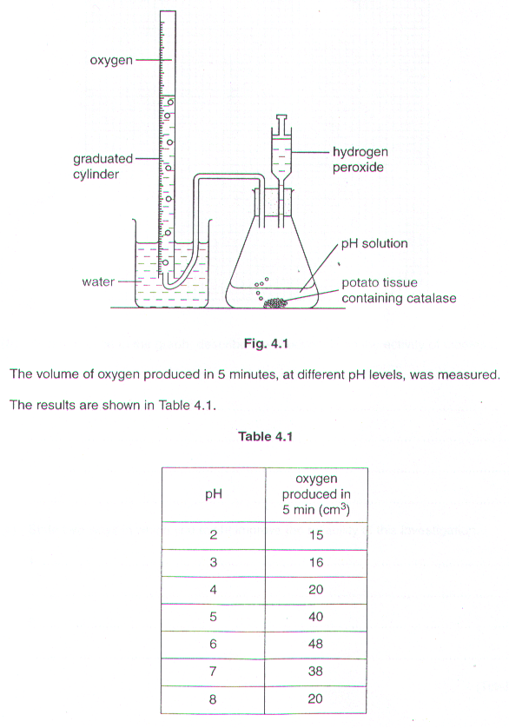

- Construct a graph using the information shown in Table 4.1. Join the points using ruled lines.

- With reference to the graph, describe the effect of pH on the activity of catalase.

…………………………………………………………………………………………………………………………….

…………………………………………………………………………………………………………………………….

…………………………………………………………………………………………………………………………….

………………………………………………………………………………………………………………………….[4]

- State two ways in which you might improve the reliability of this investigation.

1…………………………………………………………………………………………………………………………...

………………………………………………………………………………………………………………………….…

2…………………………………………………………………………………………………………………………...

………………………………………………………………………………………………………………….………[2]

[Total: 10]

Hydrogen peroxide is a poisonous compound which sometimes forms in living tissues. As a safeguard, substances within the cells are able to break down this compound, releasing molecules of oxygen in the process.

Some plant material was cut into pieces and then ground in a mortar with sand and water. The resulting material was filtered. Fresh pieces of pieces of filter paper were soaked in the filtrate, dried in an oven at 40ºC and then cut into 1cm squares.

Six test-tubes, each containing 30 cm³ of hydrogen peroxide, were placed in water baths at different temperatures. Pieces of the treated filter paper were added to each test-tube. The filter paper sank to the bottom for a while; all the pieces then rose to the surface.

The time taken for the filter paper to float to the surface was noted for each test-tube. The results are given in Table 1.

Table 1

Temperature  / ºC | Time  /seconds
5 | 70
15 | 38
25 | 24
35 | 14
45 | 10
55 | 36

- Construct a graph from the results given in table 1.

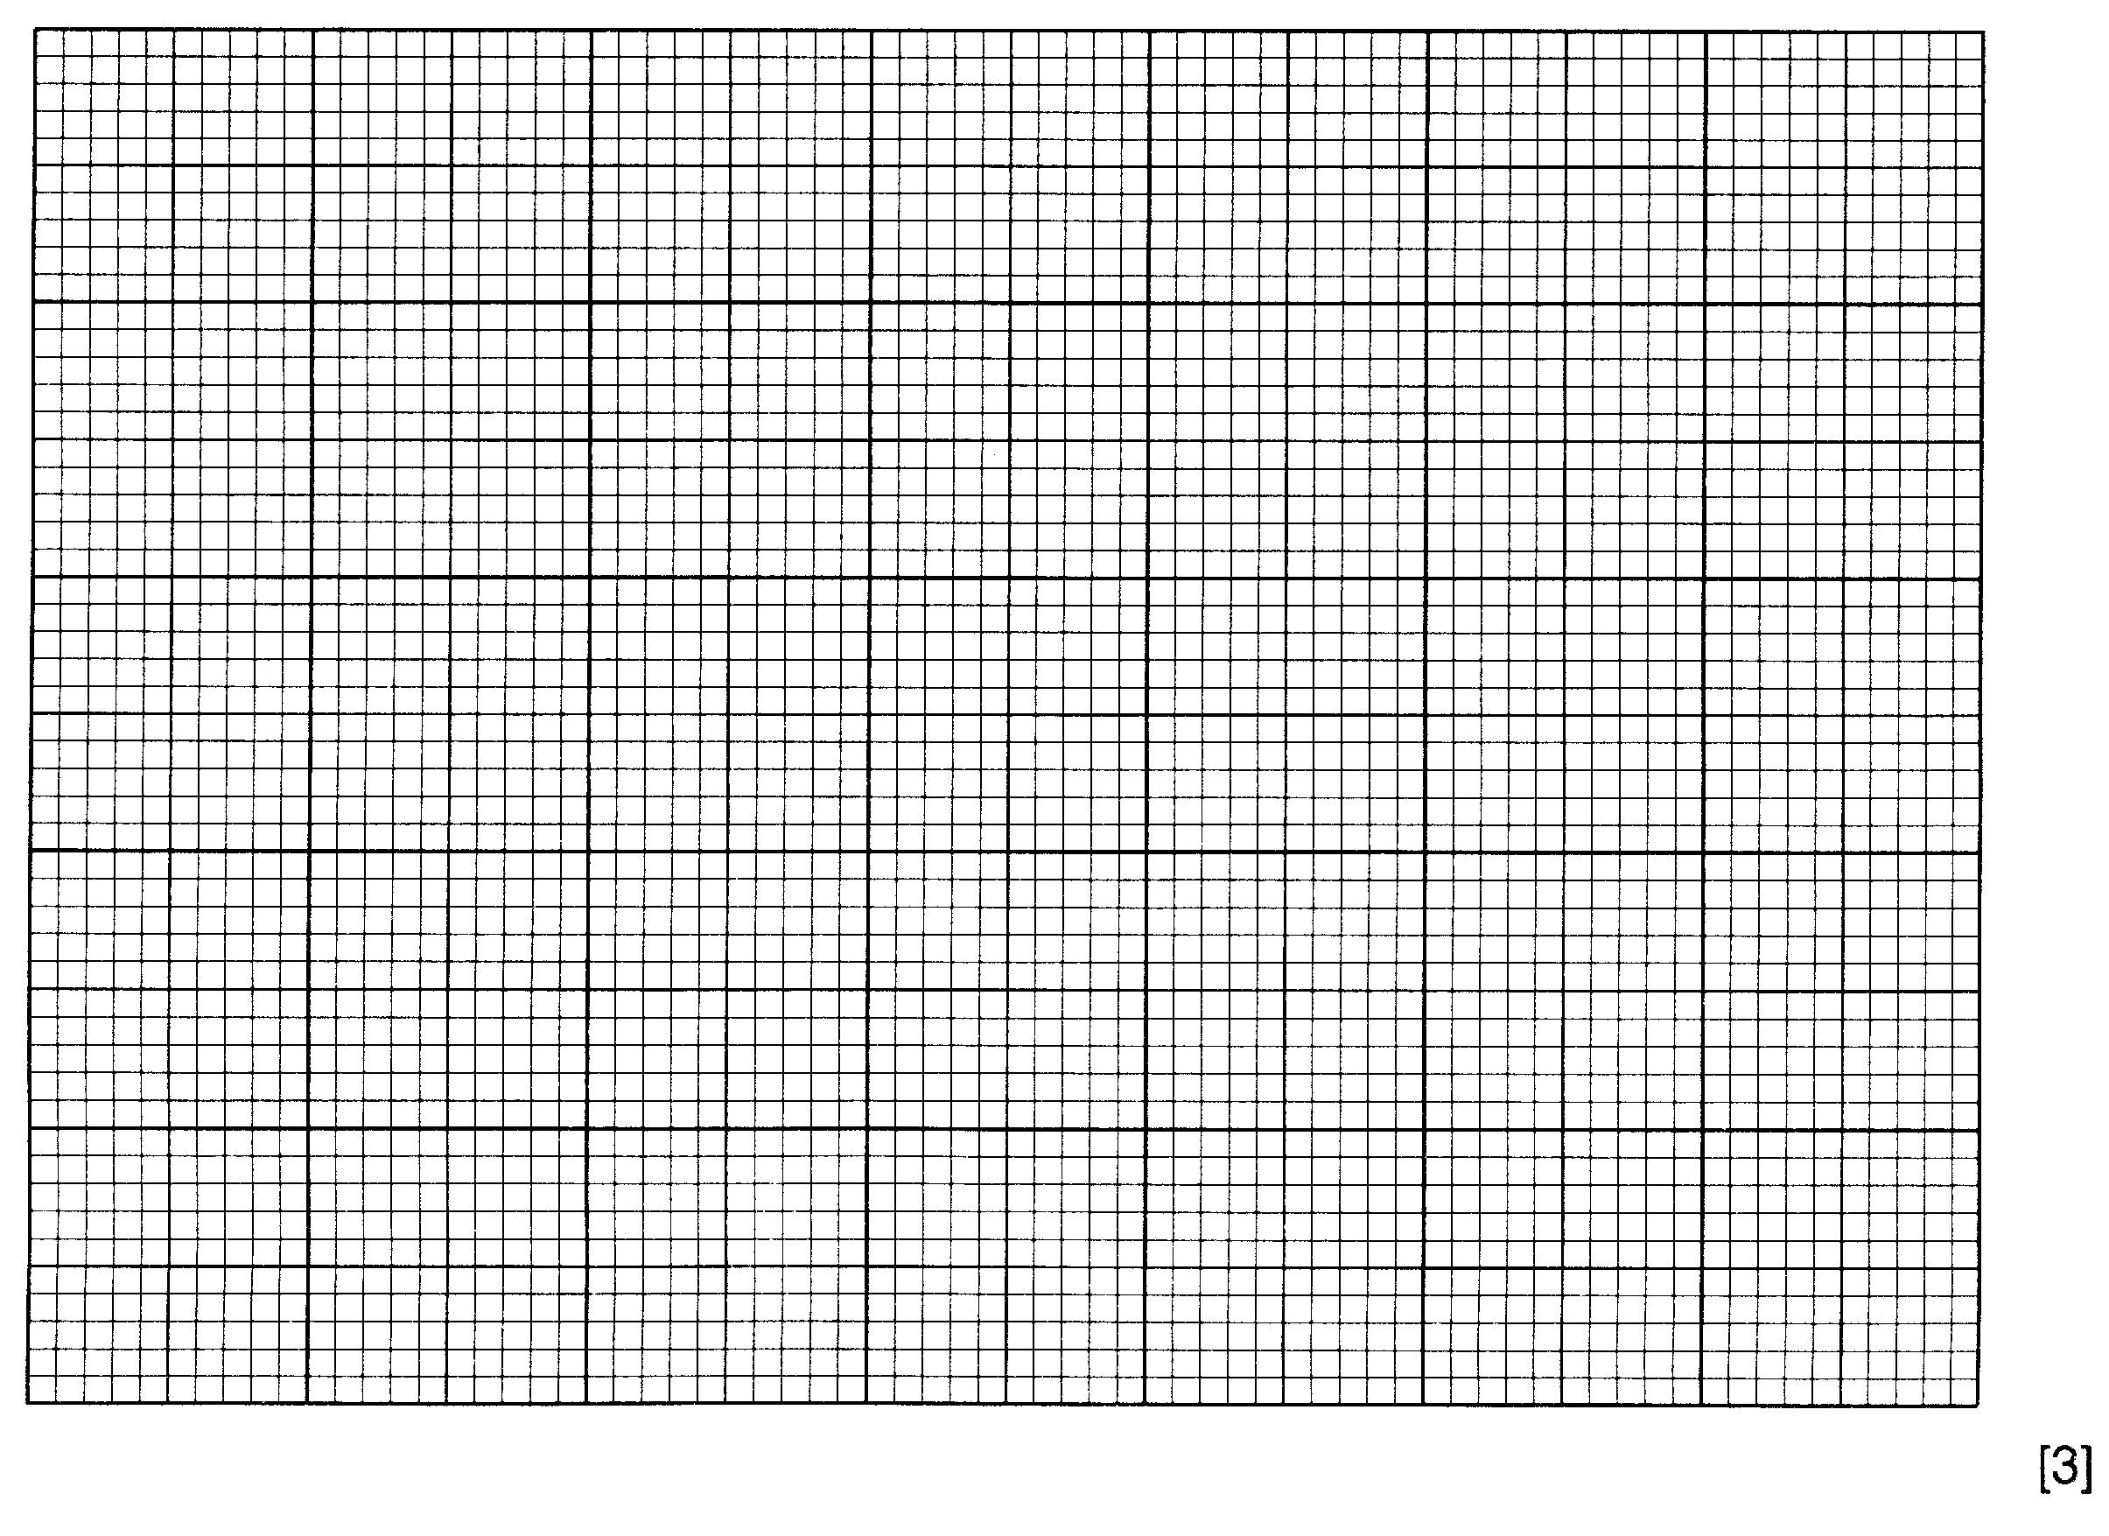

(b) (i) Why were 1. Sand, and 2. Water added to the tissue before grinding?

- sand ………………………………………………………………………………….

…………………………………………………………………………………………….

2. water …………………………………………………………………………………

……………………………………………………………………………………………

- Draw a simple diagram of the apparatus you would use to filter the material after grinding.

- Suggest why the soaked filter paper was not dried more quickly, in an oven at 85 ºC.

…………………………………………………………………………………………………………….

…………………………………………………………………………………………………………[3]

(c) (i) Suggest why the filter paper eventually rose to the surface in each test-tube.

…………………………………………………………………………………………………………….

…………………………………………………………………………………………………………….

…………………………………………………………………………………………………………….

- What additional observation might have been made to confirm your explanation?

…………………………………………………………………………………………………………….

…………………………………………………………………………………………………………[3]

- Suggest why the curve, after falling steadily to the 45 ºC reading, began to rise at 55 ºC.

…………………………………………………………………………………………………………….

…………………………………………………………………………………………………………….

…………………………………………………………………………………………………………[2]

- Curves which usually relate enzyme activity to temperature usually rise to a peak, as shown in Fig. 4.

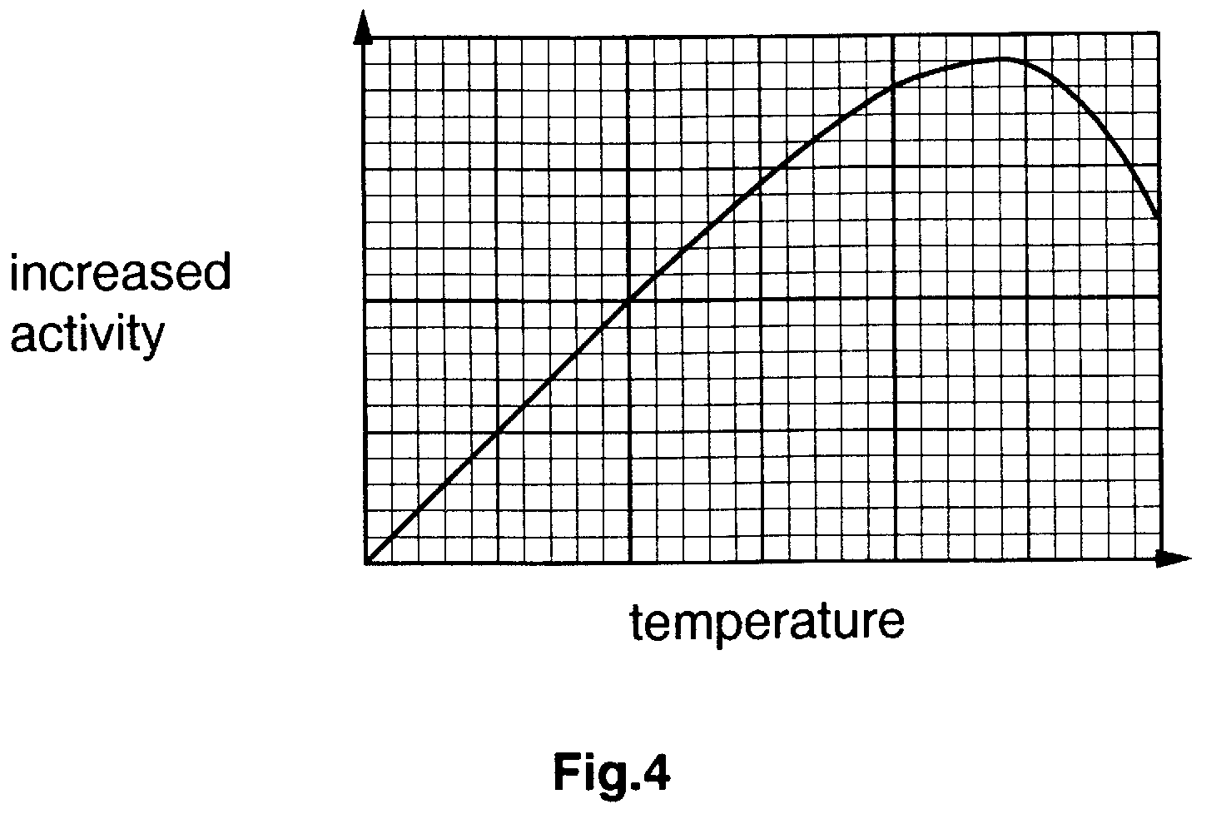

Suggest how the information given in Table 1 might be used to obtain a graph of this type.

…………………………………………………………………………………………………………….

…………………………………………………………………………………………………………….

…………………………………………………………………………………………………………….

…………………………………………………………………………………………………………[1]

(a) (i) Describe how you would carry out a test to show the presence of fat in a biscuit.
What observation would indicate the presence of fat?

Test………………………………………………………………………………………………………………

…………………………………………………………………………………………………………………...

Observation……………………………………………………………………………………………………...

………………………………………………………………………………………………………………..[3]

- Describe how you would use this test to compare the fat content of two different types of biscuit.

…………………………………………………………………………………………………………………...

…………………………………………………………………………………………………………………...

………………………………………………………………………………………………………………..[2]

- Complete the equation below to summarise the process of fat digestion.

Fat + Water ……………………………….. …………………………………… + ………………………...…[3]
(enzyme)

[Total: 8]

