- Describe the term digestion.

……………………………………………………………………………………………………………………………

……………………………………………………………………………………………………………………………

………………………………………………………………………………………………………………………….[2]

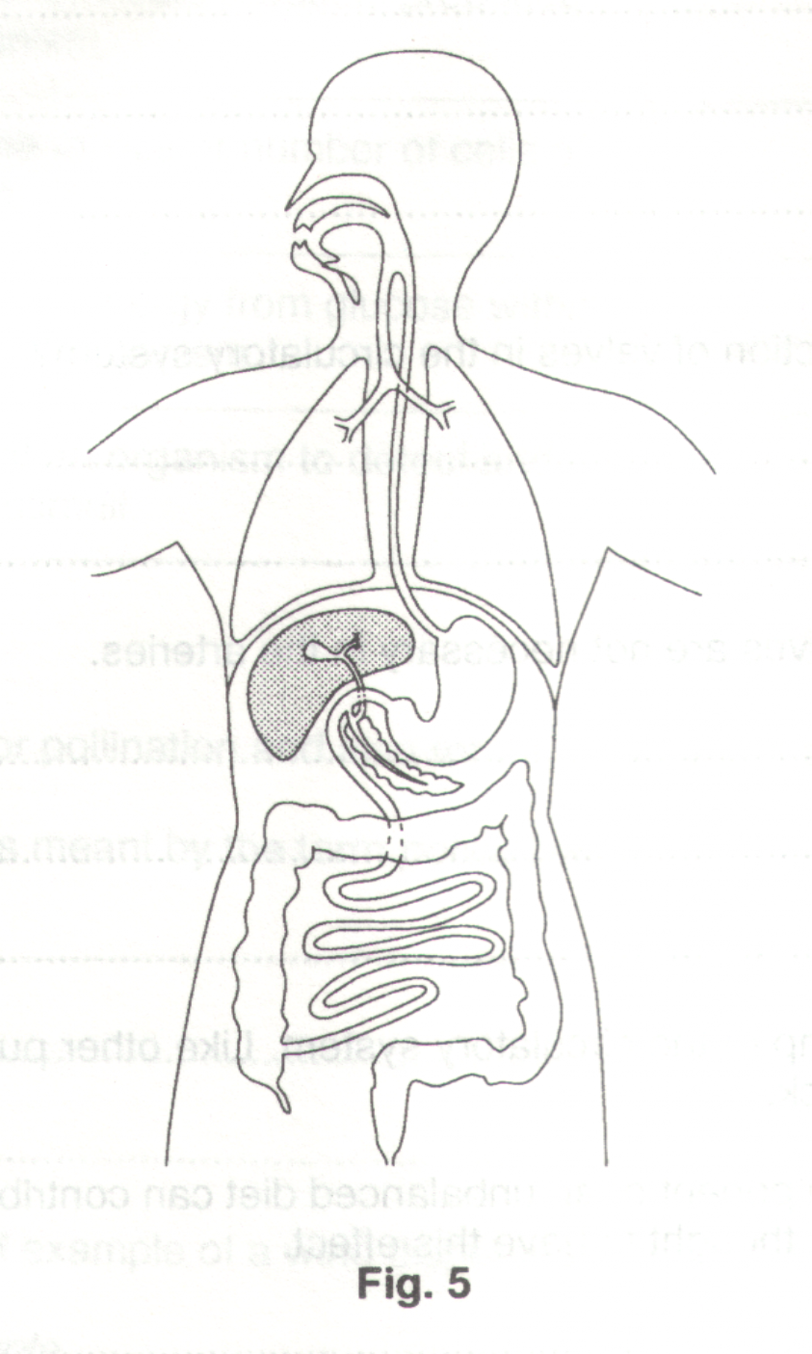
- Fig. 5 shows the human digestive system.

- By means of labelled lines, identify the large intestine, pancreas oesophagus and stomach.

- The pancreas produces pancreatic juice which assists with digestion. Which important chemical, not involved in the process of digestion, is also produced and secreted by the pancreas ?

………………………………………………………………………………………………………………..[1]

- What is the main function of the large intestine ?

…………………………………………………………………………………………………………………...

………………………………………………………………………………………………………………..[1]

- Describe three ways in which the stomach is involved in the digestion of food rich in protein.

1………………………………………………………………………………………………………………….

…………………………………………………………………………………………………………………...

2………………………………………………………………………………………………………………….

…………………………………………………………………………………………………………………...

3………………………………………………………………………………………………………………….

………………………………………………………………………………………………………………..[3]

Fig. 7 shows the liver, a section of the small intestine, and associated blood vessels.
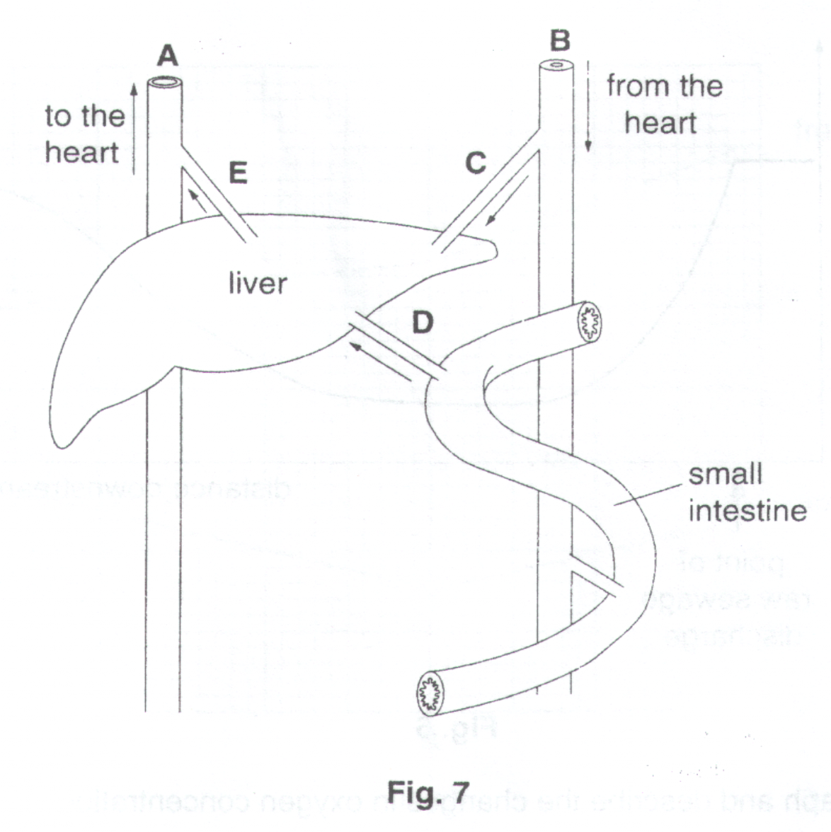
- Identify the blood vessels A and B.

A…………………………………………………………………………………………………………………………..

B……………………………………………………………………………………………………………………..…[2]

- In what way is the blood supply of the liver unusual ?

…………………………………………………………………………………………………………………………….

……………………………………………………………………………………………………………………….…[1]

- Name the waste product which is made in the liver, passed into the blood, and then removed by the kidneys.

………………………………………………………………………………………………………………………….[1]

- (i) State and explain one difference in the composition of the blood flowing in vessels C and E.

difference………………………………………………………………………………………………………...

explanation………………………………………………………………………………………………………

………………………………………………………………………………………………………..………[2]

- State and explain one difference in the difference in the composition of the blood flowing in vessels D and E, after a meal containing a lot of starch has been digested.

difference………………………………………………………………………………………………………...

explanation………………………………………………………………………………………………………

………………………………………………………………………………………………………..………….

…………………………………………………………………………………………………………..……[3]

- The liver produces a liquid which is added directly to the partly-disguised food in the small intestine. This liquid makes the digestion of fats more efficient.

- Name this liquid.

………………………………………………………………………………………………………………..[1]

- Describe how it helps digestion.

………………………………………………………………………………………………………..………….

………………………………………………………………………………………………………..………….

………………………………………………………………………………………………………..………….

………………………………………………………………………………………………………..………….

………………………………………………………………………………………………………..………….

………………………………………………………………………………………………………..………[3]

Fig. 5 shows part of the alimentary canal.
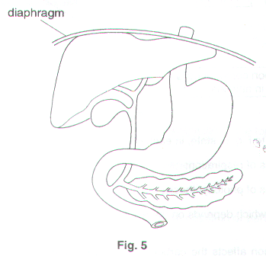
- On Fig. 5, label

- stomach
- liver
- pancreas [3]

- Describe the parts played by the liver and the pancreas in the digestion of fats.

Liver……………………………………………………………………………………………………………………….

…………………………………………………………………………………………………………………………….

…………………………………………………………………………………………………………………………….

Pancreas…………………………………………………………………………………………………………………..

…………………………………………………………………………………………………………………………….

………………………………………………………………………………………………………………………….[4]

[Total: 7]

Fig. 5 is a diagram showing some of the structures and processes found in an animal.
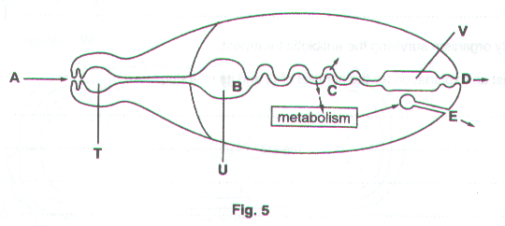
- Name structures T, U and V.

T…………………………………………………….……………………………………………………………………..

U…………………………………………………….…………………………………………………………………….

V…………………………………………………….……………………………………………………………...…..[3]

Some processes which occur in animals are shown by letters A to E in Fig. 5.

- Name the two characteristics of all living things which are represented in Fig. 5.

1…………………………………………………….……………………………………………………………………..

2…………………………………………………….…………………………………………………………………..[2]

- Name the processes which would occur in a living animal at A, B and C.

A…………………………………………………….…………………………………………………………………….

B…………………………………………………….……………………………………………………………………..

C…………………………………………………….……………………………………………………………...…..[3]

Villi are involved in the process which occurs at C.

- Explain how villi are adapted to carry out this process.

…………………………………………………….…………………………………………………….………………...

…………………………………………………….…………………………………………………….………………...

…………………………………………………….…………………………………………………….………………...

…………………………………………………….…………………………………………………….………………...

…………………………………………………….…………………………………………………….……………...[3]

[Total: 11]

Young mosquitoes (larvae) feed on water plants, such as Chlorella.

However, adult female mosquitoes feed on the blood of mammals, such as cows, horses and humans. During the process, they can transmit diseases, such as malaria.

The mosquitoes produce only one protease enzyme, called trypsin. Scientists have identified a hormone that switches off the ability of mosquitoes to secrete trypsin. They genetically modified Chlorella to make the hormone and introduced the plant into lakes where mosquitoes are a problem. This reduces the population of mosquitoes and should help to prevent the spread of malaria. Other animals that eat Chlorella are not affected because they do not depend on trypsin alone.

(a) (i) Explain why an adult female mosquito needs to secrete trypsin.
…………………………………………………………………………………………………..
………………………………………………………………………………………………….
………………………………………………………………………………………………[2]

(ii) What product would be present in the gut of a mosquito if trypsin had been active?
……………………………………………………………………………………………….[1]

(iii) Suggest one use of this product in the body of the mosquito.
……………………………………………………………………………………………….[1]

(b) Suggest why developing the genetically modified Chlorella may be a better way of killing mosquitoes than using insecticides.

……………………………………………………………………………………………………..

……………………………………………………………………………………………………..

……………………………………………………………………………………………………..

…………………………………………………………………………………………………..[3]

(c) Food supply is one factor that affects the growth of a population.

State two other factors that also affect population growth.

1. …………………………………………………………………………………………………….

2. ………………………………………………………………………………………………...[2]

(d) (i) Define the term hormone.
…………………………………………………………………………………………………..
…………………………………………………………………………………………………..
………………………………………………………………………………………………[2]
(ii) Hormones are used medically to control or improve human fertility.

Name a hormone used for this purpose and state its function.
…………………………………………………………………………………………………..
…………………………………………………………………………………………………..
………………………………………………………………………………………………[2]

[Total : 13]

