Fig. 2.1 shows a red blood cell and a root hair cell.
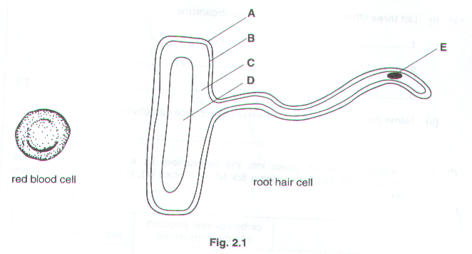
(a) (i) Select two structures in the root hair cell which are also present in the red blood cell. In each case state the
letter, A to E, and name the structure.

- Letter………………………………………………………………………………………………………..

Name of structure…………………………………………………………………………………………...

- Letter………………………………………………………………………………………………………..

Name of structure………………………………………………………………………………..………[2]

- Name one structure which is typical of many plant cells but which is not present in the root hair cell.

………………………………………………………………………………………………………………..[1]

- State one major function of each cell and describe one way in which the cell is adapted to carry out this function.

- Red blood cell.

Function…………………………………………………………………………………………………………

…………………………………………………………………………………………………………………...

Adaptation……………………………………………………………………………………………………….

………………………………………………………………………………………………………………..[2]

- Root hair cell.

Function…………………………………………………………………………………………………………

…………………………………………………………………………………………………………………...

Adaptation……………………………………………………………………………………………………….

………………………………………………………………………………………………………………..[2]

[Total: 7]

Blood flows around the body in arteries, capillaries and veins.

- Explain what part the structure of arteries and veins plays in the circulation of blood around the body.

Arteries……………………………………………………………………………………………………………………

…………………………………………………………………………………………………………………………….

…………………………………………………………………………………………………………………………….

Veins………………………………………………………………………………………………………………………

…………………………………………………………………………………………………………………………….

…………………………………………………………………………………………………………………….……[4]

- Blood in the smallest arteries in a muscle flows into networks of capillaries.

The flow through these networks is much slower than through arteries or veins.

Suggest how these features, together with the structure of capillaries, assist in supplying glucose to muscle cells.

…………………………………………………………………………………………………………………………….

…………………………………………………………………………………………………………………………….

…………………………………………………………………………………………………………………………….

…………………………………………………………………………………………………………………………….

…………………………………………………………………………………………………………………….……[4]

- Muscles cells need a supply of oxygen.

- Explain how oxygen is carried in the blood.

…………………………………………………………………………………………………………………

………….………………………………………………………………………………………………[3]

- Explain what causes the blood to release more oxygen in active muscles than in resting muscles.

…………………………………………………………………………………………………………………

………….………………………………………………………………………………………………………

…………………….……………………………………………………………………………………………

……………………………………………………………………………………………………………….[3]

[Total: 14]

Fig. 6 shows some blood cells as they appear under the microscope.
(a) (i) What is structure X?

……………………………………………………………………………………………………..…………[1]

- Which type of blood cells are cells B and C?

……………………………………………………………………………………………………………..…[1]

(iii) What are the functions of cells B and C ?

………………………………………………………………………………………………………………...…

………………………………………………………………………………………………………………[1]

- Describe clearly one difference in structure between a white blood cell and a red blood cell, that can be seen using a light microscope.

………………………………………………………………………………………………………………….…………

………………………………………………………………………………………………………………….………[1]

- What is the function of red blood cells in the circulatory system ?

………………………………………………………………………………………………………………….………[1]

- With the aid of diagrams, describe how white blood cells can destroy bacteria in the blood system.

………………………………………………………………………………………………………………….…………………...

………………………………………………………………………………………………………………….…………………...

………………………………………………………………………………………………………………….…………………...

………………………………………………………………………………………………………………….………………..[4]

- When the skin is cut and a blood vessel is damaged, a blood clot forms to cover the damaged area.

- State two reasons why this is important for the body.

1………………………………………………………………………………………………………………….

…………………………………………………………………………………………………………………...

2………………………………………………………………………………………………………………….

…………………………………………………………………………………………………………………...

- Which component of the blood plasma is directly involved in the clotting of blood ?

………………………………………………………………………………………………………………..[3]

- What is the importance of having sufficient iron in the diet ?

………………………………………………………………………………………………………………….…………

………………………………………………………………………………………………………………….………[2]

Fig. .4.1 shows a section through the heart.
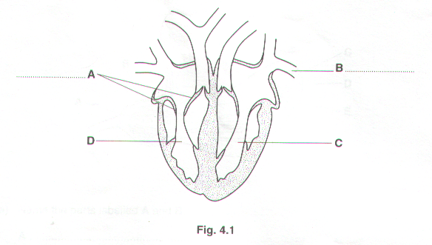
- On Fig. 4.1

(i) name the parts labelled A and B [2]

(ii) shade the cavity of the ventricle which contains oxygenated blood. [1]

- suggest why the wall around chamber C is much thicker than around chamber D.

…………………………………………………………………………………………………………………...

…………………………………………………………………………………………………………………...

………………………………………………………………………………………………………………..[2]

- The coronary arteries supply blood to the heart muscle.

- Suggest two activities of humans which might cause a clot in the coronary artery.

1………………………………………………………………………………………………………………….

2………………………………………………………………………………………………………………[2]

- Explain what might be the result of such a blockage.

…………………………………………………………………………………………………………………...

…………………………………………………………………………………………………………………...

………………………………………………………………………………………………………………..[2]

- Fig. 4.2 shows a plan of the circulatory system.
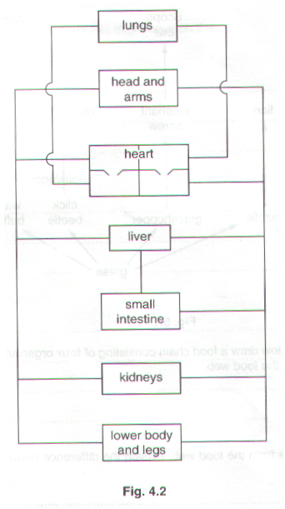
On Fig. 4.2

(i) label where urea is formed [1]

(ii) label where urea is excreted [1]

(iii) show, using a series of arrows, the route taken by urea between these two organs [2]

[Total: 13]

