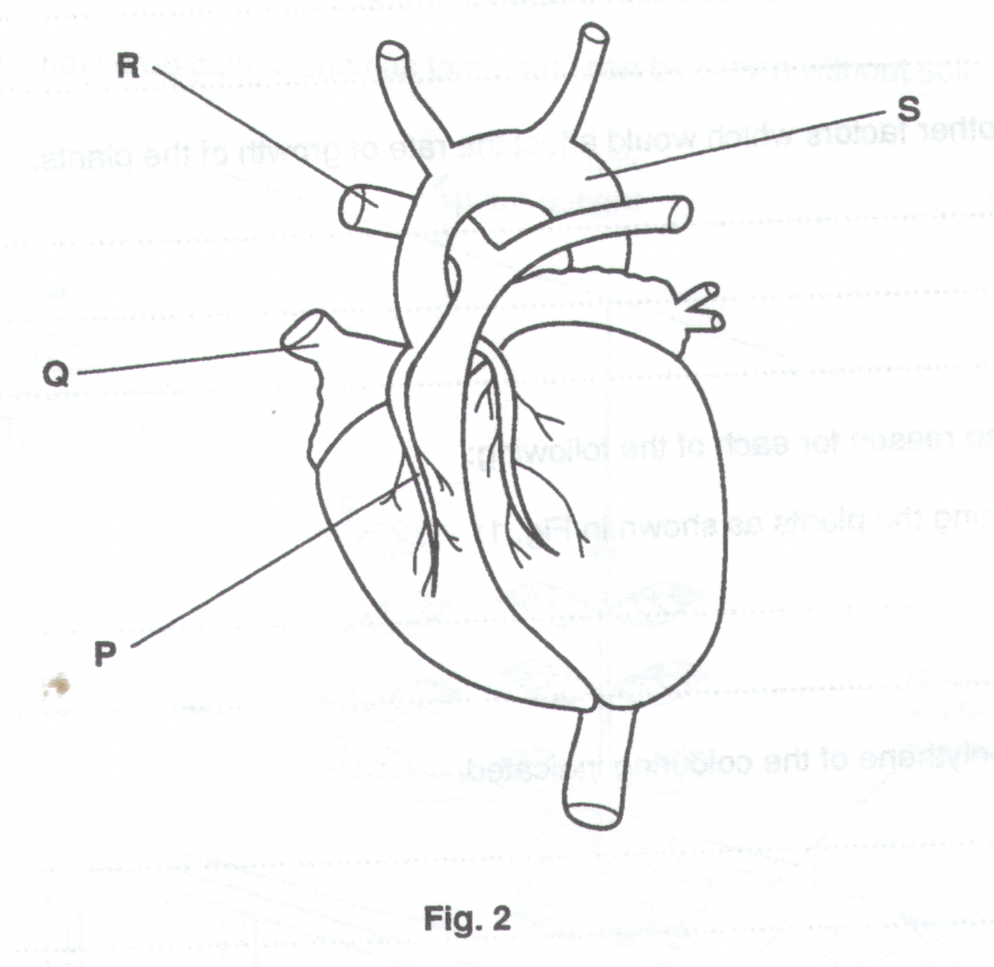
Fig. 2 shows a human heart.

- Complete the table to show whether the blood vessels P, Q, R and S in Fig. 2 above is oxygenated or de-oxygenated, and under high or low pressure.
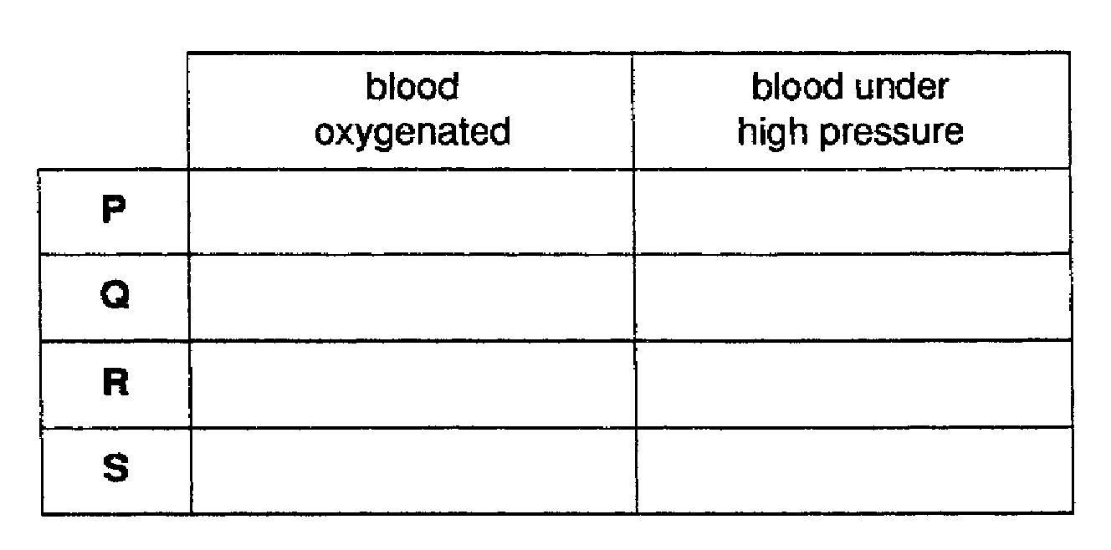
(b) (i) State two substances in food that are believed to cause heart disease.

1…………………………………………………………………………………………………………………

2…………………………………………………………………………………………………………………

- State two other factors that are possible causes of heart disease.

1…………………………………………………………………………………………………………………

2………………………………………………………………………………………………………………[4]

When artery P becomes blocked (see Fig. 2), it is sometimes replaced, during an operation, with a vein taken from another part of the patients body.

(c) (i) When the vein is sewn into place, why must great care be taken to ensure that it is the correct way around ?

………………………………………………………………………………………………………………………………………

………………………………………………………………………………………………………………………………………

- Suggest and explain one advantage and one disadvantage of using the patient’s own vein rather than an artery transplanted from another person.

Advantage

………………………………………………………………………………………………………………………………………

………………………………………………………………………………………………………………………………………

………………………………………………………………………………………………………………………………………

Disadvantage

………………………………………………………………………………………………………………………………………

………………………………………………………………………………………………………………………………………

………………………………………………………………………………………………………………………………………
[6]

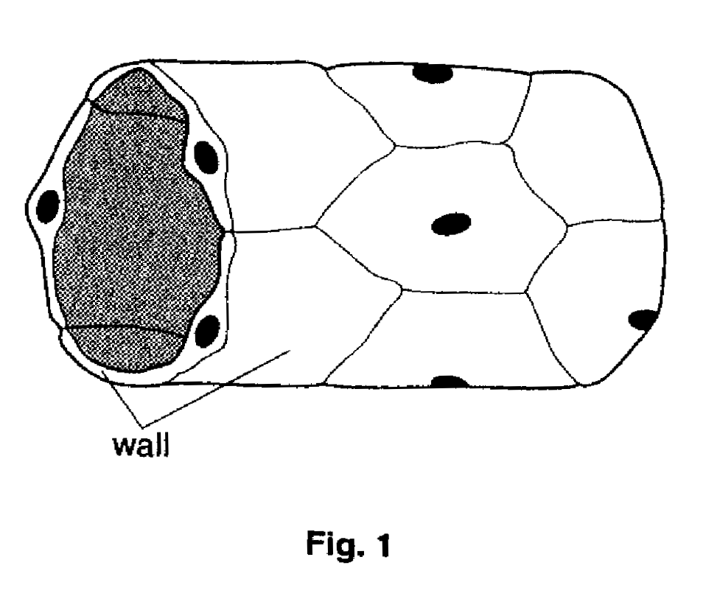
Fig. 1 shows a short length of a blood vessel.
(a) (i) Which type of blood vessel is shown in Fig. 1 ?

…………………………………………………………………………………………………………..……[1]

- Explain how the wall is suited to the functions of this blood vessel.

…………………………………………………………………………………………………………………...

…………………………………………………………………………………………………………………...

………………………………………………………………………………………………………………..[2]

Fig. 2 shows the pressure of the blood as it completes one circulation of the body (excluding the lungs).
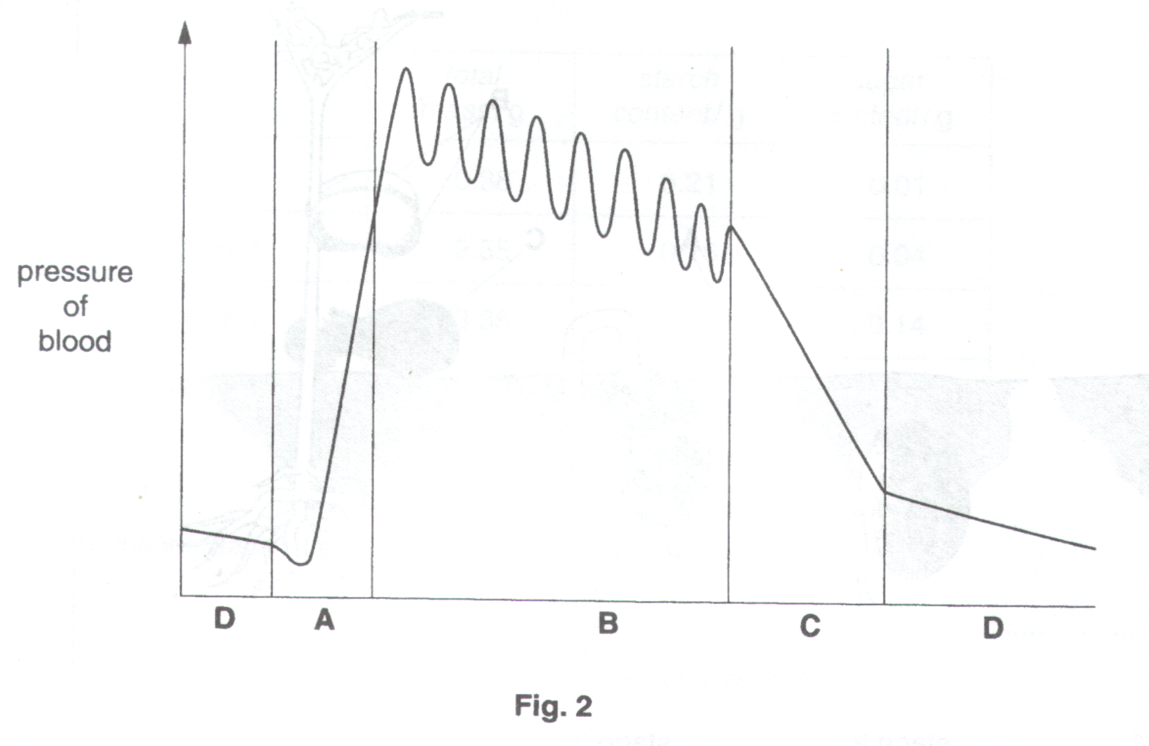
- State which labelled section of the graph shows the pressure of the blood as it passes through

Arteries…………………………………

Veins…………………………………..

Capillaries……………………………..

The Heart………………………………

- Suggest why the blood pressure in the pulmonary artery is not as high as that in the aorta.

…………………………………………………………………………………………………………………….……[1]

- Explain how blood pressure might be affected by eating foods rich in animal fats and cholesterol.

…………………………………………………………………………………………………………………….………

…………………………………………………………………………………………………………………….………

…………………………………………………………………………………………………………………….………

………………………………………………………………………………………………………………….………[2]

[Total: 10]

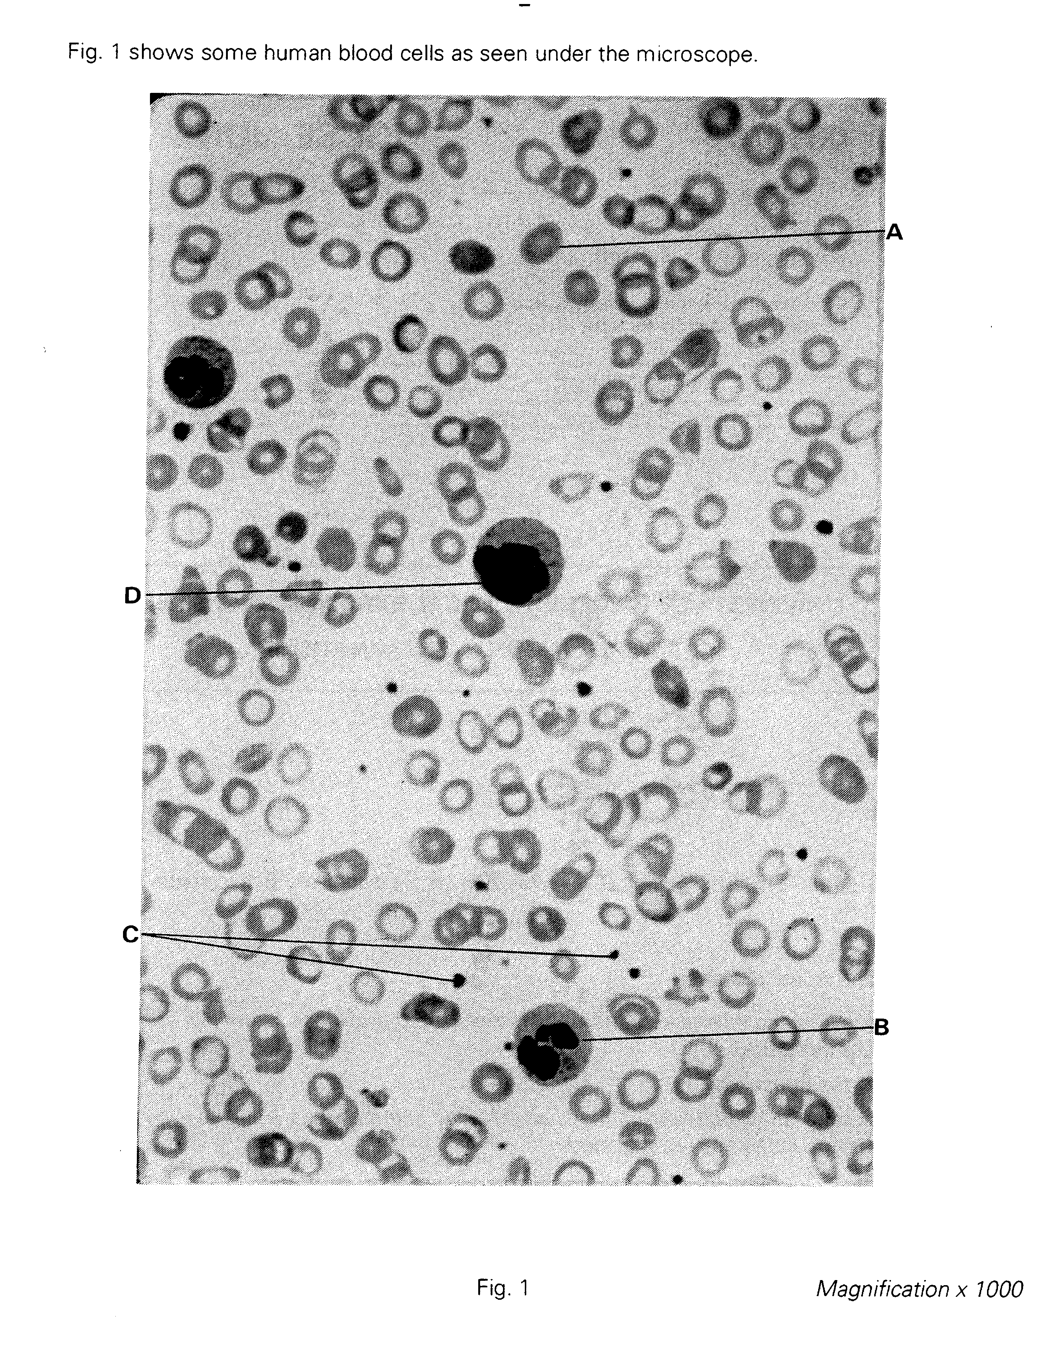

(a) (i) List three visible differences between cell A and cell B.

- ………………………………………………………………………………………

- ………………………………………………………………………………………

- ……………………………………………………………………………………[3]

- Suggest what the blood component C may be.

………………………………………………………………………………………..[1]

- In the space below, make a large, labelled drawing of cell D.

[5]

- Measure the diameter of cell D, in the photograph and in your drawing. Record your measurements below:

Diameter of D in photograph ………………………….

Diameter of D in drawing ……………………………

In the photograph, the cells are shown magnified x 1000. In the space below, use this information, and the measurements you made, to calculate the magnification of the cells in your drawing. Show your working.

Magnification ……………………………… [3]

Table 1 shows the results of an investigation into the efficiency of an athlete’s heart. His heart rate (pulse rate) during periods of exercise was measured. At the same time, the amount of blood being pumped from his heart per minute was determined.

Heart rate/ beats per min. | Blood output/ cm³ per min.
55 | 4000
70 | 4800
80 | 5200
90 | 5600
120 | 6000
140 | 6000
150 | 5800
170 | 4600

Table 1

a) Plot a line graph of these results on the grid provided, joining the points by straight, ruled lines. [6]
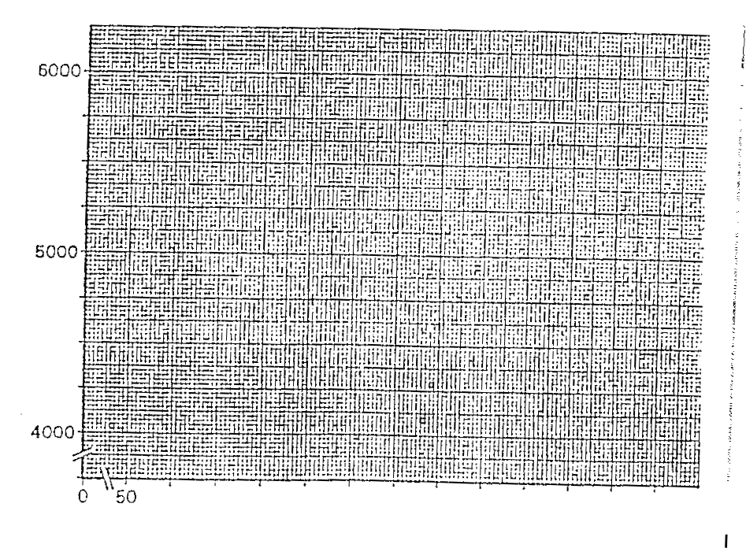
b) From the graph, determine the output of blood when the heart rate was 100 beats per minute.

………………………………………………………………………………………………..[1]

c) From the information in Table 1, determine how much blood the heart pumped out at each beat when the heart rate was 120 beats per minute. Show your working.

Working

Answer …………………………………….. [3]

d) How does the efficiency of the heart at 130 beats per minute compare with its efficiency at 160 beats per minute? Suggest an explanation for this difference.

………………………………………………………………………………………………………..

………………………………………………………………………………………………………..

………………………………………………………………………………………………………..

……………………………………………………………………………………………………[3]

